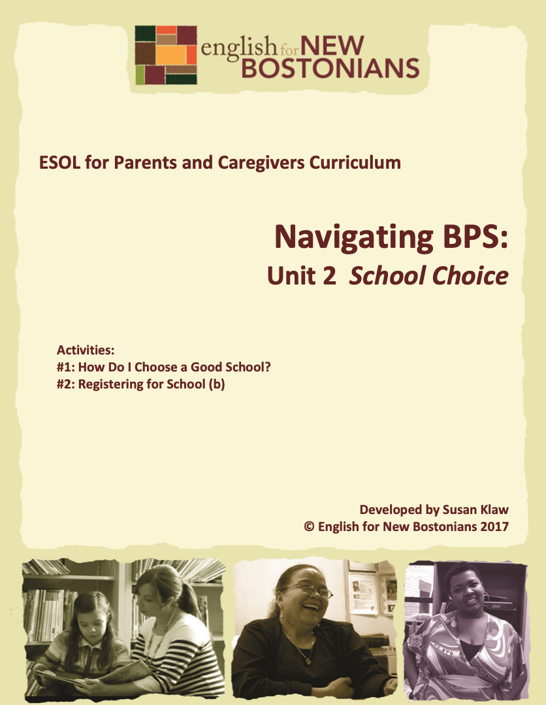
Developed by Susan Klaw
© English for New Bostonians 2022

About English for New Bostonians
English for New Bostonians (ENB) invests in the future of our region by fostering a high-quality ESOL system that prepares immigrants to pursue their educational, economic and civic aspirations. Through grant making, training teachers, and building public awareness, ENB expands the number of English for Speakers of Other Languages (ESOL) seats, improves program quality across agencies, customizes curricula to diverse subpopulations, and leverages private and public resources. Founded in 2001 by the Mayor’s Office for Immigrant Advancement (MOIA), immigrant leaders, and local foundations, ENB now involves several city departments, approximately 20 public and private funders, and numerous community organizations.

About the ESOL for Parents and Caregivers Initiative
Through ESOL for Parents and Caregivers, ENB guides ESOL providers and immigrant-rich schools in building partnerships to facilitate parent engagement in schools, enabling parents/caregivers to improve their English and digital literacy skills, navigate school systems, and understand expectations and opportunities for school involvement and ways to optimize children’s learning. At the same time, ESOL for Parents helps adults prepare to pursue their own educational and employment goals, while supporting children’s learning – aiming to eliminate multigenerational poverty.

About Susan Klaw
Susan Klaw has directed, taught in, and developed original curriculum materials for Boston-based parent ESOL programs since 1991. She has delivered extensive training locally and nationally on various aspects of Family Literacy and been named a “Literacy Champion” by the Massachusetts Literacy Foundation, Parent Educator of the Year by the Children’s Trust Fund, and Adult Educator of the Year by the Massachusetts Coalition for Adult Education.

About the ESOL for Parents and Caregivers Curriculum
The Curriculum (on ENB website and available free of charge) gives ESOL teachers background materials, lessons and activities designed to help immigrant parents learn English and become more effectively involved in their children’s education. Selecting curriculum units and lessons relevant to their classes, ESOL teachers can orient immigrant parents to the U.S. school system and provide practical skills such as interpreting report cards, participating in teacher conferences, advocating for children, and supporting children's learning at home. While some information is Boston specific, much can be used in any locale. ENB can assist in adapting materials for school districts. Additionally, ENB offers a Companion Middle/High School Guide, as well as a Digital Learning Guide to support online instruction.

Using the ESOL for Parents and Caregivers Curriculum
All materials are intended to be downloaded and widely used. Please cite English for New Bostonians and credit English for New Bostonians on all reproductions. We welcome feedback and stories on how you and your students are using the ESOL for Parents and Caregivers Curriculum!

Thanks to the many public and private funders that have supported this project, especially the Highland Street Foundation, Shipley Foundation, Hamilton Foundation, Moses Kimball Foundation, Plymouth Rock Foundation, Blum Shapiro Foundation and the Mayor’s Office for Immigrant Advancement’s We Are Boston Gala.

Contact us at info@englishfornewbostonians.org
or visit us online at www.englishfornewbostonians.org

ACTIVITY #1: HOW DO I CHOOSE A GOOD SCHOOL?

Note to teacher: parents should be visiting schools in December and registering their choices in January. Thus this two activity unit is best done late November-early December.

Rationale:
Parents in Boston are given a number of choices of schools their children can attend. They have to figure out on what basis to rank those choices. Here students consider what makes a good school, how they can find out about different schools, and how to choose a school for their child.
Student Objectives:
▪ Students will be able to name characteristics of a good school.
▪ Students will be able to express opinions about good and bad reasons for choosing schools.
▪ Students will become aware of the information available to them about schools on the BPS website.
Materials:
▪ Handout: Is This a Good Reason to Choose a School?
Activity Outline:
1. Explain objectives.
2. Group Brainstorm Activity: What is a good school? Divide students into small groups to discuss among themselves the question, What is a good school? Have each group choose a note taker who will report back the group’s ideas. After 10-15 minutes of small group discussion, reconvene and list on the board all the characteristics of good schools that students have generated.
3. Have students look at the list and write down the two characteristics of good schools on the list that are most important to them personally. Tabulate these results on the board by having students each read their top two priorities and making check marks on the board next to items chosen. Many parents will choose “close to home” in their top two. It is important to help students weigh this against other factors. Ask whether for high school students, being close to home is as important as it is for elementary students. Ask what they would do if they find out that the school closest to home is not a very good school, that is, it doesn’t meet many of the other criteria they have listed. Ask students whose choices differ from those of the majority in the class to explain their choices. This way the group benefits from hearing different perspectives.

4. Ask students how they can learn about which schools in Boston are good schools. Write their ideas on the board. Go through a process similar to the one above by asking each student to choose off the list what they think is the best way to learn about different schools. Again, have them share those choices. Many will choose the “talk to my friend” method of learning about schools. Point out that it is important to talk to as many friends, relatives and acquaintances as possible. Don’t just rely on the advice of one person, because she or he might have different needs than you do. Suggest that at break time, students talk to their classmates for advice about schools or give them informal time to do so in the class in their first languages.
5. Distribute the Handout: Is This a Good Reason to Choose a School? Do a vote with your feet activity for each scenario. Put a sign that says NO in one corner of the classroom and one that says YES in another. After reading each statement together, have students get up and go stand under one sign or the other, depending on whether they think this is a good reason to choose a school. Especially if there are differences of opinion, ask for volunteers to share their reasoning.
6. With students, go to the BPS website and searh for Discover BPS. Look for the Boston Public Schools Choice and Registration Guide for the current school year. This Guide will walk parents through the registration and school choice process.
Follow-up:
▪ With intermediate students, go to Topic 1: Navigating BPS, Unit 5: Looking Beyond to Other Choices—Exam Schools, Pilot Schools, Charter Schools, Independent Schools, Advanced Work Classes.
▪ On the BPS website, visit the page describing the Welcome Centers. Parents have to go to the Welcome Centers to register their children for school for the first time or to request transfers. They can also go there to get advice about school choices and BPS policies and to get information about BPS in many languages. Have students identify the Welcome Center nearest them, the hours it is open, etc.
▪ Visit the closest BPS Welcome Center

Handout: Is this a good reason to choose a school?
Vote Yes or No
1. Carla is a 5th grader. He wants to go to a middle school where his two best friends are going.
2. Michelle wants her child to go to an elementary school that has an after school program because she works full time.
3. Mei, who is an immigrant from China, wants her child to go to an elementary school that has a lot of other Chinese families and staff that speak Chinese.
4. Chris is an 8th grader. He tells his mother the best school is the closest high school because it has a good basketball team and he likes basketball.
5. Li wants his son to go to a small high school so he will get more individual attention and help applying to college.
6. Teresa wants her three children to go to the elementary school that is on the same block as her apartment.

ACTIVITY #2: REGISTERING FOR SCHOOL
(Can be used/adapted for use with beginning level students)
Rationale:
Parents must register early in the process if they want to get their child into any of their first choice schools. Here parents learn how to use the BPS website to get school registration information.
Student Objectives:
▪ Students will understand the basics of the BPS school registration process.
▪ Students will become more familiar with the BPS website.
Materials:
▪ Handout: Registration Process Worksheet to be created by teacher

Note to Teachers: The most up to date information on the BPS school registration process will be available on the BPS website, under the Enroll tab. Familiarize yourself with the basic steps in the process before helping students log-on and extract basic information. Two things are important to know: First, parents only need to go and physically register their children for school when children are starting kindergarten, when they are new to the system, or when parents want to request a transfer. They do this at one of the Welcome Centers. To start school a child must be four years old by September 1 for K1 (basically pre-school) or five years old by September 1 for K2. Once a child is in a school, they get to stay there. When they reach a transition point, such as leaving 5th grade and moving on to middle school, or leaving 8th grade to go to high school, the family receives a set of school choices to prioritize and send back in through their child’s school. Second, registration occurs in several rounds. Within those rounds, it is not first come, first serve. However, families are unlikely to get their first choice schools if they do not register in the first round which is typically during the month of January. The website will list the dates of the registration rounds as well as school visit days for parents to learn more about the customized list of schools they have gotten off the website. Even if the registration process is too complex to tackle in a beginning-level ESOL class, students can be given individual support to find the help they need at the Welcome Center closest to them.

Activity Outline:

- Explain objectives.

- If there is a BPS parent outreach coordinator connected to your site, invite them to the class to explain the process.

3. Explore current information available on the BPS website about registering for schools and create a worksheet for students to fill out which has them list, for example, the dates of the first registration period, or the schools they can choose from, or the address or the Welcome Center closest to them, etc.
4. Ask students what they already know about registering for BPS. Fill in basics from the information above. See what questions students have and note them so they can be helped to find the answers when they go to the BPS website
5. Determine who in the class will need to register a child, e.g. someone with child not yet in school. If there are no students in that situation, the teacher might decide not to spend much time on-line. Rather than have parents actually get specific information off the website, the goal would be for parents to know that registration information is available when they need it. If there are a couple of students in the class with young children starting school, those are the parents to focus on, allowing other students to spend time browsing the BPS website and practicing switching from one language to another.
6. On Chromebooks, help students locate school registration information on the BPS website. Especially for beginning students, show them how they can change the language from English. Give them the handout you have created called Registration Process Worksheet to complete.
7. Summary: Reiterate that to get their first choices, parents must register during the first registration round. Review those dates.
Follow-up:

▪ Visit the closest BPS Welcome Center

