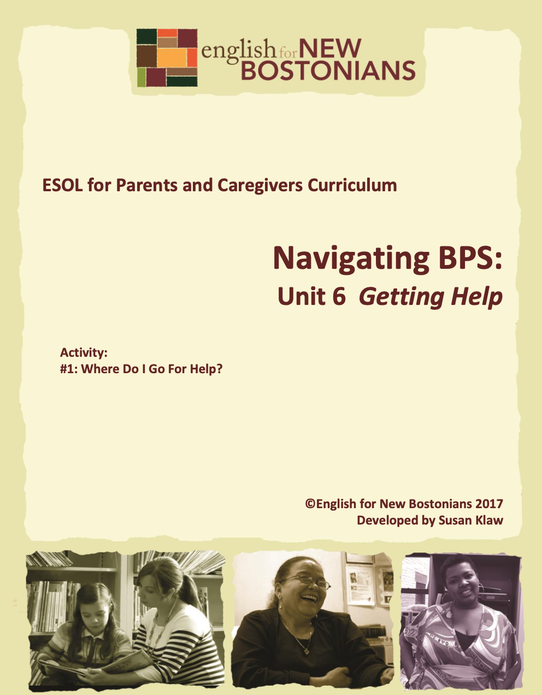
Developed by Susan Klaw
© English for New Bostonians 2022

About English for New Bostonians
English for New Bostonians (ENB) invests in the future of our region by fostering a high-quality ESOL system that prepares immigrants to pursue their educational, economic and civic aspirations. Through grant making, training teachers, and building public awareness, ENB expands the number of English for Speakers of Other Languages (ESOL) seats, improves program quality across agencies, customizes curricula to diverse subpopulations, and leverages private and public resources. Founded in 2001 by the Mayor’s Office for Immigrant Advancement (MOIA), immigrant leaders, and local foundations, ENB now involves several city departments, approximately 20 public and private funders, and numerous community organizations.

About the ESOL for Parents and Caregivers Initiative
Through ESOL for Parents and Caregivers, ENB guides ESOL providers and immigrant-rich schools in building partnerships to facilitate parent engagement in schools, enabling parents/caregivers to improve their English and digital literacy skills, navigate school systems, and understand expectations and opportunities for school involvement and ways to optimize children’s learning. At the same time, ESOL for Parents helps adults prepare to pursue their own educational and employment goals, while supporting children’s learning – aiming to eliminate multigenerational poverty.

About Susan Klaw
Susan Klaw has directed, taught in, and developed original curriculum materials for Boston-based parent ESOL programs since 1991. She has delivered extensive training locally and nationally on various aspects of Family Literacy and been named a “Literacy Champion” by the Massachusetts Literacy Foundation, Parent Educator of the Year by the Children’s Trust Fund, and Adult Educator of the Year by the Massachusetts Coalition for Adult Education.

About the ESOL for Parents and Caregivers Curriculum
The Curriculum (on ENB website and available free of charge) gives ESOL teachers background materials, lessons and activities designed to help immigrant parents learn English and become more effectively involved in their children’s education. Selecting curriculum units and lessons relevant to their classes, ESOL teachers can orient immigrant parents to the U.S. school system and provide practical skills such as interpreting report cards, participating in teacher conferences, advocating for children, and supporting children's learning at home. While some information is Boston specific, much can be used in any locale. ENB can assist in adapting materials for school districts. Additionally, ENB offers a Companion Middle/High School Guide, as well as a Digital Learning Guide to support online instruction.

Using the ESOL for Parents and Caregivers Curriculum
All materials are intended to be downloaded and widely used. Please cite English for New Bostonians and credit English for New Bostonians on all reproductions. We welcome feedback and stories on how you and your students are using the ESOL for Parents and Caregivers Curriculum!

Thanks to the many public and private funders that have supported this project, especially the Highland Street Foundation, Shipley Foundation, Hamilton Foundation, Moses Kimball Foundation, Plymouth Rock Foundation, Blum Shapiro Foundation and the Mayor’s Office for Immigrant Advancement’s We Are Boston Gala.

Contact us at info@englishfornewbostonians.org
or visit us online at www.englishfornewbostonians.org

ACTIVITY #1: WHERE DO I GO FOR HELP?
Rationale:
It is usually easiest and most effective for students to talk to someone at their child’s school when they need help. The resource list provided here suggests that first and then directs parents to two types of centers within BPS specifically designed to work with parents. Both the Welcome Centers and the Newcomer Assessment and Counseling Center have multilingual capabilities.
Student Objectives:
▪ Students will become familiar with four places they can go for help
▪ Students will build speaking skills as they share personal stories
Materials:
▪ Handout: Getting Help—a Resource List
Activity Outline:
1. Explain objectives.
2. Opening discussion: hand out index cards. Tell students to think of a time since their child started school that they had a question or a worry or needed help to change something related to school. Have them write on the index card what they did or who they talked to about their child. Go around the class and have students share the situation they thought of and what they did to try to resolve the problem.
3. Distribute the Handout: Getting Help—A Resource List
4. Read the handout together. Pause after each resource and ask students to share any personal experiences with the resource mentioned. Urge them to save the list.
Follow-Up:
▪ If the class is in a school-based site and the school has a parent coordinator or parent liason, invite that person to come and meet your students, become familiar with your class, and answer questions.
▪ Take a class trip to the nearest Welcome Center to familiarize students with the Center. Call ahead so that someone on staff would be available to meet with your group.

Handout: Getting Help--A Resource List
There will be many times when you need help with some school problem. If your child attends a Boston public school, here are some suggestions.
1. Parent Coordinator or Parent Liason at your child’s school
▪ Not all schools have parent coordinators, but many do. They have different titles, but they all work with parents. Just ask in the school office whether there is a parent coordinator at the school and how you can meet with her.
2. Teacher and Principal at your child’s school
▪ If the problem is about your child in the classroom, talk first to the teacher. For other problems, talk to the principal. They can probably help or can refer you to someone you can talk to.
3. Welcome Centers
▪ You must go to a BPS Welcome Center to register your child for school or to request a transfer to another school. You can also go to a Welcome Center to get advice about school choices and about BPS policies. You can also get written information (in many languages) about the Boston public schools, summer programs, and various programs to help your family. You do not need to make an appointment to visit a Welcome Center. To see where the four Welcome Centers are located, go to the BPS website www.bostonpublicschools.org and type in Welcome Centers in the “Search the site” box.
4. Office of English Language Learners
▪ This BPS department oversees all programs for English Language Learners (called ELL’s), including assistance and advocacy for their parents. They are located in the School Department building at 2300 Washington St. You can call OELL at 617 635 9435 and ask to speak to a parent liason.

