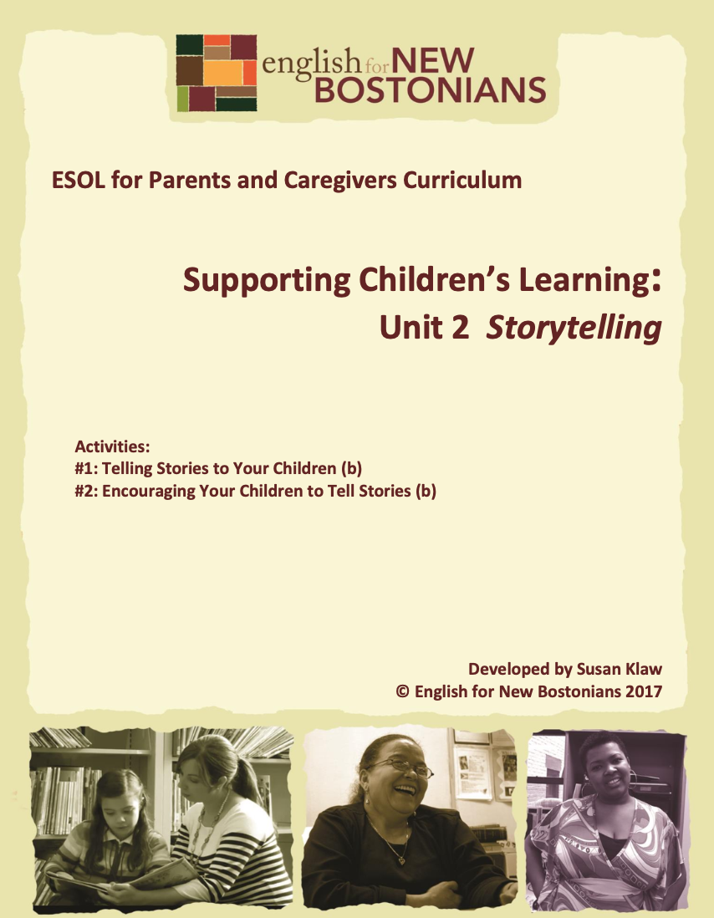About English for New Bostonians
English for New Bostonians (ENB) invests in the future of our region by fostering a high-quality ESOL system that prepares immigrants to pursue their educational, economic and civic aspirations. Through grant making, training teachers, and building public awareness, ENB expands the number of English for Speakers of Other Languages (ESOL) seats, improves program quality across agencies, customizes curricula to diverse subpopulations, and leverages private and public resources. Founded in 2001 by the Mayor’s Office for Immigrant Advancement (MOIA), immigrant leaders, and local foundations, ENB now involves several city departments, approximately 20 public and private funders, and numerous community organizations.

About the ESOL for Parents and Caregivers Initiative
Through ESOL for Parents and Caregivers, ENB guides ESOL providers and immigrant-rich schools in building partnerships to facilitate parent engagement in schools, enabling parents/caregivers to improve their English and digital literacy skills, navigate school systems, and understand expectations and opportunities for school involvement and ways to optimize children’s learning. At the same time, ESOL for Parents helps adults prepare to pursue their own educational and employment goals, while supporting children’s learning – aiming to eliminate multigenerational poverty.

About Susan Klaw
Susan Klaw has directed, taught in, and developed original curriculum materials for Boston-based parent ESOL programs since 1991. She has delivered extensive training locally and nationally on various aspects of Family Literacy and been named a “Literacy Champion” by the Massachusetts Literacy Foundation, Parent Educator of the Year by the Children’s Trust Fund, and Adult Educator of the Year by the Massachusetts Coalition for Adult Education.

About the ESOL for Parents and Caregivers Curriculum
The Curriculum (on ENB website and available free of charge) gives ESOL teachers background materials, lessons and activities designed to help immigrant parents learn English and become more effectively involved in their children’s education. Selecting curriculum units and lessons relevant to their classes, ESOL teachers can orient immigrant parents to the U.S. school system and provide practical skills such as interpreting report cards, participating in teacher conferences, advocating for children, and supporting children's learning at home. While some information is Boston specific, much can be used in any locale. ENB can assist in adapting materials for school districts. Additionally, ENB offers a Companion Middle/High School Guide, as well as a Digital Learning Guide to support online instruction.

Using the ESOL for Parents and Caregivers Curriculum
All materials are intended to be downloaded and widely used. Please cite English for New Bostonians and credit English for New Bostonians on all reproductions. We welcome feedback and stories on how you and your students are using the ESOL for Parents and Caregivers Curriculum!

Thanks to the many public and private funders that have supported this project, especially the Highland Street Foundation, Shipley Foundation, Hamilton Foundation, Moses Kimball Foundation, Plymouth Rock Foundation, Blum Shapiro Foundation and the Mayor’s Office for Immigrant Advancement’s We Are Boston Gala.

Contact us at info@englishfornewbostonians.org
or visit us online at www.englishfornewbostonians.org

Storytelling: Topic 3 Unit 2 Page 2 ©English for New Bostonians 2017

ACTIVITY #1: TELLING STORIES TO YOUR CHILDREN
(Can be used/adapted for use with beginning level students)
Rationale:
Storytelling is an important tool for building language skills, developing imagination and bridging different cultures. When parents tell personal stories to their children or recount stories they were told as children, children learn more about their parent’s lives and the culture they grew up in, and they develop their first language skills.
Student Objectives:
▪ Students will understand the value of telling their children stories from their lives. ▪ Students will become more comfortable telling personal stories.
▪ Students will improve their oral language fluency.
Materials:
▪ Handout: Poem: Las abuelitas, by Virgil Suárez
▪ Google images or props to illustrate unfamiliar vocabulary in Las abuelitas ▪ Handout: Picture Grid for Storytelling
▪ Children’s Book: Tell Me a Story, Mama, by Angela Johnson. Out-of-print but available used from Amazon.com.
▪ Supplementary: Children’s Book: In My Family/En Mi Familia, by Carmen Lomas Garza.
Activity Outline:
1. Explain objectives.
2. Tell a brief story yourself about something that happened to you or something you did when you were a child. You are going to be asking students to tell stories, so it is important to model that process. Keep it simple. Tell it a second time if you have beginning students.
3. Ask: What did you learn about me from my story? What can your children learn from your stories?
4. Tell a story your parents or grandparents used to tell you. Ask students to think about stories they heard as children from parents or grandparents. Ask for volunteers to share these remembered stories. Ask the storytellers why they think they remember that story.
5. With intermediate students, read together and discuss the poem “Las abuelitas.” Before you begin, preview key words: gourds, piñata, crack open, treasure, maracas, rattle. Use Google images or bring in props to help make the vocabulary come alive.
Storytelling: Topic 3 Unit 2 Page 3 ©English for New Bostonians 2017

Have Spanish speaking students translate the few Spanish words for their classmates. When you have read through the poem several times, have students talk with partners to answer the question, “What was the gift the grandmothers brought.”
6. If you have the supplementary text In my Family/En Mi Familia, read the page “The Weeping Woman/La Llorona,” in which the artist describes a story her grandmother used to tell her. Many Central American students will recognize this traditional legend.
7. Ask for a show of hands: How many of you tell stories to your children? Point out that stories can be very short. For example, if you tell your children “When I was little, my parents were very poor. So we never got any presents at Christmas,” that is a story. Ask students to share some of the stories they tell their children.
8. Explain that students are going to tell stories from their lives to their classmates. Have them fill out the Picture Grid for Storytelling. Assure them they don’t have to be good at drawing. Stick figures are fine. The exercise is to help them think of a story to tell.
9. Have each student pick one of the memories from their life which they represented pictorially to use as their story. In a small class, have students sit in a circle and share their chosen story with the whole group. If there is time and interest, ask each person to share a second story.
10. In a larger class, where having each student share with the whole group may take too long and not hold student interest, have students share stories with one partner, and then again with another partner. With this technique, they get the chance to practice telling their story in English more than once. For another game like format in which students tell their stories multiple times, divide the class in half and create two circles, an inner one and an outer one. Those on the inner circle are the “listeners” and they remain in place. Those on the outer circle are the “storytellers” and they move around the circle. Pairs in the inner and outer circles face each other. The storytellers are given one to two minutes to tell their story to their listener partner. Then you call out Move and they move on to the next listener and repeat their story. After several repetitions, switch the roles and the listeners become story tellers and vice versa. Note: this technique is adapted from Zero Prep, by Laurel Pollard and Natalie Hess, Alta Book center Publishers, 1997. There it is called Concentric Circle Talk.
11. If you use the partner or circle formation for storytelling, not everyone hears all the stories. Ask whether anyone has a story that they would like to share with the whole group.
12. Read aloud the children’s book, Tell Me a Story, Mama, by Angela Johnson. This is a lovely story about a young African American girl who keeps asking her mother to
Storytelling: Topic 3 Unit 2 Page 4 ©English for New Bostonians 2017

tell her the story about such and such. Before her mother has a chance to say anything, the little girl proceeds to tell the whole story herself. She has memorized all the stories her mother has told her and loves them. If you happen to have an assistant in the classroom (or a very advanced student reader) you can read the book together, with one person being the child, the other the mother It is hard to gather multiple copies of this book because it is out of print, although inexpensive used copies are available through Amazon. However, if you like the book and want to use it as a class text from which to extract vocabulary and meaning, and to further the conversation about storytelling, you could type up the text so students have a transcript to follow along with as you read aloud. To help students better understand the text, show how the difference in font signifies who is speaking and repeat several times that the little girl is retelling the stories she has heard so many times from her mother. Note: you can also begin the activity by reading this book.
Follow-Up:
▪ Read with students the bilingual book In My Family/En Mi Familia, by Carmen Lomas Garza. This beautiful book is a collection of paintings of scenes from the artist’s Mexican American childhood. Each painting is accompanied by a story, in English and in Spanish, in which she tells what is happening in the painting. Rather than read the whole book, students can choose their favorite picture, read the accompanying story, and then retell it to a partner. Beginning students can describe what is happening in the picture they chose or why they like that particular picture.
▪ Grammar review: Use In My Family/En Mi Familia to review the present continuous. Students can describe what is happening in each of the scenes. Use Tell Me a Story, Mama to review the past tense of regular and irregular words.
Storytelling: Topic 3 Unit 2 Page 5 ©English for New Bostonians 2017

Handout: Las abuelitas
When our grandmothers
come to visit, they bring us
gifts, regalitos, as they say
in Spanish, like sweet
caramelo. They bring us
stories from their childhoods
in Cuba when they too
were little girls, abuelita Nana,
abuelita Maña, cuentos
like the ones about giant gourd
trees and their smooth branches
curved low with moon-round gourds
they hit like piñatas, and the gourds
fell and cracked open, inside
a treasure of seeds
to make maracas rattle,
shake them to the beat of salsa music.
Las abuelitas cup their hands
To our ears like those dark gourds,
inside each, a little whisper
Of our abuelitas’ lives in Cuba.
By Virgil Suárez, from the collection of poems Love to Mama, edited by Pat Mora, Lee & Low Books, Inc., New York, 2001.
Storytelling: Topic 3 Unit 2 Page 6 ©English for New Bostonians 2017

Handout: Picture Grid for Storytelling
Directions: In each of the squares below, draw a quick picture that shows something you remember from that time in your life.

When I was five years old | When I was a teenager
When I was in my 20’s | Now

Storytelling: Topic 3 Unit 2 Page 7 ©English for New Bostonians 2017

ACTIVITY #2: ENCOURAGING YOUR CHILDREN TO TELL STORIES (Can be used/adapted for use with beginning level students)
Rationale:
Research says that being able to understand and tell a story is an important language skill. It helps children use more complicated language and helps them become better readers and writers. Thus children need to be exposed to oral stories and encouraged to tell and shape their own stories.
Student Objectives:
▪ Students will learn four different ways to encourage their children to tell stories. ▪ Students will try at home at least one of three story telling techniques with their children.
▪ Students will build oral fluency.
Materials:
▪ Pictures copied from an assortment of children’s books
▪ Family pictures (print or on phone)
▪ Index cards
Activity Outline:
1. Explain objectives.
2. Explain the format of the activity: students will practice four different storytelling exercises that they can use at home with their children to encourage their children to tell stories. Write the four kinds of storytelling on an easel pad to refer back to and to frame the activity.
Storytelling Exercise #1: Telling stories about things that have happened to you.
∙ A good way to encourage children to tell stories is to remind them of an activity. For example: Do you remember what happened when we went to the zoo? Parents can practice this in pairs, using shared class activities and experiences. Or, do you remember what happened when we had the surprise baby shower for Rosa? Or, do you remember what happened that day we all went to the library?
Storytelling Exercise #2: Retelling Stories
▪ Remind students what retelling a story is. You may have done it with students in prior classes as a skill building activity. Remind them of the way
Storytelling: Topic 3 Unit 2 Page 8 ©English for New Bostonians 2017

the little girl in Tell Me a Story, Mama (used in the previous activity) is always retelling her mother’s stories. Ask them whether their children ever retell the stories they have heard in the family. This is a good place for a mini prefix lesson: “re” means again, as in retell, review, repeat, redo, recall, recycle.
▪ Practice retelling stories with family pictures. In pairs, students take turns telling each other stories about the people or scenes in their family photos. Model the kind of story you want, so that students go beyond merely identifying the person in the photo. For example: “This is my Aunt Norma. She was very important in my life because she took care of me every day after school. I always went to her house.” After a picture is described, the person listening has to retell the story. Switch the pairs so students repeat this process several times with different partners.
▪ A second powerful retelling story technique is to have students retell a personal story their partner has shared with them. Reuse the picture grid from Activity #1, and have students use it as the basis for another story. Ask them to share these stories with a partner. Explain ahead of time that students will be expected to retell their partner’s story to the group, so they should make sure they understand what their partner is telling them.
Tell parents that at home, in addition to retelling stories about family pictures, they can invite their children to retell the story of a favorite book or movie or to make up a new ending to either one. Children love to do this.
Storytelling Exercise #3: Telling stories from pictures in children’s books
▪ Prepare for this exercise by copying ahead of time some illustrations from picture books which lend themselves to telling a story about the picture.
▪ Demonstrate to students how you can take a picture in a children’s book and tell a story about it. This can be in any language the parent chooses. It can be an imaginary story or it can be a story which relates to the text. When parents read to their youngest children, they can encourage their children to tell stories about the pictures they are looking at.
▪ As for a student to volunteer to do a role play with you. First, you be the parent and encourage the “child” to tell a story about the picture. When you are done, switch roles.
▪ Before students do their own parent/child role plays like the one that has just been modeled, write some leading questions on the board that can be used to elicit stories.
Storytelling: Topic 3 Unit 2 Page 9 ©English for New Bostonians 2017

What do you think is happening here?
What do you think is going to happen next?
Why is ………………………………..?
How is ___________ feeling in this picture?
Explain that these are open-ended questions. (See Topic 3, Unit 3: Reading with Children, Activity #6). Open-ended questions can’t be answered with a Yes or No and don’t have simple right answer. Reinforce that parents should ask open-ended questions when they are reading with a child, talking to a child, or encouraging a child to tell stories.
▪ Divide student in pairs and hand out copies of the pre-selected pictures.. Then have the pairs do the role play of a parent reading to a child and encouraging the child to tell stories about the pictures. Encourage students switch roles.
▪ Ask for volunteers who would like to do their role play for the whole class. Storytelling Exercise #4: Telling imaginary stories together.
▪ Sitting in a circle, one person begins telling a story and stops in mid sentence. For example, Once upon a time there was a chicken who laid black eggs. When she first saw the black eggs, she………The next person continues the story, also stopping mid sentence, hopefully at a dramatic point. Then the next person picks it up, etc. etc. The first few times, you might want to begin the story yourself. After that, designate one of the stronger speakers in your class to begin. If there is an overhead projector in the classroom, you could type out the story as it is being created.
▪ Because this will be hard for beginning students, after playing the game in English a few times, try grouping students by their first languages and having them play the game in Spanish or Arabic or Chinese.
▪ Encourage students to try this game as a family at home, perhaps during a family dinner, before going to bed, or in the car. It works well with multiple ages. Remind them that they can play the game in whatever language they want; it doesn’t need to be in English.
3. Briefly review the four types of storytelling activities parents have practiced: telling stories of things that have happened to you, retelling stories, telling stories from pictures in children’s books, telling imaginary stories. Have students write down on an index card which of the four they will try that night with their children as homework. The following day, have them report back on their experience.
Storytelling: Topic 3 Unit 2 Page 10 ©English for New Bostonians 2017

