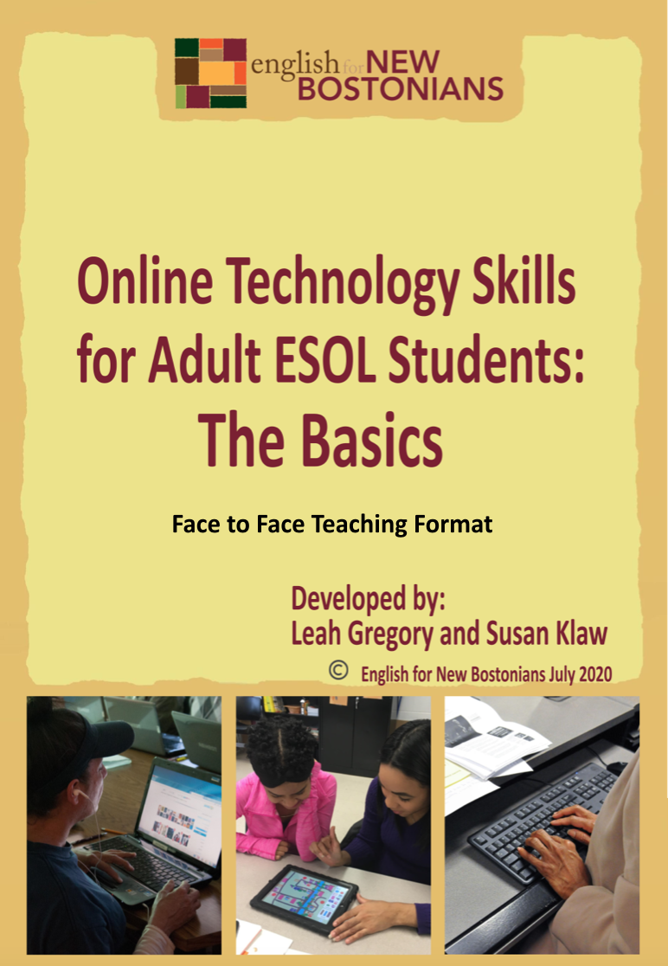

Face to Face Teaching Format: The Basics of Online Technology Skills for Adult ESOL Students

Pre-Activity: Identifying Technology Skills
Worksheet #1: Technology Skills Assessment and Goals

Activity 1: Chromebook Introduction and Setup
Worksheet #2: Chromebook Basics
    - What is a Chromebook?
    - Frequently Asked Questions
    - Check for Understanding
Guide #1: Opening and Using Your Chromebook
- Introduction Video
- Common Vocabulary
    - Chromebook Setup

Activity 2: Setting up a Google Email Account (Gmail)
Guide #2: Creating a Gmail during the Chromebook Setup
Guide #3: Creating a Gmail on a web browser (on any device)
Worksheet #3: Email Vocabulary
Worksheet #4: Email Vocabulary (cont.) and Greetings
- Formal vs. Informal
Worksheet #5: Writing an Email
Guide #4: Attaching a Document to an Email

Activity 3: Downloading and Using Zoom and other Applications on a Chromebook
Guide #5: Downloading and Using Application on your Chromebook
- Discussion Questions
Guide #6: Download and Signing in to Zoom
Guide #7: Using Zoom on a Chromebook
    - Exercise: Zoom Chromebook Review
Guide #8: Using Zoom on a Smartphone
- Exercise: Zoom Smartphone Review

Activity 4: Student Guide to Google Classroom
Worksheet #6: Google Classroom Basics (for students)
- What is Google Classroom?
- Frequently Asked Questions
- Check for Understanding
Guide #9: Connecting to a Google Classroom on a Chromebook
- Introduction Video
- Google Classroom Guide
Worksheet #7: Google Classroom Exploring

Pre-Activity: Identifying Technology Skills
Rationale: It is important to note that Online Learning and Technology literacy requires whole sets of skills that most learners have to acquire if they have never been a part of an online learning platform. These skills need to be taught and recognized as necessary skills in order to complete an online learning course. Know that many of the skills in this brief curriculum are skills that will assist in a student’s learning, but are not everything. Careful planning and consideration of time, devices, connection, self-motivation and discipline are necessary for successful online learning for students of all ages. This curriculum supplement is merely a skills guide for beginner online learners during Face to Face learning. It can serve to assist the teacher in teaching technology skills to their students and as a Guide for students working independently at home.

Student Objectives:
- Students will identify skills that they have and skills that they need to acquire.
- Students will make goals for themselves when starting online learning.

Materials:
- Worksheet #1: Technology Skills Assessment and Goals

Activity Outline:
- Explain the objectives. As teachers, we need to empower students with the knowledge that they already have and show how it can help them tackle new challenges. Technology is certainly a new challenge! By allowing students to share what they already know about technology, it allows you to know where you stand in your class via digital skills. And students can be very helpful to their classmates as they work through mastering digital skills. Read through the worksheet Technology Skills Assessment and Goals worksheet and have students identify the skills they know right now.
- Review the discussion questions and ask students to discuss their answers in small groups.
- Have students identify a few technology goals that they would like to achieve throughout the year.

Follow-Up: These questions could also be used in a worksheet or small group at the end of a cycle or year to determine what the students know now after completing the course.
  - Did your skills change?
  - Was your goal achieved? Or did you make steps towards meeting your goal?
  - What was a skill you learned that was helpful in an area outside of class?
Name: ___________________

Worksheet #1: Technology Skills Assessment and Goals

Directions: Read through the technology skills needed to successfully do online learning. What skills do you need more help with? What skills do you already have? Put a Y (yes) for skills that you have right now or N (no) for skills you will need to learn. Note: A Chromebook is a type of laptop.

Pre-Class Technology Skills Assessment
Phone Laptop
- I have a Gmail or another type of email account.

- I know how to use an internet browser (search, back button, etc.).

- I can send and receive emails.

- Send an attachment to another person.

- Receive and open an attachment from another person.

- I can copy and paste text or pictures into an email or document.

- I can describe a technical problem to my teacher.

- I can open a Google doc in my Google Drive.

- I can access a meeting link to join my class (Zoom, etc.).

- I can download an application.

- I can restart my computer.

- I can type, but I want to improve my typing skills.

Discussion Questions:
- What skills do you need more help with?
- What skills do you already have?
- What skills do you want to improve?

Goals: Write about one technology goal that you hope to achieve after you complete online learning.
For example: I hope to feel more confident in typing OR I want to learn how to attach a document.

Activity 1: Chromebook Introduction and Setup

Rationale: As we navigate a digital world, the relevance of digital and technological literacy is increasingly important. Furthermore, understanding and using technology for work and family life has never been so important. In this activity, we take a look at what a Chromebook is and how students can use it. Chromebooks are an accessible, user-friendly laptop that is used throughout the nation in school districts and at home.

Student Objectives:
- Students will learn about the capabilities of a Chromebook and its basic features.
- Students will learn how to connect to WiFi.
- Students will learn vocabulary related to Chromebooks and technology in general.
- Students will set up their Chromebook and learn about “Sign In” options.

Materials:
- Chromebook (and cable cord)
- Worksheet #2: Chromebook Basics
- Guide #1:: Opening and Using your Chromebook

Activity Outline:
- Explain the objectives. Print and distribute Guide #1 for students so they can have a hard copy to follow and to save at home. The Guide is much easier to follow if you are able to print it in color.
- Before students begin, review the Chromebook Basics worksheet together. There may be words that are new to the students as they are technology words used mainly in speaking about technology. Ask if any students are familiar with Chromebooks and what has been their experience with them.
- Ask the students to work in small groups to complete the true and false exercise.
- When you start Guide #1, make sure your video is ready to be played on a screen and ensure that subtitles are turned on. You can control the speed of a video using the YouTube video settings. This is a great learning tool for students so show them how to do it and compare the speed differences in terms of comprehensibility.
- After watching the video, check for understanding. Review the vocabulary words and ensure correct pronunciation. This can also be done before you show the video. Then, read through the definitions and decide if you want to complete the exercise as a group or individually.
- Before you start the step by step part (after the video), take a poll of who does and doesn’t have a Gmail account. This will help know if students will need to create a Gmail during setup.
- If Chromebooks are NOT new, please skip to page 14 to assist students in logging in to an already set up Chromebook.
- Guide #1 is meant to be used with new Chromebooks so all students can follow the instructions as they go. Proceed step by step with students and make sure that students are not jumping ahead as they may miss an important step. Ensure that all Chromebooks are charged and/or plugged in. It is important to write the Wifi Network name and password on the board so it is visible.

Follow-Up: Students should be able to do setup and login at home on their own. At the end of Guide #1 students are also given login options. Ask students to practice logging in as a guest or with their child’s email at home.

Name: ___________________

Worksheet #2: Chromebook Basics

Directions: Read through the basics of a Chromebook and then watch the setup video. Complete the small quiz at the end of this worksheet.

What is a Chromebook?
- Chromebooks are inexpensive laptops.
- They have basic tools and functions like:
  - connecting to the internet
  - checking email
  - browsing websites
  - downloading applications (apps)
- Chromebooks have a Google operating system (Chrome OS).

Frequently Asked Questions (FAQs)
Q. Does a Chromebook have internet access?
- Chromebooks need to connect to a private or public network. They do not have automatic internet access.
Q. Can my Chromebook work if I don’t have internet access?
- Yes, but first you need to turn on the “offline” option.
Q. Can my Chromebook get a virus?
- Anything is possible, but Chromebooks are much safer than regular laptops.
Q. Does a Chromebook come with Microsoft Office or other programs?
- No, you need to download applications specifically for Chromebooks.

Let’s check your understanding. Circle if the sentence is true (T) or false (F).

- Chromebooks are exactly the same as a laptop. T F
- Chromebooks have the internet automatically. T F
- It is possible to check email and download applications. T F
- Chromebooks are more expensive than a desktop computer. T F
- Chromebooks are safe machines. T F

Guide #1: Opening and Using your Chromebook

Directions: Watch the video for an overview of the setup (double click on the picture or link). Then, follow the instructions in Part C to go through each part step by step.

Setting up your new Chromebook. In this video you will learn how to:
- Turn on and off your Chromebook
- Choose your settings
- Connect to wifi
- Log in as a user or guest
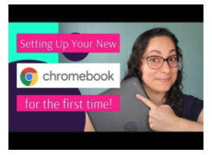
Click on the picture to view the video in YouTube
Courtesy of Tech Goes Home

Read the vocabulary words and match with the definitions by putting the correct letter next to the vocabulary word. These vocabulary words will help you understand the directions.

- Plug in _____ a. To select something electronically
- Charge _____ b. Options to make something easier
- Press _____ c. Moving up or down on a computer
- Click _____ d. Connect to electrical outlet in the wall
- Choose _____ e. Conditions of an agreement
- Accessibility _____ f. Connect to a battery
- Proceed _____ g. To continue something
- Scroll _____ h. Apply pressure to something
- Terms _____ i. To select an option
- Trackpad _____ j. A touch sensitive square on a laptop

Follow this Guide as you go through your Chromebook setup.

- Plug in your Chromebook to charge. Open your Chromebook and press the power key.

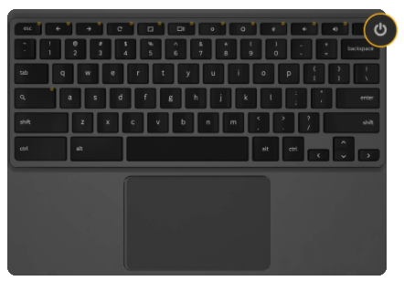Google

- Understand your trackpad:

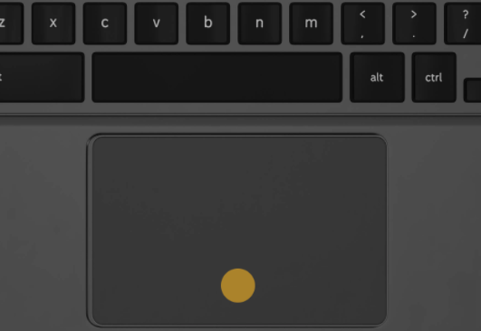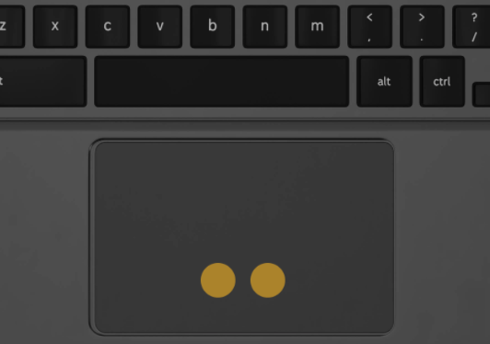Google

Click = Press One Finger
Right Click = Press Two Fingers
Scroll = Move Two fingers up and down
(do not click)

- Choose the language you prefer. Then click “Let’s Go”. We recommend English so that you can receive help from your teacher if needed.

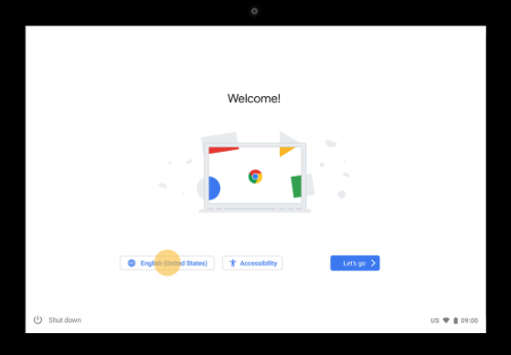 Google

Language
Let’s Go

- Choose the language and keyboard options. Then select OK.

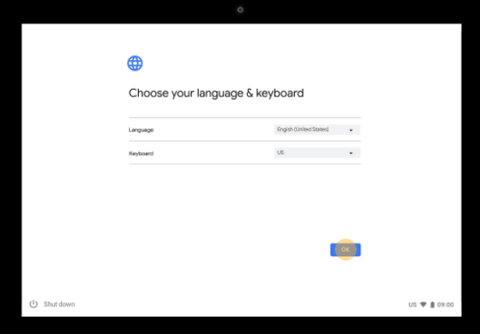 Google

Select OK

- Choose accessibility features if you want. After, click OK, then proceed to Let’s go!

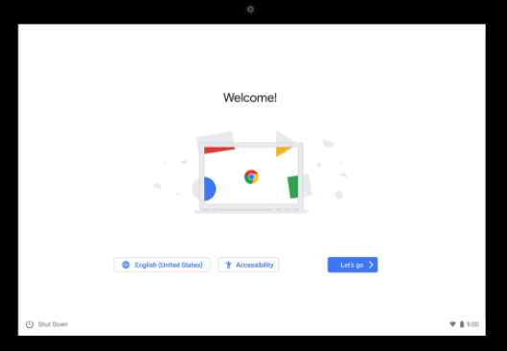 Google

Accessibility
Let’s Go!

- Now we will connect to WiFi. Choose your network, then click next. If your network has a password, enter the password and click next.

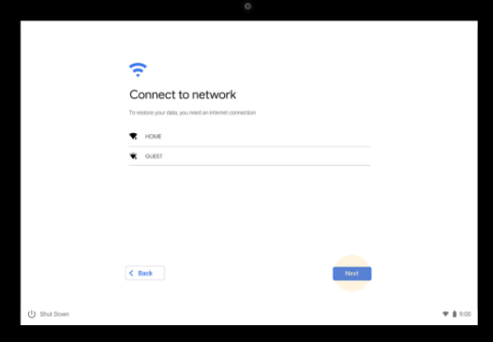 Google

Select WiFi
- Review the terms and click accept and continue.

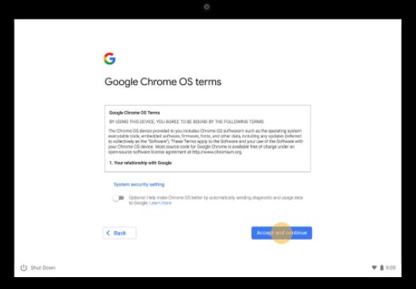 Google

Accept

- Type your Google email address (Gmail) and click Next. If you don’t have Gmail, please create it (see Create a Gmail on your Chromebook here or on page 12). A Gmail account needs to be used with a Chromebook. A Yahoo or Hotmail email will not be valid.

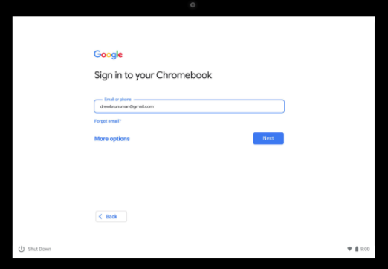 Google

Write your Gmail here.
Create a new email if you don’t have a Gmail.

- Type your password and click Next. To view your password click the “” button.

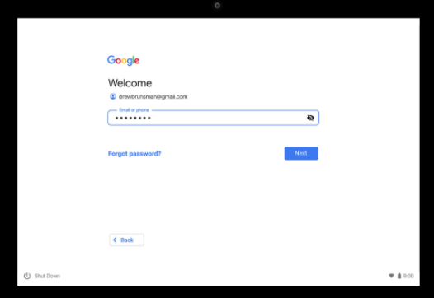 Google

Type your password here

- You are signed in! Now accept and continue.

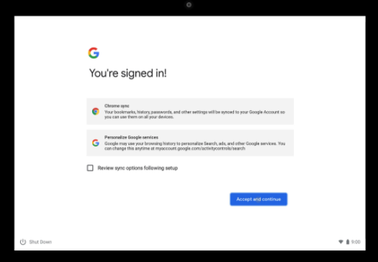 Google

Accept and continue

💡 Note: A Chromebook can directly connect with your Android phone and install the same applications on your phone, on your Chromebook. If you do not want this, you can choose to “not connect” when it asks you.

Two options to Sign In to an already set up Chromebook:

Option #1: You may also click “Browse as a Guest”. This means anyone can use the Chromebook, they do not need to have a Gmail.

Option #2: You can add another person to your Chromebook. Click “Add Account” to add another Gmail account.

Sign out of an account: To sign out of an account and sign in to another one, click the time/battery in the bottom right corner, then click →

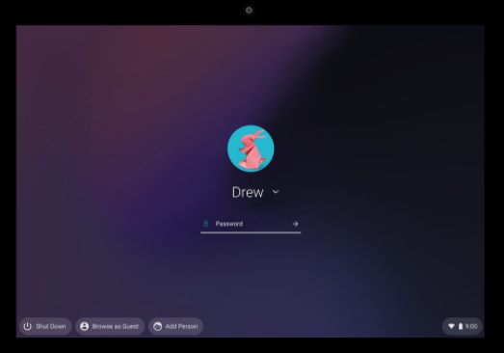 Google

Option 1: Browse as Guest (no password needed)
Option 2: Add another account
Sign Out

Activity 2: Setting up a Google Email Account (Gmail)
Rationale: As we navigate a digital world, the relevance of digital and technological literacy is increasingly important. In this activity, we take a look at creating and writing an email as well as attaching documents such as important forms, paperwork and/or homework assignments. This activity was designed to help students not only create an email, but learn the vocabulary and functions of Gmail.

Student Objectives:
- Students will learn how to create an account on Gmail.
- Students will learn about informal vs. formal greetings in an email.
- Students will learn relevant vocabulary in order to write emails and add an attachment.

Materials:
- Chromebook (and cable cord)
- Guide #2: Creating a Gmail during the Chromebook Setup
- Guide #3: Creating a Gmail on a Web Browser
- Worksheet #3: Email Vocabulary
- Worksheet #4: Email Vocabulary (cont.) and Greetings
- Worksheet #5: Writing an Email
- Guide #4: Attaching a Document

Activity Outline:
- Explain the objectives. Distribute the Guide #2, Creating a Gmail during the Chromebook Setup, if your students are creating a Gmail as they are setting up a new Chromebook.
- Distribute Guide #3 Creating a Gmail on a Browser if students are using Chromebooks that have already been setup. They will use the Chrome Browser on their Chromebooks. On a phone and/or tablet they can use other browsers.
- As the class moves through the Gmail steps, make sure to stress the importance of not only a secure password, but also of remembering and storing their passwords. Brainstorm places to store passwords where they won’t be lost.
- After accounts are created, the teacher could create a document where all student emails are available for classmates to access (written or electronic). This will aid in future activities.
- Brainstorm with students how often they use Gmail and in what contexts. Add to the list any employment or school related uses which students haven’t mentioned.
- Next, in the worksheets Email Vocabulary and Email Greetings, work with students to learn new vocabulary in order to navigate Gmail, as well as appropriate greetings and subjects for emails.
- The worksheet Writing an Email should be used as a written activity first so that the teacher can correct it and then the student can type the final draft on their Chromebook. Teachers could put all the class emails in a hat and have students draw a name to send their email to. This could be done before or after the draft is written. This worksheet could also be given as homework.
- Distribute the Guide #4, Attaching a Document and ensure that students have a document to attach or simply practice identifying where the attachment buttons are. This is not an easy task and remember that they first need a document to attach before they can do the actual exercise.

Follow-Up: Create scenarios where your students can practice writing various types of emails (child’s teacher, doctor, boss, or friend). Then ask them to attach a picture from their phone or Chromebook. Encourage students to check their email frequently by sending out emails to the class and having a competition to see who responds the fastest. Or ask students in class to stand up in response to questions about how often they check their emails: Once a day? Once a week? Etc.

Guide #2 : Creating a Gmail during the Chromebook Setup

Directions: During your Chromebook setup, if you don’t have a Gmail account, follow the instructions below to set up an account.

Follow these steps below to create your account on a Chromebook:
- When it says “Sign in to your Chromebook” and you do not have a Gmail, click “Create Account”.
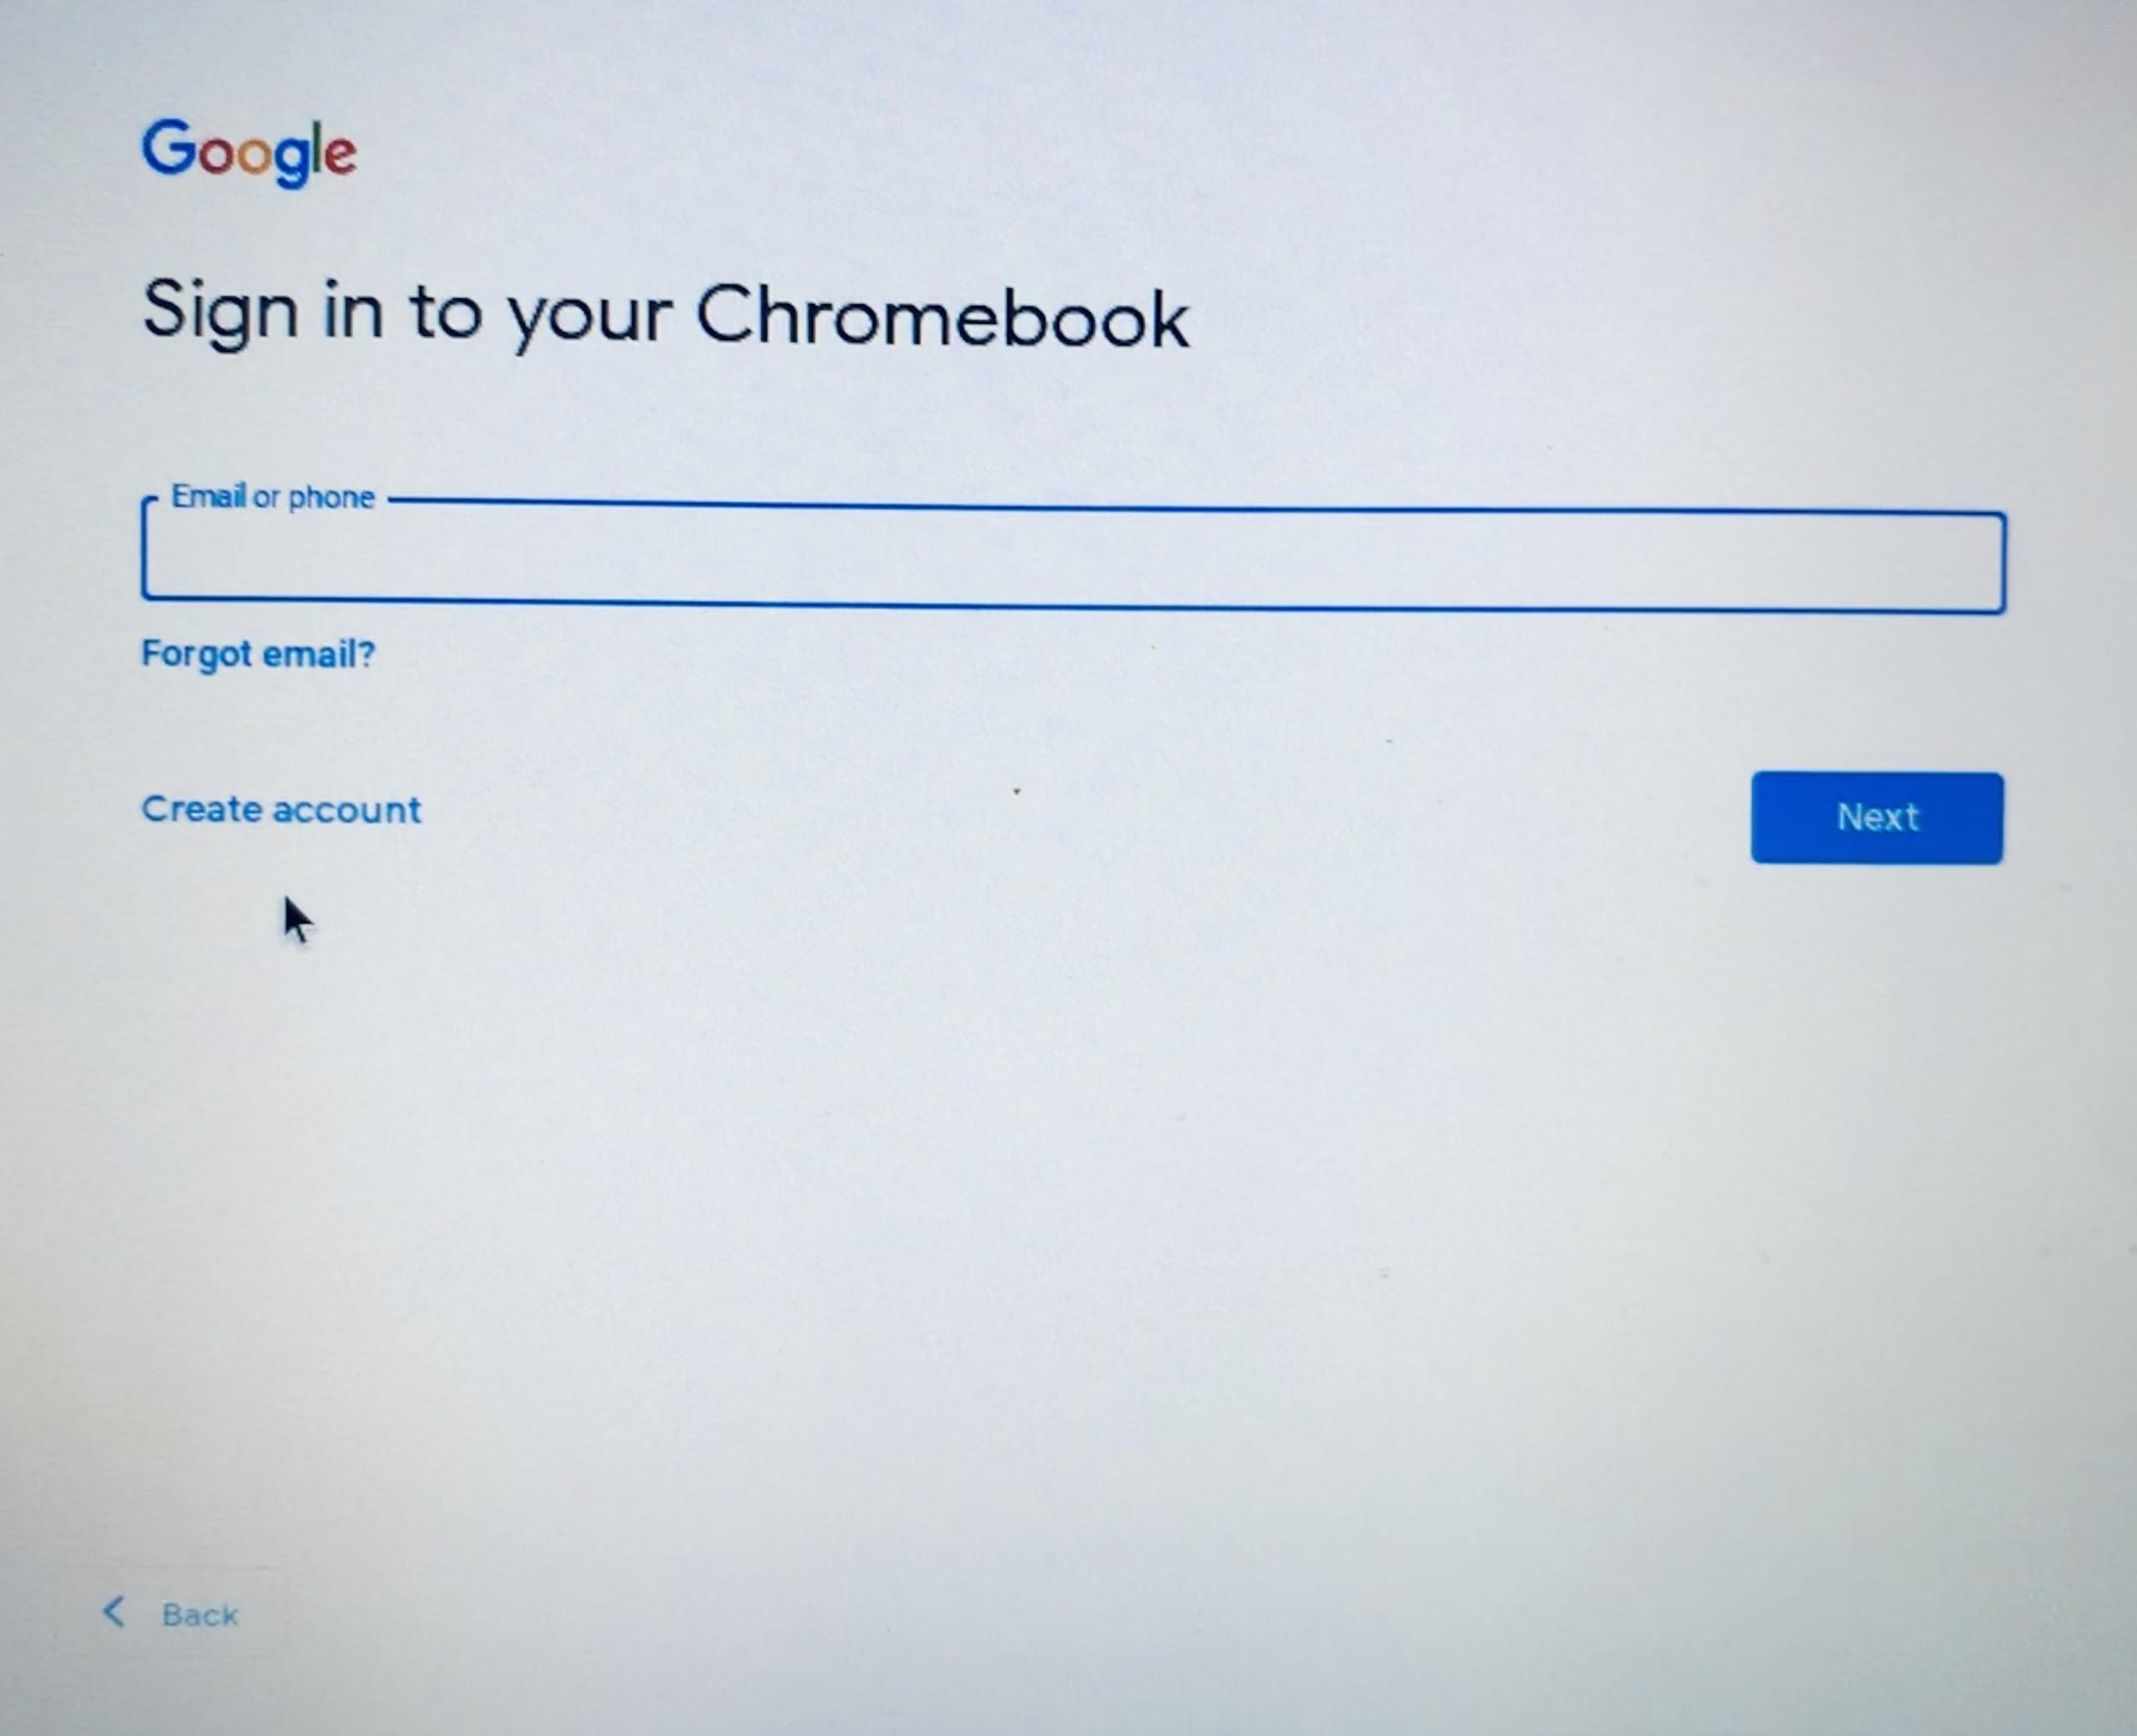

Create account
- Type your first and last name. Click “Next”.
- Type your information, month, day, birth year, and gender. Click “Next”.
- Choose your Gmail address. You can choose an address they created for you or click “Create your own Gmail address”. Click “Next”.
- Create a strong password. Do not use your name or birthday in your password. Click “Next”.
Don’t forget to Include:
Letters (upper and lower case)
Numbers (1,2,3,4)
Symbols (@#$!%)
- Add a phone number in case you forget your password and click “Yes, I’m in” or scroll down (with two fingers!) and click “Skip” if you don’t want to put your phone number.
- Review your account. Click “Next”.
- Scroll down in the terms and click “I agree”.
- Done! Now you have a Gmail account. Click “Accept and Continue”.
💡 Note: Write down your username and password in a safe place or in a secure location on your phone.
Return To Chromebook Setup

Guide #3 : Creating a Gmail on a web browser (on any device)

Directions: Follow the directions below if you are creating a Gmail account on another device (different laptop, tablet and/or smartphone).

Follow these steps below to create your account on a web browser (Chrome, Safari, etc.):
- In your browser type gmail.com and press enter:

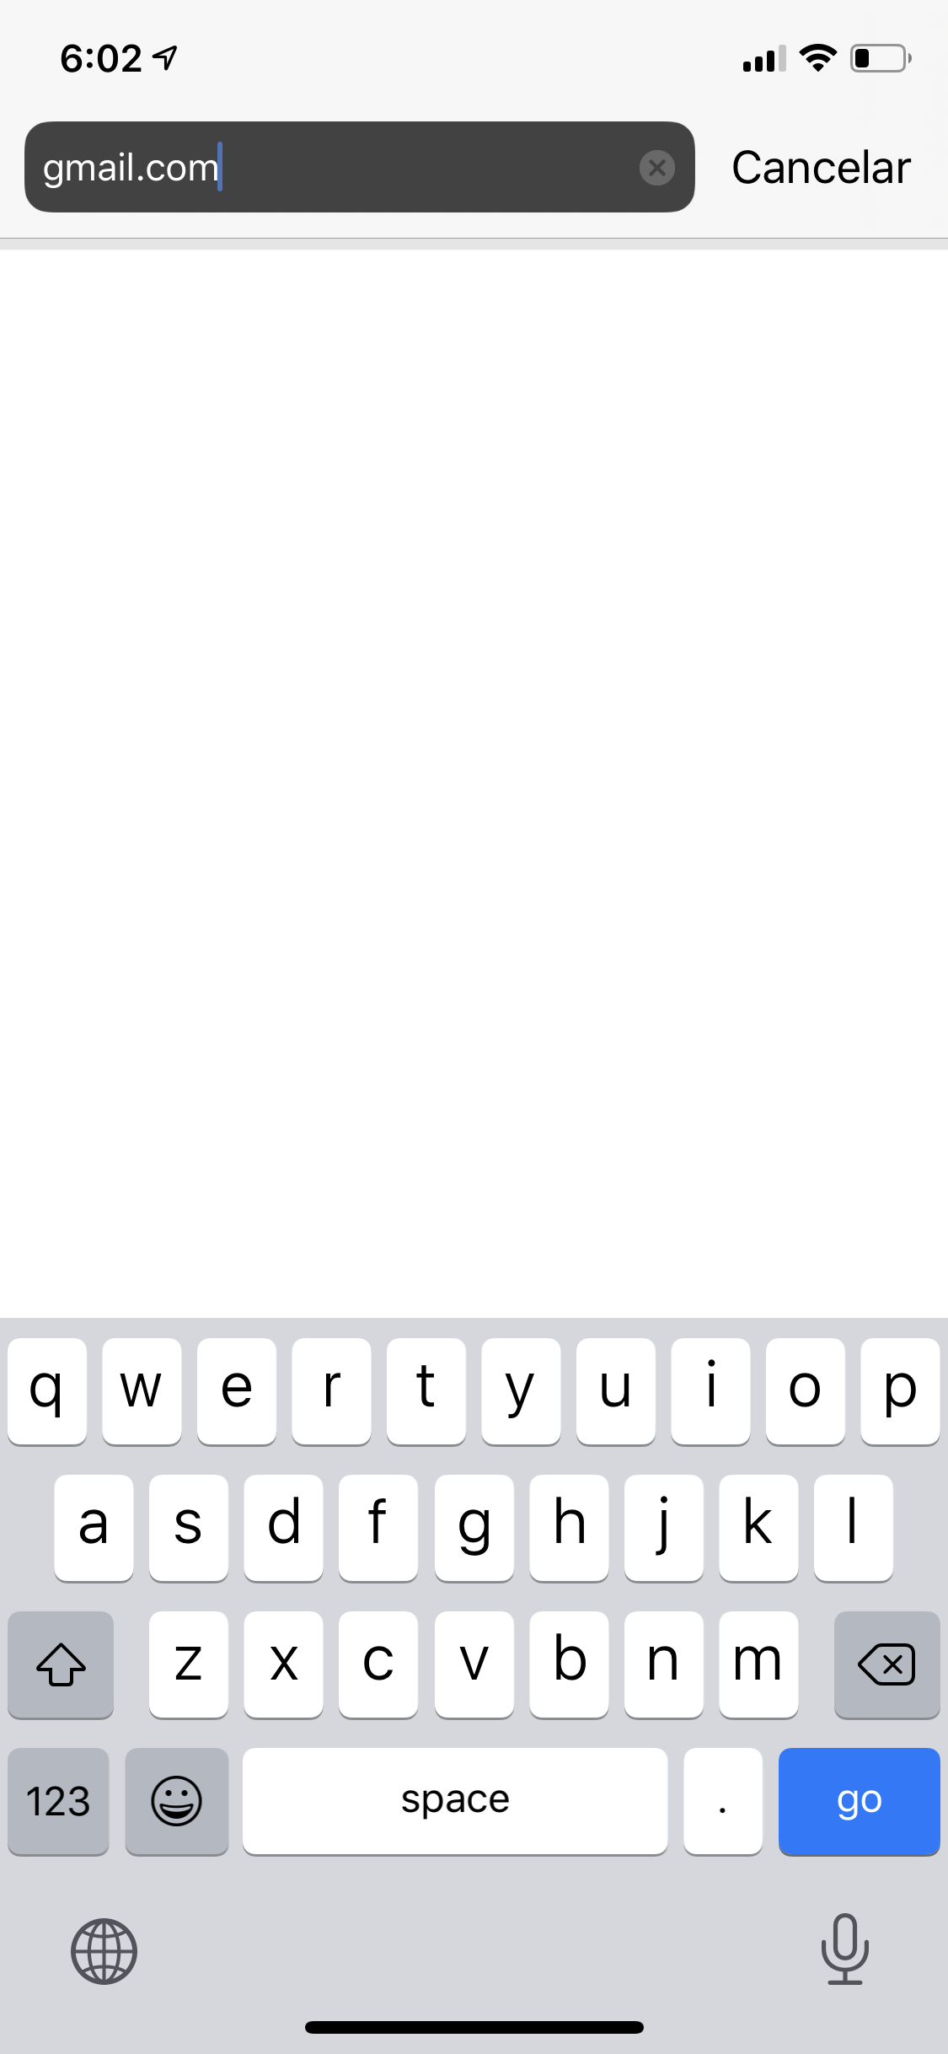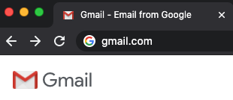

- Complete the information. This includes, First Name, Last Name, Username (your email address name), password and then type your password again to confirm. Click “Next”.
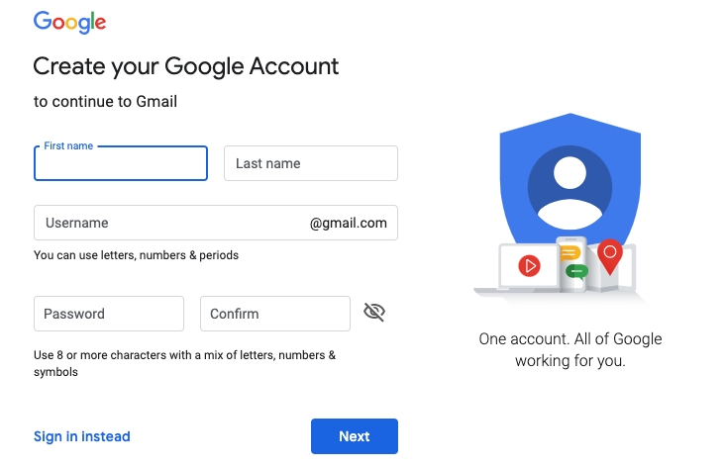

- Add a phone number or a different email address (optional) if you forget your password this will help you create a new one.
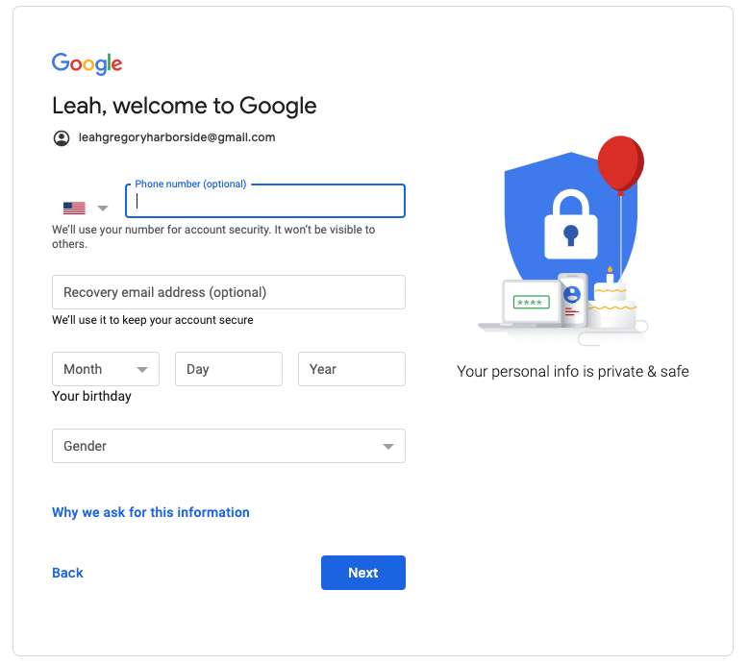

- Create a strong password. Do not use your name or birthday in your password. Click “Next”.
Don’t forget to Include:
Letters (upper and lower case)
Numbers (1,2,3,4)
Symbols (@#$!%)
- Next, read through the terms and scroll down (with two fingers!). Click “I agree”.

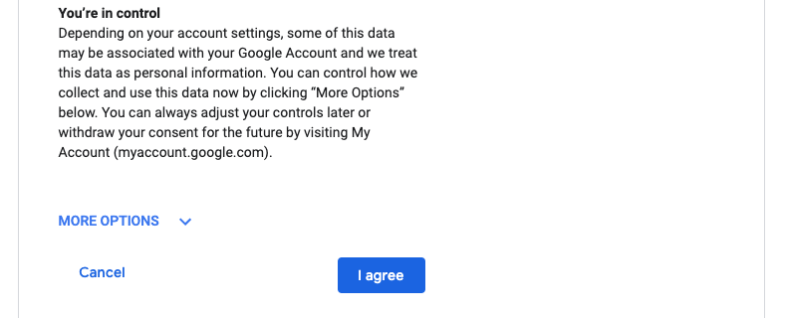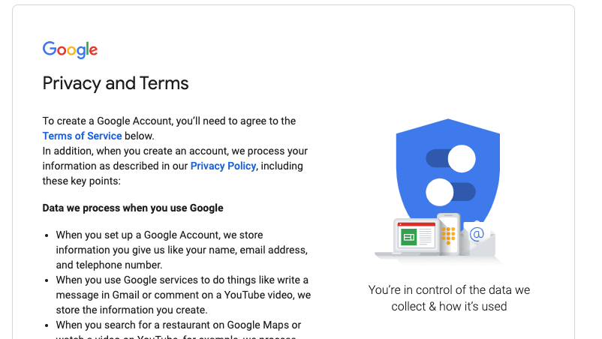

- Done! You created a Gmail account.

💡 Note: Write down your username and password in a safe place or in a secure location on your phone.

Name: ___________________

Worksheet #3: Email Vocabulary

Directions: Complete the following activities to learn more about email vocabulary.

Email Vocabulary

Let’s learn how to say our email.

Remember:

@ = at
. = dot
_ = underscore

Now, let’s practice! Repeat these emails with a partner:

jamesbond@gmail.com

susie_q@gmail.com
Let’s practice with your email:
- Write your email address here: ___________________________________________________
- Now recite your email to a partner.
- Check your partner’s writing and make sure it is correct.
- Now listen to your partner as they tell you their email address.
- Write your partner’s email address here: ____________________________________________

B. Read the vocabulary words and match with the definitions by putting the correct letter next to the vocabulary word.

- Sender ______ a. To write an email
- Recipient ______ b. 2-3 words or a short sentence about the email
- Spam / Junk ______ c. When you write back to an email.
- Subject ______ d. When you send an email you received to another person
- CC / “carbon copy” ______ e. A space where you can add another email address that
- BCC / “blind carbon copy”______ is indirectly for another person. Everyone sees email.
- Compose ______ f. An electronic folder where your emails are received.
- Inbox _____ g. The person who sends the email
- Reply ______ h. A space where you can add another email address that
- Forward ______ indirectly for another person. Nobody can see the email.
i. Emails from unknown senders with false information
j. The person who receives the email

Name: ___________________

Worksheet #4: Email Vocabulary (cont.) and Greetings

Directions: Review and read through the different parts of an email. Then, read through and identify different greetings used in informal and formal emails.

- Review the vocabulary in the email.

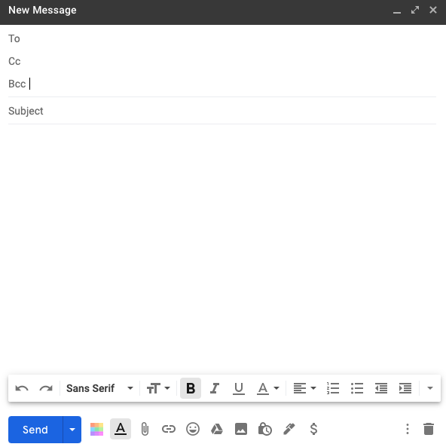

Recipient
Indirect recipient (everyone can see their email)
Indirect Recipient (nobody can see their email)
2-3 words about the email
Body (your email!)
Attach a document from your computer
Attach a document from your Google Drive

Greeting options to start an email:
Formal | Informal
- Dear Ana, | - Hi Ana,
- Dear Ms. Santana, | - Hi all,
- Dear Mrs. Ramos, | - Hey Ana,
- To Whom it May Concern | - Hello!
- Dear Sir, / Dear Madam, | - No greeting necessary

- Signatures options to close an email:
Formal | Informal
- Best, | - Thanks,
- My best, | - Talk to you soon,
- Sincerely, | - See you soon,
- Thank you, | - Take care,
- Respectfully, | - Cheers,

Name: ___________________

Worksheet #5: Writing an Email

Directions: Practice writing an email to a classmate, coworker or teacher. Make sure to include all the parts of an email. After this practice, type your email on your Chromebook.

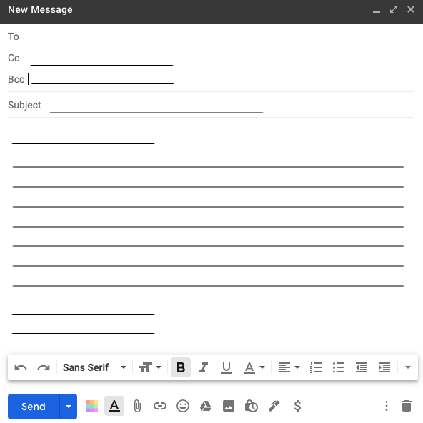

Now practice typing on your Chromebook!

Name: ___________________

Guide #4: : Attaching a Document to an Email

Directions: After you write your email, read through the Guide below to learn how to attach a document from your computer or from your Google Drive.

- Many times teachers ask students to send their homework, a picture, or some type of document in their email. This can be confusing so let’s look at the options. When you write an email you have two options to attach a document.

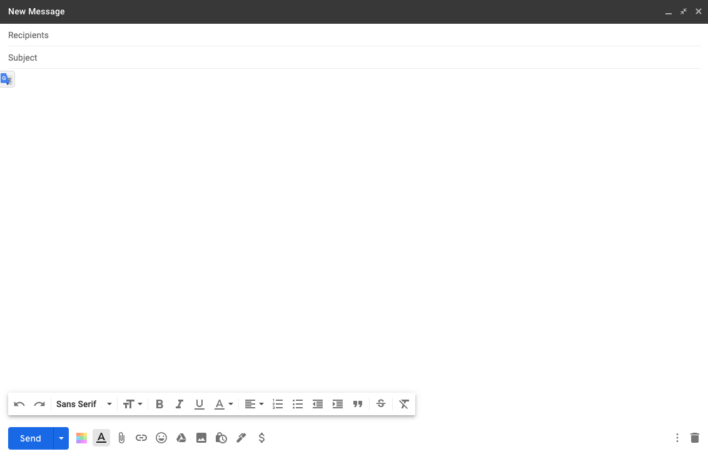

Option 1
Option 2

Option #1: This option attaches something that is on your computer (in a folder or desktop). If you click the small paperclip (📎 ) then it will open a new window with all the documents on your computer and you can search for the document to include.

Option #2: This option attaches something that is in your Google Drive. Your Google Drive is where your teacher might send homework or quizzes and connects with Google Classroom (we will talk about this in Activity 4). If you click the triangle () then your Google Drive will open and you can search for the document to include.

💡 Note: Google Drive is “cloud space”, this means that it is extra space on the internet for you to put your work and documents. This is connected to your email. Just like you have folders for your class, Google Drive is a place where you can organize your electronic documents!

Activity 3: Downloading and Using Zoom and Other Applications on a Chromebook

Rationale: As we navigate a digital world, the relevance of digital and technological literacy is increasingly important. Furthermore, understanding and using technology for work, home and family life has never been so important. In this activity, we will explore downloading and using applications, specifically Zoom, on a Chromebook and smartphone. Please note: Technology is ever-changing. These application worksheets and the Guides are current as of July 2020.

Student Objectives:
- Students will learn to download applications on the Chromebook (specifically Zoom).
- Students will become familiar with the settings and options available on Zoom.
- Students will learn how to download and use Zoom on a smartphone.

Materials:
- Chromebook (and cable cord)
- Guide #5: Downloading and Using Applications on your Chromebook
- Guide #6: Downloading and Signing in to Zoom on your Chromebook
- Guide #7: Using Zoom on a Chromebook
- Guide #8: Using Zoom on a Smartphone

Activity Outline:
- Explain the objectives. Explain to students that the majority of Chromebooks have Google Play Store in their launcher, but some older Chromebooks may not or need updating. In this case, the Chrome Web Store can be accessed through a browser and used to download apps the same way.
- Teachers should describe the difference between the Google Play Store app and the Chrome Web Store. That is, Google Play Store works directly with android apps that can work on a Chromebook and an android phone. Chrome Web Store works with the Chrome browser. Either way, the stores both download apps to the Chromebook. It is noted on the picture in the Guide #5 Downloading and Using Applications on your Chromebook that you can use either.
- Distribute and read through Guide #6 Downloading and Signing in to Zoom on your Chromebook. Explain that Zoom is a common platform that teachers use for their online classes. Feel free to explore downloading a different application such as Google Meets.
- Using Zoom on a Chromebook looks different than on a laptop, desktop and phone. For this reason, the Guide #7 Using Zoom on a Chromebook outlines how the Zoom application looks currently on a Chromebook and will provide guidance to students and teachers who are not familiar with how it may look on a Chromebook. Distribute and go through the exercise with the class. It would be helpful to already create a Zoom meeting that students can access.
- If the classroom has the ability to project a Zoom call on a large screen, then an option to review the Zoom app could be projecting it on a screen and going through each function. However, this could be done on individual Chromebooks too. In order to complete the exercise on the worksheet, students should be in an active meeting.
- Many students find it easier to use Zoom on their smartphone and then navigate through Google Classroom or other websites on their Chromebook. Use the Guide #8 Using Zoom on a Smartphone to help students understand how to add the application to their smartphone.

Follow-Up: Assign students with a partner in the class that they need to connect with via Zoom to complete an assignment. Encourage students to connect using a smartphone and/or a Chromebook.

Guide #5 : Downloading and Using Applications on your Chromebook

Directions: Follow the Guide to learn more about downloading different applications to your Chromebook. This is similar to how a phone or tablet works.

- Login to your Chromebook using your username and password (Gmail email and password).

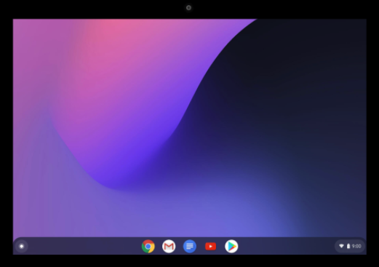 Google

Home screen

- Click the button in the bottom left corner. This is called the “Launcher”.

Google

Launcher

- Next, click the up arrow to see all your applications.

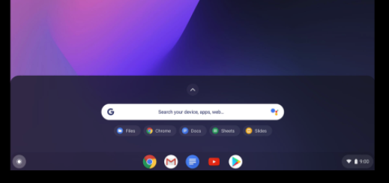 Google

Click the up arrow
- Click Google Play Store or click the small dots on the right side of the screen to find the Web Store App. Alternatively, you can search in the Chrome browser to find an app on the Web Store.

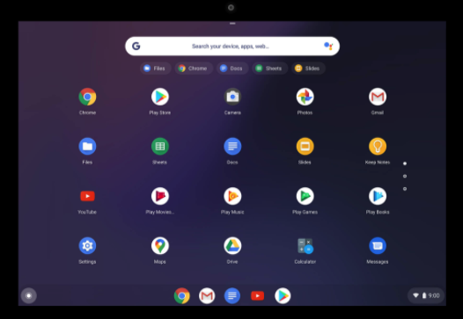Google

Click Google Play to search for apps
To find the Web Store app

- Search for the application you want and click install. Now you can find your applications in your launcher or at the bottom of your screen.

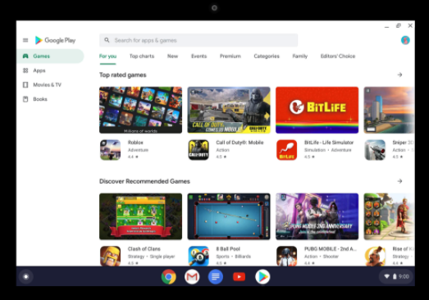 Google

Search here
Launcher

- Now you can install applications like Zoom or Google Classroom. The Chromebook already comes with many applications like: Google Chrome, Gmail and YouTube.

Questions for Discussion:

- What apps do you use on your phone?
- Are they available on your Chromebook? (hint: search in the Play Store or Chrome Web store)
- List two apps that are already installed on your Chromebook:

- List two apps you want to install on your Chromebook:

Guide #6: Downloading and Signing in to Zoom

Directions: Follow the instructions to download an application on your Chromebook. Search for “Zoom” and download this application to your Chromebook.

- After you have downloaded Zoom to your Chromebook, it will be in your toolbar at the bottom of your screen or in your launcher.

- Open your Zoom application and login using your Gmail (you can also create an account, but it's easier to use your Gmail).
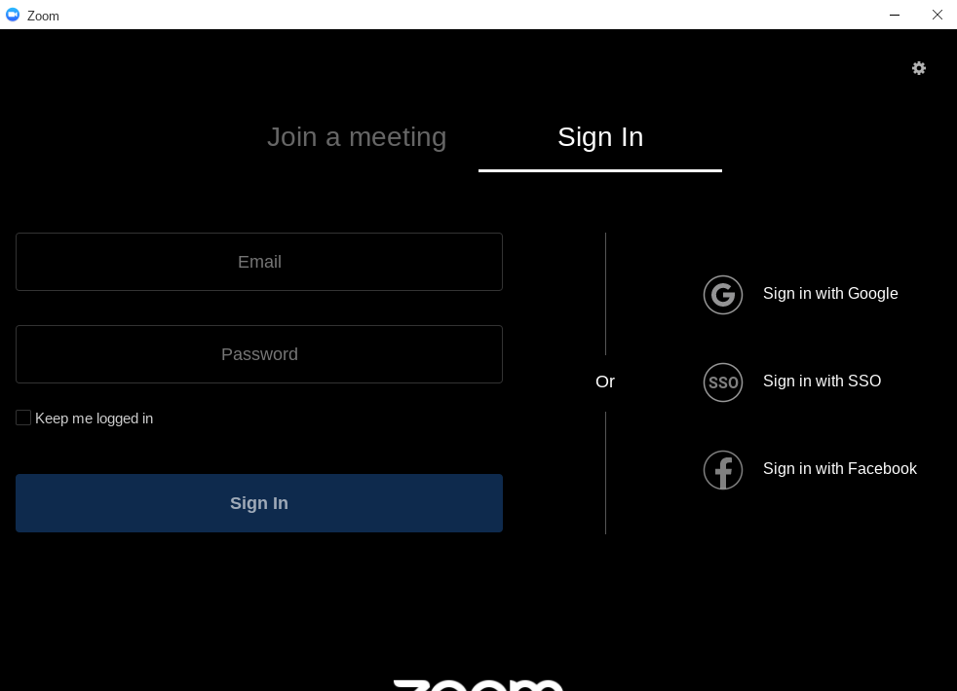

- Now you will enter the login page. Type your Gmail address, then Gmail password. Click “next”.

- Alternatively, you can “join a meeting” directly if you have the Meeting ID and Password.
Make sure you do not check “☑” the “Don’t connect to Audio” box.
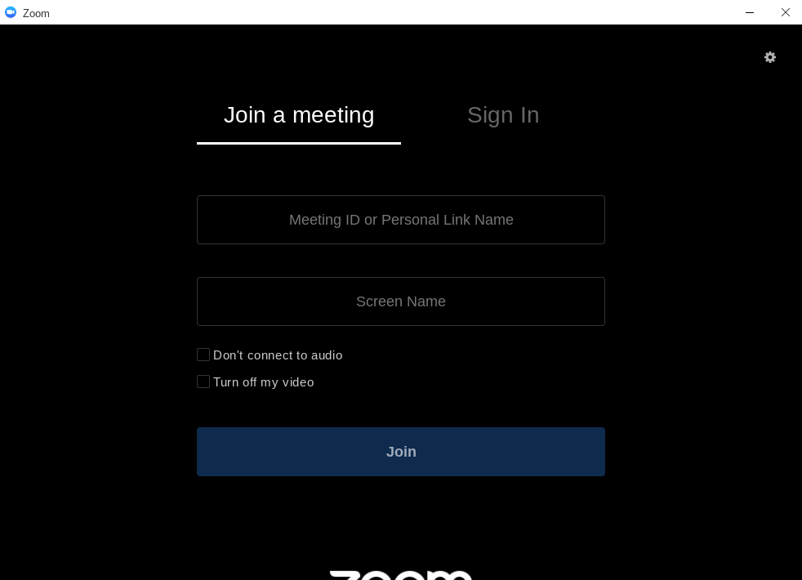

Meeting ID
Password

Make sure this is not checked

💡 Note: Please remember to update your Chromebook when it gives you a notification!

Guide #7: Using Zoom on a Chromebook

Directions: Practice logging in to a class meeting and using the controls. Let’s review first!

- There are two options to connect to a Zoom meeting.

- Option #1: Manually enter the meeting by typing in the Meeting ID and Password you have gotten after opening the Zoom application.
- Option #2: Click on a link that was sent to you by the Host. (A “host” is the owner of the meeting) and this will open the Zoom application or a browser window (depending if you have the application installed or not)

- Before you enter the meeting, Zoom will ask you to “Join with Video” or “Join without Video”. Choose the option you prefer. If you want your camera on so your picture can be seen, click “Join with Video”, if you don’t want your camera on, click “Join without Video”.

- When you enter, you probably will enter a waiting room and it will be a white screen. Wait here until the Host lets you into the meeting. The white screen looks like this:

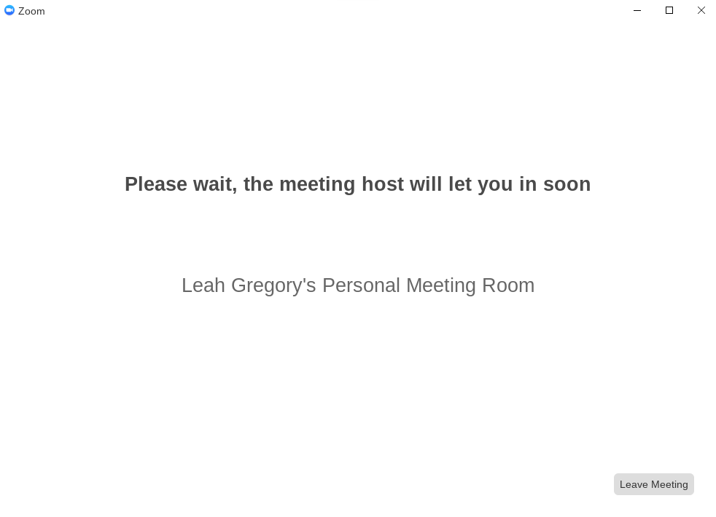

- When you enter the meeting, your screen will look like this:

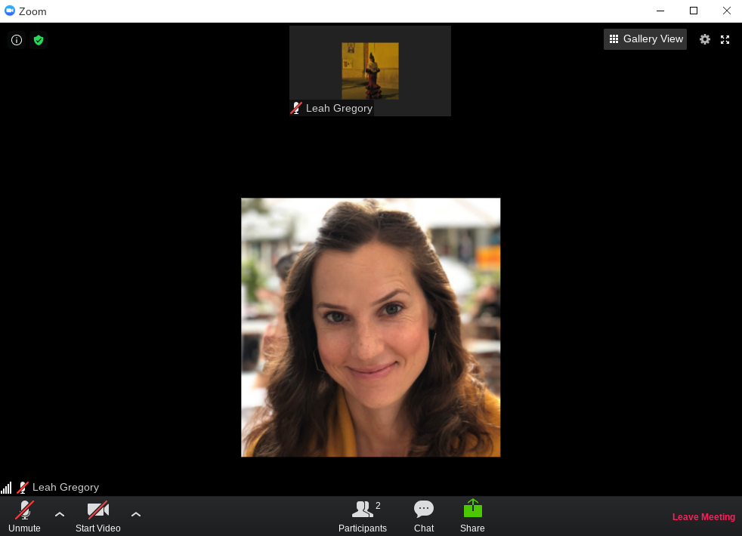

- Let’s take a look at the different options and settings in Zoom.

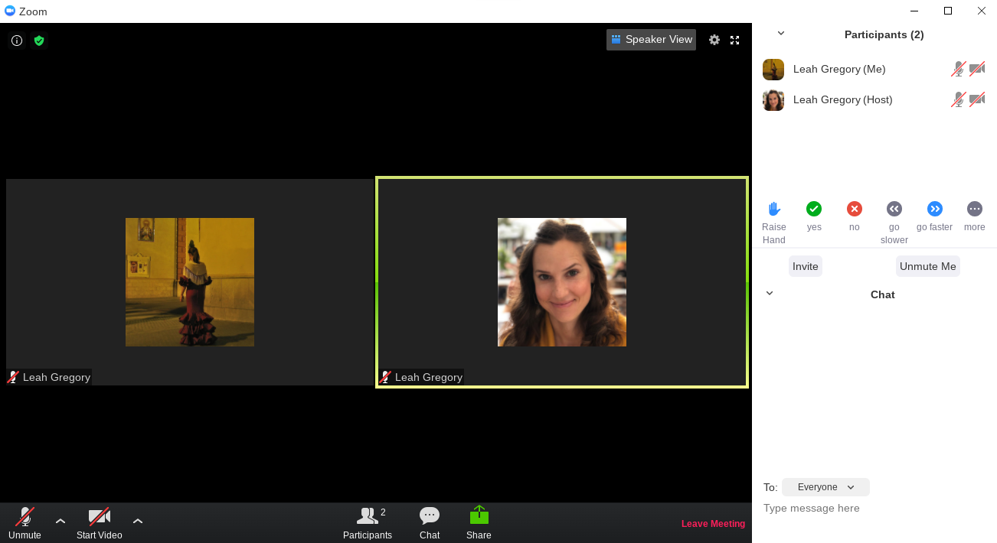

Change your view
Chat Here

Turn on or off your camera
Mute and Unmute
Participants
Chat
Share your Screen
Exit
Raise your hand for a question
Change your name by clicking your name and click “rename”
More Options

💡 Note: If you do not see the “Start a Meeting” option it is because you are not signed in. You must sign in to start a meeting with someone. Remember to sign in using your Gmail.

Exercise: Now open the Zoom screen, connect to a call (with a link or Meeting ID and password) or start a meeting and view the options in the picture above. Please remember that this is a participant view and the host view will look a little different (no raise hand option).

1. Practice clicking the Mute/Unmute button. What does the red line on the microphone mean?

- Change your view from Speaker View to Gallery View. What is the difference?

- Raise your hand so the teacher can see you have a question. How do I put my hand down?

- Change your name to include your class name (ex. Leah - ESOL 2). What did you change it to?

- Open the chat and write something to everyone. Confirm that your teacher and classmates can see your message.

Guide #8: Using Zoom on a Smartphone

Directions: Download the Zoom Application on your smartphone in the Google Play Store store or the Apple App Store. This App is free.

- Download the app on your smartphone and then sign in using your Gmail email address and password. The full name of the app is “ZOOM Cloud Meetings”.
- Android: https://bit.ly/zoomandroidENB
- Iphone: https://bit.ly/zoomappleENB

- Your teacher may send you a direct link, if you click this link you will enter directly into Zoom and will not have to sign in (skip to #6).

- When you open the application on your smartphone, you will see the “sign in” window (or you will already be signed in, go to step #4). Click sign in and then sign in with your Gmail address OR you can Join a Meeting directly using a Meeting ID and Password.
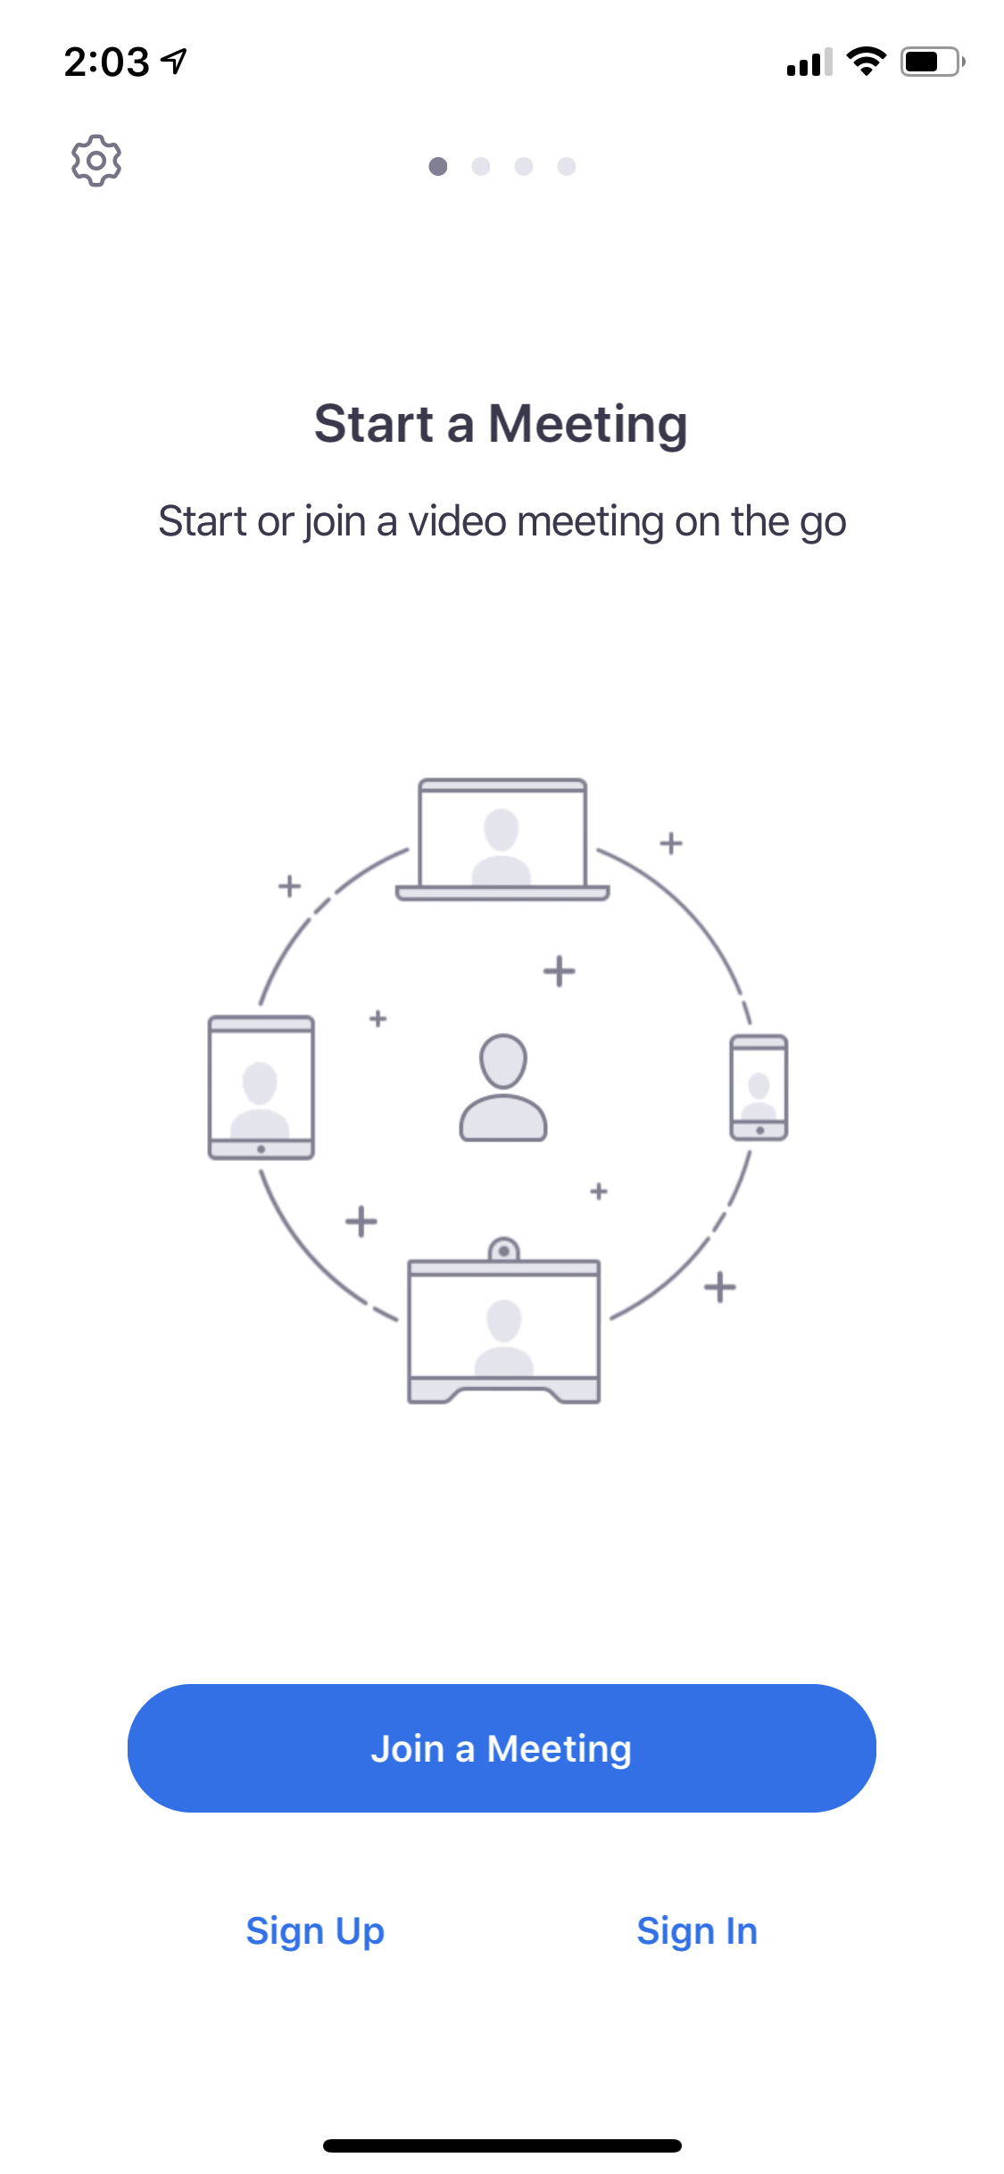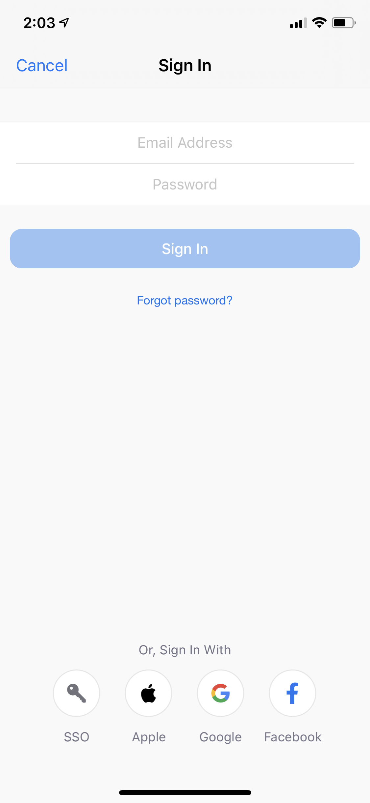

Option 2 Join a Meeting directly without signing in
Option 1 Sign in to your account using Gmail
- After you sign in your application will look like this picture. You have the option to host a meeting or join a meeting (remember, a “host” is the owner of the meeting).
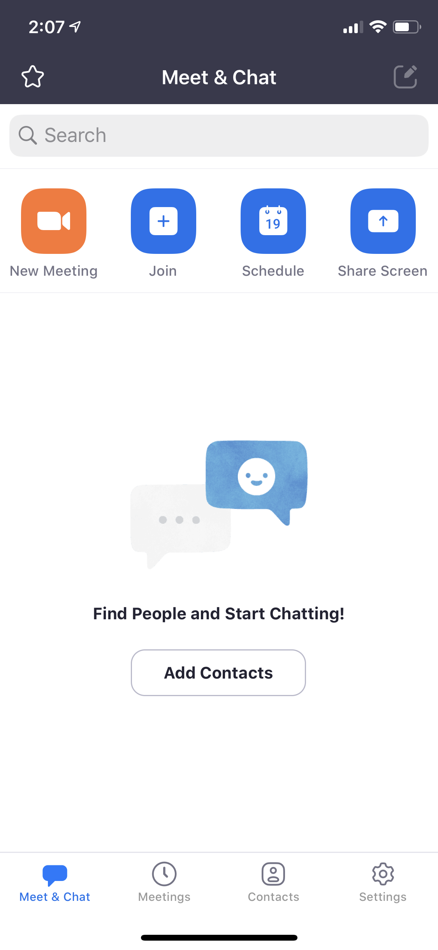

Host your own meeting
Join a meeting
- If you decide to join a meeting, you need to to type your Meeting ID and Password. Ask the host for this information.
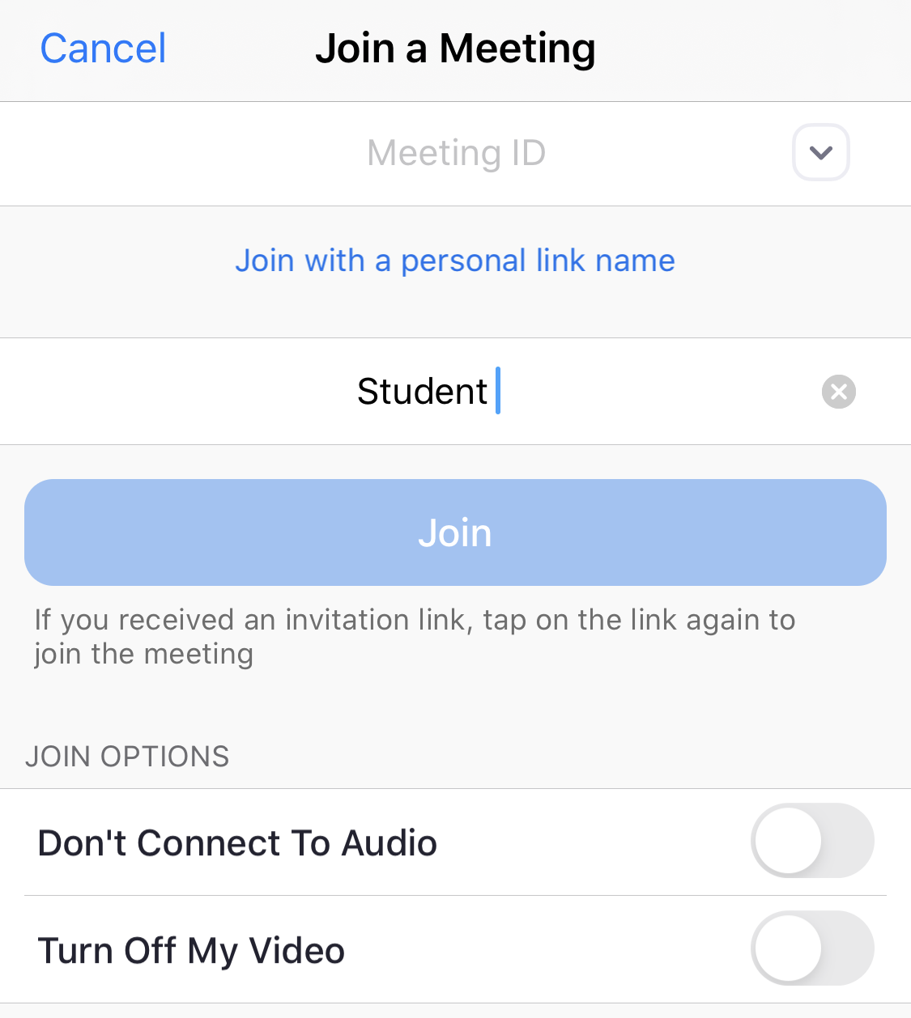

Type your name here
Type the Meeting ID here

- Zoom will ask you to preview your video (or you can turn it off). Then click “Join with video” or “Join without Video”.
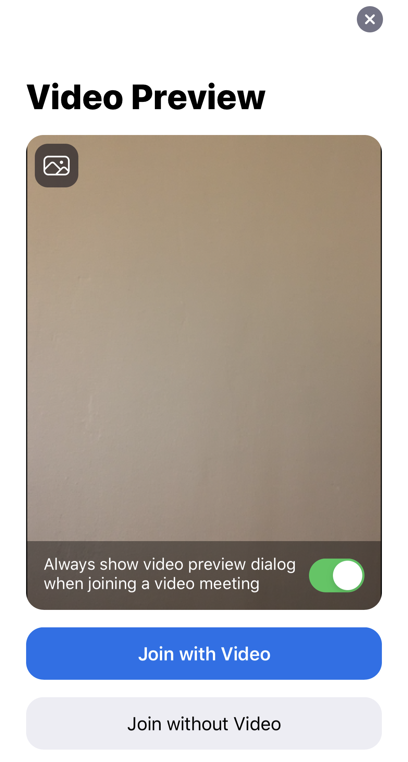

- Next, you will enter a waiting room and you need to wait until the Host adds you to the class. Then you will enter the meeting and you can see your options.

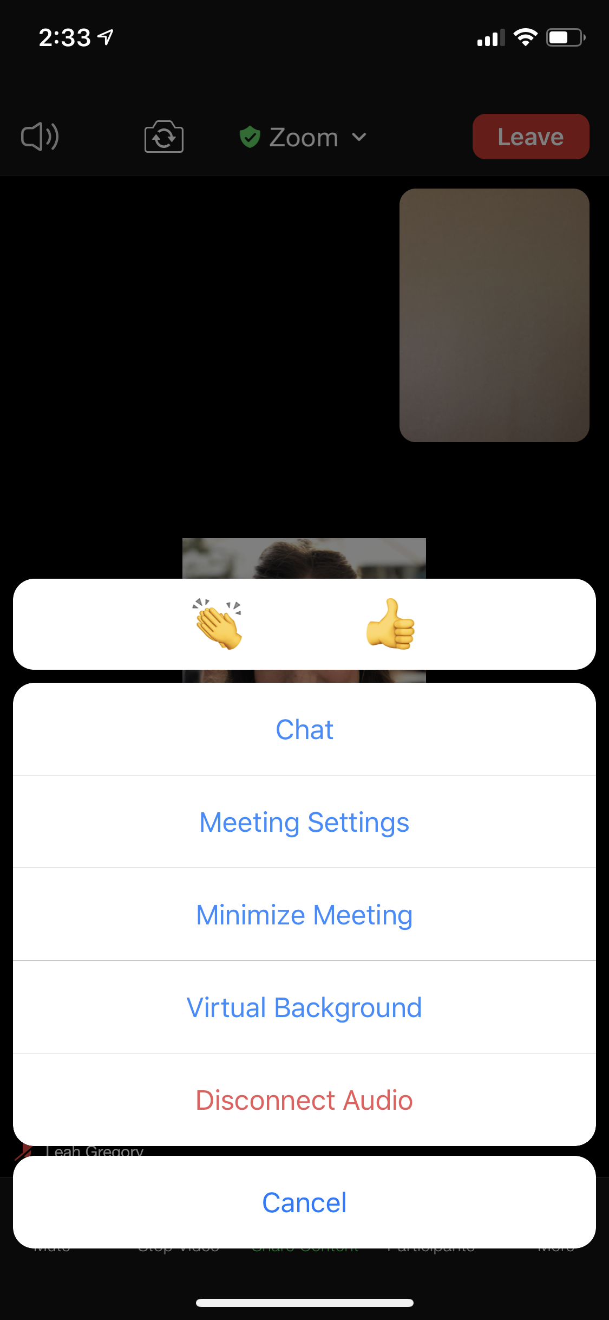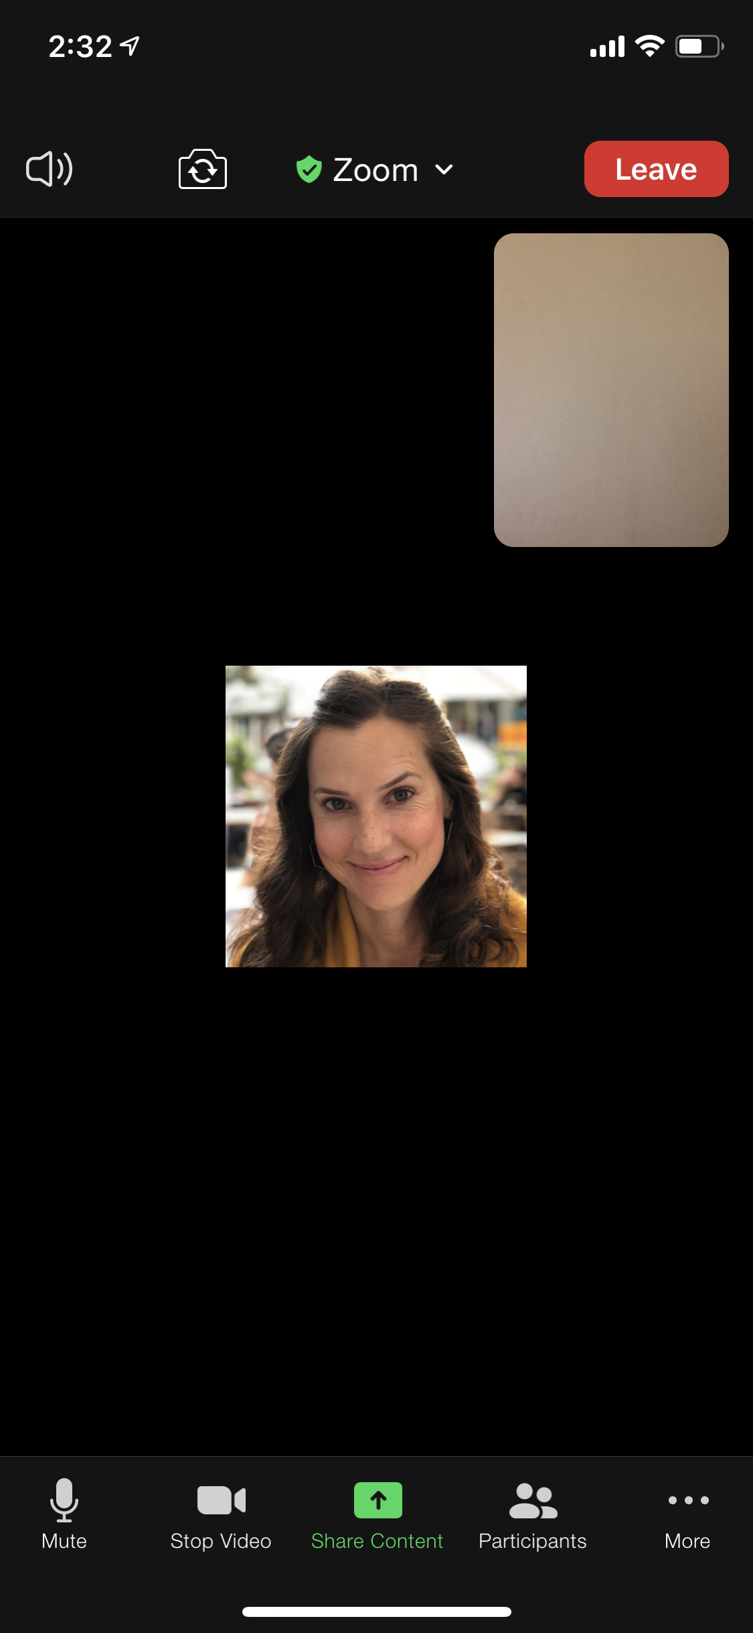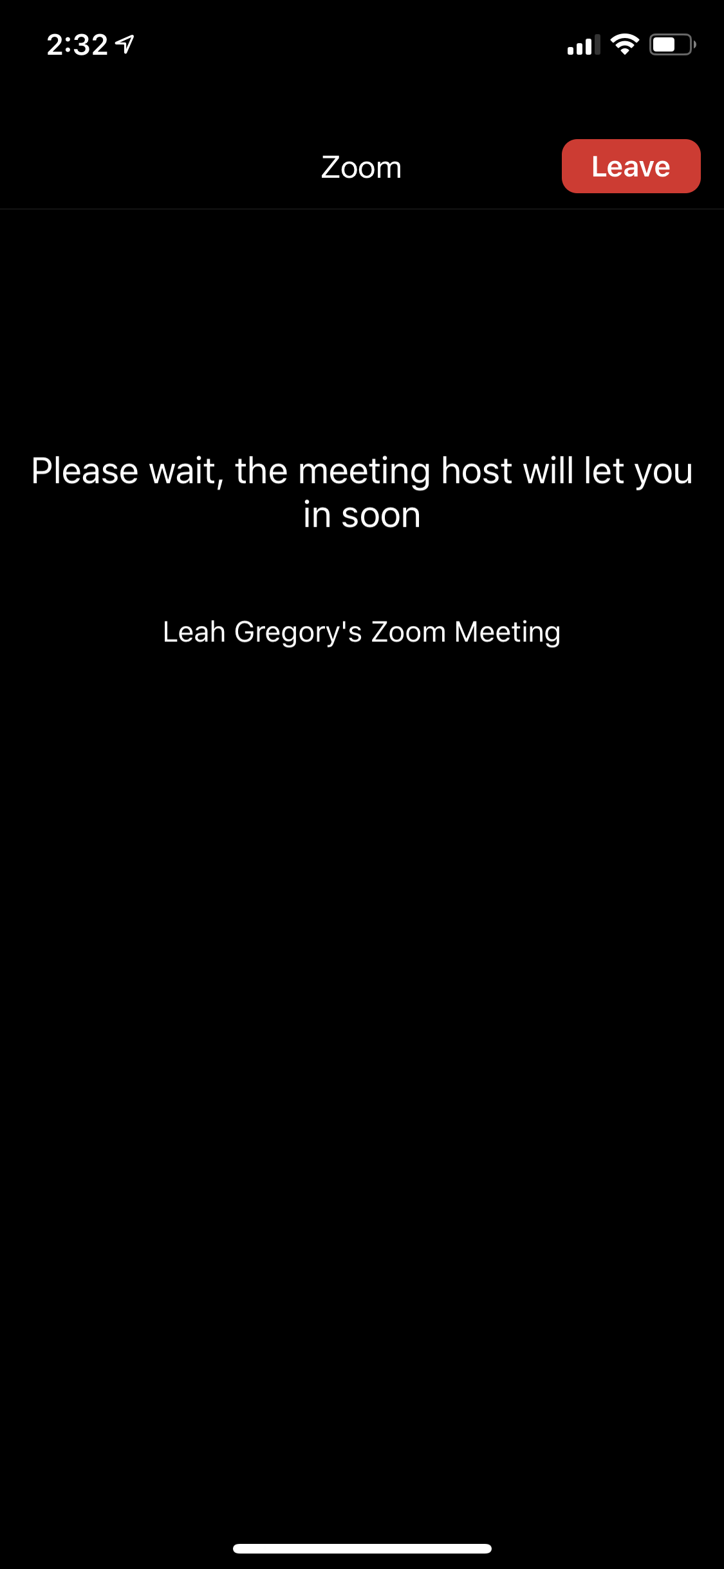

Waiting Room
Main Page
“More” options
View Participants
Start/Stop Video
Mute/ Unmute
Exit

- On your phone you also have the option to Chat, View Participants and raise your hand. To raise your hand, click “Participants” and you can see your options. Click “More” to see other options. Click on your name to change your name.

Exercise: Now open the Zoom App on your smartphone, connect to a call or start a new meeting and view the options. The directions and pictures represent the participant view, if you are a host, your view will look a little different. Write or discuss your answers with your class.

- Practice clicking the Mute/Unmute button. What does the red line on the microphone mean?

- Raise your hand so the teacher can see you have a question. How do I put my hand down?

- Change your name to include your class name (ex. Leah - ESOL 2). What did you change it to?

- Open the chat and write something to everyone. Confirm that your teacher and classmates can see your message.

Activity 4: Student Guide to Google Classroom

Rationale: As we navigate a digital world, the relevance of digital and technological literacy is increasingly important. In this activity, we take a look at Google Classroom and how students can connect to this platform to receive notifications, get homework and receive grades/feedback. The following Guides and exercises are meant to be a basic introduction and exploration of Google Classroom, but students will probably need more guidance depending on what the teacher decides to do and how they use it.
Please note that teachers should know how to navigate and post in a Google Classroom before teaching these activities to their students. Teachers can choose to use Google Classroom at a basic level (disseminate information and messages via the Stream) or at a more advanced level (posting homework, quizzes, using other programs that integrate Google Classroom, etc.) A good resource for teachers is Google’s great Google Classroom Resource.

Student Objectives:
- Students will learn about the tools, functions, and three main sections of Google Classroom.
- Students will learn how to access their Google Classroom.

Materials:
- Chromebook (and cable cord)
- Worksheet #6: Google Classroom Basics
- Guide #9: Connecting to a Google Classroom
- Worksheet #7: Explore Google Classroom

Activity Outline:
- Explain the objectives. Review the worksheet Google Classroom Basics with the class and check their understanding by completing the small True/False questions.
- Set up the video on a projector to view in the classroom. Alternatively, students could watch it on their own with headphones. After viewing the video, students could watch as the teacher demonstrates how to join a classroom by going through the steps on the projected screen. Alternatively, the teacher could send an invite to the class during the class time so the students can follow the steps on their Chromebooks (or smartphones). Please note, if students join on their smartphones, they need to download the Google Classroom application.
- Print out a copy of Guide #9 Connecting to a Google Classroom for each student to have.
- Remember that the teacher is responsible for inviting students to their classroom, posting homework, grading and returning assignments, and can post updates and notifications. It is suggested that the Google Classroom is already set up with a message from the teacher, plus an assignment students can view when they enter the classroom (such as a Google form).
- Ask students to write a message in the stream and make sure students have notifications turned on. It also may be beneficial to have students connect to the Google Classroom on their smartphones by downloading the app and connecting to the classroom using the class code.
- Depending on the assignment, if the student needs Google Docs to complete it, they will also need to download this application. To keep it simple, ask students to write on the stream as their first assignment. Complete the worksheet Explore Google Classroom.

Follow-Up: Students could work with their children to better understand Google Classroom, as many K-12 students are using it. Children could open up their Google Classrooms and show their parents assignments due and turned in. Teachers should post regularly so students can get used to using it.

Name: ___________________

Worksheet #6: Google Classroom Basics (for students)

Directions: Read through the basics of a Google Classroom. Complete the small quiz at the end of this worksheet.

What is Google Classroom?
- Google Classroom is an application that students and teachers can use to communicate with each other.
- It has basic tools and functions where students and teachers can:
  - Write messages, notifications and updates
  - Send homework documents and worksheets
  - View and Grade homework, quizzes and other assignments
  - Share resources, videos or other material
- To use Google Classroom, a teacher needs to add you to their class and then you can access all the materials.

Frequently Asked Questions (FAQs)
Q. Can I use Google Classroom anywhere?
- Yes. Anywhere you have internet access, you can use Google Classroom. There is an offline option that has limited things you can do.
Q. What can I do in Google Classroom?
- You can communicate with your teacher and classmates, access homework, quizzes and assignments from your teacher, complete assignments using Google Docs, Sheets or Slides (different applications) and send them back to your teacher, and view your grades.
Q. Can I use Google Classroom to DO my homework?
- No. Google Classroom will give you your homework, but you need to use other applications (Google Docs, Sheets, Slides, Forms) to complete your assignments. On your smartphone, you need to download all 5 applications.

Let’s check your understanding. Mark if the sentence is true (T) or false (F).
- Google Classroom is a place where I can see my teacher. T F
- I can view and submit homework to my teacher. T F
- I can complete my homework in Google Classroom. T F
- My teacher can send messages and notifications. T F
- I can’t view Google Classroom on my smartphone. T F

Guide #9: Connecting to a Google Classroom on a Chromebook

Directions: Watch the video for an overview of Google Classroom. Then, follow the instructions in Part B to go through each part step by step.

Connecting to a Google Classroom. In this video you will learn how to:
- Accept an invitation to join a Google Classroom
- Learn about the different parts of Google Classroom
- Access your homework
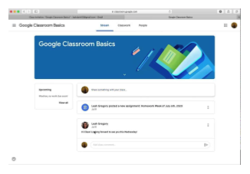
Click on the picture to view the video on YouTube.

Follow this Guide as you connect for the first time to your Google Classroom

- You have two options to connect to your Google Classroom.
  - Option #1: Your teacher will send you an email invitation and you can click “Join” (demonstrated in the video above).
  - Option #2: Your teacher will give you a code to enter the classroom. When you have the code, go to classroom.google.com , sign in with your Gmail and click on the “+” symbol in the top right corner. It looks like this:

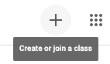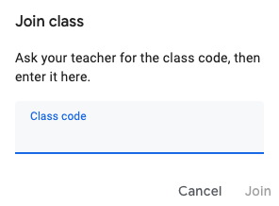

1. Click the plus sign
2. Enter class code
- When you connect to the Google classroom for the first time, you do not need to connect again. You can access your Google Classroom by going to classroom.google.com
- Now you are in the classroom. Let’s take a tour. There are three sections in the classroom: Stream, Classwork and People.

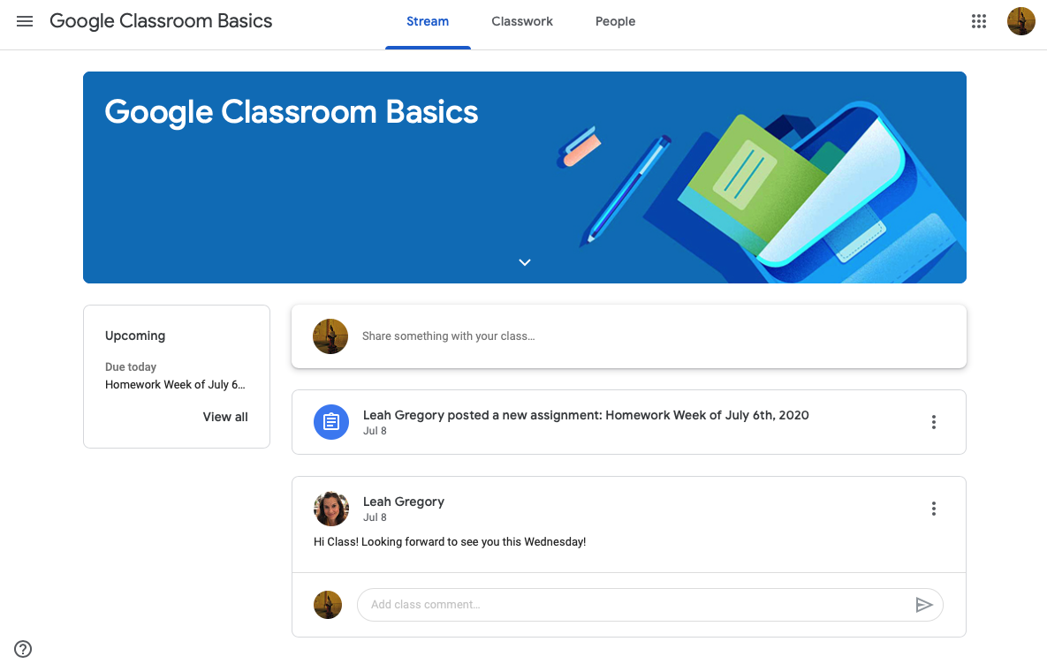

Three Sections
Write messages and see notifications from your teacher.
Assignments and homework that are scheduled
These are the different sections:
- Stream: write and read notifications from your teacher and/or your classmates.
- Classwork: view and access your homework and material from your teacher.
- People: view your teachers and classmates in your class.

Turn on Notifications
It is important to turn on notifications for the Google Classroom, so every time your teacher posts something you will receive a notification.

    - Click on the 3 lines in the top left corner.

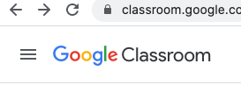

    - Scroll down and click “Settings”.

    - Make sure Notifications are turned on. Like in this picture:

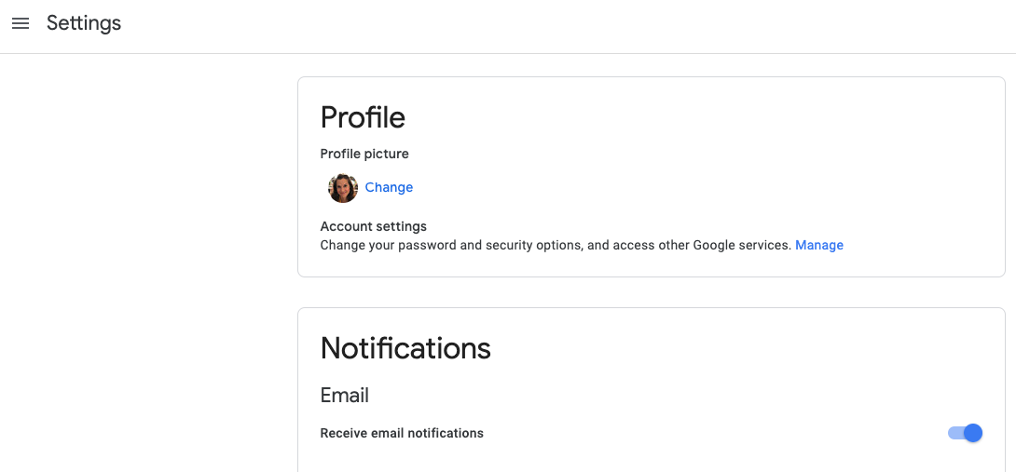

    - Click the 3 lines again to return back to your classroom page.

💡 Note: If you connect and use Google Classroom on your smartphone, you must download the application first.

Access Homework

- Your teacher will add homework to the “Classwork” section in the Google Classroom. To view the homework, click “Classwork” and then click the homework. In the homework, click “View Assignment” .
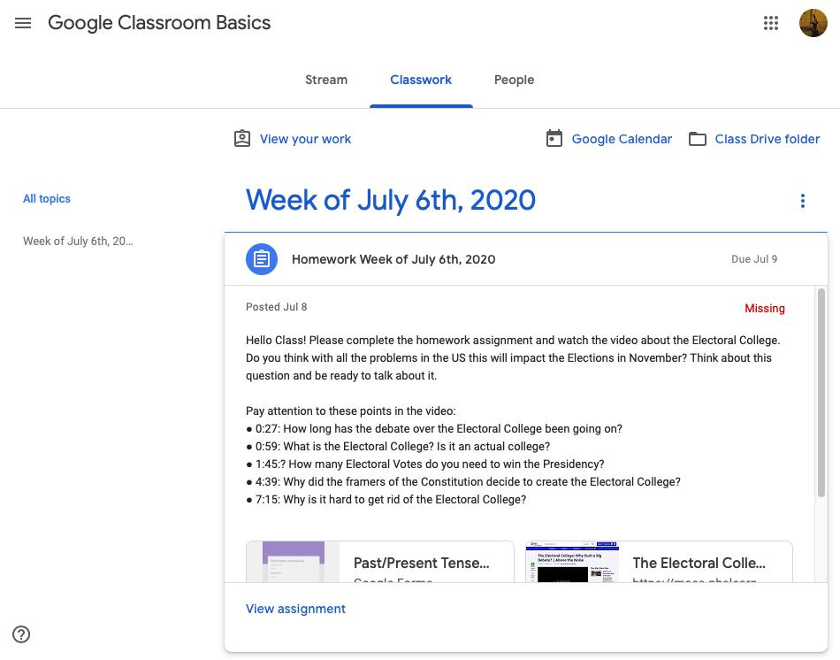

View Assignment
- When you view the assignment, you will view the exercise and you need to open the Google Doc or Form to complete the assignment.
- After you complete the assignment, return to the Google Classroom and click “Turn In”. You can also send your Teacher a private message about the assignment.

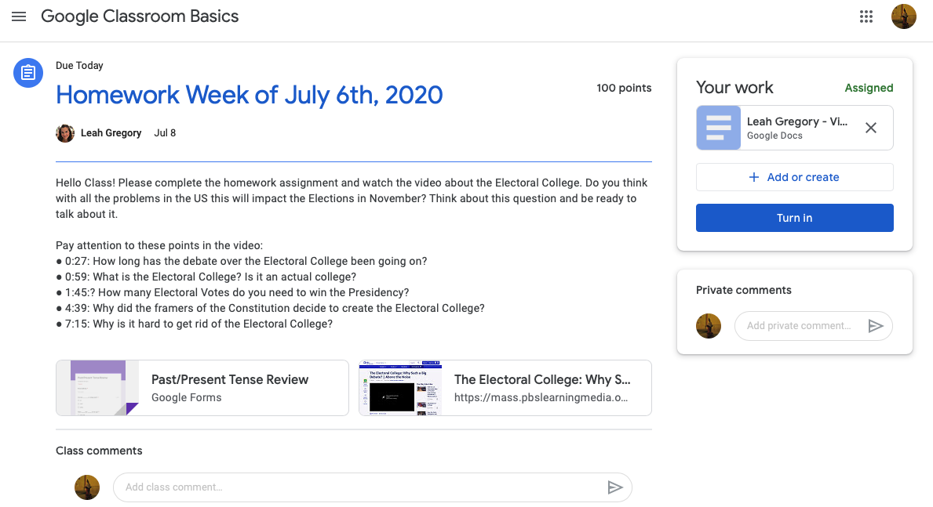

Homework Document
When you complete the homework click “Turn In”
Private Message to Teacher
💡 Note: If you connect and use Google Classroom on your smartphone or tablet to complete your homework, you must download Google Docs and Google Forms too.
Name: ___________________

Worksheet #7: Google Classroom Exploring

Directions: Access the Google Classroom with your teacher’s invitation. Explore Google Classroom with a partner and complete the exercises below.

- Google Classroom Review
- What are the three sections of Google Classroom?
1.
2.
3.

- Where can I write a message in Google Classroom?

- Write a message to your class introducing yourself, include:
  - Your Name (My name is…)
  - Where are you from? (I am from…)
  - What is your favorite food? (My favorite food is…)

- Google Classroom Assignment
- If your teacher gave you an assignment:
  - View the assignment
  - Open the Document
  - Complete the Assignment
  - Return to Google Classroom
  - Click “Turn In”

