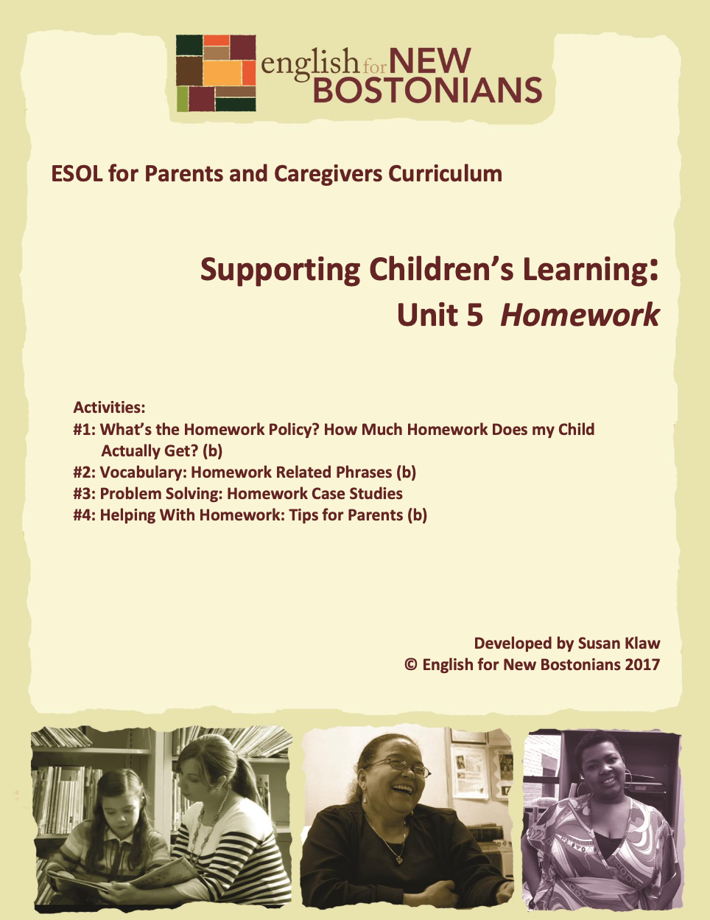About English for New Bostonians
Developed by Susan Klaw
© English for New Bostonians 2022

English for New Bostonians (ENB) invests in the future of our region by fostering a high-quality ESOL system that prepares immigrants to pursue their educational, economic and civic aspirations. Through grant making, training teachers, and building public awareness, ENB expands the number of English for Speakers of Other Languages (ESOL) seats, improves program quality across agencies, customizes curricula to diverse subpopulations, and leverages private and public resources. Founded in 2001 by the Mayor’s Office for Immigrant Advancement (MOIA), immigrant leaders, and local foundations, ENB now involves several city departments, approximately 20 public and private funders, and numerous community organizations.

About the ESOL for Parents and Caregivers Initiative
Through ESOL for Parents and Caregivers, ENB guides ESOL providers and immigrant-rich schools in building partnerships to facilitate parent engagement in schools, enabling parents/caregivers to improve their English and digital literacy skills, navigate school systems, and understand expectations and opportunities for school involvement and ways to optimize children’s learning. At the same time, ESOL for Parents helps adults prepare to pursue their own educational and employment goals, while supporting children’s learning – aiming to eliminate multigenerational poverty.

About Susan Klaw
Susan Klaw has directed, taught in, and developed original curriculum materials for Boston-based parent ESOL programs since 1991. She has delivered extensive training locally and nationally on various aspects of Family Literacy and been named a “Literacy Champion” by the Massachusetts Literacy Foundation, Parent Educator of the Year by the Children’s Trust Fund, and Adult Educator of the Year by the Massachusetts Coalition for Adult Education.

About the ESOL for Parents and Caregivers Curriculum
The Curriculum (on ENB website and available free of charge) gives ESOL teachers background materials, lessons and activities designed to help immigrant parents learn English and become more effectively involved in their children’s education. Selecting curriculum units and lessons relevant to their classes, ESOL teachers can orient immigrant parents to the U.S. school system and provide practical skills such as interpreting report cards, participating in teacher conferences, advocating for children, and supporting children's learning at home. While some information is Boston specific, much can be used in any locale. ENB can assist in adapting materials for school districts. Additionally, ENB offers a Companion Middle/High School Guide, as well as a Digital Learning Guide to support online instruction.

Using the ESOL for Parents and Caregivers Curriculum
All materials are intended to be downloaded and widely used. Please cite English for New Bostonians and credit English for New Bostonians on all reproductions. We welcome feedback and stories on how you and your students are using the ESOL for Parents and Caregivers Curriculum!

Thanks to the many public and private funders that have supported this project, especially the Highland Street Foundation, Shipley Foundation, Hamilton Foundation, Moses Kimball Foundation, Plymouth Rock Foundation, Blum Shapiro Foundation and the Mayor’s Office for Immigrant Advancement’s We Are Boston Gala.

Contact us at info@englishfornewbostonians.org
or visit us online at www.englishfornewbostonians.org

ACTIVITY #1: WHAT’S THE HOMEWORK POLICY? HOW MUCH HOMEWORK DOES MY CHILD ACTUALLY GET?
(Can be used/adapted for use with beginning level students)

Note to teachers: This activity also appears in Topic 1, Unit 3, Activity #4. If this activity has already been done, just review briefly the homework policy from the current version of the Guide to Boston Public Schools for Families and Students. If this activity has not been done, we recommend that you use it to begin the following unit on homework because it provides an overview to the stated BPS policy. The activity is repeated below. If you have parents in your classes whose children go to schools in different districts, or go to charter schools, you can use the BPS policy simply as a sample. Homework policy doesn’t differ much district to district. The rest of the homework unit isn’t specific to one school system and can be used in any Parent ESOL class or Family Literacy program.

Rationale:
Parents understand that monitoring homework is a primary parental responsibility. In elementary school-based parent ESOL classes, “Being able to help my child with homework” is the number one reason students give for joining the class. Understanding the BPS policy versus their child’s actual experience helps parents learn how to advocate for their children.
Student Objectives:
∙ Students will understand how much homework BPS says their children should get and what to do if that if that isn’t happening.
∙ Students will be able to compare a written policy with their own experience.
Materials:
∙ Current Guide to Boston Public Schools for Families and Students, page on “Homework Recommendations.” If you do not have a hard copy of the Guide, you can download it from the BPS website.. Once there, search for the Guide and look at the table of contents.
∙ Handout: My Child’s Experience with Homework.
Activity Outline:
1. Explain objectives.
2. Ask two whole group discussion questions: Why do teachers give homework? How much homework do you think children should get? List responses on the board.
3. Have students in partners discuss these questions. If you have several students in your class who never went to school, group students in threes.
∙ When you were in elementary school, did you have homework?
∙ Did you have homework every day?
∙ What did you have to do for homework?
Ask students to report back to the group what their partner(s) said.

4. Distribute and have students fill out the handout: My Child’s Experience with Homework.
5. Read together the section on homework recommendations for elementary school from the BPS Guide. Compare the reasons given by BPS for homework with those students listed in the initial discussion. Compare recommended homework time with what students thought. Point out that the amount of homework goes up as children get older. BPS recommends 30-60 minutes per day for elementary school, 2 hours for middle school and 2 ½ hours for high school.
6. Have parents look back at the handout they filled out to consider whether their child’s actual experience matches BPS policy. Do a Vote with your Feet activity. Write these three statements on paper and post them in different corners of the room:
∙ My child gets 30-60 minutes of homework per day.
∙ My child gets less than 30 minutes of homework per day.
∙ My child gets more than 60 minutes of homework per day.

Ask students to stand under the statement that matches their child’s experience.
7. Have those students whose children either get too little or too much homework to elaborate. Ask whether it bothers them. If it does, have the class help problem solve. What should this student do? Talking to the child’s teacher is the answer you are looking for. If a child isn’t getting much homework, the teacher should be asked to explain her homework system. The parent can refer to the page in the Guide. If the parent continues to worry because her child gets too little homework, she should ask to meet with the Principal. If a child is spending too long doing homework every night, the parent should also meet with the teacher and work out a different homework plan. Unless a parent tells them, a teacher has no way of knowing if a child is struggling far too long to complete homework assignments.
Follow-Up:
∙ For those students who have children in middle and high school, they could look at the homework recommendations for those age groups in the following pages in the Guide. Encourage any concerned parents to meet with their child’s teacher and ask them to report back to the group on the meeting
∙ College Talk: Take a moment to explain to students how most of the work you do in college is homework, or independent work. You are expected to do approximately 10 hours per week of independent work for each course you are taking. A full time student usually takes four courses a semester. Homework in elementary, middle and high school teaches students how to learn independently. This is something they need to be able to do to succeed in college.

Handout: My Child’s Experience with Homework
Fill in the blank or circle the answer for each sentence.
My child is in _______________________ grade.
My child gets homework (Circle one option):
every day 3-4 times a week once a week never
It usually takes my child _______________________ to do the homework. Amount of time (minutes, hours)
The homework is ( too hard, just right, too easy ) for my child. (Circle one) ______________________________________________________________________
If you have more than one child in school, complete the same sentences for your second child. My child is in _______________________ grade.
My child gets homework (Circle one option):
every day 3-4 times a week once a week never
It usually takes my child _______________________ do to the homework. Amount of time (minutes, hours)

The homework is ( too hard, just right, too easy ) for my child. (Circle one)

ACTIVITY #2: VOCABULARY: HOMEWORK RELATED PHRASES (Can be used/adapted for use with beginning level students)
Rationale:
Learning a set of phrases related to the process of doing homework will help parents be better able to understand and communicate with their children’s teachers and to understand their own English teachers better.
Student Objectives:
∙ Students will be better able to talk to their children’s teacher about homework.
∙ Students will learn 10 homework related phrases.

Materials:
∙ Handout: Reviewing the Meaning of Homework Related Phrases
∙ Handout: Using Homework Related Phrases in Context
Activity Outline:
1. Explain objectives
2. Go over key homework related phrases. Use examples from your own class and then ask students questions about their homework practices, such as “Do you always follow directions?”
a. assign homework
b. assignment
c. check homework
d. complete homework
e. hand in homework
f. figure out

g. follow directions
h. supposed to do
i. have a battle over homework
j. fall behind
3. Have students write the words and definitions in their notebooks or on either side of an index card to create flash cards for easy review. Use Quizlet to create vocabulary exercises with the words.
4. Distribute handout Reviewing the Meaning of Homework Related Phrases for a quick review to check understanding. (This handout could also be done as homework).
5. Distribute handout Using Homework Related Phrases in Context. Read over the directions together carefully, stressing the importance of following directions (one of the homework related phrases). Remind them that they shouldn’t start doing any school work until they are sure they understand the directions. This is a skill they can also help their children with when their children do homework.
6. Circulate to help as needed. Offer praise and encouragement. As you do so, point out this is the role parents can take as their children do their homework. The assignment is complete when students have self corrected and read through the dialogue several times.

Handout: Reviewing the Meaning of Homework Related Phrases

Directions: Circle the correct meaning below.

Assign homework
∙ explain a project
∙ give students homework to do
∙ ask students to give you their homework
Assignment
∙ the homework a teacher tells students to do
∙ the newspaper
∙ errands
Check homework
∙ put a check mark on the page
∙ look over the homework
∙ put homework in your backpack
Complete homework
∙ finish the homework assigned
∙ finish a book
∙ a homework packet
Hand in homework
∙ put the homework in your hand
∙ put the homework in your desk
∙ give the homework to the teacher
Figure out
∙ to draw a figure of a person
∙ to go out
∙ to solve or understand something
Follow directions
∙ to do what the directions say
∙ to walk around in a circle
∙ to direct traffic
Supposed to do
∙ expected to do something
∙ think about doing something
∙ read 20 pages

Have a battle over homework
∙ disagree about what the homework is
∙ struggle over the homework
∙ throw the homework in the trash
Fall behind
∙ to not know the answers
∙ to not know as much as your classmates
∙ to not do your homework

Handout: Using Homework Related Phrases in Context
Directions: Fill in the blanks in the following conversation of a parent/teacher conference using the phrases from the list below. Note that you may have to the change the verb to the –s form. Each phrase is used only once. Next, pick a partner and correct your answers together. After you have finished, read the dialogue aloud. Read it several times and change roles.

assign homework assignment have a battle over homework check homework complete the homework fall behind hand in homework figure out supposed to do follow directions
Teacher: Thank you for coming in to meet with me Ms. Lopez. I wanted to talk with you about Ronnie’s homework. He seldom _______________ _______ __________________. I am worried that he is going to __________________ __________________.
Parent: I know. Every night we __________ _____ ____________ _______ ______________.
Teacher: That must be hard. Maybe I can help. Let’s start by reviewing my homework policy. I ______________ _________________ every night. Students write the __________________ down in their notebooks. I expect parents to _______________ _____________________ every night.
Parent: Ronnie sometimes doesn’t know what he is _________________ ______ ________.
Teacher: If students don’t understand what they are supposed to do, I tell them to ask me questions before they go home. And I tell the students to ______________________ __________________ carefully.
Parent: Ronnie says he can’t _______________________ _______ __________________ because it takes too long.
Teacher: How long does it take him?
Parent: I think it is the math that takes him so long. Just the math takes him almost two hours. He says he can’t ________________ _________ the problems.
Teacher: Maybe that is why homework is such a battle. He needs some extra help with math. .

ACTIVITY #3: PROBLEM SOLVING: HOMEWORK CASE STUDIES
Rationale:
The case study approach allows students to problem solve together, pooling their own experience with homework with that of their classmates. It respects and encourages their expertise as parents.
Student Objectives:
∙ Students will learn solutions to common homework problems.
∙ Students will increase their abilities to express ideas orally
Materials:
∙ Handout: Homework Case Studies
∙ Case Study notes for Teachers
Activity Outline:
1. Explain objectives.
2. Opening discussion: Are there any homework problems in your family? What are they? Note the problem on the board, but don’t brainstorm possible solutions. You will come back to this after students work on the case studies.
3. Hand out the Homework Case Studies and read them aloud. Ask students to raise their hands when they hear or read any of the vocabulary words from the previous activity (Activity #2: Homework Related Phrases). Once the new vocabulary words have been spotted, students should underline the words in their texts.
4. Divide students into small groups to read the case studies together and problem solve solutions. Have each group choose a recorder who writes fairly easily. That person will write down the group’s ideas, once they come to some consensus, in order to report back to the whole class. Tell the recorder not to worry about spelling. Allow ample time for the groups to discuss the cases.
5. In the whole group, go over each case study, asking what solutions the small groups have come up with. Write the solutions on the board. After the first group reports, have succeeding groups only report on new and different solutions. Alternate which group reports first.
6. Alternate structure: If sufficient time isn’t available for students to read all the case studies, give each small group two to three case studies to read and try to solve. When a group reports back to the whole class, students have to retell the story as well as share their solutions.
7. Look back at the initial list of actual homework problems parents identified. Now look at each one and brainstorm solutions to those real problems.

Handout: Homework Case Studies
1) Henry works overnight at the airport and sleeps in the morning. Then he picks up his children from school and takes care of them in the afternoon and evening while his wife works. His daughter Alexandra is in 3rd grade. Every day Henry has a battle with her about doing her homework. He thinks she should do it as soon as she gets home from school. She says she hates homework and wants to play on the computer or with her friend who lives next door. He makes her sit down right away at the kitchen table and get her assignments out of her backpack. She always ends up crying.
What can Henry do? He is tired of having a battle every day about homework.
2) Olivia was surprised when she got a note from her daughter’s teacher. The note said that Jennifer seldom handed in her homework. Olivia knew that Jennifer completed the homework every night before dinner. Olivia would not let Jennifer watch any TV until she had checked to see that her homework was complete.
What do you think the problem is?
What can Olivia do?

3) Tomas’s son Juan goes to an afterschool program every day after school. In the program, the children do their homework right after snack time. Tomas thinks that Juan always completes his homework in the program. When he gets the first report card, Juan got a low grade from his teacher on the standard: “Completes and returns homework assignments.” Tomas was upset.
Who is responsible for this problem?
What can Tomas do differently?
4) Erica’s daughter is in 3rd grade. Every night she spends at least two hours on her homework and she still doesn’t finish it. When Erica tells her she has to stop because it is time to go to bed, her daughter starts to cry. She says, “I have to finish my homework. That’s the rule. My teacher will be mad at me.” Erica is worried about her daughter.
What should Erica do?
5) Alma’s seven year old son is in second grade. He often says he doesn’t have any homework or he did it in school. Alma knows he has had many substitute teachers this year because his teacher has been sick. She is worried if he never gets homework, he won’t learn as much as the children in the other second grade and he will fall behind.
What should Alma do? Who should she talk to?

6) Daniel is in fourth grade and his teacher assigns a lot of homework every night. When his mother asks him if he has finished his homework, Daniel often tells her that he doesn’t understand what he is supposed to do. He is supposed to do a project for social studies, but doesn’t remember what the project is. He has a math worksheet to complete, but doesn’t understand the directions. He thinks he is supposed to read some pages in his science book, but isn’t sure what pages to read.
How can his mother help Daniel?

7) Marta only went to school in her country through third grade. As a mother, she believes she should help her children with their homework. But often she can’t. She doesn’t know what a graph is. She doesn’t know how to figure out what is the main idea of a paragraph. She doesn’t know what an essay is. She doesn’t know how to do research on the internet.

What can Marta do?

Homework Case Studies Notes for Teachers
There are no right answers to the case studies. The important thing is for parents to share possible solutions with each other. Here are some points the teacher might add to the discussion if necessary.
Case Study 1: Point out that children can be given choices as to when they want to do their homework on a regular basis. Some prefer to do it as soon as they get home from school. Others want to wait until after dinner.
Case Study 2: Mother might make sure child actually puts homework in the backpack. This is part of helping a child get organized. The mother should then check each day to make sure it got handed in.
Case Study 3: It is very important for parents to realize that even though their children may be in afterschool programs where they do homework, it is still the parent’s responsibility to check every night that the homework was finished.
Case Study 4: Mother should talk to child’s teacher and report how long it is taking child to complete homework and come up with a solution which doesn’t leave the child in tears every night.
Case Study 5: Alma should talk to the principal. It doesn’t make sense to talk to the teacher because there have been a string of substitutes.
Case Study 6: Mother should help him come up with a system of writing down his assignments before he leaves school every day. In many schools children are given agendas precisely for this purpose.
Case Study 7: One resource parents may not know about is that in Boston there is free homework help offered after school at most of the branch libraries. This is a good resource for parents to use if they can’t help their children with the homework or if their children are having trouble getting the homework done at home.

ACTIVITY #4: HELPING WITH HOMEWORK: TIPS FOR PARENTS (Can be used/adapted for use with beginning level students)
Rationale:
Having drawn on their own experiences to solve homework issues in the previous activity, here students read, digest and incorporate into their parenting ideas from the experts on how to best help children with their homework.
Student Objectives:
∙ Students will be able to name at least two ways they can better help their children with their homework.
∙ Students will improve speaking and reading skills.
Materials:
∙ Handout: How Do You Handle Homework in your Family?
∙ Handout: Parents Homework Check List
Activity Outline:
1. Explain objectives.
2. Distribute Handout: How Do You Handle Homework in your Family? Divide students into pairs for a quick warm up discussion. After the group comes back together, ask students whether there have been any changes in how homework is done in their families now that they have homework too.
3. Read aloud Homework Tips for Parents. Preview key words and phrases first. Have parents share examples from their families as you go along.
4. Have students read over the handout to themselves. Ask them to check off any things they currently do. Ask them to circle something they would like to try with their children and share that with the group.
5. Summary discussion question: Is there anything you learned about doing homework that will help you as a student, in addition to helping you help your children?
6. Homework: Students try some new approach to homework with their children. They report back on the success of that approach.

Follow-Up:
- Distribute copies of Reading Rockets Homework Tips for Parents in Spanish for Spanish speaking students to read at home.
- Have parents go to YouTube and search videos about How to Help Your Child With Homework. Get them to share any videos with their classmates they liked.

Handout: How Do You Handle Homework in Your Family?

Directions: With a partner discuss the following questions. You do not need to write down the answers. Just talk to and listen to your partner.

When do your children do their homework?
When do you do your homework?
Where do your children do their homework?
Where do you do your homework?
Do you turn off the TV when your children do their homework? Do you turn off the TV when you do your homework?
Do you sit with your child and help them with homework or do you just check to see that the homework is complete?
What do you do when your child doesn’t understand the homework?
What do you do when you don’t understand your homework?
Do you reward your child for finishing their homework or for doing a good job on the homework?

Handout: Parents Homework Checklist¹
Homework Policy: Know the school’s or the teacher’s homework policy. Make sure you have a copy.
Assignments: Ask your child about the homework they have. Smile when you do this. Do not yell or argue with your child over homework. Stay calm but remain firm in your expectations that they will do their homework.
It’s Not Your Homework: Do not do your child’s homework. Doing homework is your child’s responsibility, not yours!
A Quiet Place: Provide your child with a time and place for doing homework. Try to have your child do homework at the same day every day so it becomes part of the child’s routine. Set up a place that is your child’s very own spot for doing homework.
Tools of the Trade: Provide necessary “tools” to get homework completed: pencils, pens, crayons, ruler, calculator, dictionary, and other items.
Check the Homework: Review your child’s homework to make sure that it is complete and satisfactory.
No Interruptions Please: Check to make sure that your child is concentrating and working at a pace that will allow her to complete the assignments.
Homework is a Priority: Turn off TV and put away cell phones. Find some quiet work you can do while your child is doing homework such as reading, doing your own homework, paying bills, making shopping lists.
Read, Read, Read: Read to or with your child every day. Even if you child doesn’t have homework, read together.
Praise is Important: Talk about the important of school and doing homework. Make a big deal with grandparents or other relatives and friends about what a great job your child is doing with homework. At times, give your child a reward for a job well done.

¹ Adapted from the Florida Parental Information and Resource Cent

