Remote Teaching Format: The Basics of

Online Technology Skills for Adult ESOL Students

Guidance for Teachers during Remote Teaching and Learning

Pre-Activity: What is Remote Learning and What Skills are Needed
Worksheet #1: Skills Assessment and Goals

Activity 1: Downloading and Using Zoom and other Applications
Guide #1: Using Zoom on a Smartphone
- Exercise: Zoom Smartphone Review
Guide #2: Downloading and Using Applications on your Chromebook
- Discussion Questions
Guide #3: Downloading and Signing-in to Zoom
Worksheet #2: Using Zoom on a Chromebook
    - Exercise: Zoom Chromebook Review

Activity 2: Setting up a Gmail Account
Guide #4: On a web browser
Worksheet #3: Email Vocabulary
Worksheet #4: Email Vocabulary (cont.) and Greetings
- Email Vocabulary
- Formal vs. Informal
Worksheet #5: Writing an email
Guide #5: Attaching Documents and/or Files

Activity 3: Chromebook Introduction and Setup
Worksheet #6 : Chromebook Basics
    - What is a Chromebook?
    - Frequently Asked Questions
    - Check for Understanding
Guide #6: Opening and Using Your Chromebook
- Introduction Video
- Common Vocabulary
    - Chromebook Setup
Guide #7: Creating a Gmail during the Chromebook Setup
Guide #8: Connecting your Chromebook to WiFi or a Hotspot at Home

Activity 4: Student Guide to Google Classroom
Worksheet #7: Google Classroom Basics (for students)
- What is Google Classroom?
- Common Questions
- Check for Understanding
Guide #9: Connecting to a Google Classroom on a Chromebook
- Introduction Video
- Google Classroom Guide
- Worksheet #8:Exploring Google Classroom

Guidance for Teachers during Remote Teaching and Learning
It is important to note that Online Learning and Technology Literacy require whole sets of skills that most students have to acquire if they haven’t used an online learning platform before. These skills need to be identified as necessary skills in order to complete an online learning course. Know that many of the skills in this brief curriculum are skills that will assist with a student’s learning, but they are not everything. Careful planning and consideration of time, devices, connection, self-motivation and discipline are necessary for successful online learning for students of all ages. This Curriculum is merely a basic technology skills Guide for students during online learning. It can serve to assist the teacher in teaching technology skills to their students and as a Guide for students working independently at home.

Keep in mind the following tips:

- We recommend distributing hardcopies of these Guides and worksheets to students at the beginning of their course. Make sure to only distribute Guides for Unit 2: Technology Skills for Beginners in a Remote Setting (the Unit 1 guides have different numberings which might confuse students). If the course is 100% remote learning, they could be sent to students or given out on a designated distribution day where students meet face to face to receive materials needed to successfully participate in the online class. In the Materials list for each activity, the Guides and worksheets are active links for ease of printing and/or viewing. Note that these Guides are easier to read if printed in color. If black and white copying is the only option, make one copy and mark key information before making multiple copies. These activities are best viewed and used in the Google Chrome browser.

- Activities may vary greatly depending on the instructor’s technical skills and abilities. Please test new technology before using it on your students. A great opportunity to see what students see is by inviting yourself on a Zoom call using two devices (and two emails). Or you could add yourself as a student to your Google Classroom. Use a Chromebook that your program may have so you can understand it better. Or try doing things on your phone vs. a laptop to experience the difficulties or just the different formatting of the technologies being introduced.

- Remote Learning relies heavily on independent learning time. Much of the Zoom classes should be conversation or explaining new topics so that students are ready to do their own learning outside of the live video class. Alternatively, Zoom classes could be recorded and posted in the Google Classroom or uploaded to a private youtube channel.

- Constant reinforcement of these skills will allow students to get used to using and navigating by themselves. Use these platforms multiple times a week to encourage students to also use them.

- Consider that students may not be able to navigate between screens easily. For example, if the student is in a live Zoom class, they may not be able to switch to a browser or another application and then return to the Zoom class. Consider teaching these skills with the student connecting to the Zoom class on a phone and then using their Chromebook to follow along. That being said, it may be easier for students to connect with their phones to Zoom if they are required to navigate between multiple screens on their Chromebook. If you plan on sharing your screen on Zoom, a Chromebook would be better as the screen is bigger.

- Shared screen, breakout rooms and polling are three powerful tools that Zoom has that will enable a better learning experience for everyone. Try these out with a family member or friends to gain more confidence before trying it out on students. Remember that being the host is not the same as being the student, so try different positions so you can better understand their view.

- Activity number four is a basic introduction to Google Classroom, but the extent to which the class will use it depends completely on the teachers. Keep in mind that the activity is a basic Guide to connect your students to Google Classroom. It does not teach all the ins and outs of the Google Classroom process. A great resource for teachers can be found here: Google Classroom Resource.

Pre-Activity: What is Remote Learning and What skills are needed
Rationale: As instructors, we need to empower students with the knowledge that they already have and show how it can help tackle new challenges. By allowing students to share what they already know about technology, it allows you to know where you stand in your class.

Student Objectives:
- Students will identify skills that they have and skills that they need to acquire.
- Students will set goals for themselves when starting online learning.
Materials:
- Worksheet #1: Technology Skills Assessment and Goals

Remote Activity Outline:

Option #1: Explain the objectives. The worksheet Technology Skills Assessment and Goals can be copied into a separate document and sent as an email attachment. It can also be added as an assignment if you have students who are already connected to Google Classroom.

Option #2: Explain the objectives. The worksheet Technology Skills Assessment and Goals can be sent to students as a Google form and they can do it by themselves or with you in the class. Please note it may be difficult for students to navigate between a Virtual Classroom (i.e. Zoom or Google Meets) and Google Forms. However, the instructor could review the form in a shared screen to make sure the directions are understood and then can be sent as homework.

Discussion Questions can be done verbally in a live class. Ask students to write down their goal on a piece of paper and share it with the class. This keeps the students accountable for their goal and makes it an easy reference.

Make a copy of this Google Form and share it with your class: https://forms.gle/AbHpcPzHY6MAL5NW6

Follow-Up: This worksheet could also be used at the end of a cycle or year to determine what the students know now after completing the course. See this simple Post-Assessment Form with the same skills.
  - Did your skills change?
  - Was your goal achieved? Or were there steps made towards the goal?
  - What was a skill you learned that was helpful in an area outside of class?
Name: ___________________

Worksheet #1: Technology Skills Assessment and Goals

Directions: Read through the technology skills needed to successfully navigate online learning. What skills do you need more help with? What skills do you already have? Put a Y (yes) for skills that you have right now or N (no) for skills you will need to learn. Note: A Chromebook is a type of laptop.

Pre-Class Technology Skills Assessment
Phone Laptop
- I have a Gmail or another type of email account.

- I know how to use an internet browser (search, back button, etc.).

- I can send and receive emails.

- Send an attachment to another person.

- Receive and open an attachment from another person.

- I can copy and paste text or pictures into an email or document.

- I can describe a technical problem to my teacher.

- I can open a Google doc in my Google Drive.

- I can access a meeting link to join my class (Zoom, etc.).

- I can download an application.

- I can restart my computer.

- I can type, but I want to improve my typing skills.

Discussion Questions:
- What skills do you need more help with?
- What skills do you already have?
- What skills do you want to improve?

Goals: Write about one technology goal that you hope to achieve after you complete your course.
For example: I hope to feel more confident in typing OR I want to learn how to attach a document.

Activity 1: Downloading and Using Zoom on a Smartphone or Chromebook
Rationale: As we navigate a digital world, the relevance of digital and technological literacy is increasingly important. Furthermore, understanding and using technology for work, home and family life has never been so important. In this activity, we will explore downloading and using applications, specifically Zoom, on a Chromebook and smartphone.

Student Objectives:
- Students will learn to download applications on the Chromebook (specifically Zoom).
- Students will become familiar with the settings and options available on Zoom.
- Students will learn how to download and use Zoom on a smartphone.

Materials:
- Chromebook ( and cable cord) or smartphone
- Guide #1: Using Zoom on a Smartphone
- Guide #2: Downloading and Using Applications on your Chromebook
- Guide #3: Downloading and Signing in to Zoom on your Chromebook
- Worksheet #2: Using Zoom on a Chromebook

Activity Outline:

Option #1: Students already have the hardcopy of the Guide (or they are sent the Guide via email or linked in a text message). Students do not need to download the app right away. They can simply join via a link on their smartphone.
- Explain the objectives. Many students find it easier to use Zoom on a smartphone and then do the coursework on a Chromebook. Review Guide #1: Using Zoom on a Smartphone to help students understand how to add the application to their smartphone. Generally, the first thing teachers need to do is connect with their students and using Zoom is the first step.
- Watch the video in Guide #2: Downloading and Using Applications on your Chromebook in a shared Zoom class (via smartphone) and after viewing, ask students to follow the steps in Guide #2. Students should either have a hard copy or the teacher can send the link to view the document.
- Explain to students that the majority of Chromebooks have Google Play Store in their launcher, but some older Chromebooks may not or may need updating. In this case, the Chrome Web Store can be accessed through a browser and used to download apps the same way Google Play Store does. I have noted on the picture in the Guide that you can use either.
- Read through the Guide #3, Downloading and Signing in to Zoom on your Chromebook. Ask students to complete the steps to download Zoom on their Chromebook. Offer after hours or IT assistance if the student isn’t able to complete the steps. This could be done through individual calls to students.
- Both sets of discussion questions on page 24 and 27 can be used as questions for students during the Zoom calls. Assign exercises to students to do with a classmate during the follow up call.
- Everyone’s situation will need to be assessed and you can move steps and instructions around to better cater to your class needs.

Option #2: Students download the app on their own using a link and Guide #1 in this activity. The teacher can review with students the different functions in Zoom and continue with Option 1, steps 4-6.

Follow-Up: Assign students with a partner in the class that they need to connect with via Zoom to complete an assignment. Encourage students to connect using both a smartphone and Chromebook.

Guide #1: Using Zoom on a Smartphone

Directions: Download the Zoom Application on your smartphone in the Google Play Store or the Apple App Store. This App is free.

- Download the app on your smartphone and then sign in using your Gmail email address and password. The full name of the app is “ZOOM Cloud Meetings”.
  - Android: https://bit.ly/zoomandroidENB
  - Iphone: https://bit.ly/zoomappleENB

To view the how-to video for Iphones click on this link: https://www.youtube.com/watch?v=lO206_NezaY

- Your teacher may send you a direct link, if you click this link you will enter directly into Zoom and will not have to sign in (skip to step #6).

- When you open the application on your smartphone, you will see the “sign in” window (or you will already be signed in, go to step #4). Click sign in and then sign in with your Gmail address OR you can Join a Meeting directly using a Meeting ID and Password.

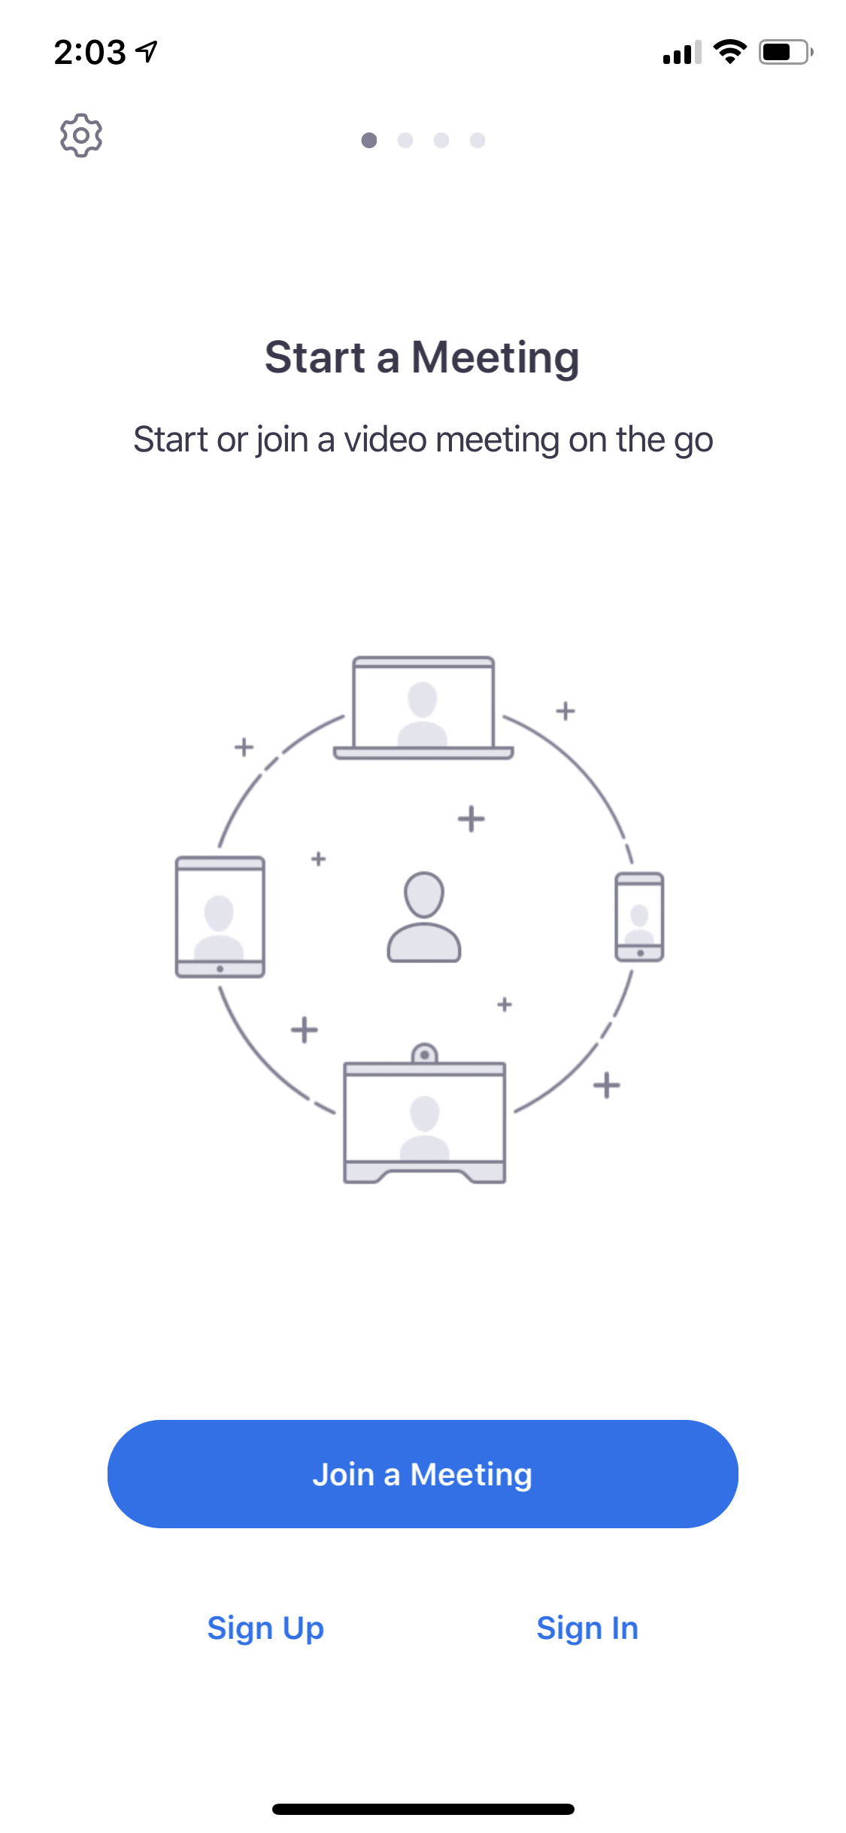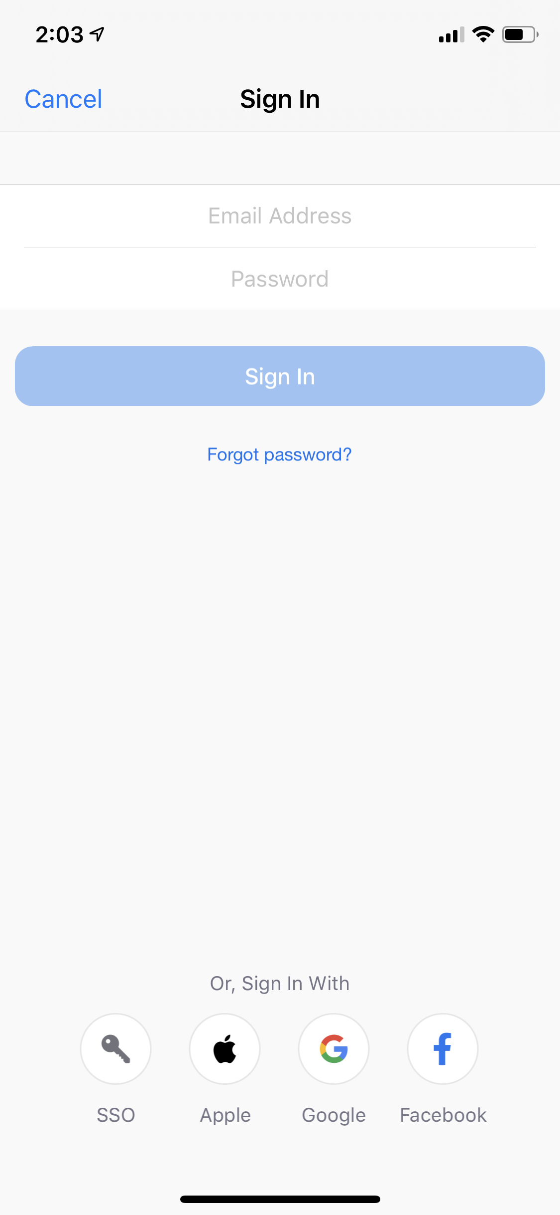

Option 2 Join a Meeting directly without signing in
Option 1 Sign in to your account using Gmail
- After you sign in your application will look like this picture. You have the option to host a meeting or join a meeting. A “host” is the owner of the meeting. Most of the time the teacher is the host and the student is the participant. If you want to have a meeting with a classmate or a friend, then you click on New Meeting and you are the host.

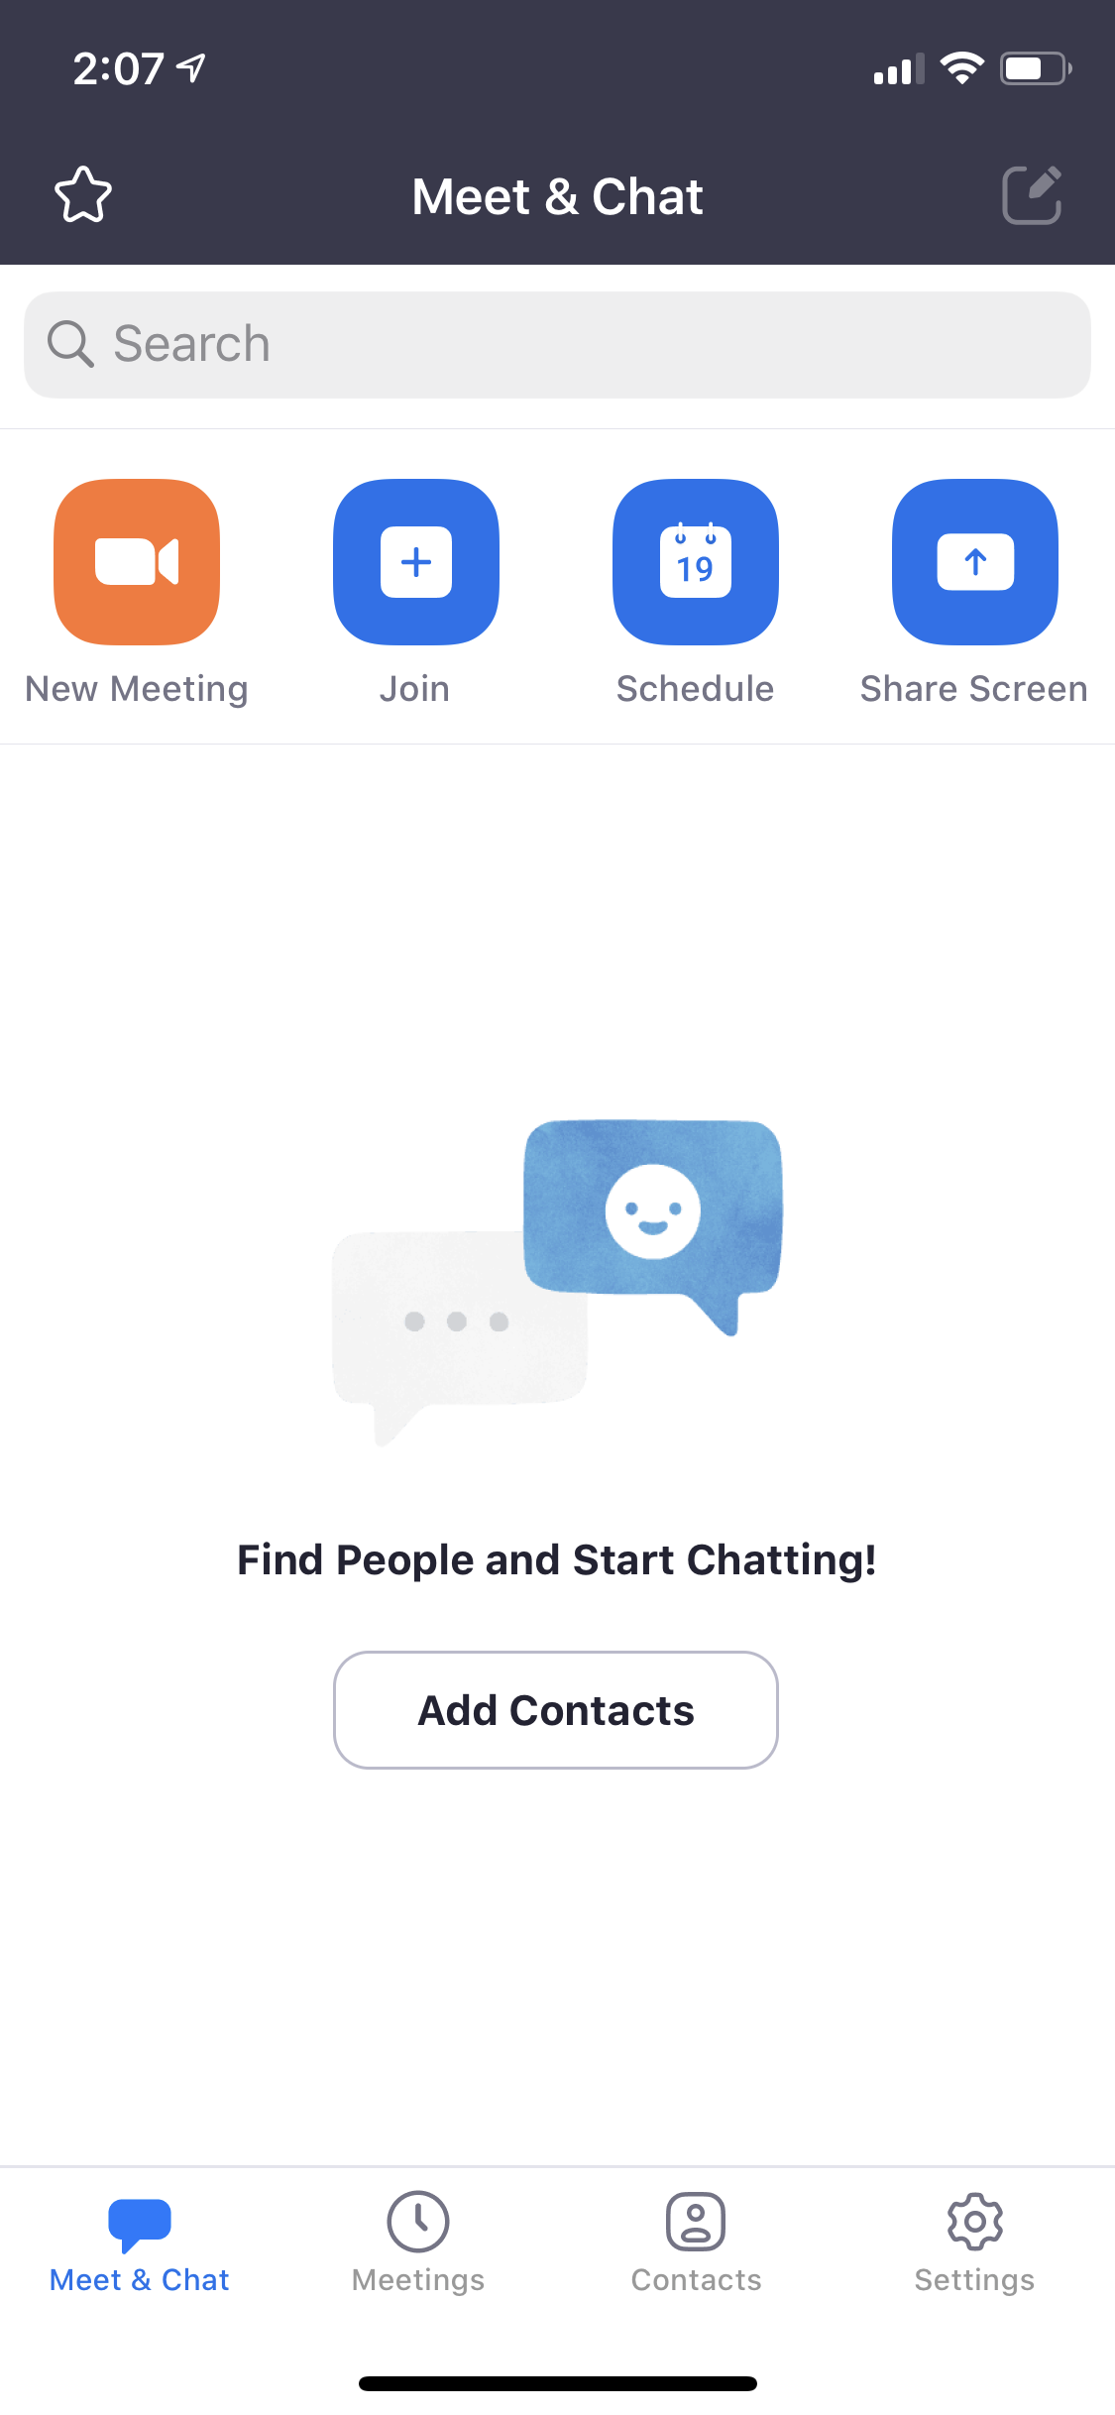

Host your own meeting
Join a meeting
- If you decide to join a meeting, you need to to type your Meeting ID and Password. Ask the host for this information.
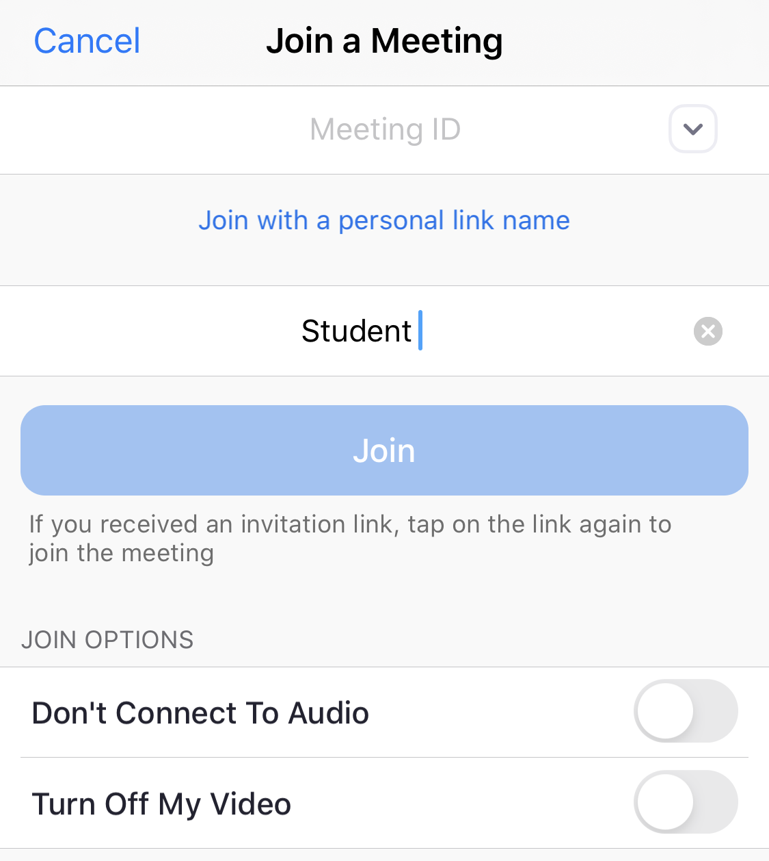

Type your name here
Type the Meeting ID here
- Zoom will ask you to preview your video (or you can turn it off). Your video is a live picture of yourself like in FaceTime on an Iphone. Then click “Join with video” or “Join without Video”.
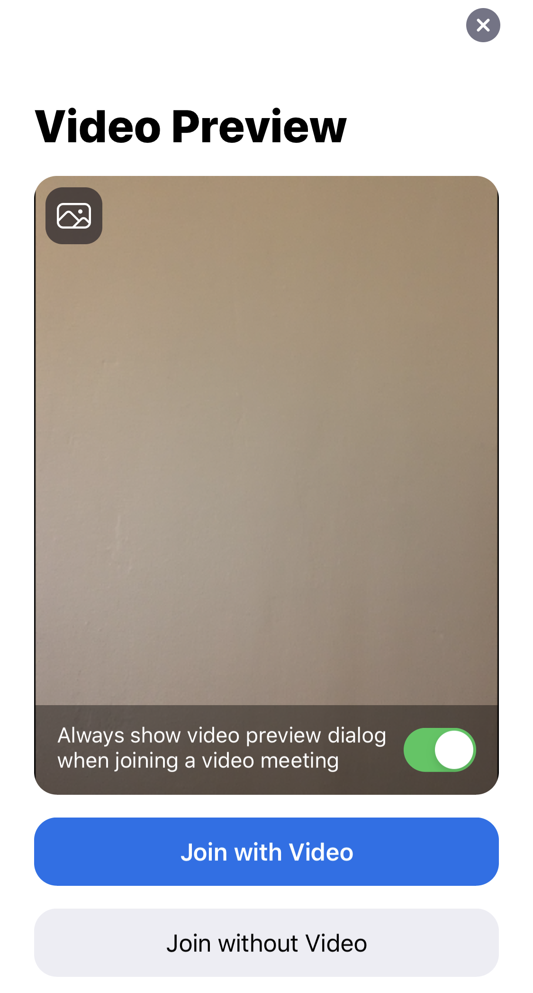

- Next, you will enter a waiting room and you need to wait until the Host adds you to the class. Then you will enter the meeting and you can see your options.

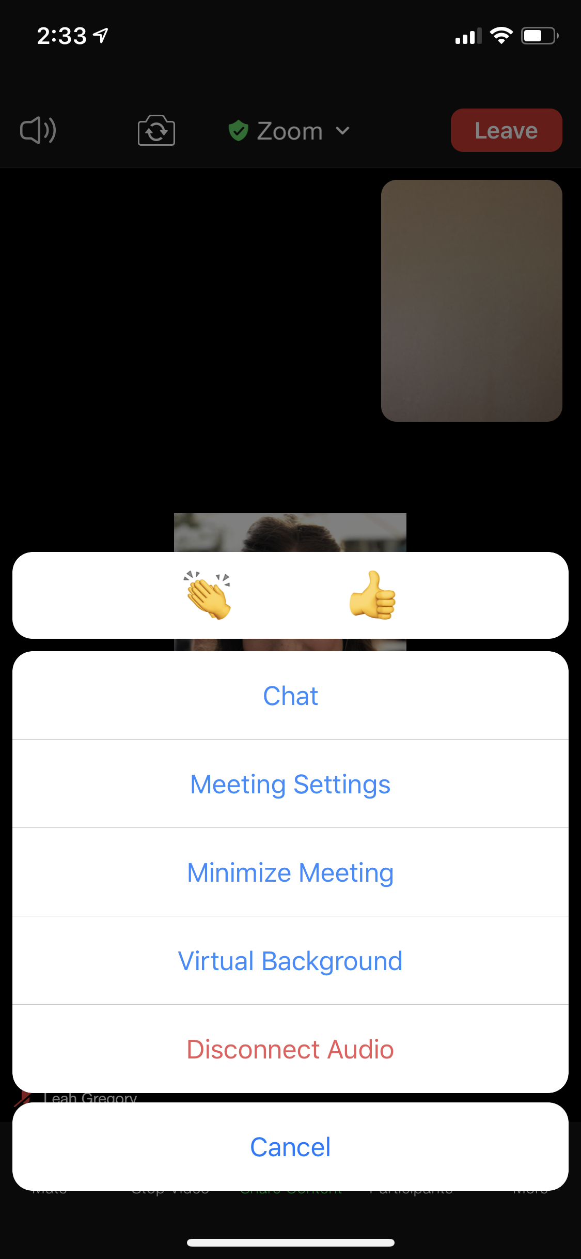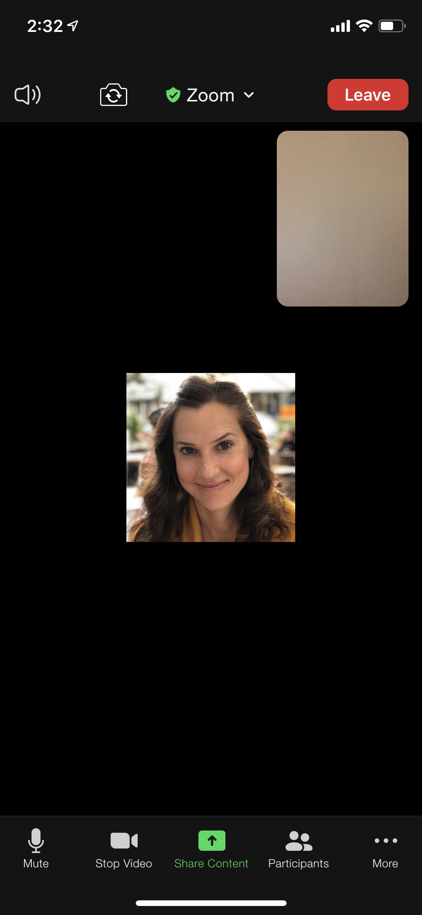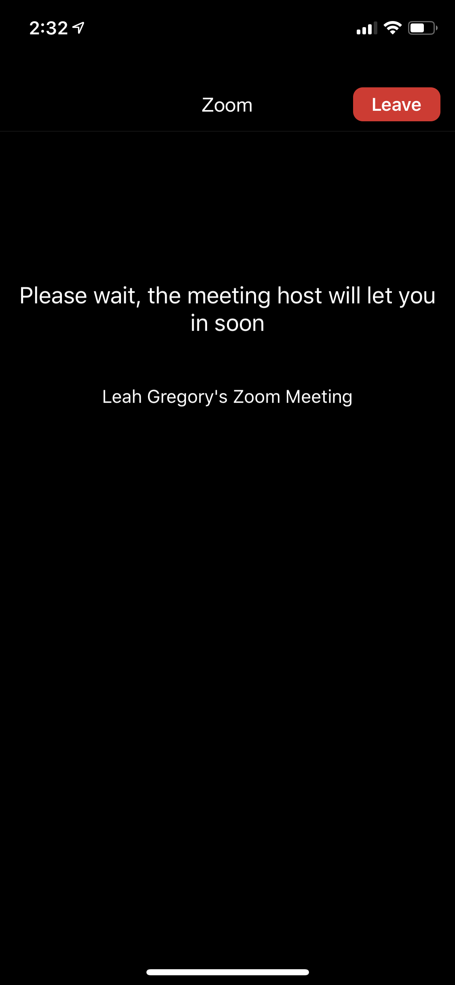

Waiting Room
Main Page
“More” options
View Participants
Start/Stop Video
Mute/ Unmute
Exit
- On your phone you also have the option to Chat, View Participants and “raise your hand”. To raise your hand, click “Participants” and you can see your options. Click “More” to see other options, like the Chat. Click on your name to change your name. This picture is the participant's view. If you are the host, you don’t have the “raise your hand option”.

Exercise: Now open the Zoom App on your smartphone. After you log in, click on “Join” to enter a meeting (participant) or click on “New Meeting” to start a meeting (host) and view the options.

- Practice clicking the Mute/Unmute button. What does the red line on the microphone mean?

- Raise your hand so the teacher can see you have a question. How do I put my hand down?

- Change your name to include your class name (ex. Leah - ESOL 2). What did you change it to?

- Open the chat (see direction #7 for the chat button) and write something to everyone. Did you see the message your teacher wrote?

Guide #2: Downloading and Using Applications on your Chromebook

Directions: Follow Guide #2 to learn more about downloading different applications to your Chromebook. This is similar to how a phone or tablet works.

Downloading applications on your Chromebook. In this video you will learn how to:
- Go to the Chrome Web Store
- Search for applications and download Zoom
- Sign in to Zoom using Gmail

To view the video click on this link: https://youtu.be/OFqnzG_liks

Follow these steps below to download applications to your Chromebook.
- Login to your Chromebook using your username and password (Gmail and password).

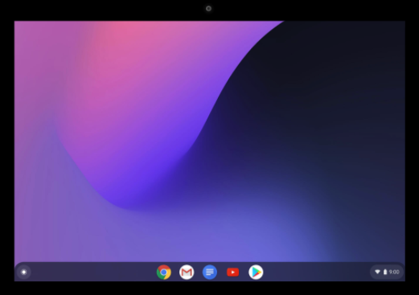 Google

Home screen

- Click the button in the bottom left corner. This is called the “Launcher”.

Google

Launcher
- Next, click the up arrow to see all your applications.

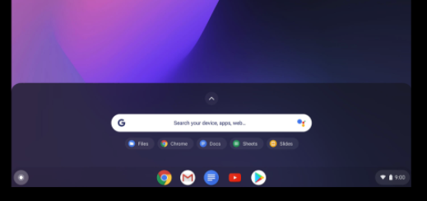 Google

Click the up arrow

- Click Google Play Store or click the small dots on the right side of the screen to find the Web Store App. Alternatively, you can search in the Google Chrome browser to find an app on the Web Store: https://chrome.google.com/webstore

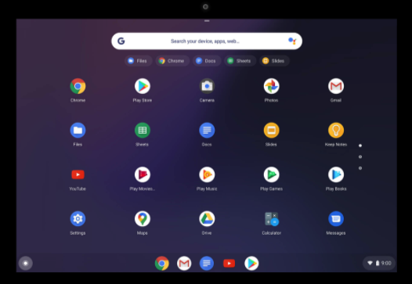Google

Click Google Play to search for apps
To find the Web Store app

- Search for the application you want and click install. Now you can find your applications in your launcher or at the bottom of your screen.

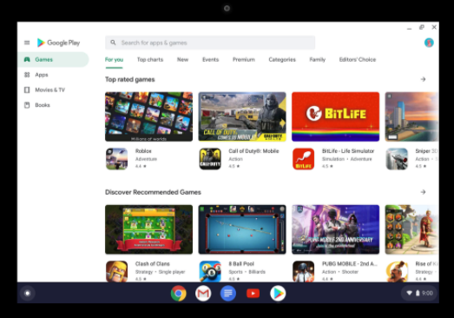 Google

Search here
Launcher

- Now you can install applications like Zoom or Google Classroom. The Chromebook already comes with many applications like: Google Chrome, Gmail and YouTube.

Questions for Discussion:

- What apps do you use on your phone?
- Are they available on your Chromebook? (hint: search in the Play Store or Chrome Web store)
- List three apps that are already installed on your Chromebook:

- List three apps you want to install on your Chromebook:

Guide #3: Downloading and Signing in to Zoom

Directions: Follow the instructions to download an application on your Chromebook. Search for “Zoom” and download this application to your Chromebook (See video above for more guidance).

- After you have downloaded Zoom to your Chromebook, it will be in your toolbar at the bottom of your screen or in your launcher.

- Open your Zoom application and login using your Gmail (you can also create an account, but it's easier to use your Gmail).
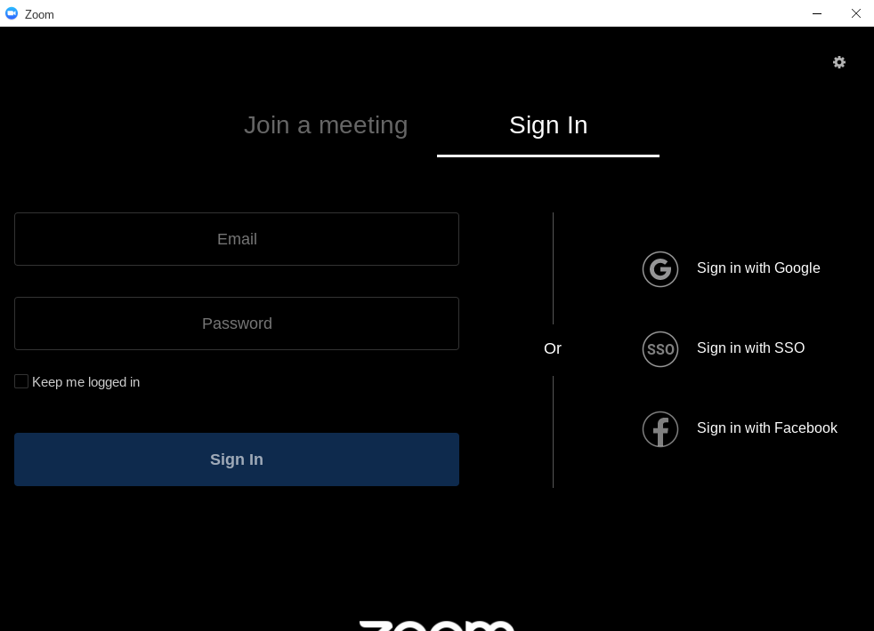

- Now you will enter the login page. Type your Gmail address, then password. Click “next”.

- Alternatively, you can “join a meeting” directly if you have the Meeting ID and Password.
Make sure you do not check “☑” the “Don’t connect to Audio” box.
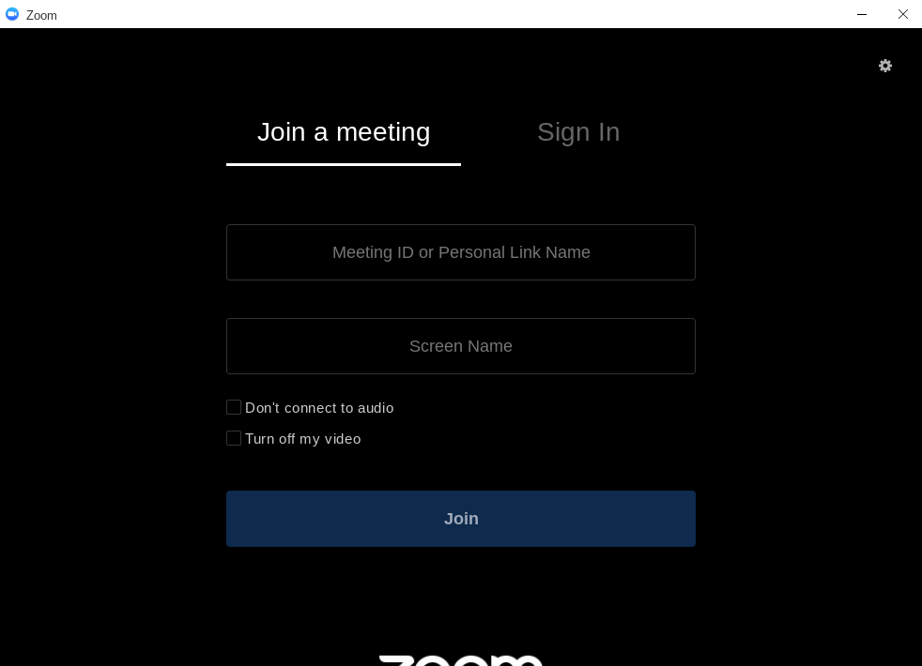

Meeting ID
Password

Make sure this is not checked

💡 Note: Please remember to update your Chromebook when it gives you a notification!

Worksheet #2: Using Zoom on a Chromebook

Directions: Practice logging in to a class meeting and using the controls. Let’s review first!

- There are two options to connect to a Zoom meeting.

- Option #1: Manually join the meeting by typing in the Meeting ID and Password.
- Option #2: Click on a link that was sent to you by the Host. (A “host” is the one who starts the meeting.

- Before you enter the meeting, Zoom will ask you to “Join with Video” or “Join without Video”. Choose the option you prefer. If you want your camera on so your picture can be seen, click “Join with Video”, if you don’t want your camera on, click “Join without Video”.

- When you enter, you probably will enter a waiting room and it will be a white screen. Wait here until the Host lets you into the meeting. The white screen looks like this:

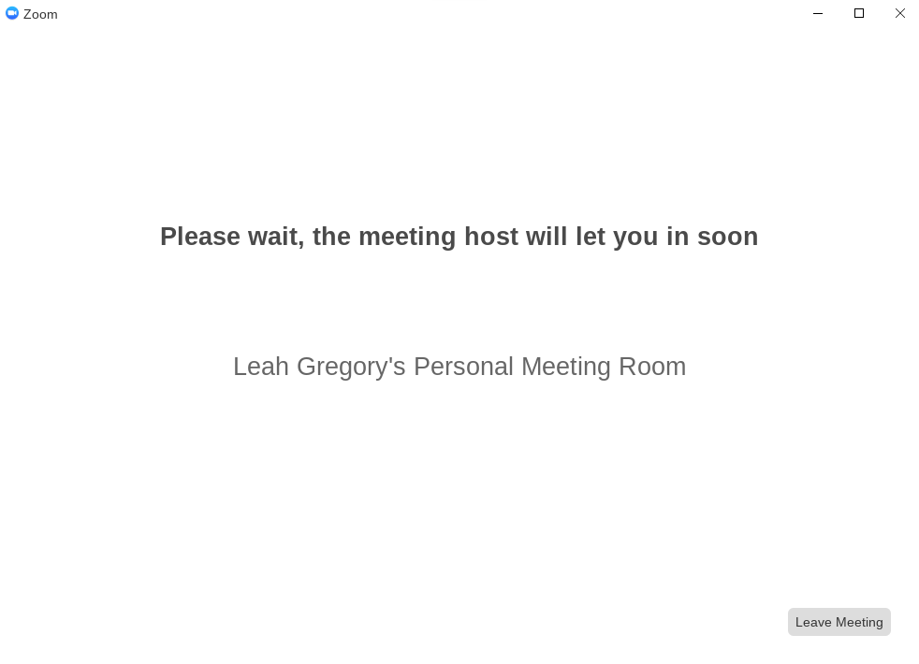

- When you enter the meeting, your screen will look like this:

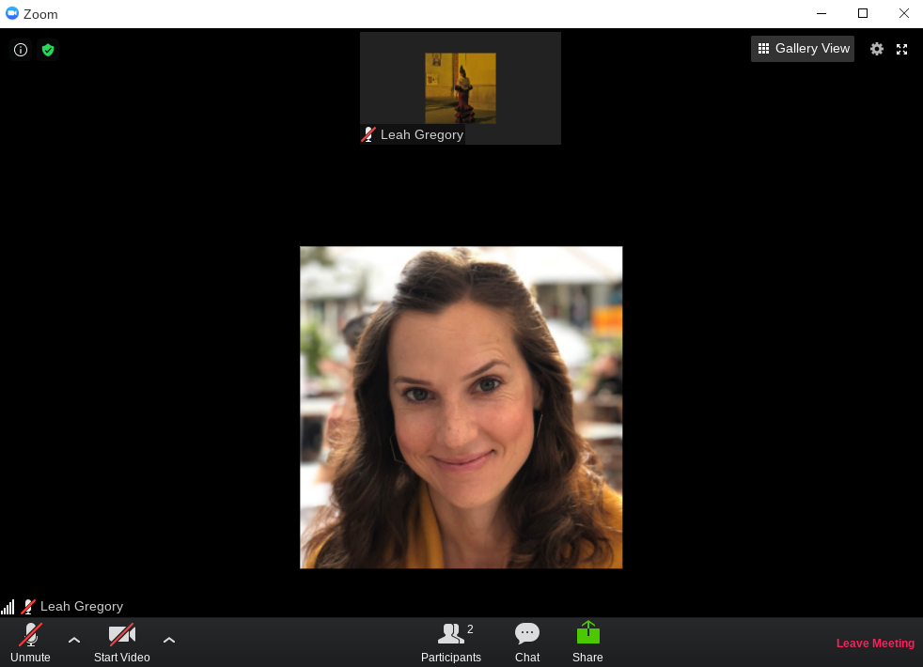

- Let’s take a look at the different options and settings in Zoom.

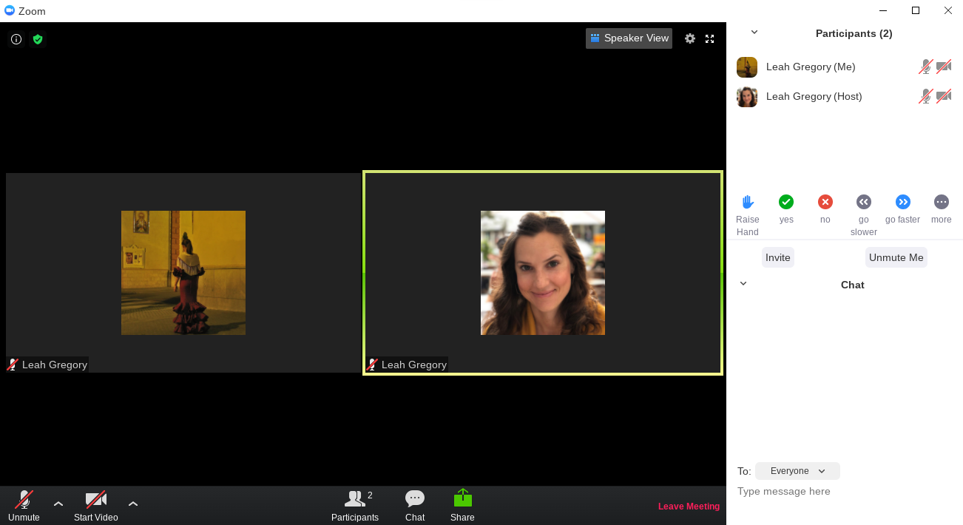

Change your view
Chat Here

Turn on or off your camera
Mute and Unmute
Participants
Chat
Share your Screen
Exit
Raise your hand for a question
Change your name by clicking your name and click “rename”
More Options

💡 Note: If you do not see the “Start a Meeting” option it is because you are not signed in. You must sign in to start a meeting with someone. Remember to sign in using your Gmail.

Exercise: Now open the Zoom screen, connect to a call (with a link or Meeting ID and password) or start a meeting and view the options in the picture above. Please remember that this is a participant view and the host view will look a little different (no raise hand option).

- Practice clicking the Mute/Unmute button. What does the red line on the microphone mean?

- Change your view from Speaker View to Gallery View. What is the difference?

- Raise your hand so the teacher can see you have a question. How do I put my hand down?

- Change your name to include your class name (ex. Leah - ESOL 2). What did you change it to?

- Open the chat (see direction #5 for the chat button) and write something to everyone. Did they see your message? Did you see your teacher’s message?

Activity 2: Setting up a Google Email Account (Gmail)
Rationale: As we navigate a digital world, the relevance of digital and technological literacy is increasingly important. In this activity, we take a look at creating and writing an email as well as attaching documents such as important forms, paperwork or assignments. This activity was designed to help students not only create an email, but learn the vocabulary and basic functions of Gmail.

Student Objectives:
- Students will learn how to create an account on Gmail.
- Students will learn about informal vs. formal greetings in an email.
- Students will learn relevant vocabulary in order to write emails and add an attachment.

Materials:
- Chromebook ( and cable cord)
- Guide #4: Creating a Gmail on a Web Browser (on any device)
- Worksheet #3: Email Vocabulary
- Worksheet #4: Email Greetings
- Worksheet #5: Writing an Email
- Guide #5: Attaching a Document to an Email

Remote Activity Outline:
- Explain the objectives. Assist students in creating a Gmail before they set up a Chromebook by using the video and Guide #4: Creating a Gmail on a Browser. They can do this on their phone or tablet. It will be easier to assist students remotely when everyone has made a Gmail prior to setting up their Chromebook.
- Watch the YouTube video in a shared Zoom class and after viewing, ask students to follow Guide #4 in order to create a Gmail at home. If they do not already have a hard copy, send them a link to view the document. Assist any students who have trouble. Another tip might be to send the www.gmail.com link as a text message so they can do it on their smartphone.
- After accounts are created, the teacher should create a document where all student emails are available for classmates to access (written or electronic). This will aid in further activities.
- Next, work with students on Worksheets #3 and #4 Email Vocabulary and Email Greetings to help them understand the vocabulary necessary to navigate Gmail, and also the appropriate greetings and subject lines for emails. Students could complete this activity in a breakout room. Ask the students to verbally say their emails or their partner’s email. Use the Chat box to have them practice typing the emails and make sure they know how to type the symbols (i.e. @, _, .)
- Alternatively, practice the vocabulary in Quizlet: https://quizlet.com/_8j6b8n?x=1qqt&i=ueso2
- Assign the extra practice quiz for homework: https://forms.gle/emgsCoX28KK2685Y9
- Worksheet #5 Writing an Email could still be used in a remote setting and students could write and send a picture of the written activity to their teacher. Or skip the rough draft and ask students to type directly in an email. Teachers could text each student a different classmate’s email and that classmate will write to their partner. Make sure they add the teacher as a “CC”. In a virtual class, share your screen and show your students directly how to attach a document (as in Guide #5).

Follow-Up: Create scenarios where your students can practice writing various types of emails (teacher, doctor, or boss). Then ask them to attach a picture from their smartphone or Chromebook. Encourage students to check their email more frequently by sending out emails to the class and having a competition to see who responds the fastest. Create a poll in Zoom to ask how often students check email.

Guide #4: Creating a Gmail on a Web Browser (on any device)

Directions: Follow the directions below if you are creating a Gmail account on a web browser (i.e. Safari, Firefox, etc.)

Create a Gmail on a web browser, on any device. In this video you will learn how to:
  - Create an email address and enter your account

To view the video on youtube click: https://youtu.be/CMjr6iNeTM4

- Follow these steps below to create your account on a web browser (Chrome, Safari etc.):
- In your browser type gmail.com and press enter:

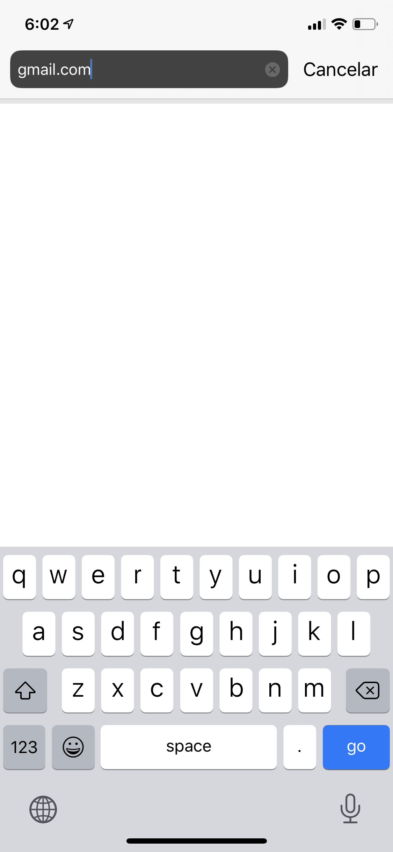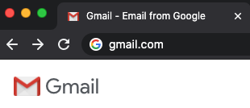

- Complete the information. This includes, First Name, Last Name, Username (your email address), password and then type your password again to confirm. Click “Next”.
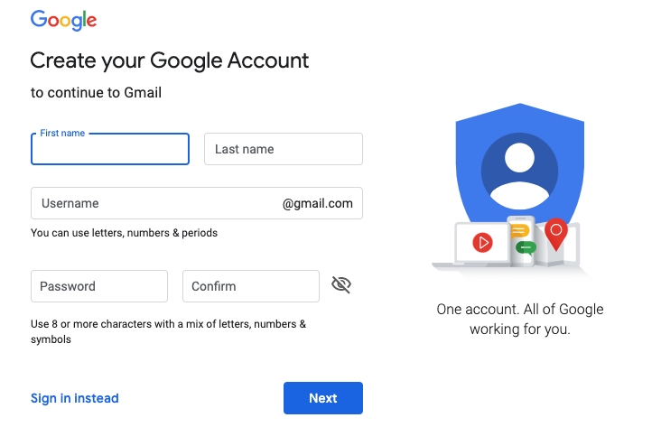

- Add a phone number or a different email address (optional), if you forget your password this will help you create a new one.
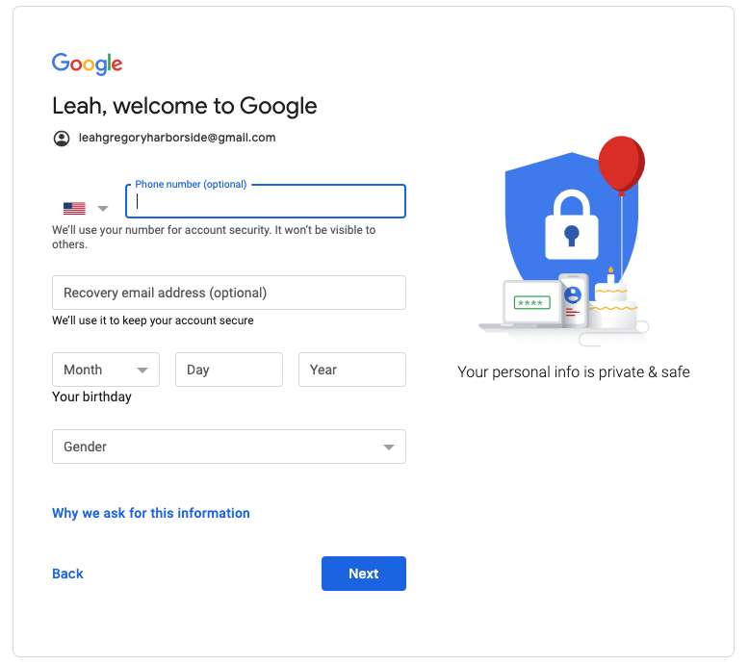

- Create a strong password. Do not use your name or birthday. Click “Next”.
Don’t forget to Include:
Letters (upper and lower case)
Numbers (1,2,3,4)
Symbols (@#$!%)

- Next, read through the terms and scroll down (with two fingers!). Click “I agree”.

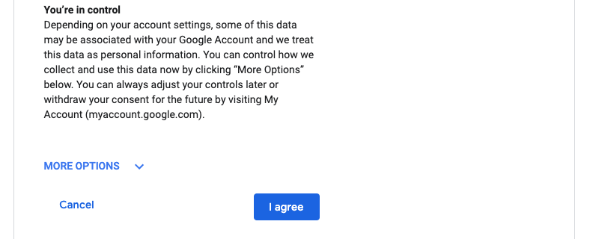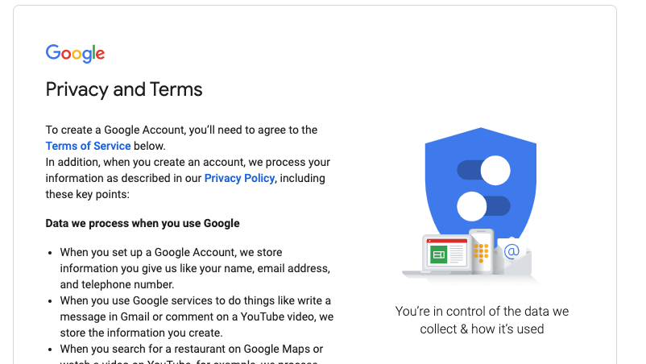

💡 Note: Write down your username and password in a safe place or in a secure location on your phone.
Name: ___________________

Worksheet #3: Email Vocabulary

Directions: Complete the following activities to learn more about email vocabulary.

Email Vocabulary

Let’s learn how to say our email.

Remember:

@ = at
. = dot
_ = underscore

Now, let’s practice! Repeat these emails with a partner:

jamesbond@gmail.com

susie_q@gmail.com
Let’s practice with your email:
- Write your email address here: ______________________________________________
- Now recite your email to a partner.
- Check your partner’s writing and make sure it is correct.
- Now listen to your partner as they tell you their email address.
- Write your partner’s email address here: ______________________________________

B. Read the vocabulary words and match with the definitions by putting the correct letter next to the vocabulary word.

- Sender ______ a. To write an email
- Recipient ______ b. 2-3 words or a short sentence about the email
- Spam / Junk ______ c. When you write back to an email
- Subject ______ d. When you send an email you received to another person
- CC / “carbon copy” ______ e. A space where you can add another email address that
- BCC / “blind carbon copy”______ is indirectly for another person. The address is visible.
- Compose ______ f. An electronic folder where your emails are received.
- Inbox ______ g. The person who sends the email
- Reply ______ h. A space where you can add another email address that is
- Forward ______ indirectly for another person. The address is not visible
i. Emails from unknown senders with false information
j. The person who receives the email

Name: ___________________

Worksheet #4: Email Vocabulary (cont.) and Greetings

Directions: Review and read through the different parts of an email. Then, read through and identify different greetings used in informal and formal emails.

- Review the vocabulary in the email.

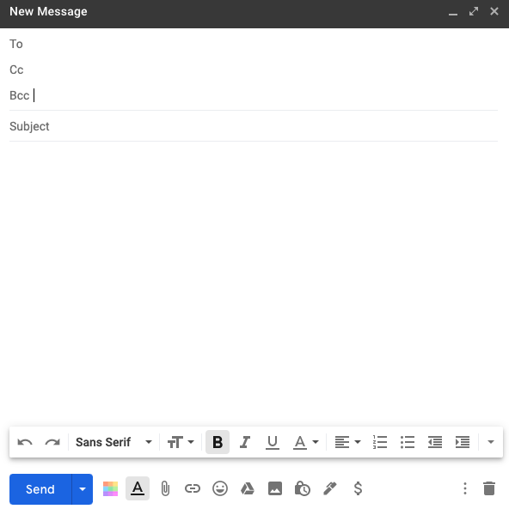

Recipient
Indirect recipient (everyone can see their email)
Indirect Recipient (nobody can see their email)
2-3 words about the email
Body (your email!)
Attach a document from your computer
Attach a document from your Google Drive

Greeting options to start an email:
Formal | Informal
- Dear Ana, | - Hi Ana,
- Dear Ms. Santana, | - Hi all,
- Dear Mrs. Ramos, | - Hey Ana,
- To Whom it May Concern | - Hello!
- Dear Sir, / Dear Madam, | - No greeting necessary

- Signatures options to close an email:
Formal | Informal
- Best, | - Thanks,
- My best, | - Talk to you soon,
- Sincerely, | - See you soon,
- Thank you, | - Take care,
- Respectfully, | - Cheers,

Name: ___________________

Worksheet #5: Writing an Email

Directions: Practice writing an email to a classmate, coworker or teacher. Make sure to include all the parts of an email. After this practice, type your email on your Chromebook.

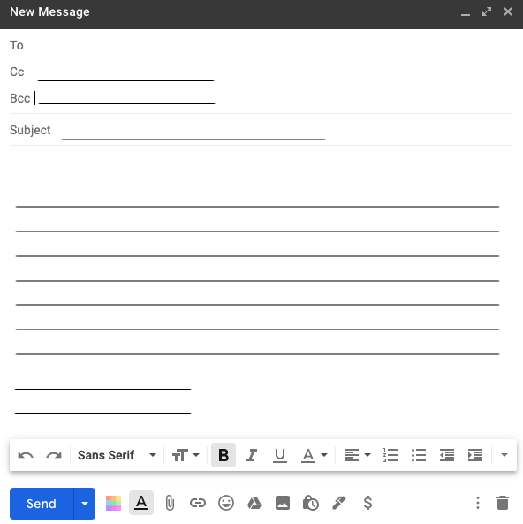

Now practice typing on your Chromebook!

Name: ___________________

Guide #5: Attaching a Document to an Email

Directions: After you write your email, read through the Guide below to learn how to attach a document from your computer or from your Google Drive.

- Many times teachers ask students to send their homework, a picture, or some type of document in their email. This can be confusing so let’s look at the options. When you write an email you have two options to attach a document.

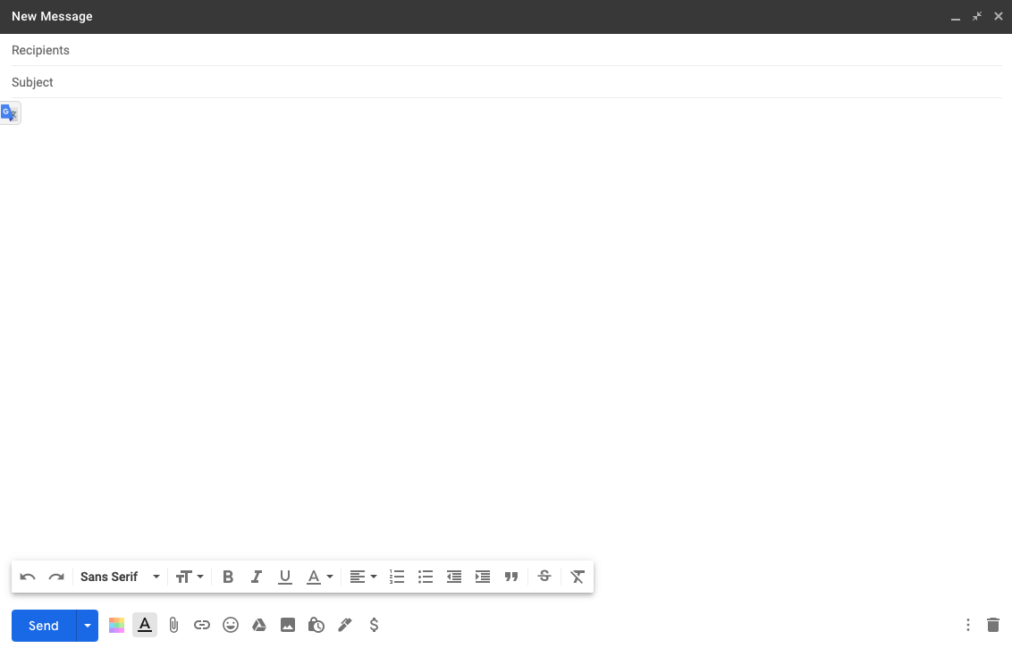

Option 1
Option 2

Option #1: This option attaches something that is on your computer (in a folder or desktop). If you click the small paperclip (📎 ) then it will open a new window with all the documents on your computer and you can search for the document to include.

Option #2: This option attaches something that is in your Google Drive. Your Google Drive is where your teacher might send homework or quizzes and connects with Google Classroom (we will talk about this in Activity 4). If you click the triangle () then your Google Drive will open and you can search for the document to include.

💡 Note: Google Drive is “cloud space”, this means that it is extra space on the internet for you to put your work and documents. This is connected to your email. Just like you have folders for your class, Google Drive is a place where you can organize your electronic documents!

Activity 3: Chromebook Introduction and Setup
Rationale: As we navigate a digital world, the relevance of digital and technological literacy is increasingly important. Furthermore, understanding and using technology for work and family life has never been so important. In this activity, we take a look at what a Chromebook is and how we can use it.

Student Objectives:
- Students will learn about the capabilities of a Chromebook and the basic features
- Students will learn how to connect to WIFI
- Students will be able to use the touchpad
- Students will learn vocabulary related to Chromebooks and technology in general
- Students will set up their Chromebook and learn about “Sign In” options

Materials:
- Chromebook (and cable cord)
- Worksheet #6: Chromebook Basics
- Guide #6: Opening and Using your Chromebook
- Guide #7: Creating a Gmail during the Chromebook Setup
- Guide #8: Connecting your Chromebook to WiFi

Remote Activity Outline:

Option #1:
- Explain the objectives. Review the worksheet Chromebooks Basics together on a shared screen (if students have the hardcopy they can also follow along).
- Create a series of five polls on Zoom to reflect the five T/F questions at the end of the worksheet. Share the polls one by one during Zoom class.
- Review Vocabulary words with students by sharing your screen. Students can write down the answer or work together in break out rooms. Remember that in a breakout room, students cannot view your screen so they will need a hardcopy or electronic copy of the worksheet.
- Use Quizlet to practice and learn the vocabulary: https://quizlet.com/_2qyxmx?x=1jqt&i=ueso2
- Bring students back together and play the video in the Guide #6 on a shared screen. Remember to turn subtitles on and slow down the video depending on your class level. Review new vocabulary. Use the Guide #7 if students need to create Gmail during setup.
- If students are setting up their Chromebook remotely, it is best done as they follow a hardcopy of the Guide OR you can walk them through it while they are on Zoom using their smartphone.
- If your Chromebooks are NOT new, skip to page number 11 in the Guide to assist students in logging in to already set up Chromebooks. If students are connecting at home, they will need to know their Wifi Network name and password to correctly set up the connection and continue to the Guide Connecting your Chromebook to WIFI or a Hostpot at Home. Use this Guide to verbally assist students or send them the link to view the Guide on their phone.

Option #2: Follow all the step in Option 1, but instead of doing poll questions for the T/F exercise (in Step #2), send the questions in a Google Form: https://forms.gle/9RaTADi4R2rY1zQX6

Follow-Up: Students should be able to do setup and login at home on their own using the Guide #6. At the end of the Guide students are also given two options to login. Ask students to practice logging in as a guest or with their child’s email at home.
Name: ___________________

Worksheet #6: Chromebook Basics

Directions: Read through the basics of a Chromebook and then watch the setup video. Complete the small quiz at the end of this worksheet.

What is a Chromebook?
- Chromebooks are inexpensive laptops.
- They have basic tools and functions like:
  - connecting to the internet
  - checking email
  - browsing websites
  - downloading applications (apps)
- Chromebooks have a Google operating system (Chrome OS)

Frequently Asked Questions (FAQs)
Q. Does a Chromebook have internet access?
- Chromebooks need to connect to a private or public network, they do not have automatic internet access.
Q. Can my Chromebook work if I don’t have internet access?
- Yes, but first you need to turn on the “offline” option.
Q. Can my Chromebook get a virus?
- Anything is possible, but Chromebooks are much safer than regular laptops.
Q. Does a Chromebook come with Microsoft Office or other programs?
- No, you need to download applications specifically for Chromebooks.

Let’s check your understanding. Say if the sentence is true (T) or false (F).

- Chromebooks are exactly the same as a laptop. T F
- Chromebooks have the internet automatically. T F
- It is possible to check email and download applications. T F
- Chromebooks are more expensive than a desktop computer. T F
- Chromebooks are safe machines. T F

Guide #6: Opening and Using your Chromebook

Directions: Watch the video for an overview of the setup (double click on the picture or link). Then, follow the instructions in Part C to go through each part step by step.

Setting up your new Chromebook. In this video you will learn how to:
- Turn on and off your Chromebook
- Choose your settings
- Connect to wifi
- Log in as a user or guest

To view the video (Courtesy of Tech Goes Home) on youtube: https://bit.ly/ChromebooksetupTGH

Read the vocabulary words and match with the definitions by putting the correct letter next to the vocabulary word. These vocabulary words will help you understand the directions.

- Plug in _____ a. To select something electronically
- Charge _____ b. Options to make something easier
- Press _____ c. Moving up or down on a computer
- Click _____ d. Connect to electrical outlet in the wall
- Choose _____ e. Conditions of an agreement
- Accessibility _____ f. Connect to a battery
- Proceed _____ g. To continue something
- Scroll _____ h. Apply pressure to something
- Terms _____ i. To select an option
- Trackpad _____ j. A touch sensitive square on a laptop

Follow this Guide as you go through your Chromebook setup.

- Plug in your Chromebook to charge. Open your Chromebook and press the power key.

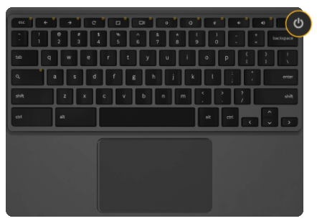Google

- Understand your trackpad:

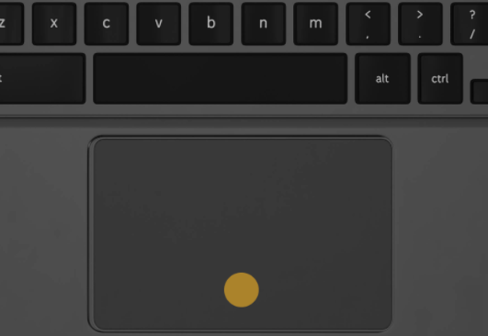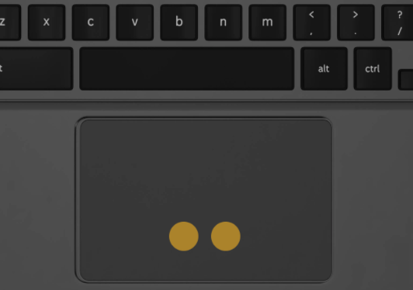Google

Click = Press One Finger
Right Click = Press Two Fingers
Scroll = Move Two fingers up and down
(do not click)

- Choose the language you prefer. Then click “Let’s Go”. We recommend English so that you can receive help from your teacher if needed.

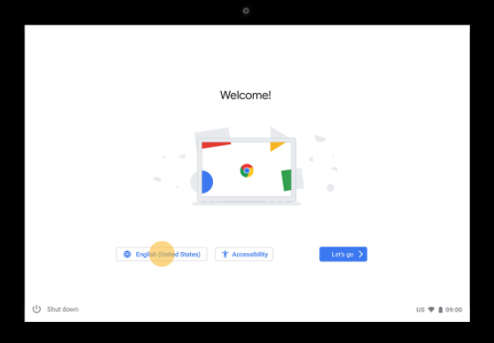Google

Language
Let’s Go

- Choose the language and keyboard options. Then select OK.

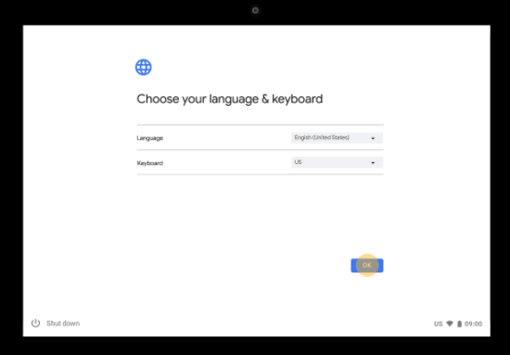Google

Select OK

- Choose accessibility features if you want. After, click OK, then proceed to Let’s go!

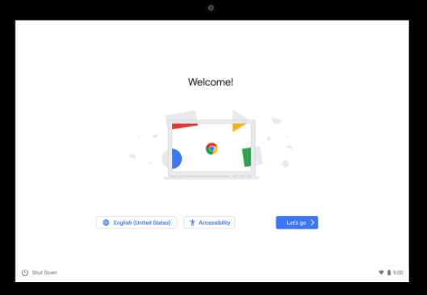Google

Accessibility
Let’s Go!

- Now we will connect to WiFi. Choose your network, then click next. If your network has a password, enter the password and click next.

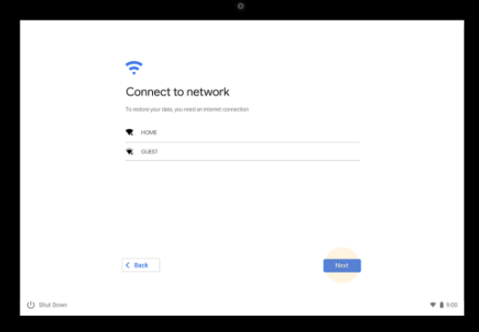Google

Select WiFi

- Review the terms and click accept and continue.

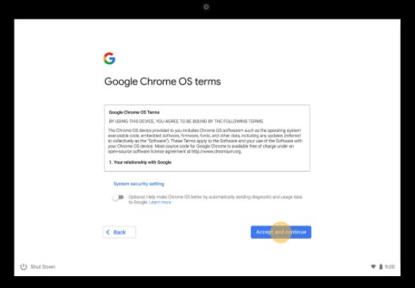Google

Accept

- Type your Google email address (Gmail) and click Next. If you don’t have Gmail, please create it (see Create a Gmail on your Chromebook here). A Gmail account needs to be used with a Chromebook. A Yahoo or Hotmail email will not be valid.

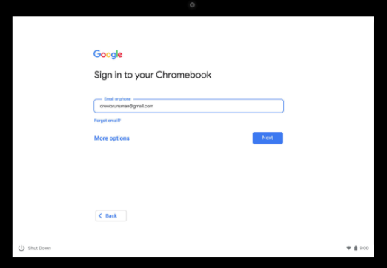Google

Write your Gmail here.
Create a new email if you don’t have a Gmail.

- Type your password and click Next. To view your password click the “” button.

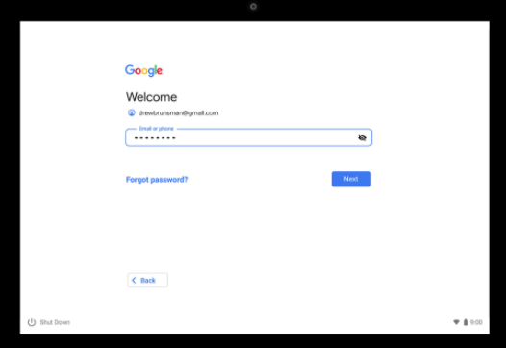Google

Type your password here

- You are signed in! Now accept and continue.

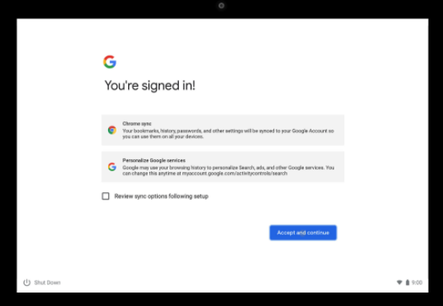Google

Accept and continue

Two options to Sign In to an already set up Chromebook:

Option #1 Sign In: You may also click “Browse as a Guest”. This means anyone can use the Chromebook, they do not need to have a Gmail.

Option #2 Sign In: You can add another person to your Chromebook. Click “Add Account” to add another Gmail account.

Sign out of an account: To sign out of an account and sign in to another one, click the time/battery in the bottom right corner, then click →

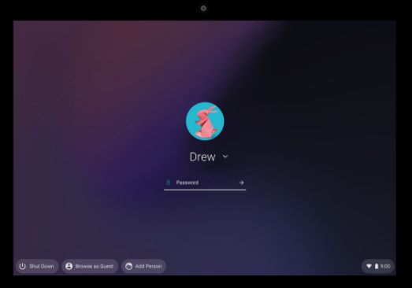Google

Option 1: Browse as Guest (no password needed)
Option 2: Add another account
Sign Out

💡 Note: A Chromebook can directly connect with your Android phone and install the same applications on your phone, on your Chromebook. If you do not want this, you can choose to “not connect” when it asks you.

Guide #7: Creating a Gmail during the Chromebook Setup

Directions: During your Chromebook setup, if you don’t have a Gmail account, follow the instructions below to set up an account.

Follow these steps below to create your account on a Chromebook:
- When it says “Sign in to your Chromebook” and you do not have a Gmail, click “Create Account”.
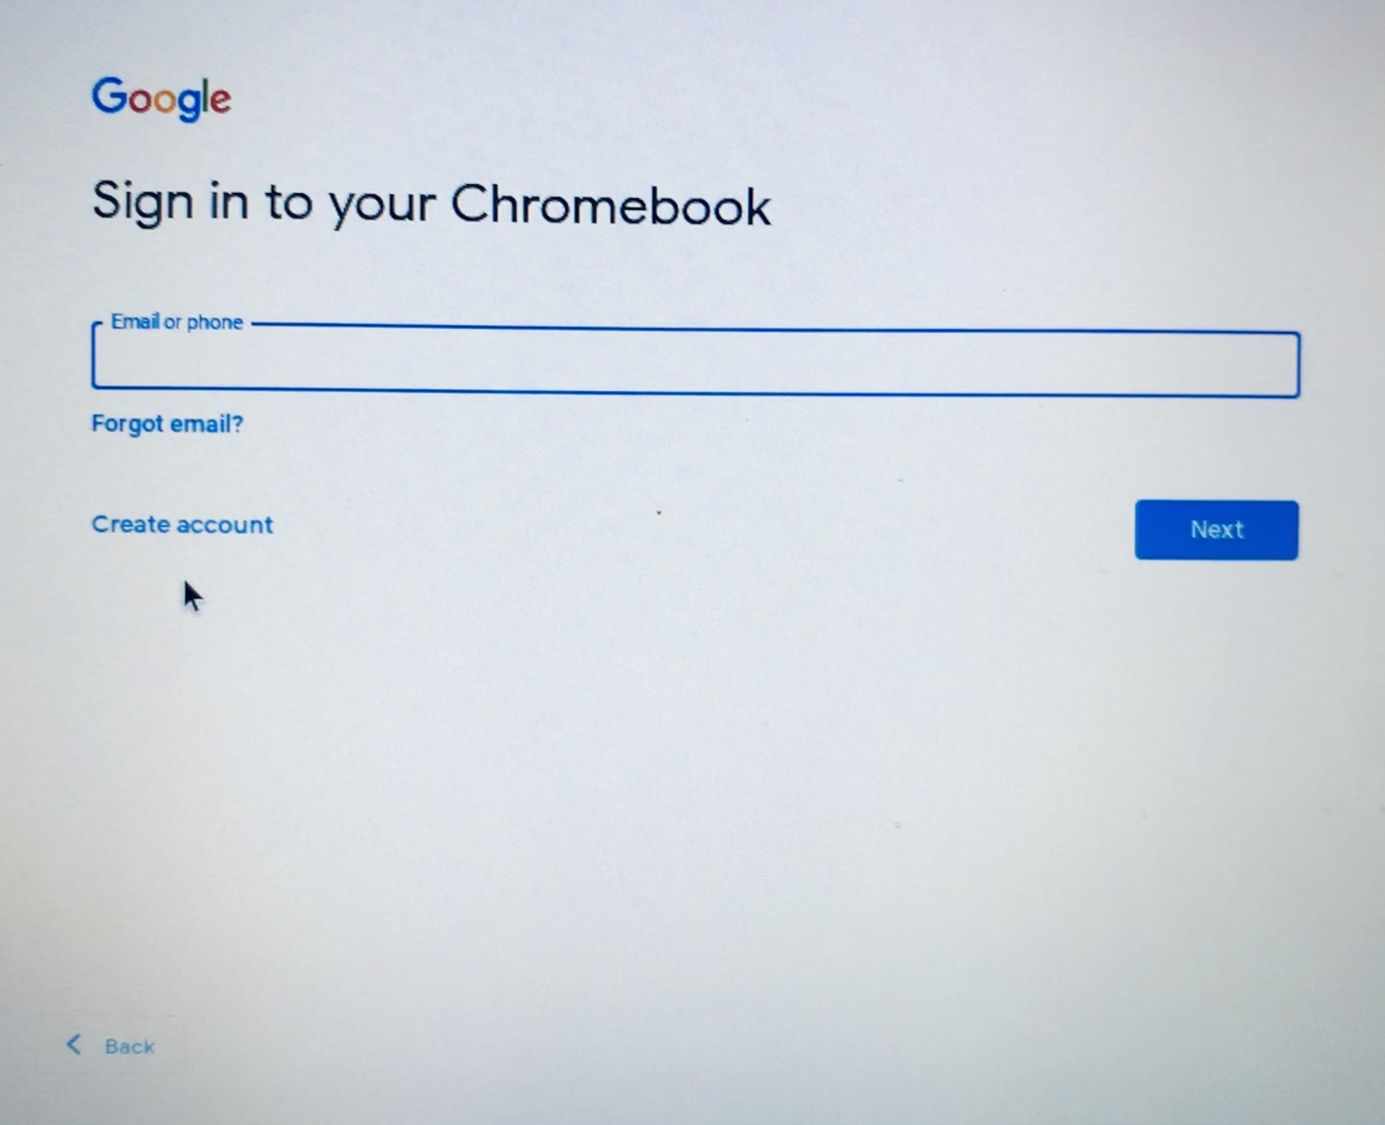

Create account
- Type your first and last name. Click “Next”.
- Type your information, month, day, birth year, and gender. Click “Next”.
- Choose your Gmail address. You can choose an address they created for you or click “Create your own Gmail address”. Click “Next”.
- Create a strong password. Do not use your name or birthday in your password. Click “Next”.
Don’t forget to Include:
Letters (upper and lower case)
Numbers (1,2,3,4)
Symbols (@#$!%)
- Add a phone number in case you forget your password and click “Yes, I’m in” or scroll down (with two fingers!) and click “Skip” if you don’t want to put your phone number.
- Review your account. Click “Next”.
- Scroll down in the terms and click “I agree”.
- Done! Now you have a Gmail account. Click “Accept and Continue”.
💡 Note: Write down your username and password in a safe place or in a secure location on your phone.
Return To Chromebook Setup

Guide #8: Connecting your Chromebook to WiFi

Directions: Watch the video for an overview of the setup (double click on the picture or link). Then, follow the instructions in Part B to go through each part step by step.

Connect to your home WiFi or hotspot. In this video you will learn how to:
  - Connect to your WiFi
  - Connect to a hotspot (through your phone or a separate device)

To view the video on youtube click: https://youtu.be/7MDOp7wTXLQ

Follow this Guide as you go through your Chromebook setup.

- Click the connection symbol in the bottom right corner.
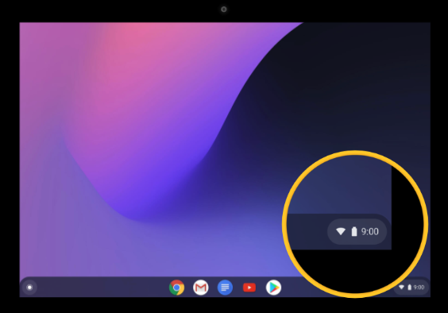Google

- Select the connection symbol again .
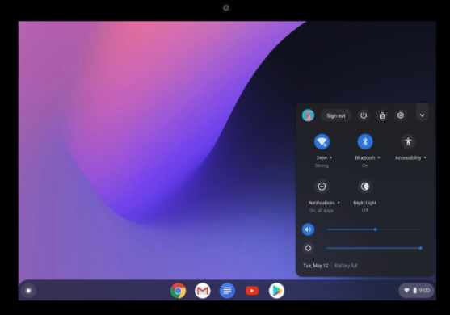Google
- If you are connecting to your Mobile, select the mobile name in the “Mobile Data”. If you are connecting to a WiFi network, select the name of your WiFi network.

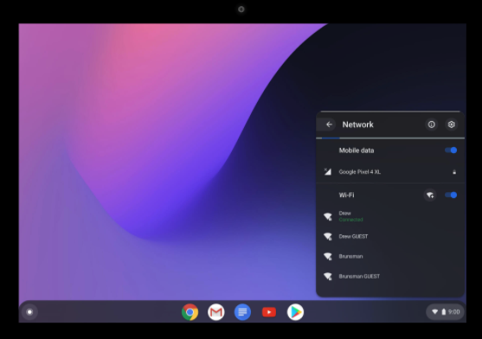Google

- Next, it will ask you to type your password if you are connecting to the WiFi. Type your password then press connect. Now it will say “connected” in green.

Activity 4: Student Guide to Google Classroom
Rationale: As we navigate a digital world, the relevance of digital and technological literacy is increasingly important. In this activity, we take a look at Google Classroom and how students can connect to this online platform to receive notifications, get homework and receive grades/feedback. The following guides and exercises are meant to be a basic introduction and exploration of Google Classroom, but students will probably need more guidance depending on how the teacher decides to use it.
Please note that teachers must know how to navigate and post in a Google Classroom before teaching this activity to their students. Teachers can choose to use Google Classroom at a basic level (disseminate information and messages) or at a more advanced level (posting homework, quizzes, using other programs that integrate Google Classroom, etc.) To find more information about Google Classroom, take some time to browse Google’s great Google Classroom Resource.

Student Objectives:
- Students will learn about the tools, functions, and three main sections of Google Classroom.
- Students will learn how to access their Google Classroom.

Materials:
- Chromebook ( and cable cord)
- Worksheet #7: Google Classroom Basics (for students)
- Guide #9: Connecting to a Google Classroom on a ChromeBook
- Worksheet #8: Exploring Google Classroom

Activity Outline:
- Explain the objectives. Remember that the teacher is responsible for inviting students to their classroom, posting homework, grading and returning assignments, and can post updates and notifications. It is suggested that the Google Classroom is already set up with a message from the teacher, plus one assignment that the students can view when they enter the classroom.
- Review Worksheet #7: Google Classroom Basics with the class and check their understanding by completing the small True/False questions or do the exercise as a Google Form Quiz.
- Set up the video in the Connecting to a Google Classroom Guide #9 to view in your shared screen. Alternatively, students could watch it on their own outside of class. After viewing the video, students could watch as the instructor demonstrates how to join a classroom on a shared screen.
- Alternatively, the teacher could send an invite to the class during the class time so the students can follow the steps on their Chromebooks (or smartphones). Please note, if students join on their smartphones, they need to download the Google Classroom application.
- Ask students to write a message in the stream and make sure students have notifications turned on. It also may be beneficial to have students connect to the Google Classroom on their smartphones by downloading the app and connecting to the classroom using the class code.
- Depending on the assignment, if the student needs Google Docs to complete it, they will also need to download this application. To keep it simple, ask students to write on the stream as their first assignment. Complete Worksheet #8 Exploring Google Classroom. Children in the family might be able to help their parents complete this assignment.

Follow-Up: Students could work with their children (if their child is using it at school) to better understand Google Classroom, by opening up their Google Classroom and showing their parents assignments due and turned in. Teachers should post regularly so students can get used to using it.
Name: ___________________

Worksheet #7: Google Classroom Basics

Directions: Read through the basics of a Google Classroom. Complete the small quiz at the end of this worksheet.

What is Google Classroom?
- Google Classroom is an application that students and teachers can use to communicate with each other.
- It has basic tools and functions where students and teachers can:
  - Write messages, notifications and updates
  - Send homework documents and worksheets
  - View and Grade homework, quizzes and other assignments
  - Share resources, videos or other material
- To use Google Classroom, a teacher needs to add you to their class and then you can access all the materials.

Frequently Asked Questions (FAQs)
Q. Can I use Google Classroom anywhere?
- Yes. Anywhere you have internet access, you can use Google Classroom. There is an offline option that has limited things you can do.

Q. What can I do in Google Classroom?
- You can communicate with your teacher and classmates, access homework, quizzes and assignments from your teacher, complete assignments using Google Docs, Sheets or Slides (different applications) and send them back to your teacher, and view your grades.

Q. Can I use Google Classroom to DO my homework?
- No. Google Classroom will give you your homework, but you need to use other applications (Google Docs, Sheets, Slides, Forms) to complete your assignments. On your smartphone, you need to download all 5 applications.

Let’s check your understanding. Mark if the sentence is true (T) or false (F). Or click here to do it as a Google Form Quiz.
- Google Classroom is a place where I can see my teacher. T F
- I can view and submit homework to my teacher. T F
- I can complete my homework in Google Classroom. T F
- My teacher can send messages and notifications. T F
- I can’t view Google Classroom on my smartphone. T F

Guide #9: Connecting to a Google Classroom on a Chromebook

Directions: Watch the video for an overview of Google Classroom. Then, follow the instructions in Part B to go through each part step by step.

Connecting to a Google Classroom. In this video you will learn how to:
- Accept an invitation to join a Google Classroom
- Learn about the different parts of Google Classroom
- Access your homework

To view the video on youtube click: https://bit.ly/googleclassENB

Follow this Guide as you connect for the first time to your Google Classroom. You have two options to connect to your Google Classroom.

Option #1: Your teacher will send you an email invitation and you can click “Join” (demonstrated in the video above).

Option #2: Your teacher will give you a code to enter the classroom. When you have the code, go to classroom.google.com , sign in with your Gmail and click on the “+” symbol in the top right corner. It looks like this:

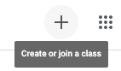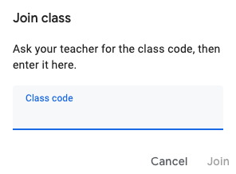

1. Click the plus sign
2. Enter class code

- When you connect to the Google Classroom for the first time, you do not need to connect again. You can access your Google Classroom by going to classroom.google.com

- Now you are in the classroom. Let’s take a tour. There are three sections in the classroom: Stream, Classwork and People.

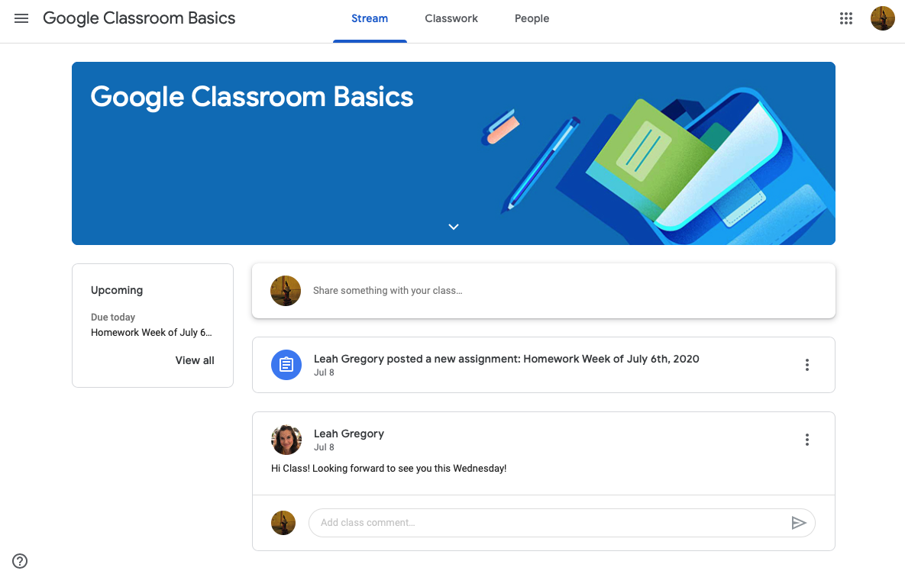

Three Sections
Write messages and see notifications from your teacher.
Assignments and homework that are scheduled
These are the different sections:
- Stream: write and read notifications from your teacher and/or your classmates.
- Classwork: view and access your homework and material from your teacher.
- People: view your teachers and classmates in your class.

Turn on Notifications
It is important to turn on notifications for the Google Classroom, so every time your teacher posts something you will receive a notification.

  - Click on the 3 lines in the top left corner.
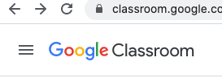

  - Scroll down and click “Settings”.

  - Make sure Notifications are turned on. Like in this picture:
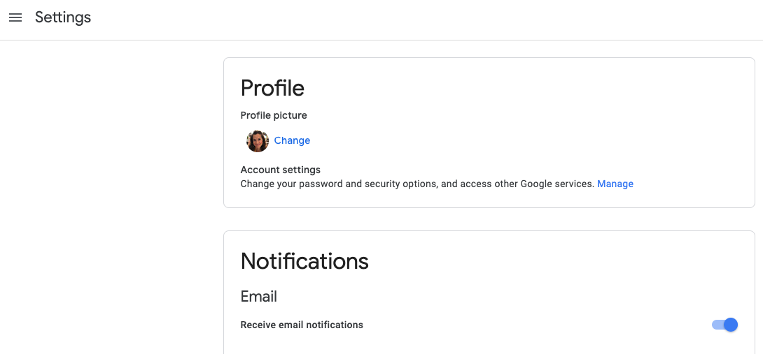

  - Click the 3 lines again to return back to your classroom page.

💡 Note: If you connect and use Google Classroom on your smartphone, you must download the application first.

Access Homework
- Your teacher will add homework to the “Classwork” section in the Google Classroom. To view the homework, click “Classwork” and then click the homework. In the homework, click “View Assignment” .
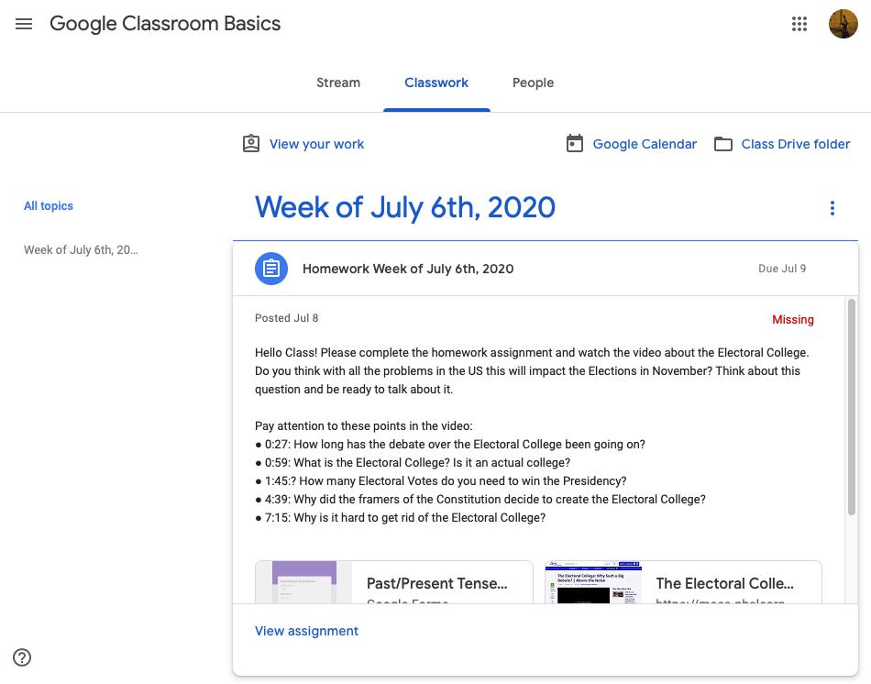

View Assignment
- When you view the assignment, you will enter the exercise and you need to open the Google Doc or Form to complete the assignment.

- After you complete the assignment, return to the Google Classroom and click “Turn In”. You can also send your Teacher a private message about the assignment.

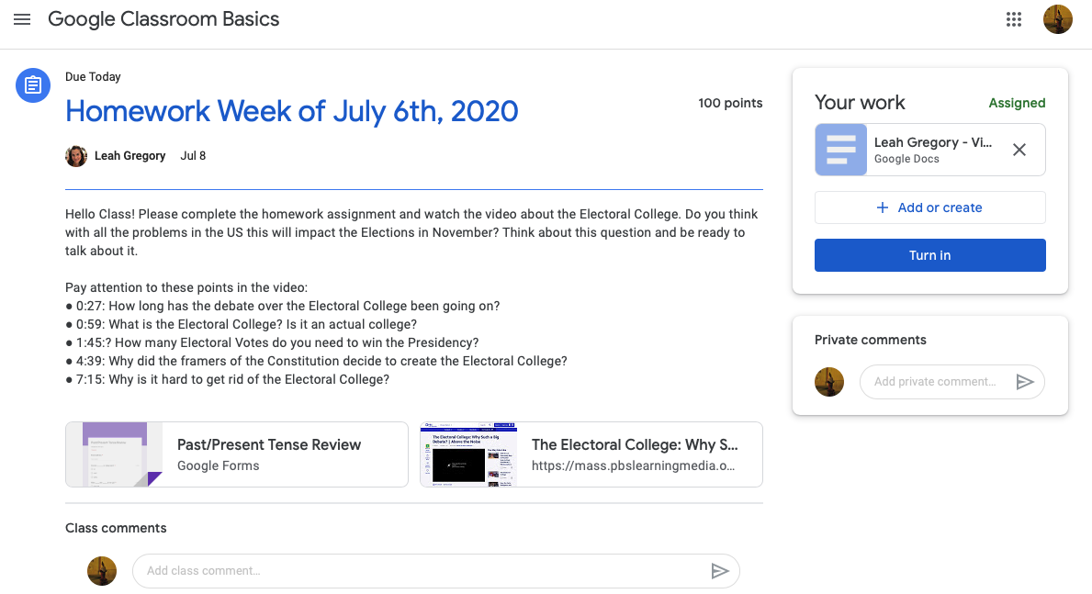

Homework Document
When you complete the homework click “Turn In”
Private Message to Teacher
Name: ___________________

Worksheet #8: Exploring Google Classroom

Directions: Access the Google Classroom with your teacher’s invitation. Explore Google Classroom with a partner and complete the exercises below.

- Google Classroom Review
- What are the three sections of Google Classroom?
1.
2.
3.

- Where can I write a message in Google Classroom?

- Write a message to your class introducing yourself, include:
  - Your Name (My name is…)
  - Where are you from? (I am from…)
  - What is your favorite food? (My favorite food is…)

- Google Classroom Assignment
- If your teacher gave you an assignment:
  - View the assignment
  - Open the Document
  - Complete the Assignment
  - Return to Google Classroom
  - Click “Turn In”

