A Life
Spent with
Children
Careers in Early
Education and Care
and Out of School
Time
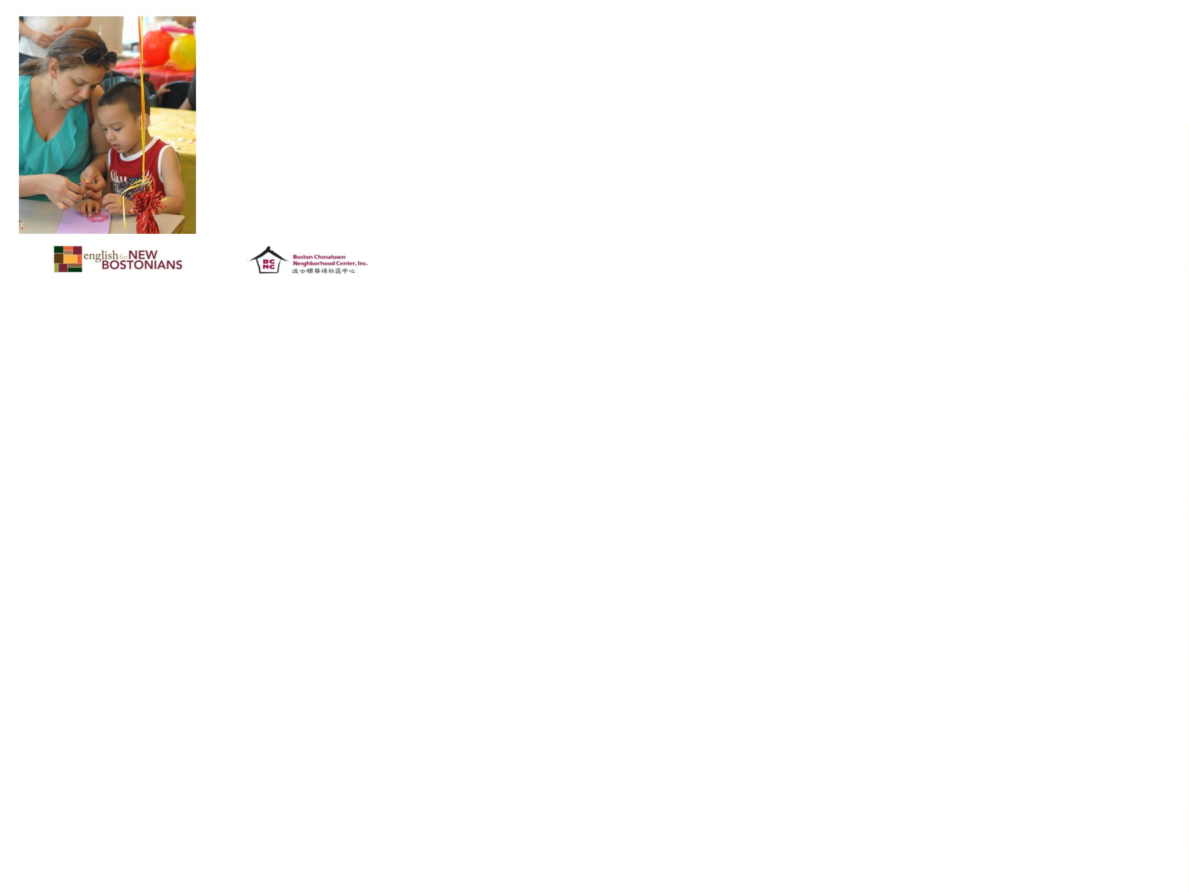

Acknowledgements
•
The following presentation was originally
developed by Boston Chinatown
Neighborhood Center, and was adapted by
English for New Bostonians.
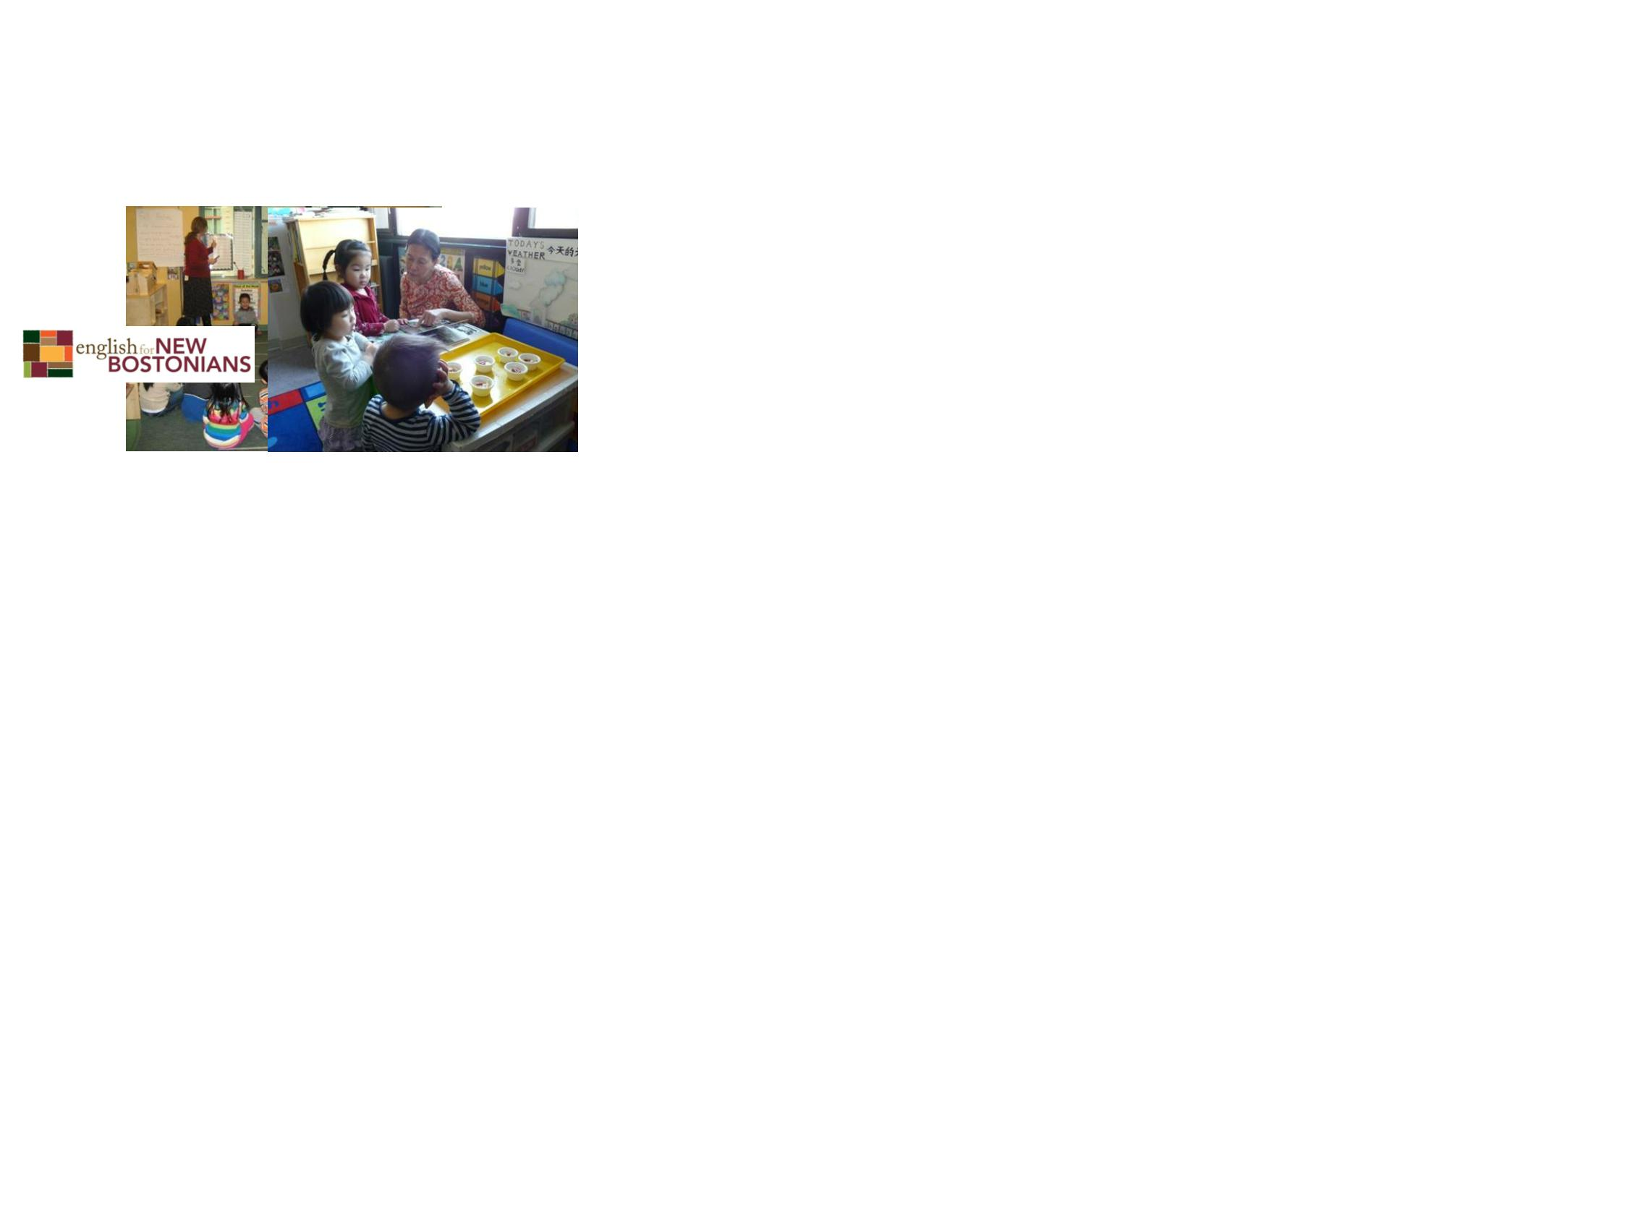

Important Vocabulary
•
•
•
•
•
•
•
•
•
Early education
Out of school time
Caregiver
Certificate
Degree (AA. BA. M.A.)
Higher Education
Module
Orientation
Success


Important Adjectives
•
•
•
•
•
•
Creative
Energetic
Playful
Successful
Friendly
Meaningful

Are you…
…fascinated with how children grow and
develop?
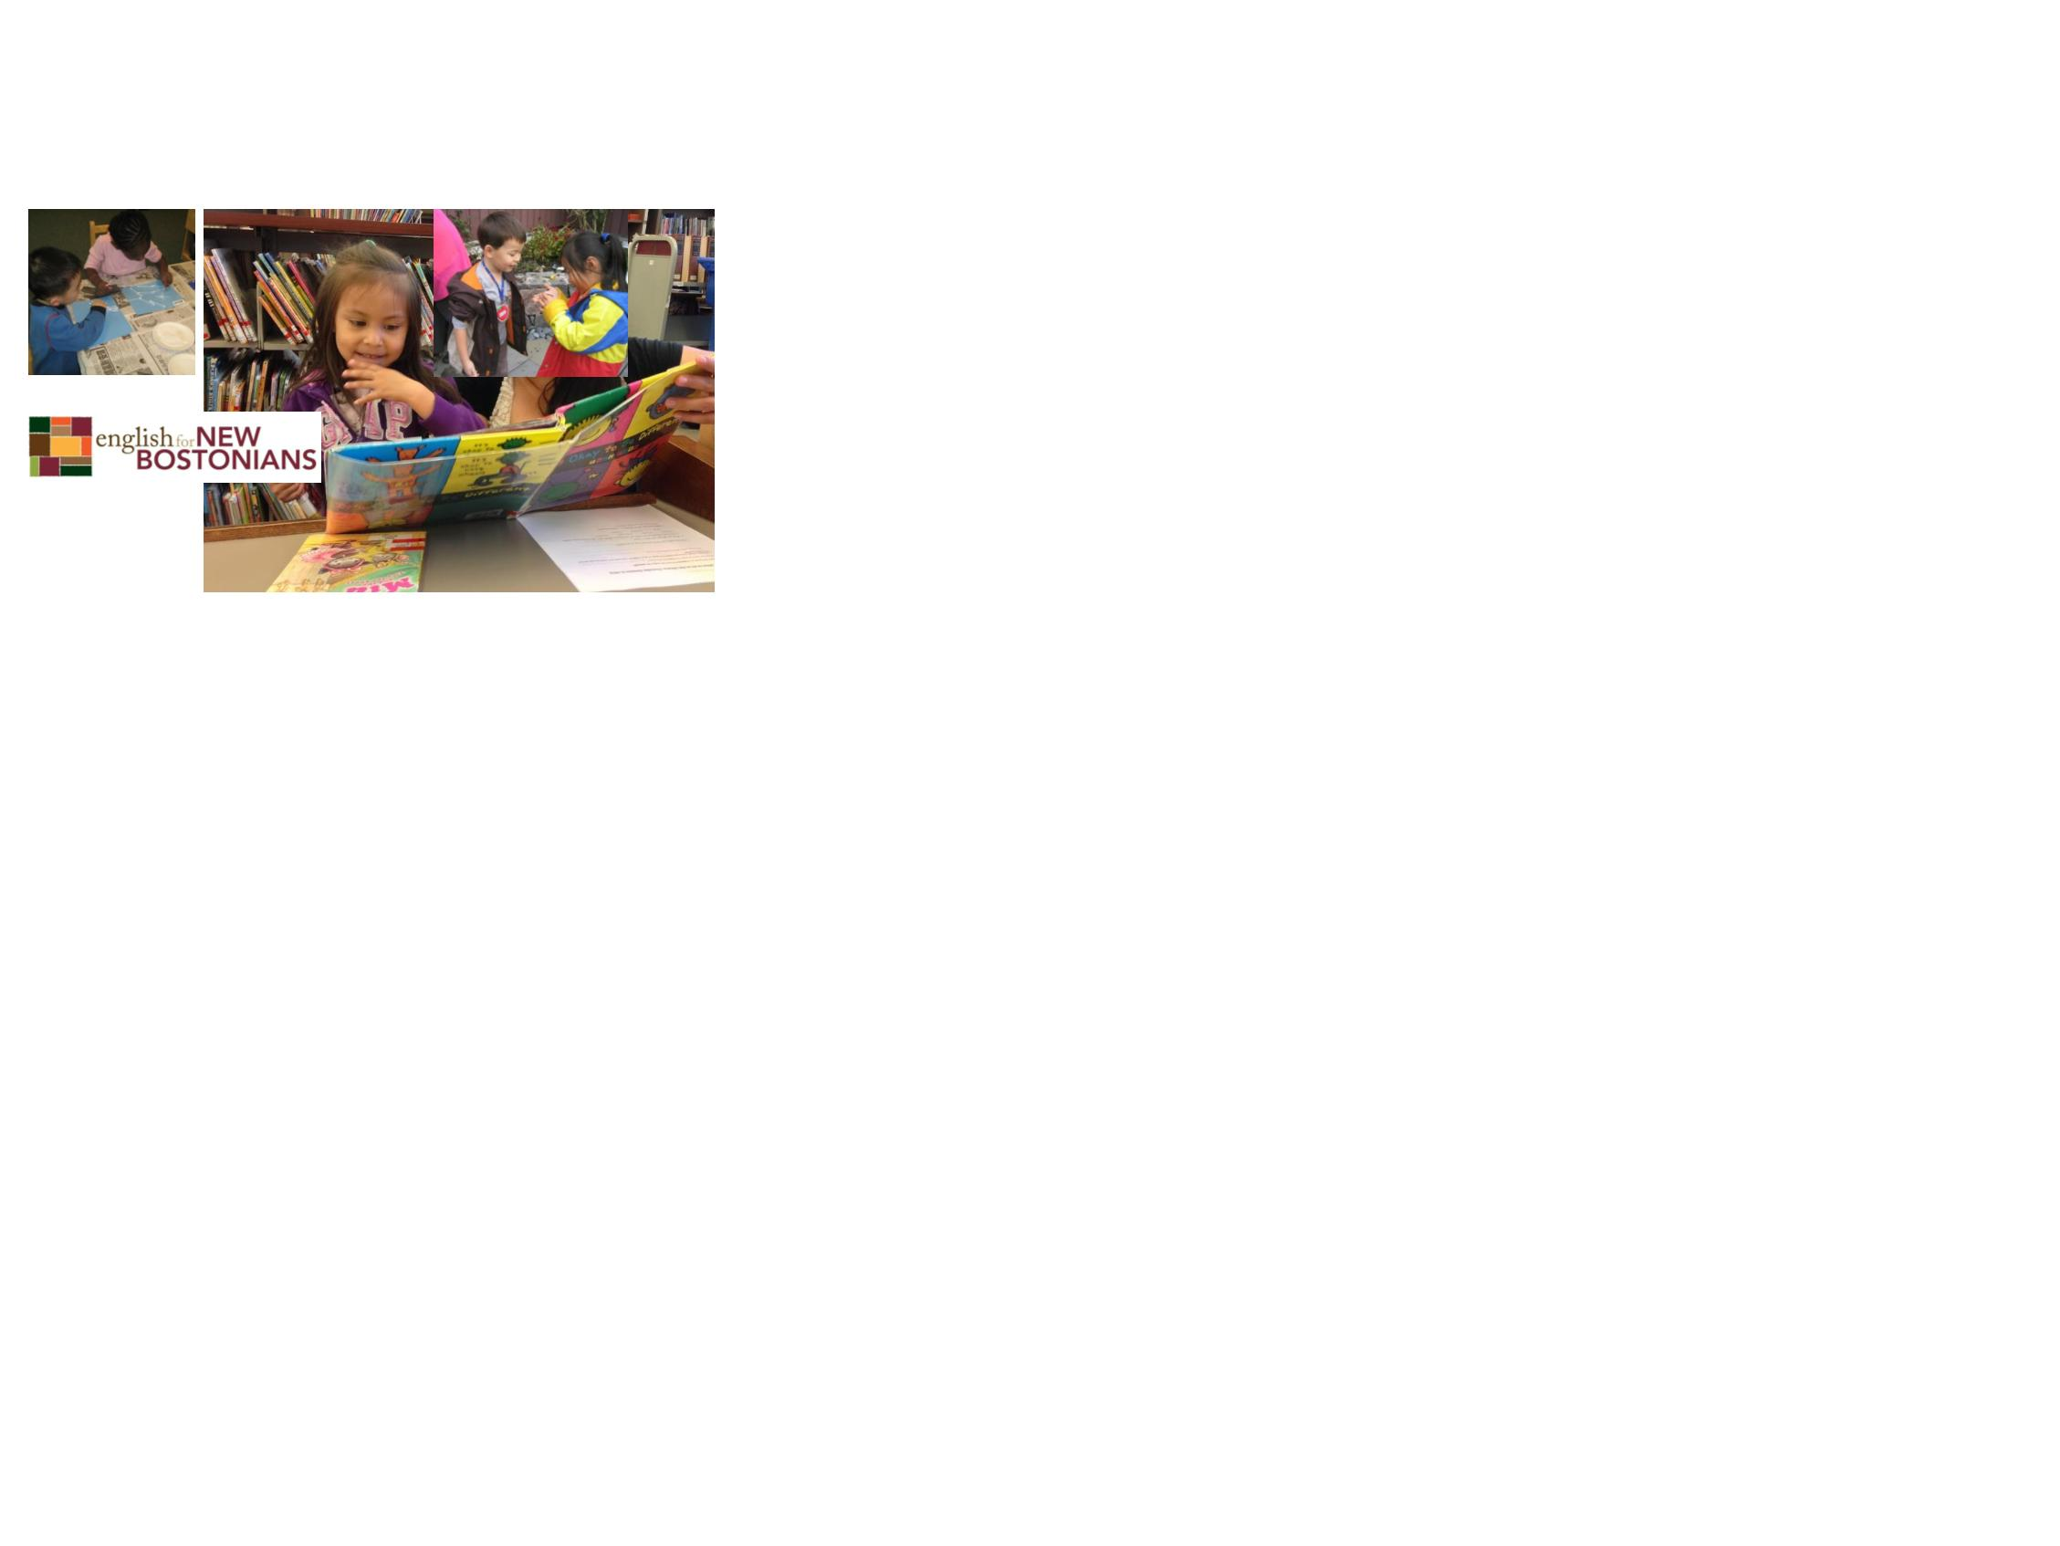

…
creative, energetic and playful?
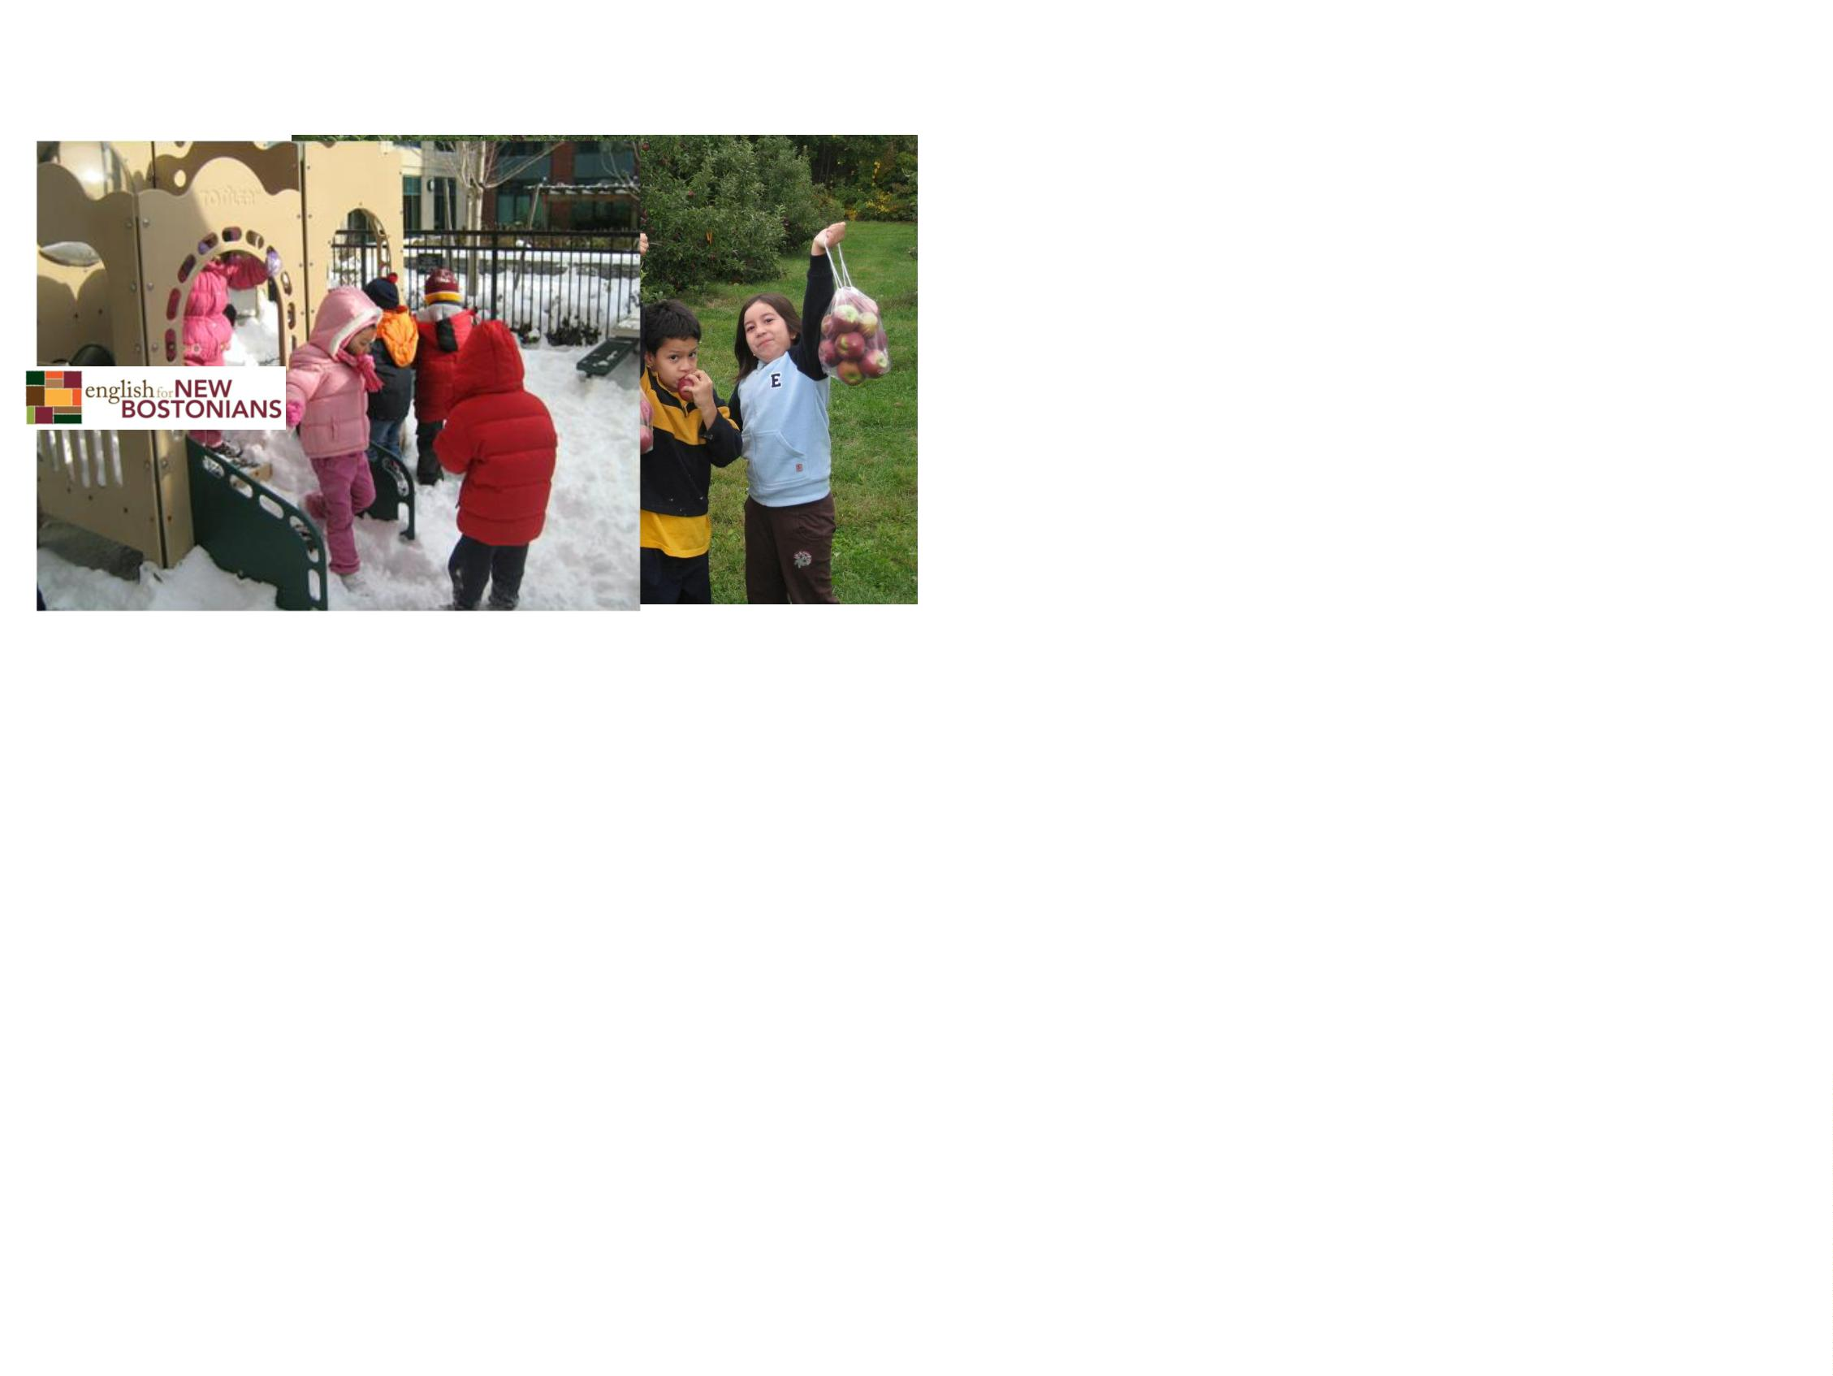

…
someone who loves to learn new
things?
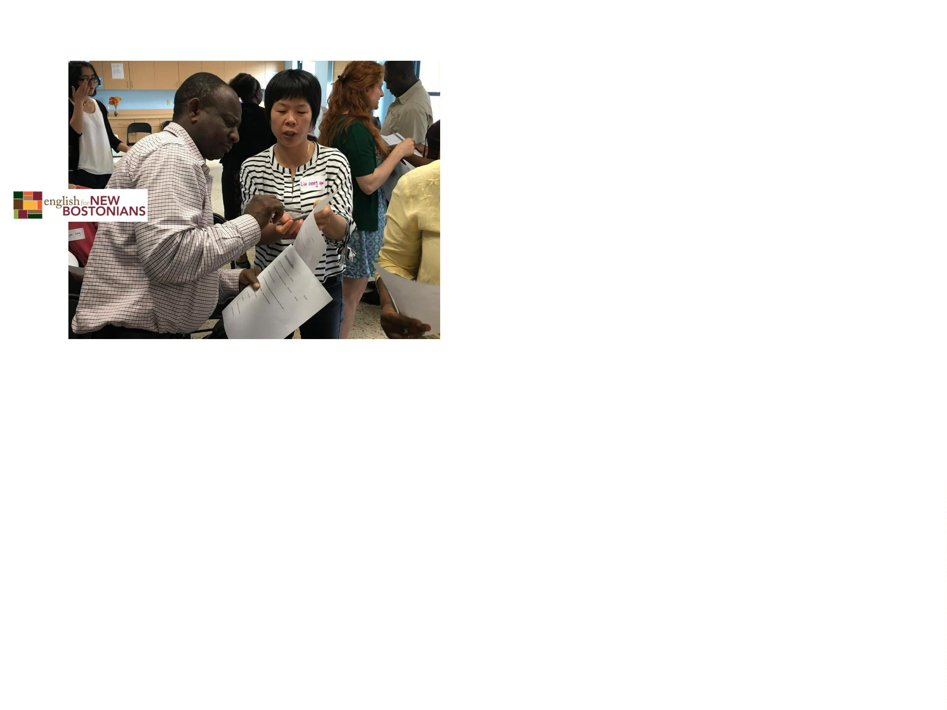

…
a people person?
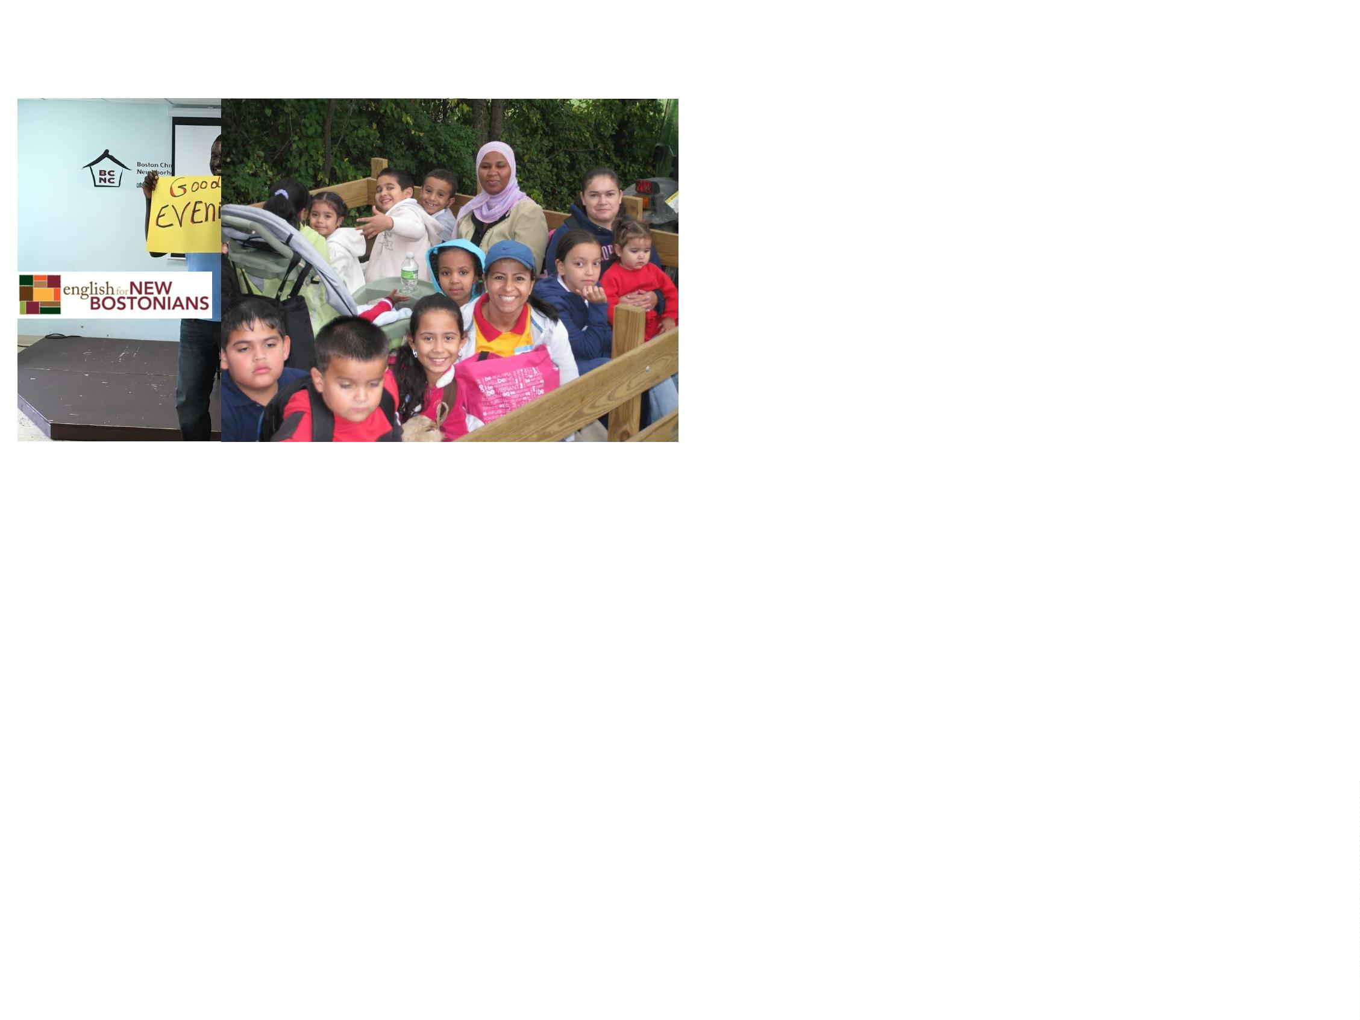

Then you might enjoy working in
early education or out of school
time.
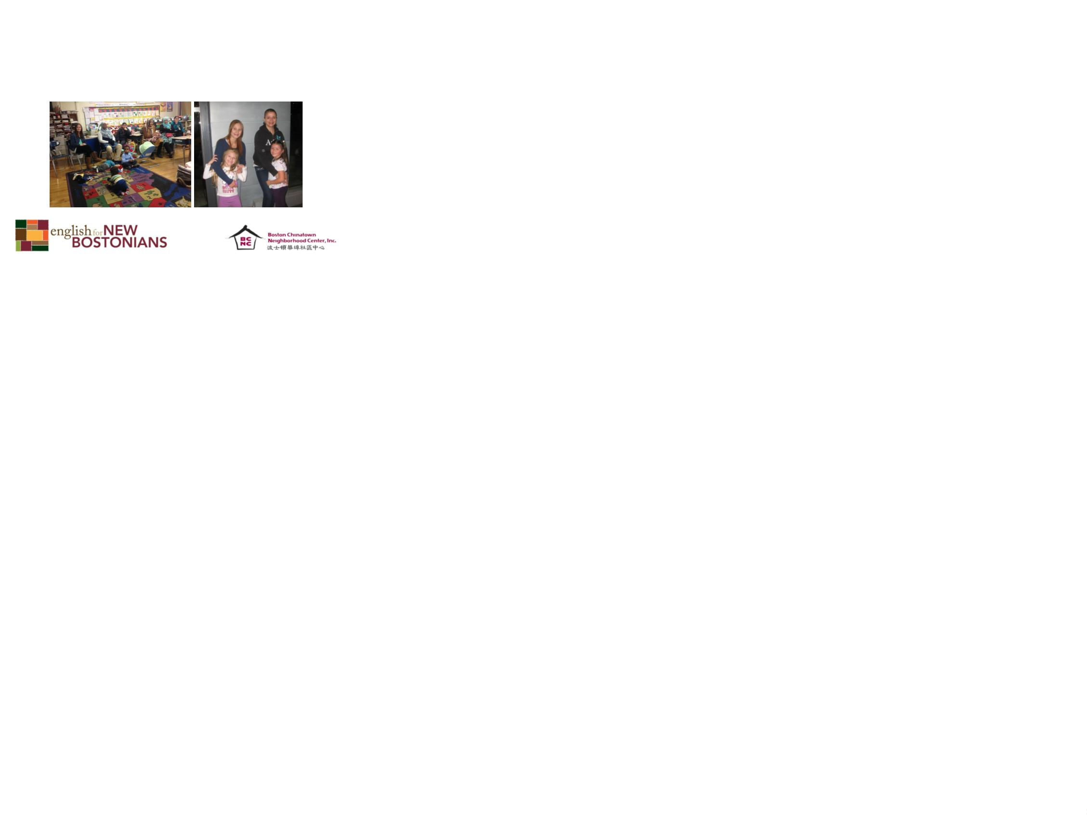

What are the jobs in the field?
There are many opportunities in many settings.
•
•
•
•
•
Family child care
Center based care
Head start
Elementary schools
Out of school programs

What is family child care?
Family child care is care
and education that
happens in a home
setting.
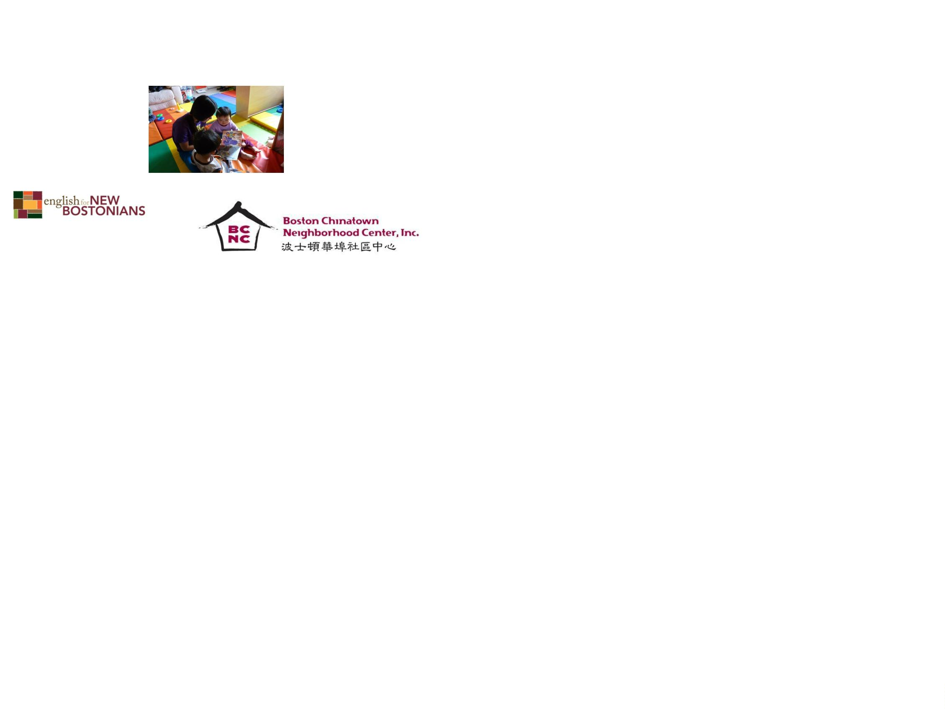

What does it take to become a
family child care educator?
You must have some experience caring for children.
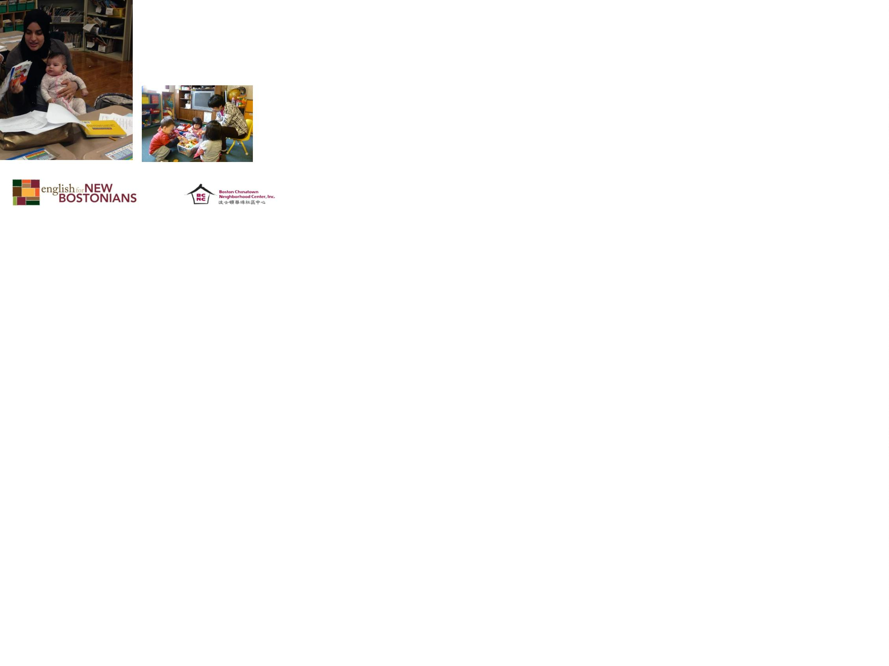

You must participate in regular
trainings
1
2
3
. A pre-orientation where you will explore basic
licensing requirements and see if this field is for
you
. A five hour module before you receive your
licensing with ideas about space, curriculum,
and beginning your home child care
. A five hour module six months after you are in
business that supports you to build a
developmentally rich curriculum

What else?
•
You must prove that you have no criminal or
abuse record and there is no one who lives with
you that has such a record.
•
•
•
You must be healthy and fit to care for children.
You must learn first aid and CPR.
You must participate in regular training to learn
about children, curriculum, families, and running
a successful family child care business.
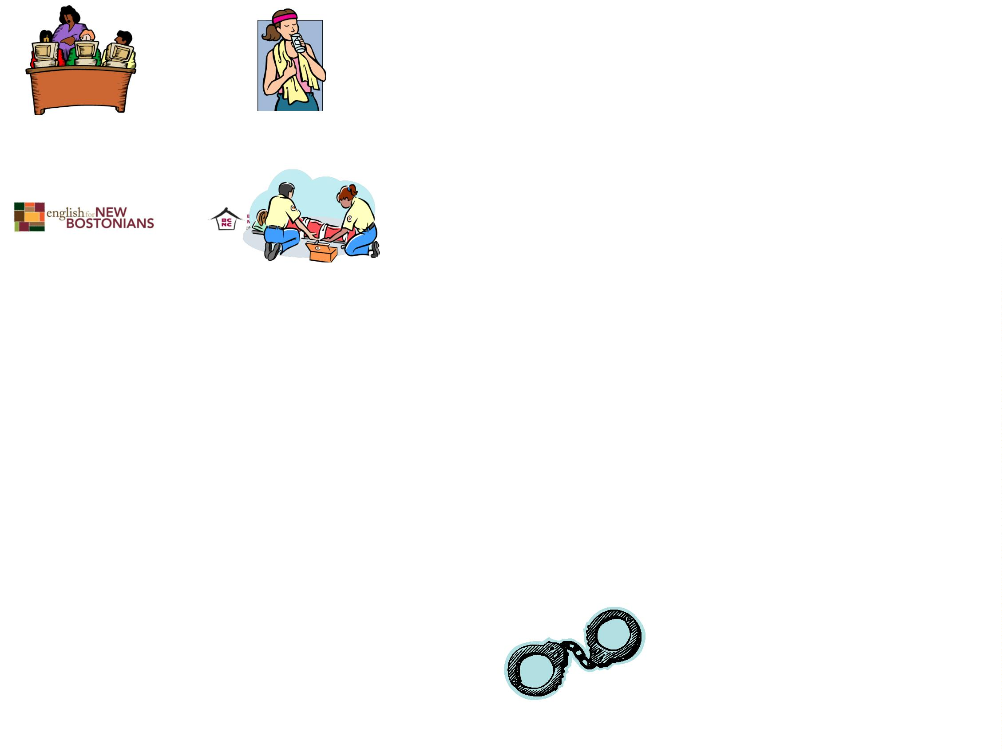

What does it take to be successful?
You need to be a smart
business person
because family child
care is a business and
you want to make a
decent living.
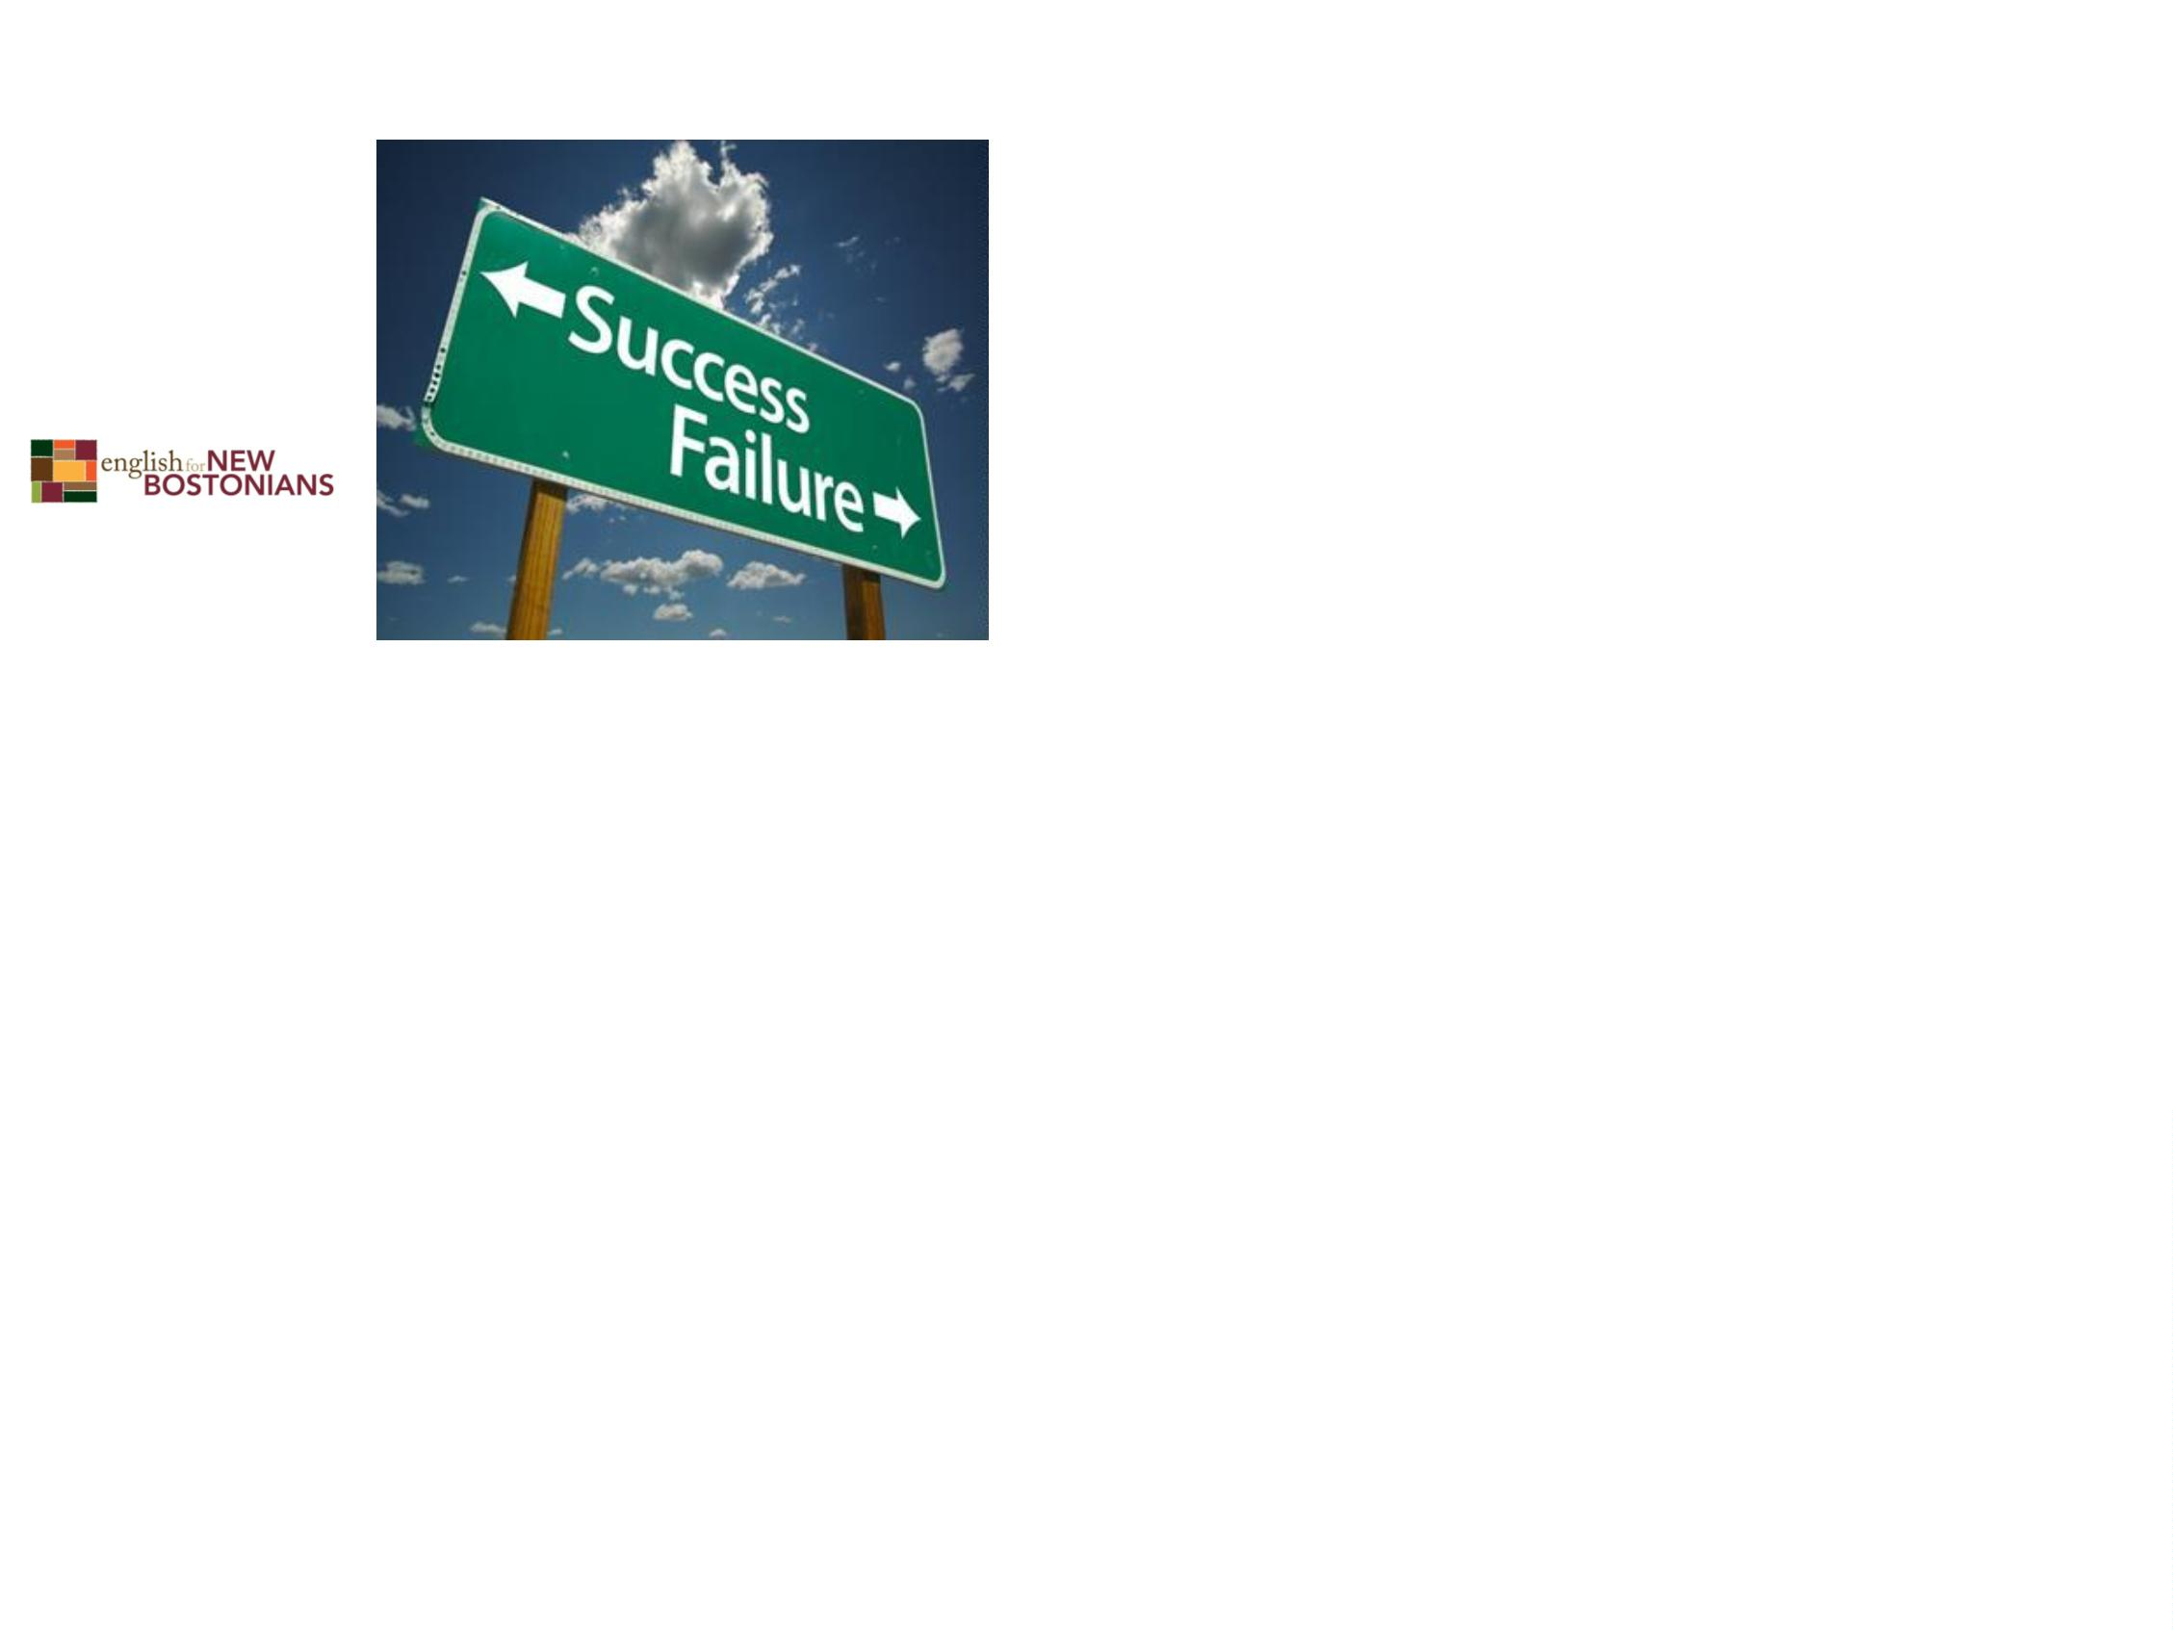

What else?
•
•
You must be energetic
to care for children all
day.
It is important to be a
person that people
trust and like. Be
friendly and caring.
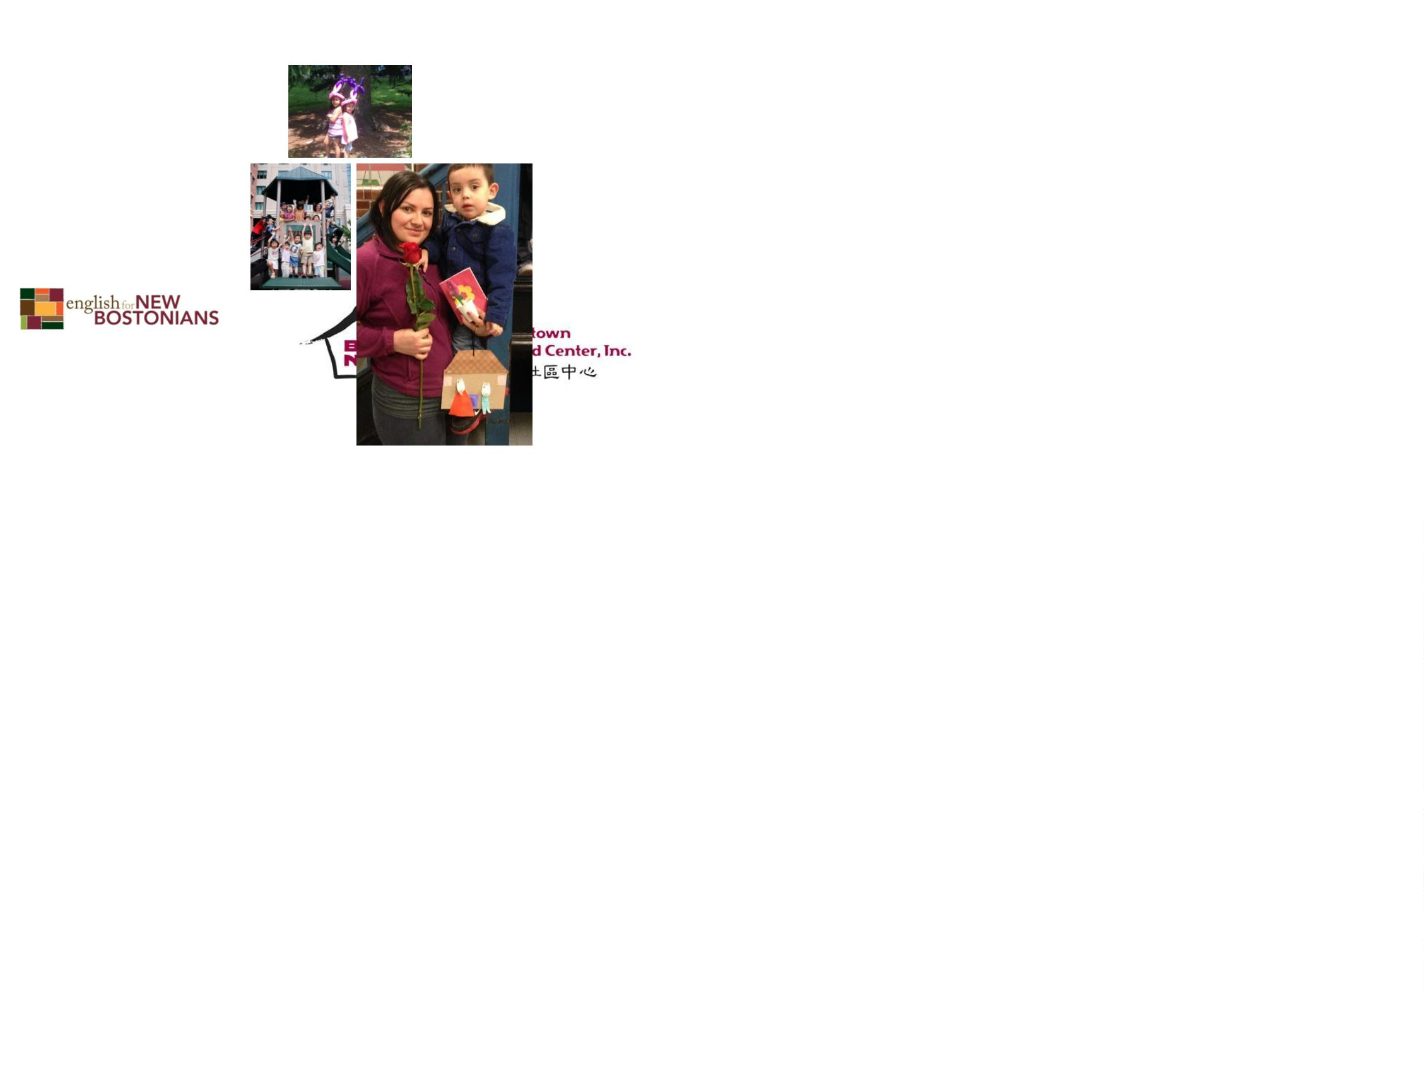

It is necessary to have…
•
A home or apartment that is safe for children
with enough room and permission from your
landlord or condo association and/or family to
become a licensed home.
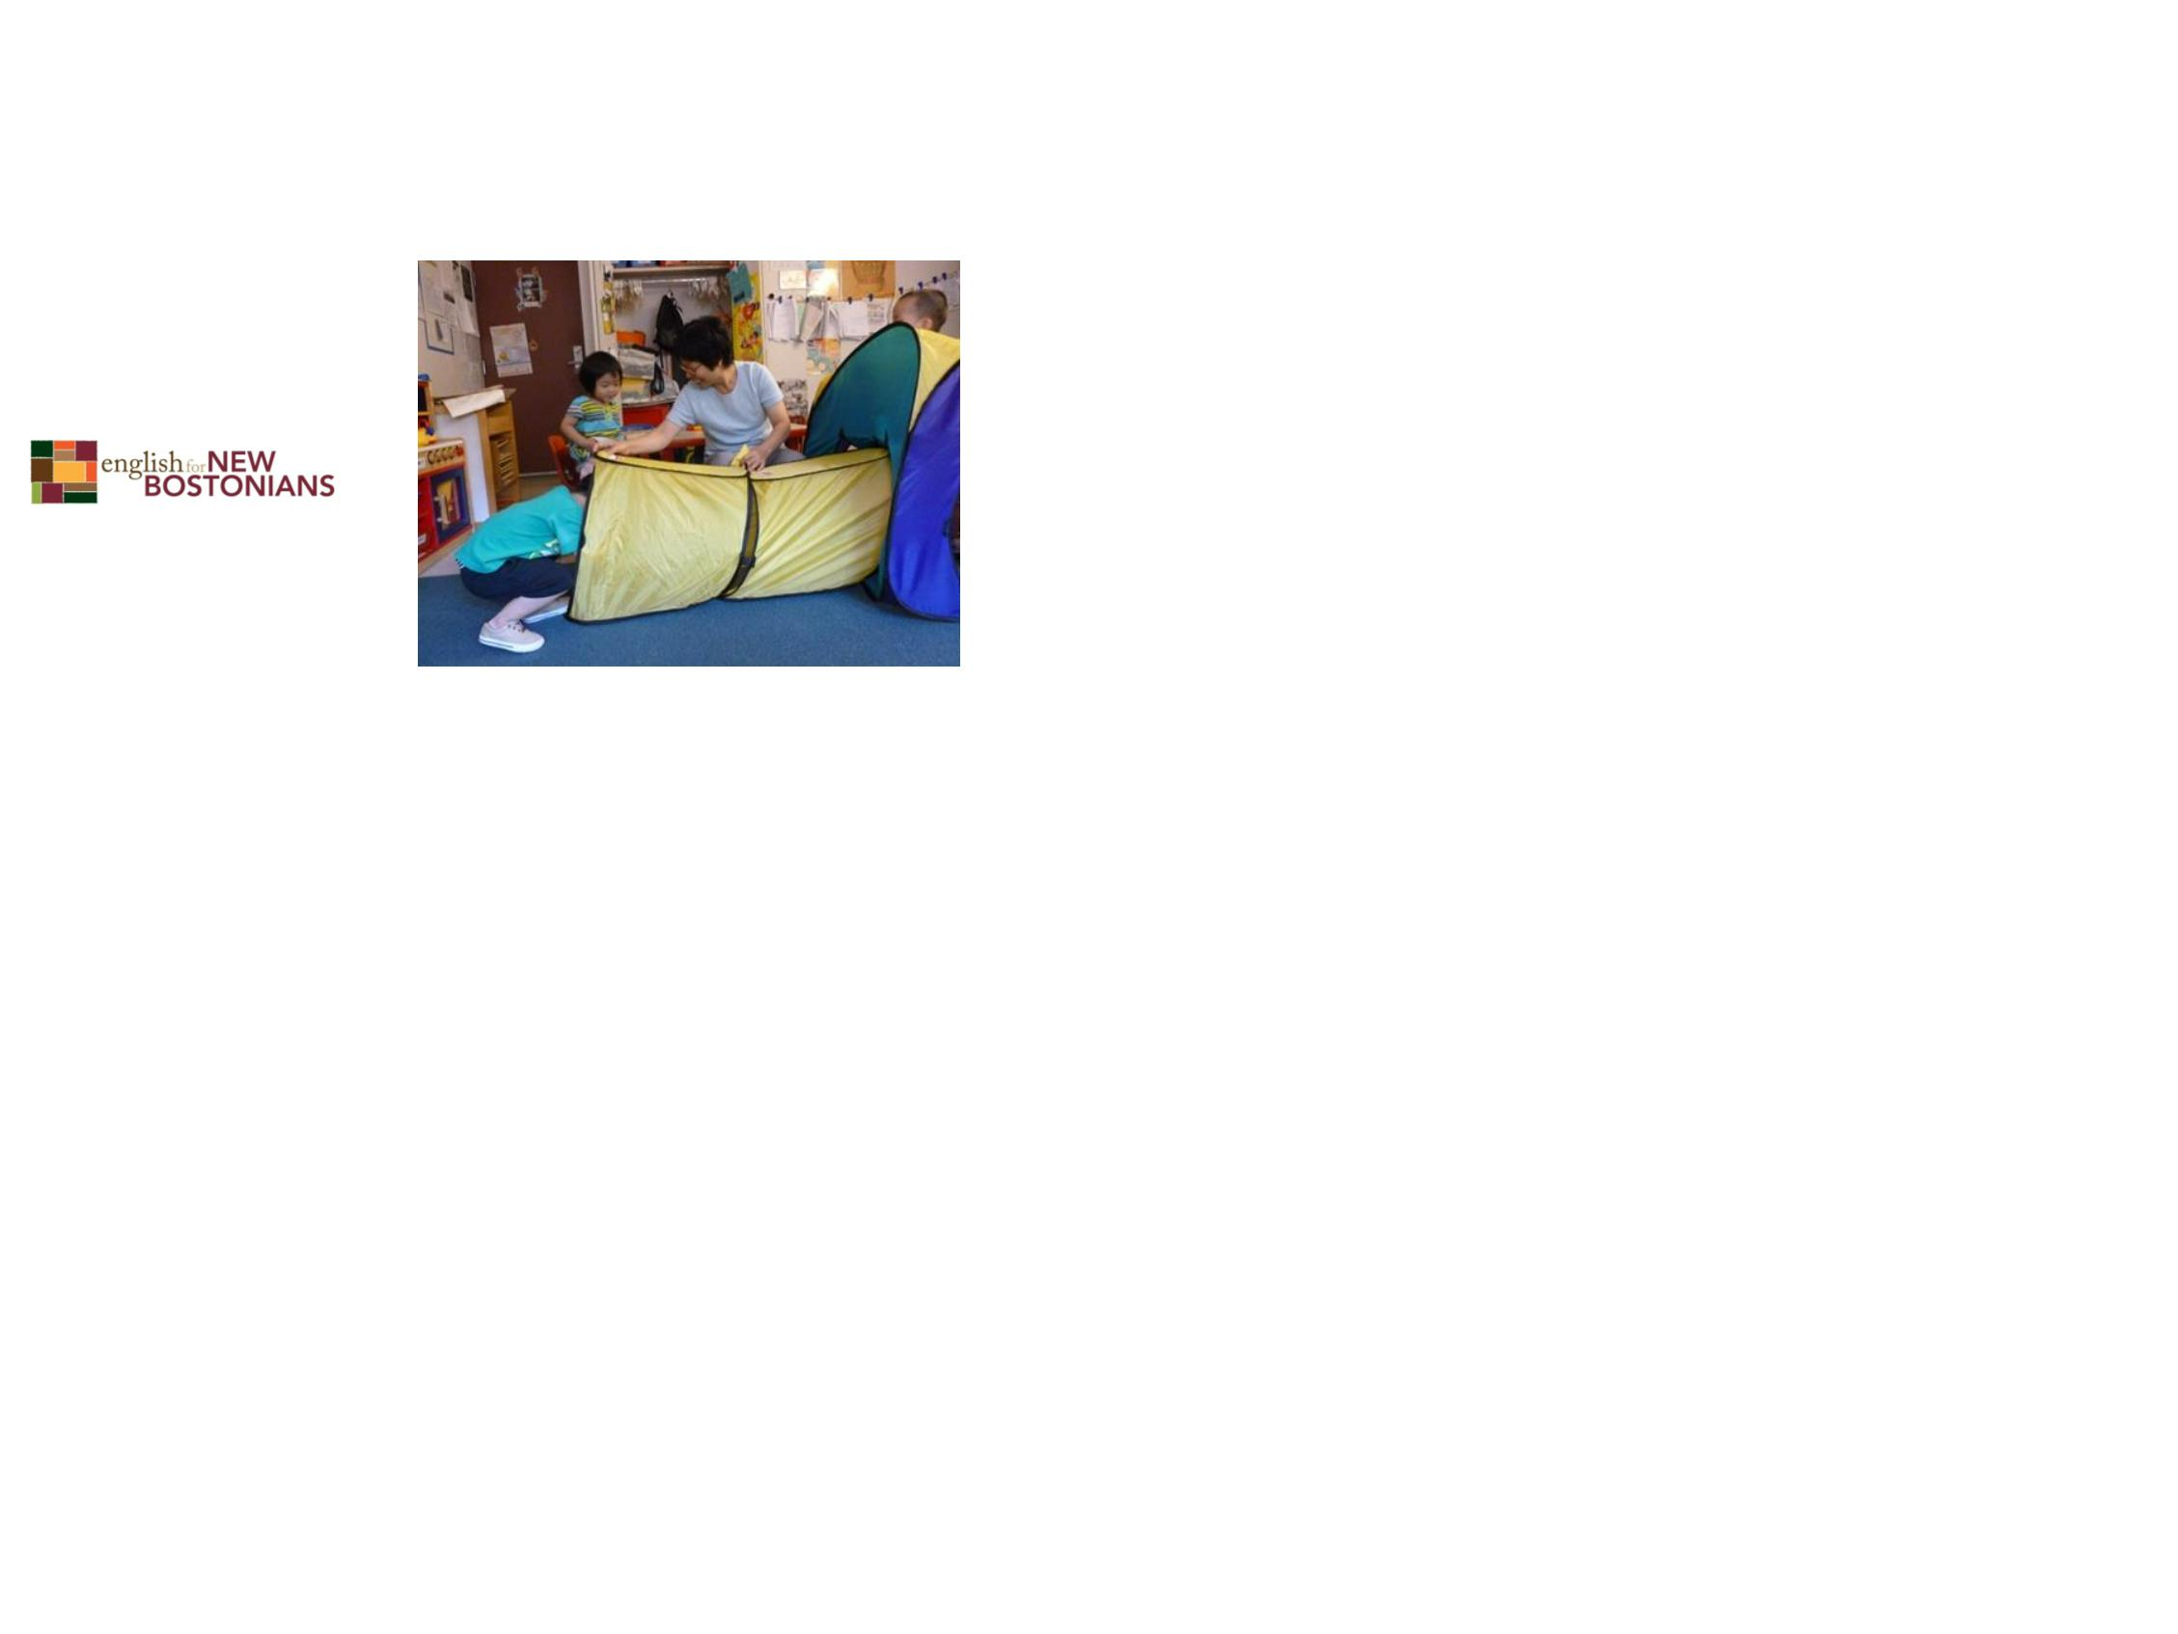

You need to be able to:
•
•
•
•
•
•
cook
keep a clean and healthy home
plan fun learning activities
keep children’s records
maintain a good relationship with parents
run a profitable business
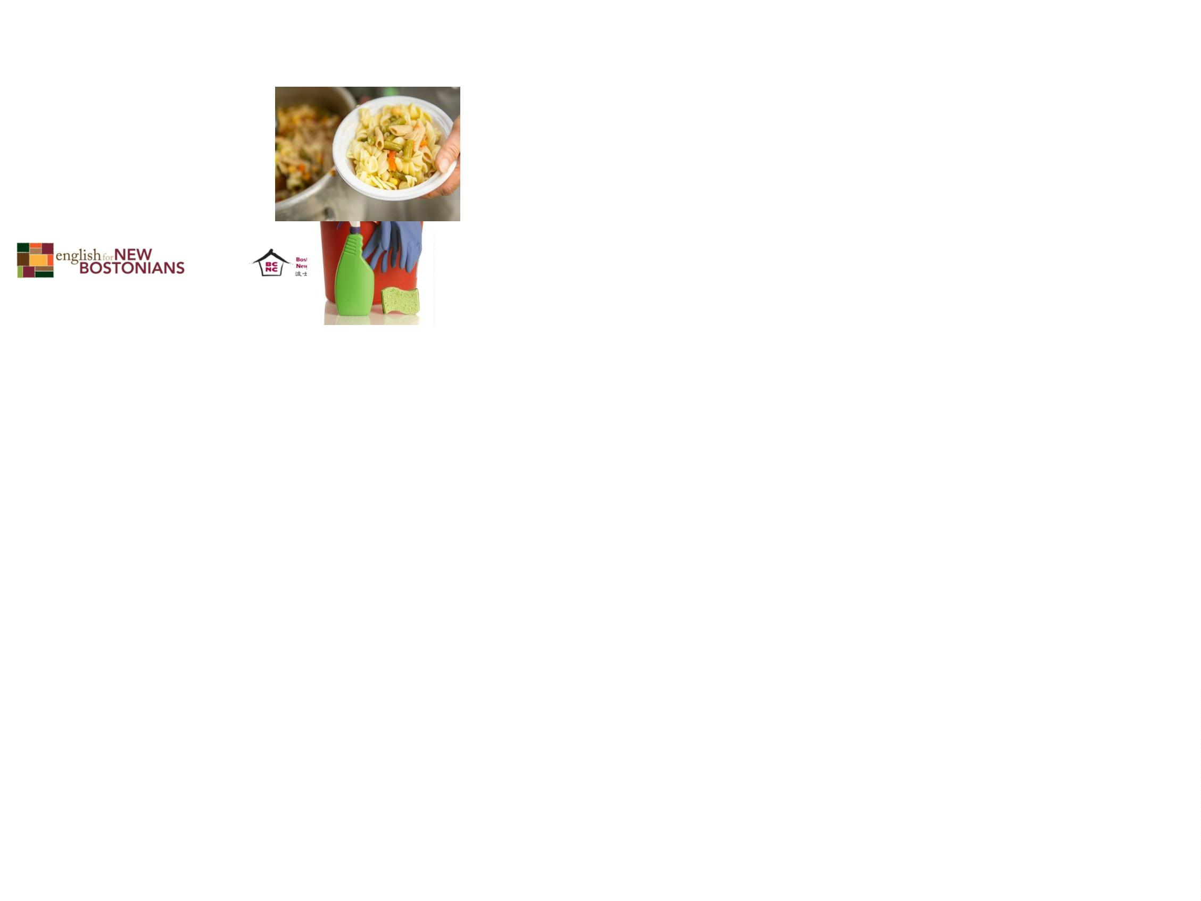

Other roles in family child care
•
You can be a home visitor
and help support the
licensing of family child
care. You will coach and
mentor home care
educators and plan
training and resources to
support them and the
children they care for in
their home.
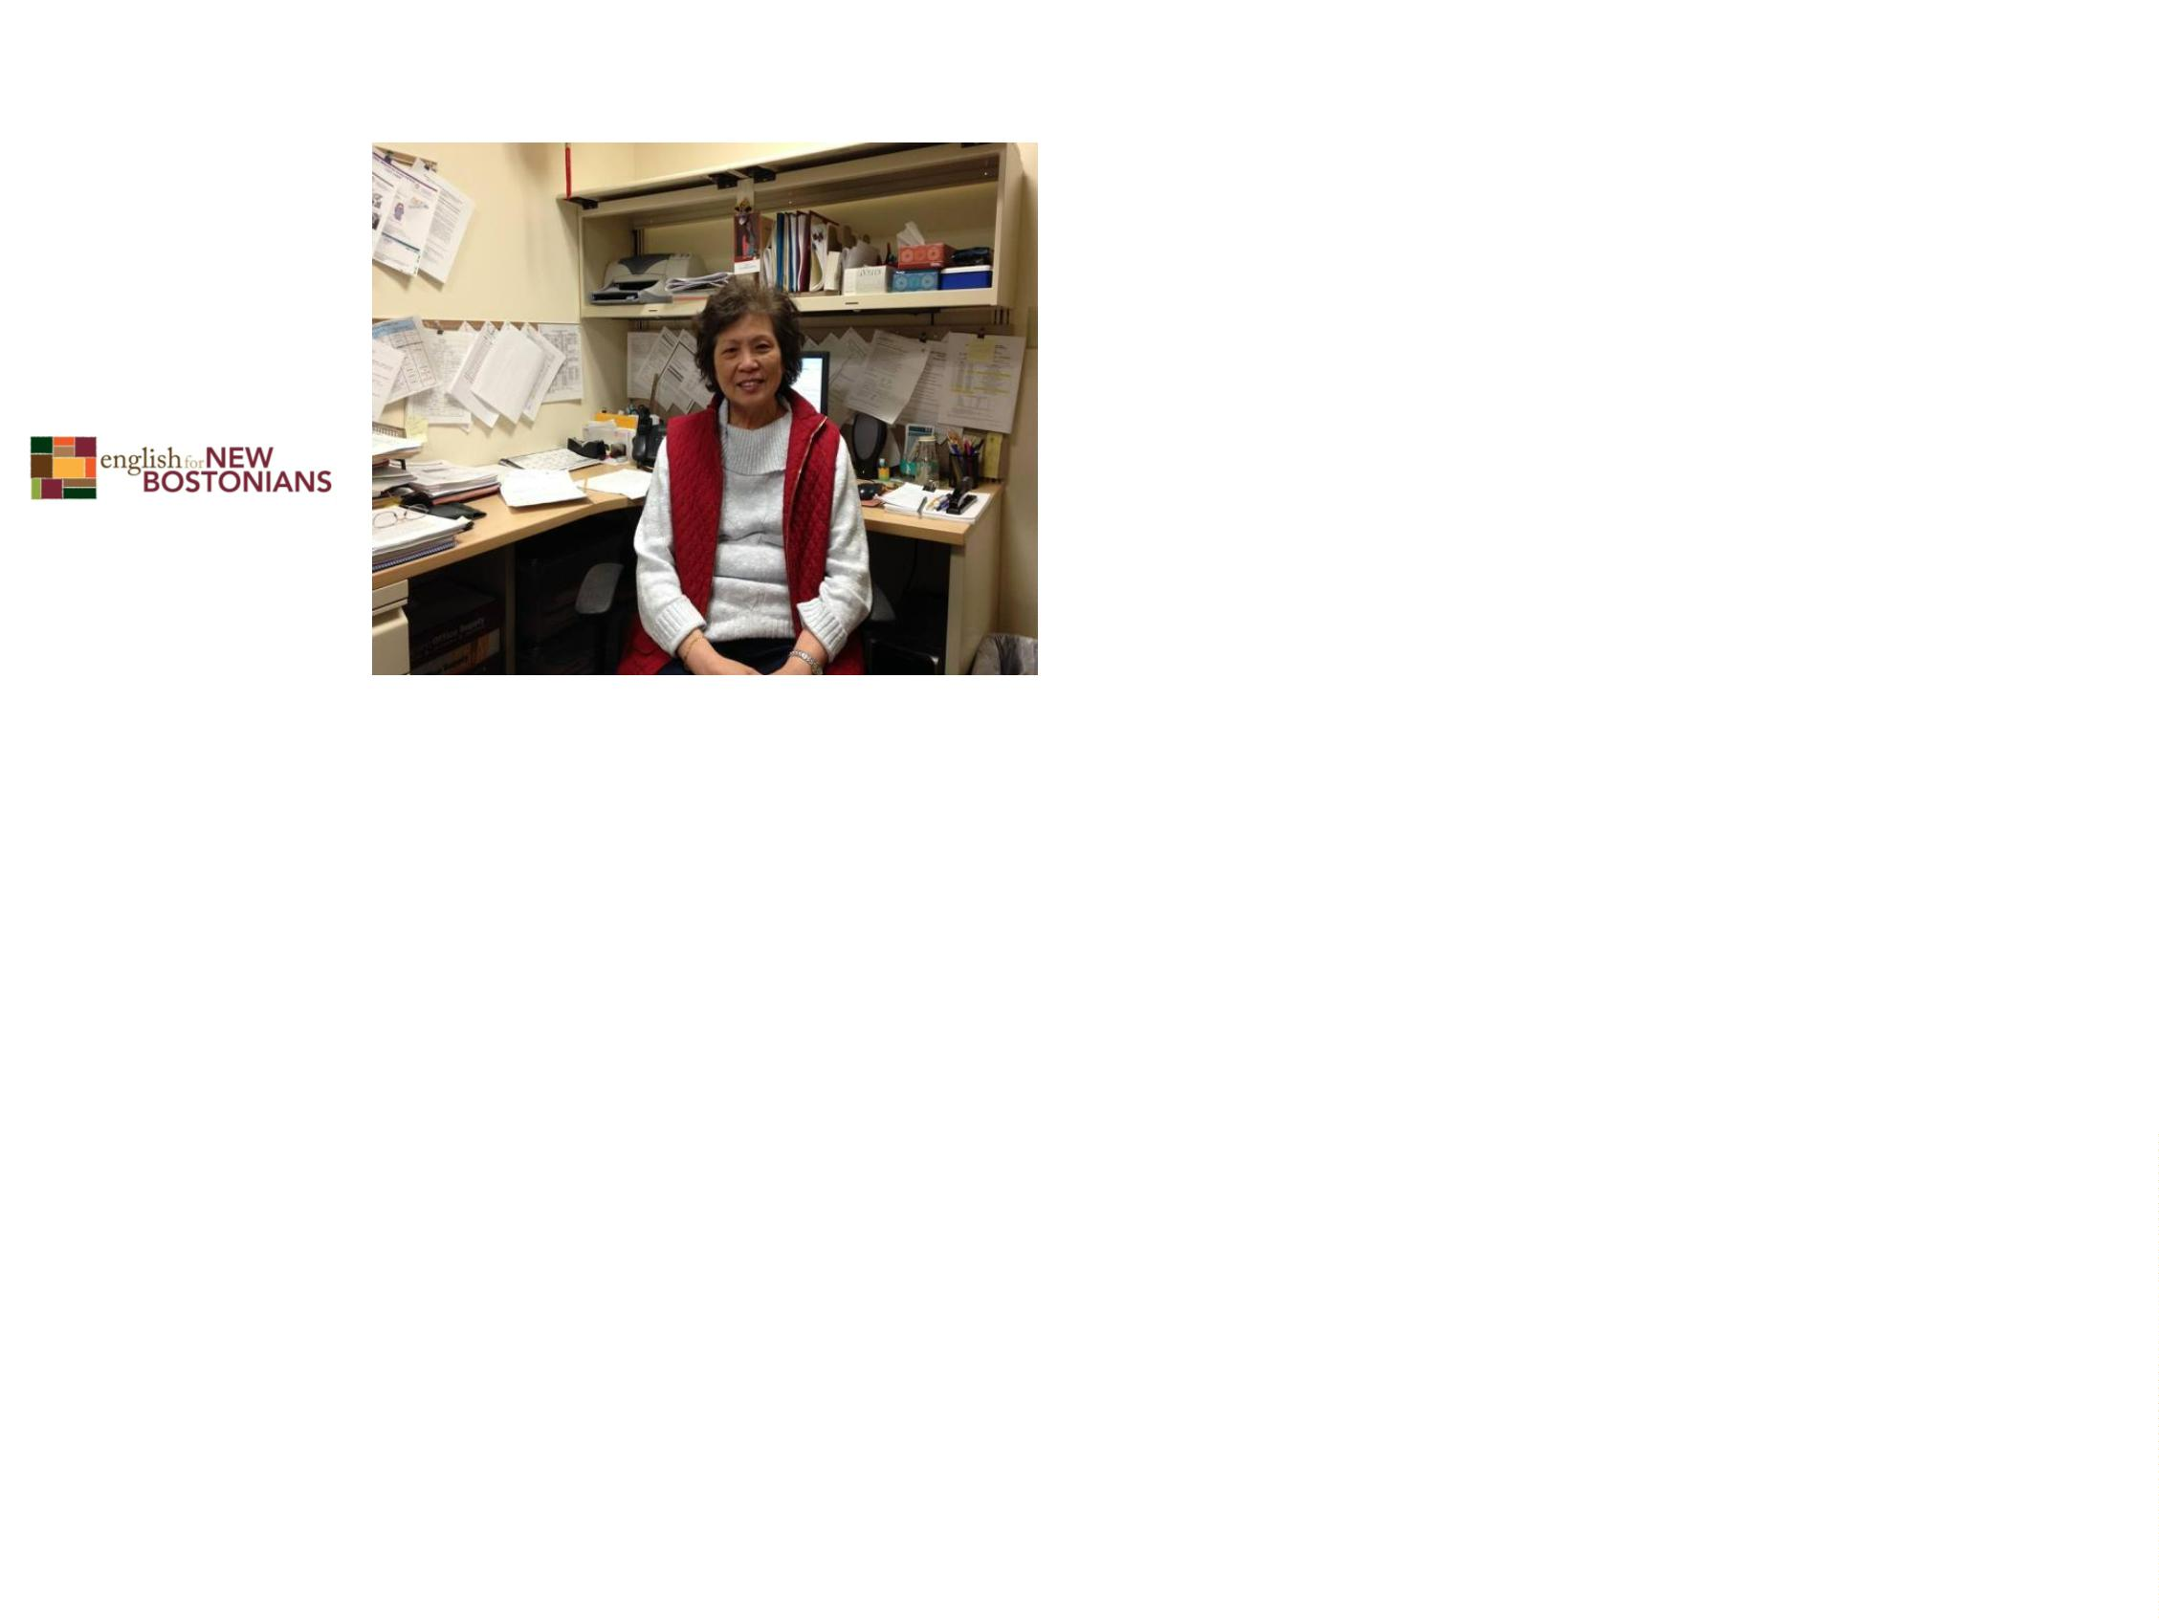

What will I need to be a home
visitor?
•
•
•
An early childhood degree (AA or BA)
Experience working with children and families
Desire to support and work with family child
care educators

Where can I learn more?
•
Your local Child Care Resource and
Referral Agency can provide basic
information about the licensing
process. In Boston, this agency is
Child Care Choices.
WWW.childcarechoicesofboston.org
•
The Early Education and Care (EEC)
website also has information on
licensing. In Boston, the local CCR&R
is Child Care Choices.
WWW.childcarechoicesofboston.org
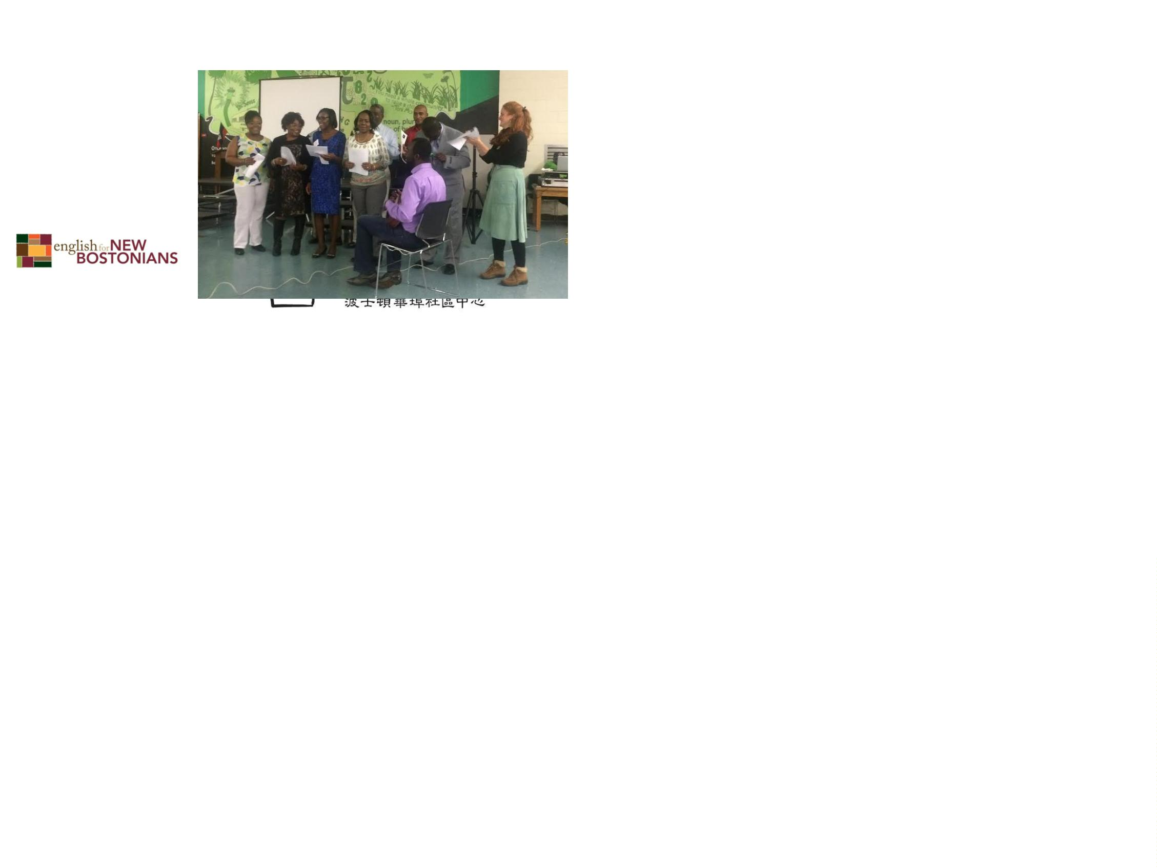

Can I get early childhood training
in other languages?
•
•
Urban College in Boston offers child
development classes in Chinese, Spanish, and
English. They also will help you with to enroll
and to apply for financial aid.
Many community colleges, like Bunker Hill,
offer early childhood education courses, but
only in English.

What do you need to work in a
child care center?
Dependability
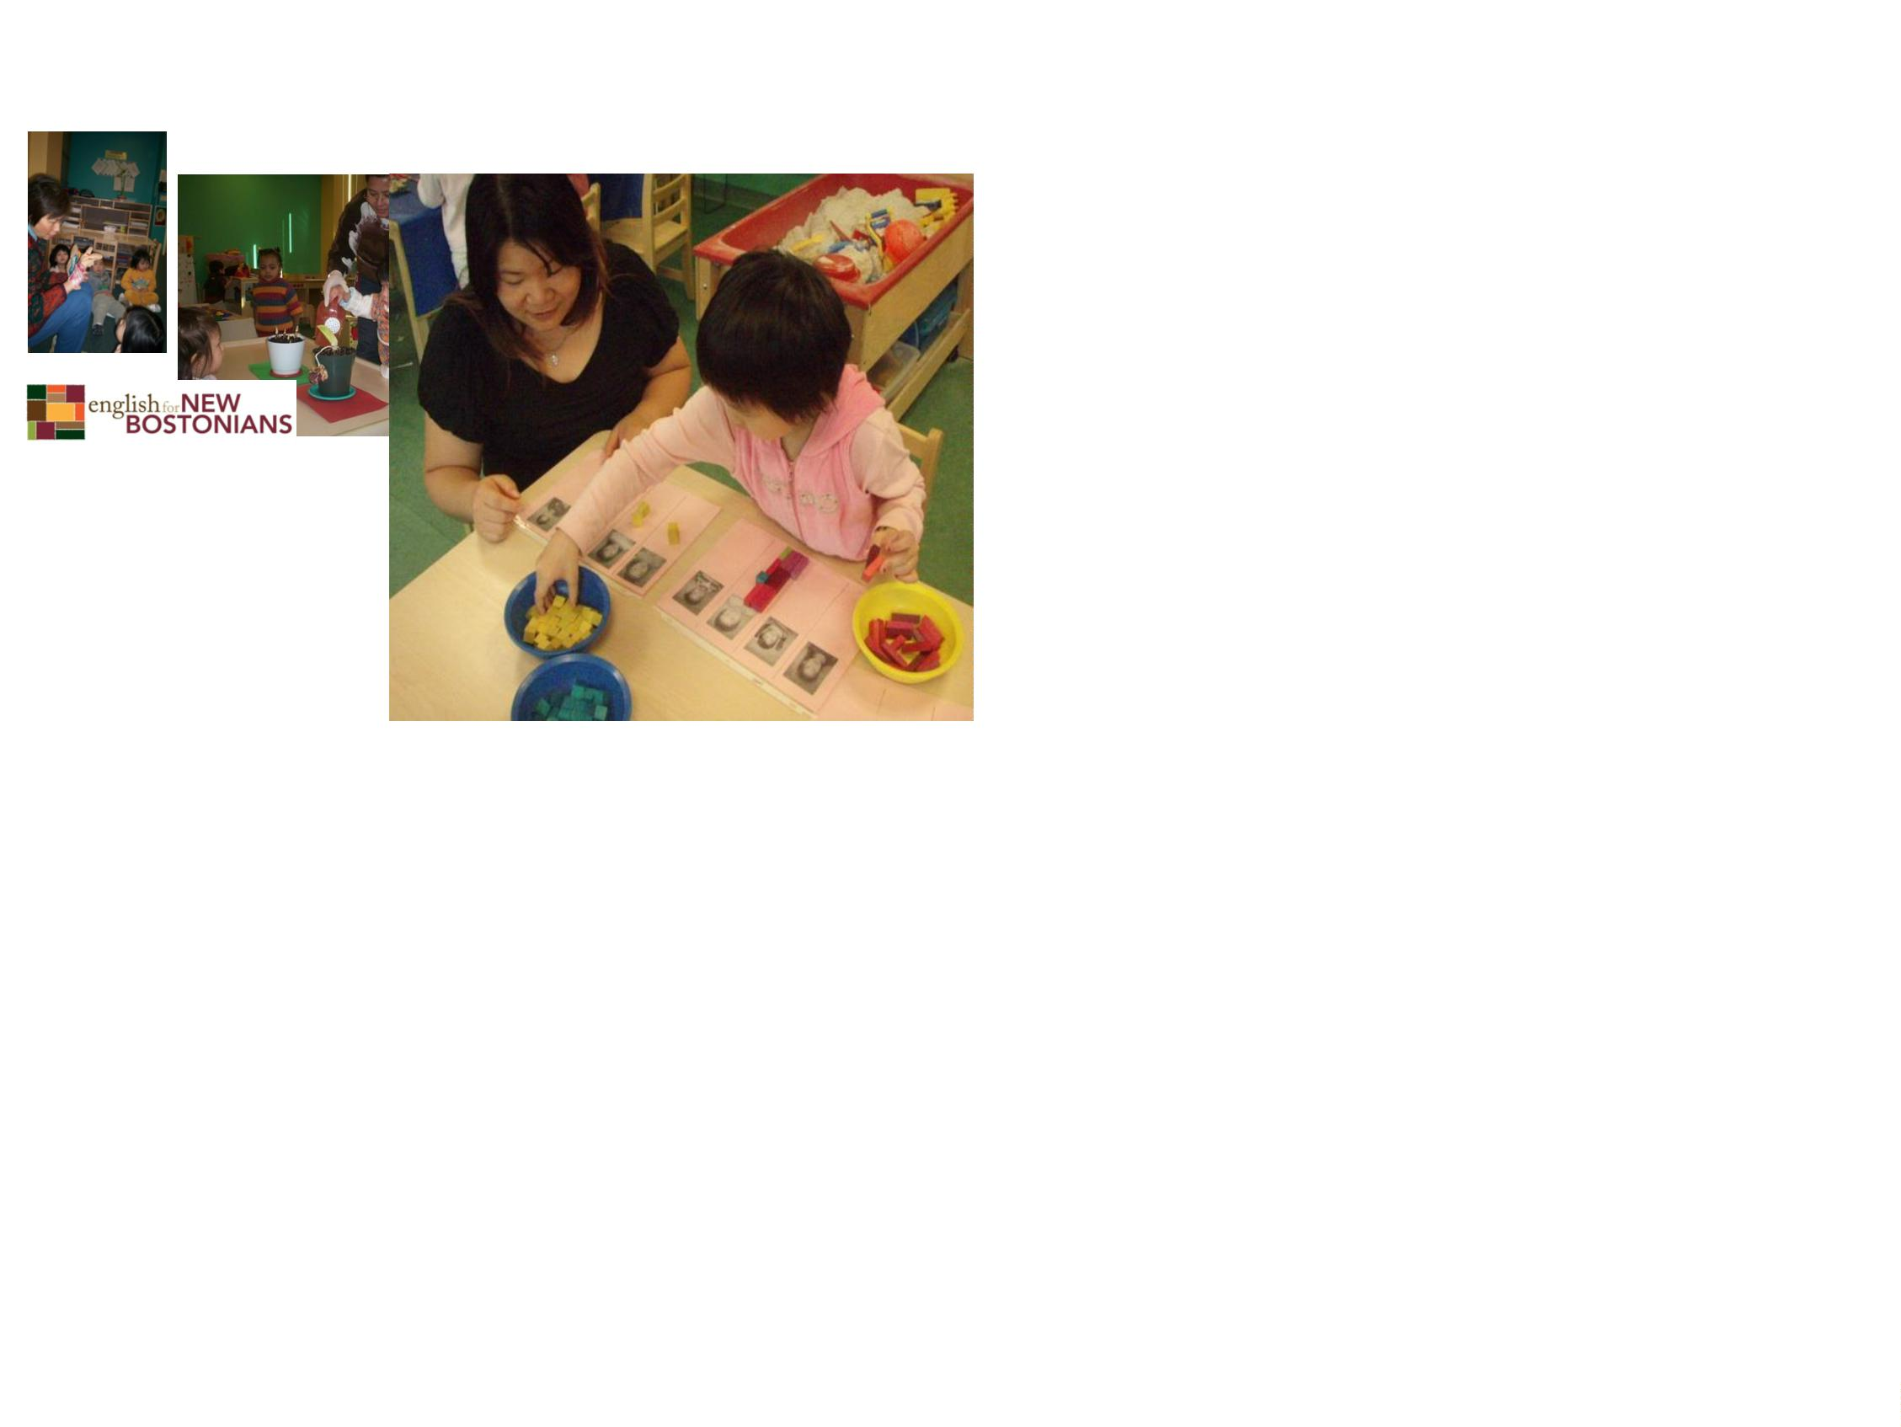

Interest in young children and how
they grow
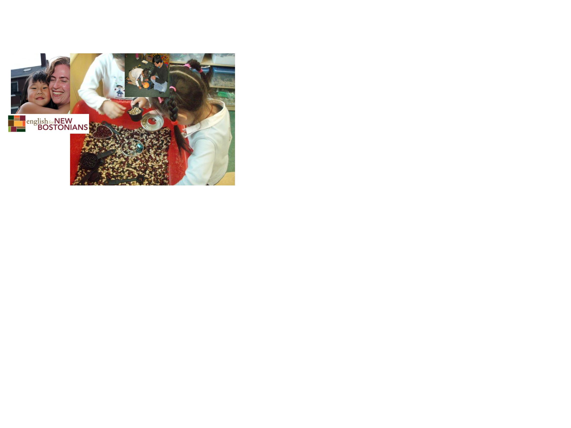

Ability to work in a team
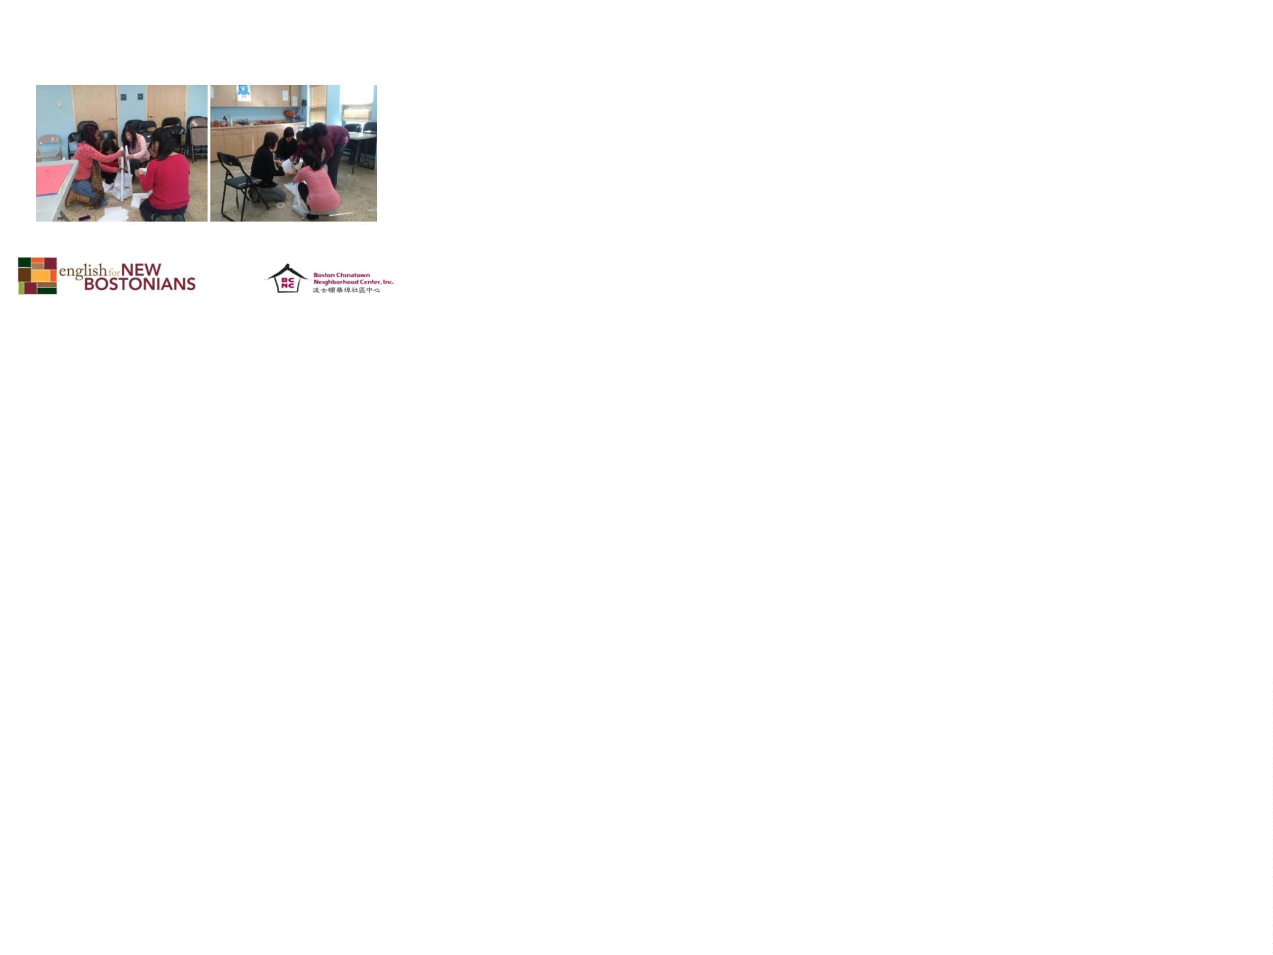

A liking for young families
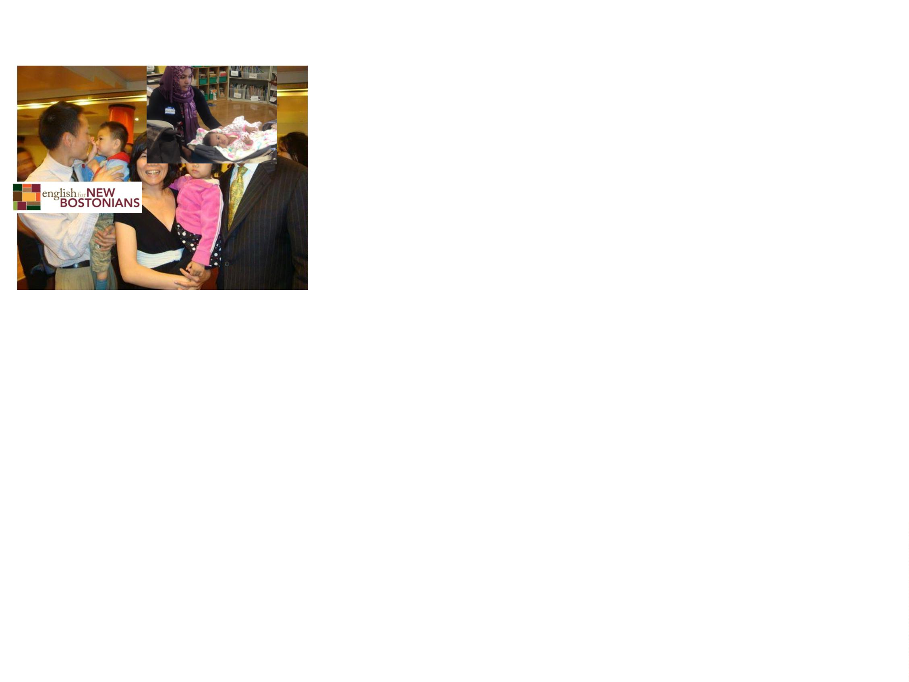

Good communication skills
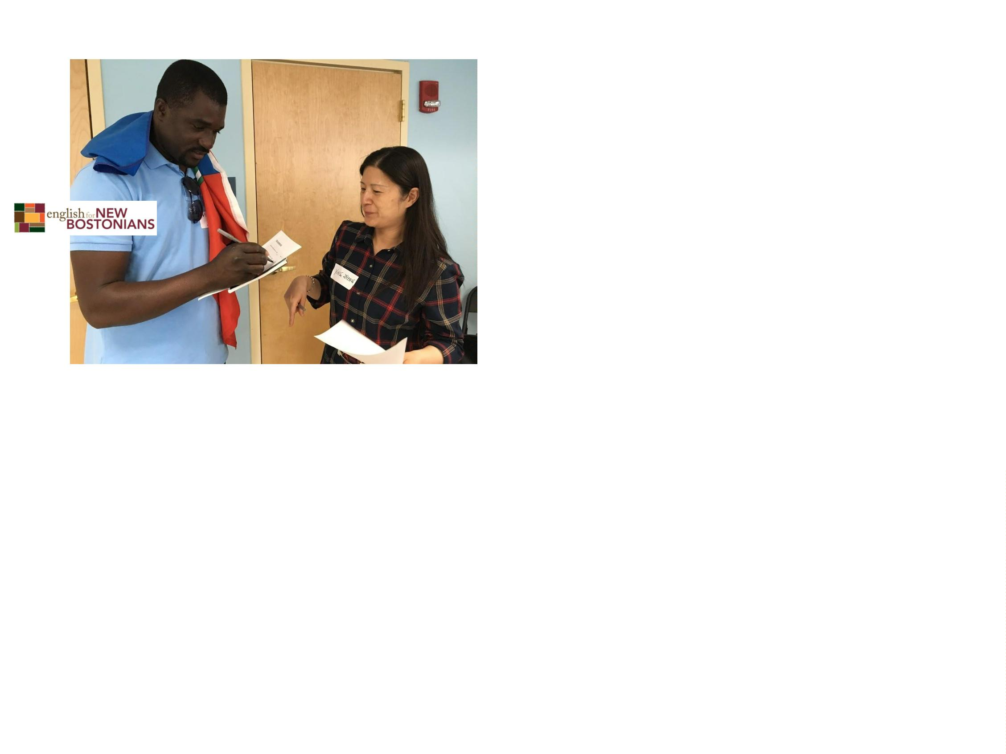

Creativity and playfulness
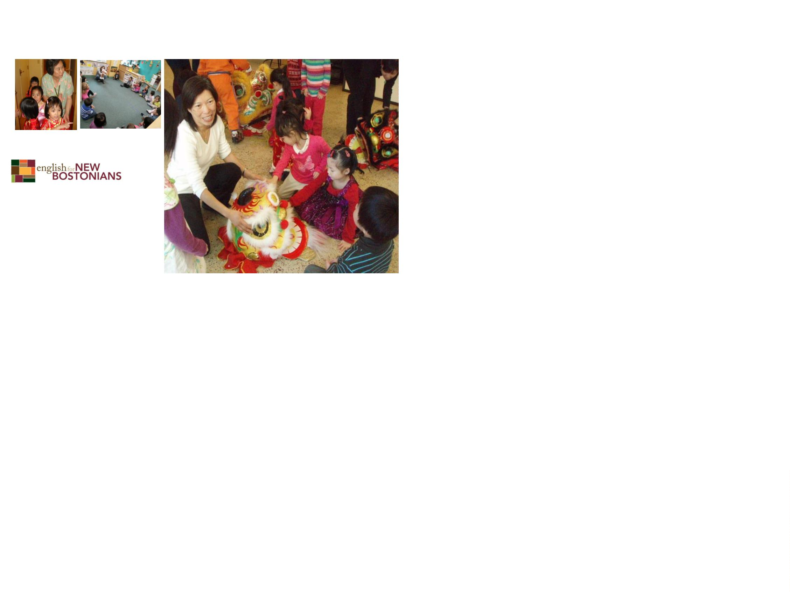

Energy and good health
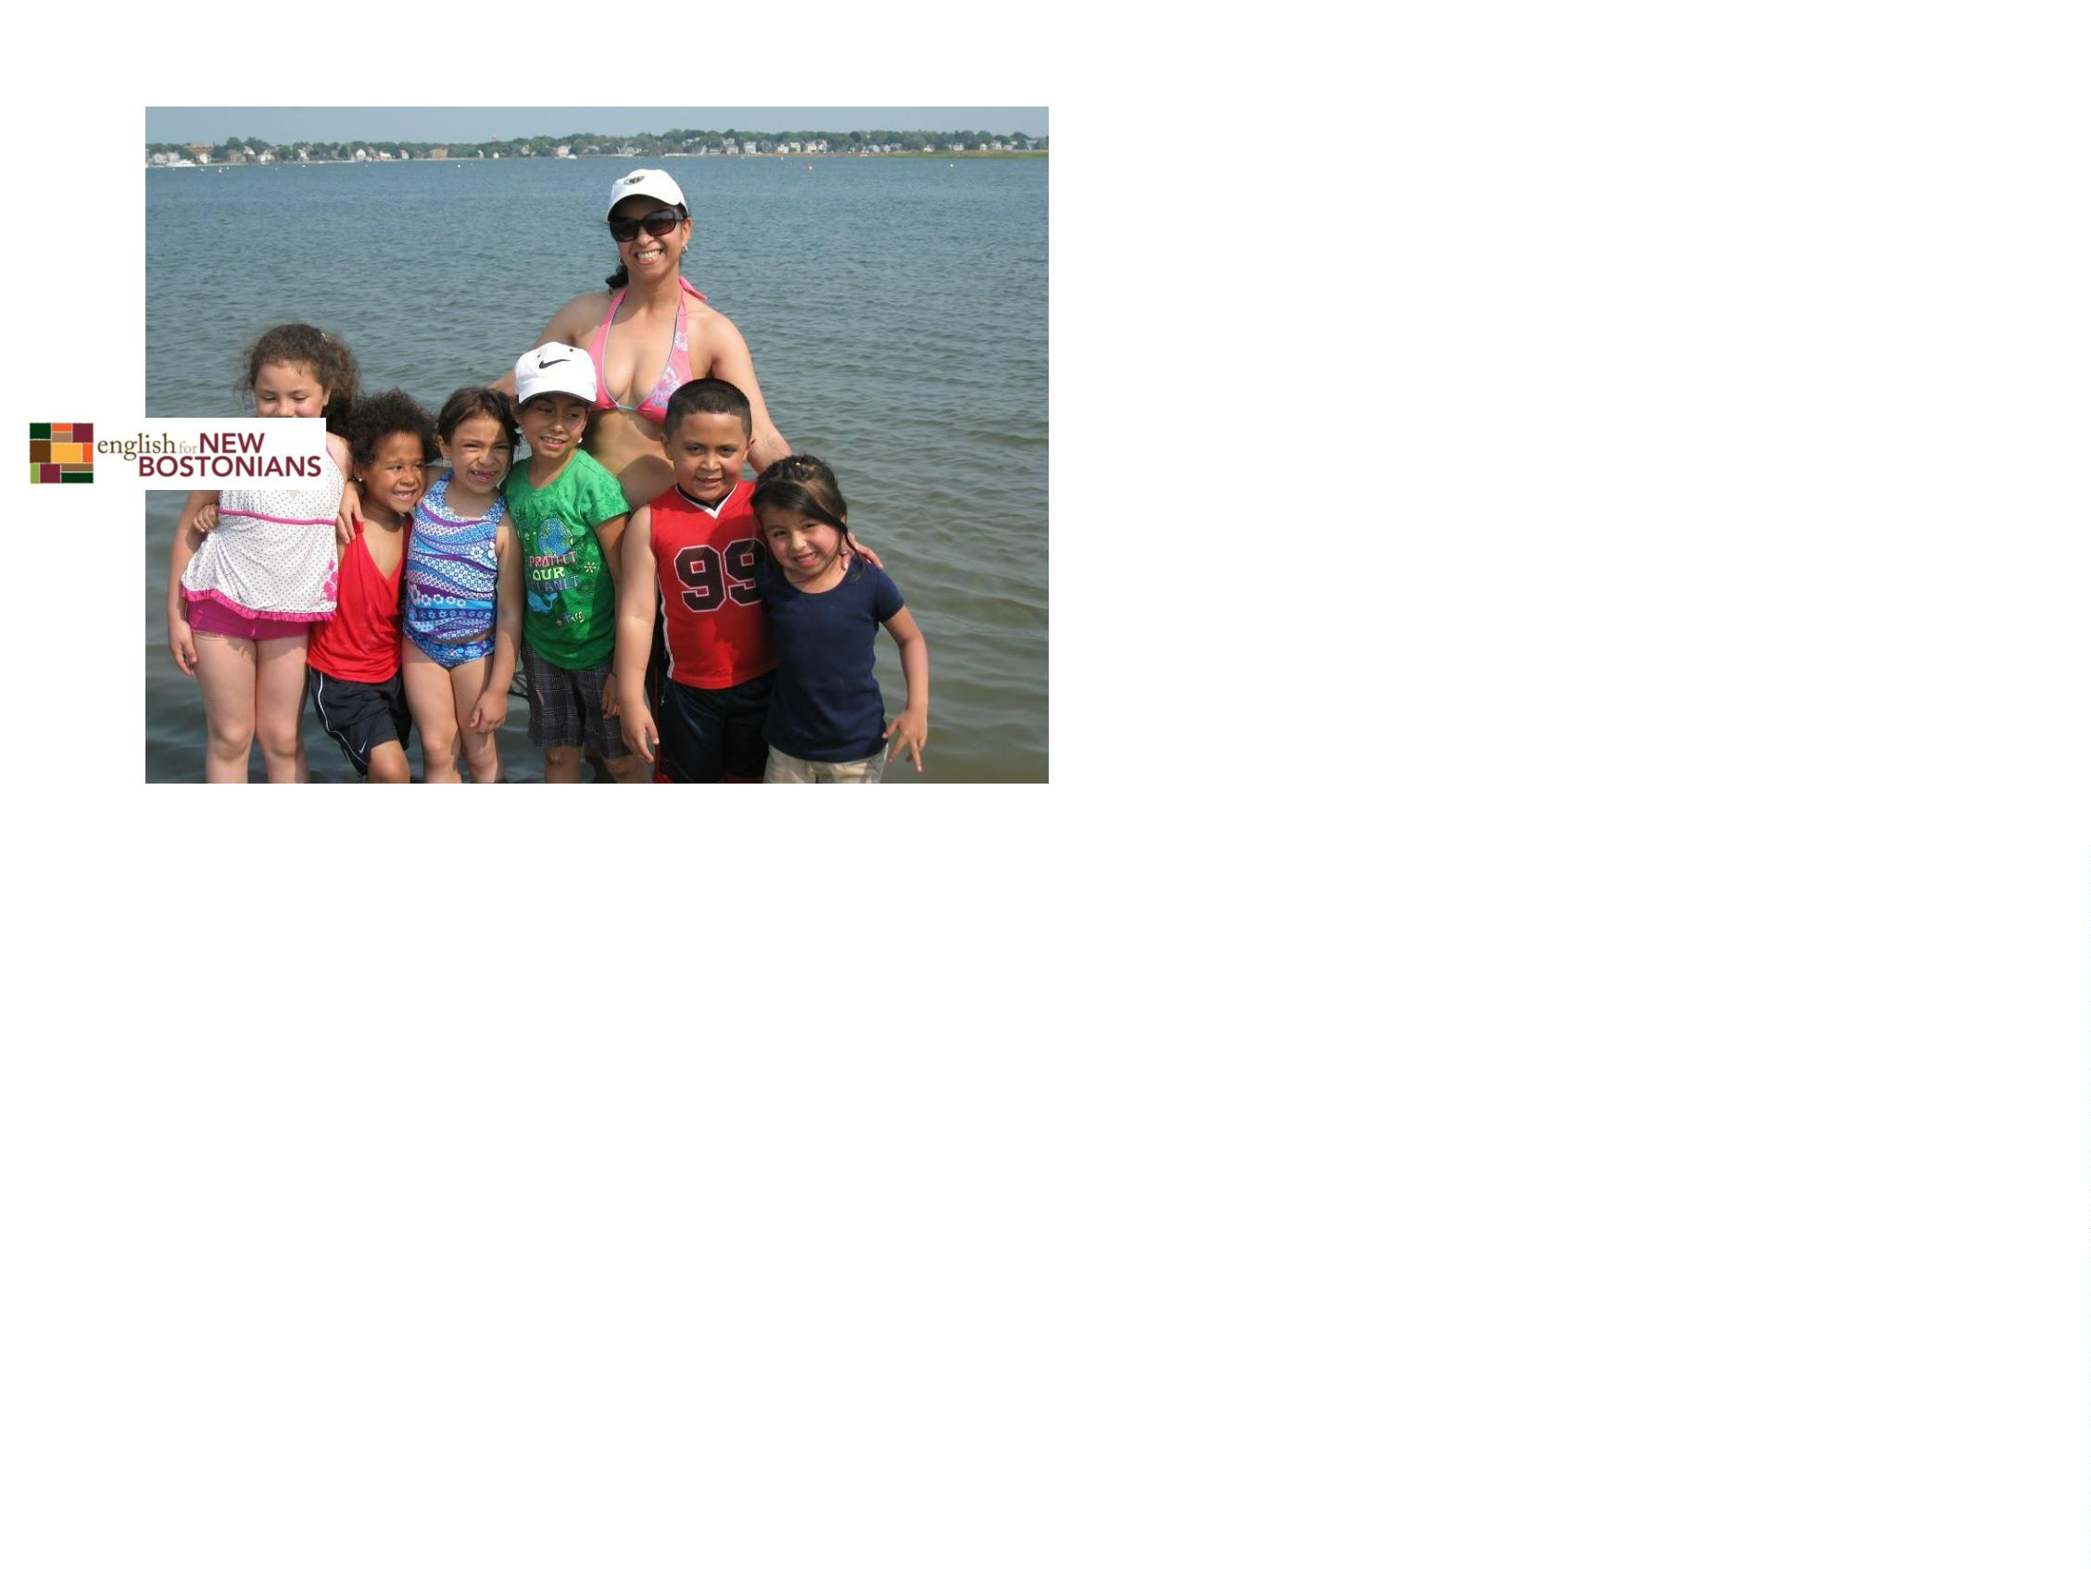

A love of learning
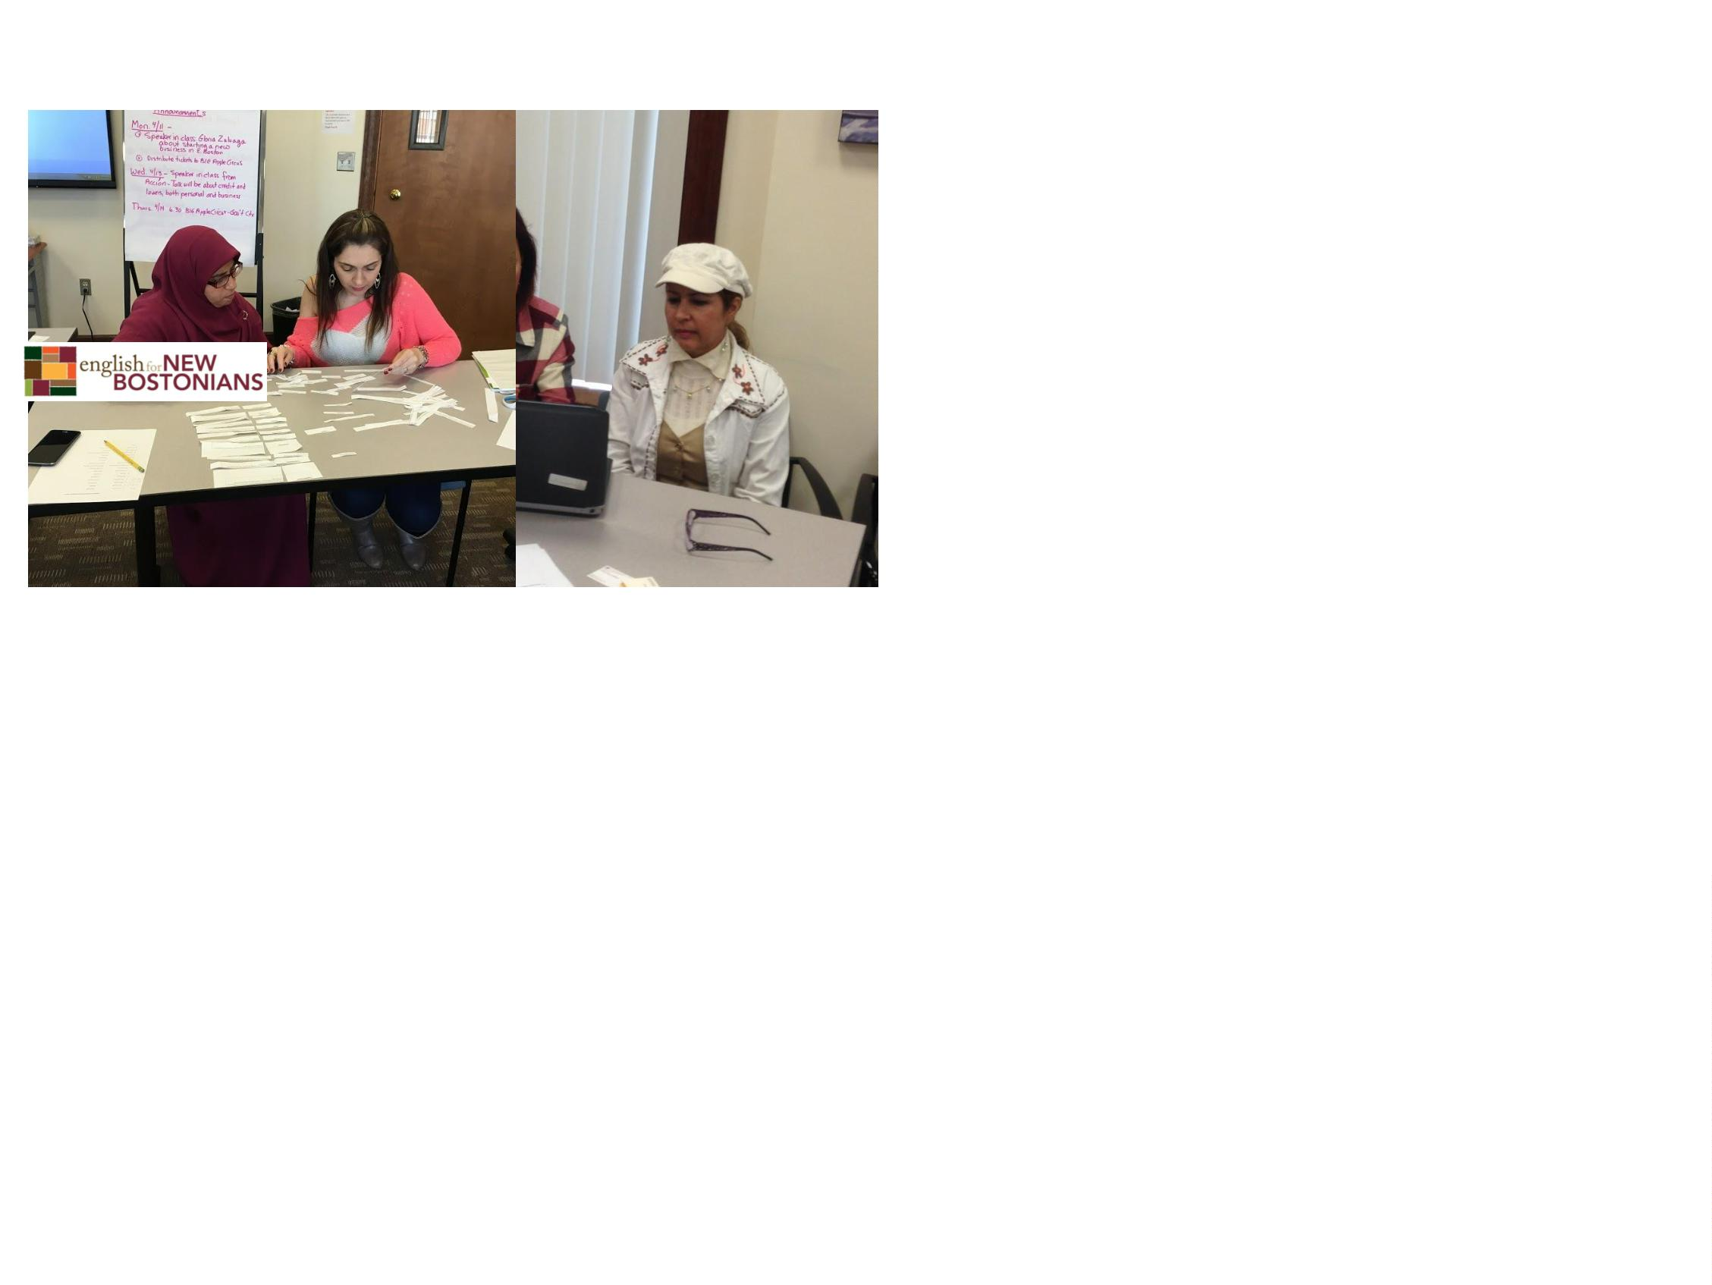

What if I want to work in a licensed
child care center as a teacher?
•
Start with a course in child development.
Many colleges offer this in English. Urban
College in Boston offers it in Chinese, Spanish,
and English.
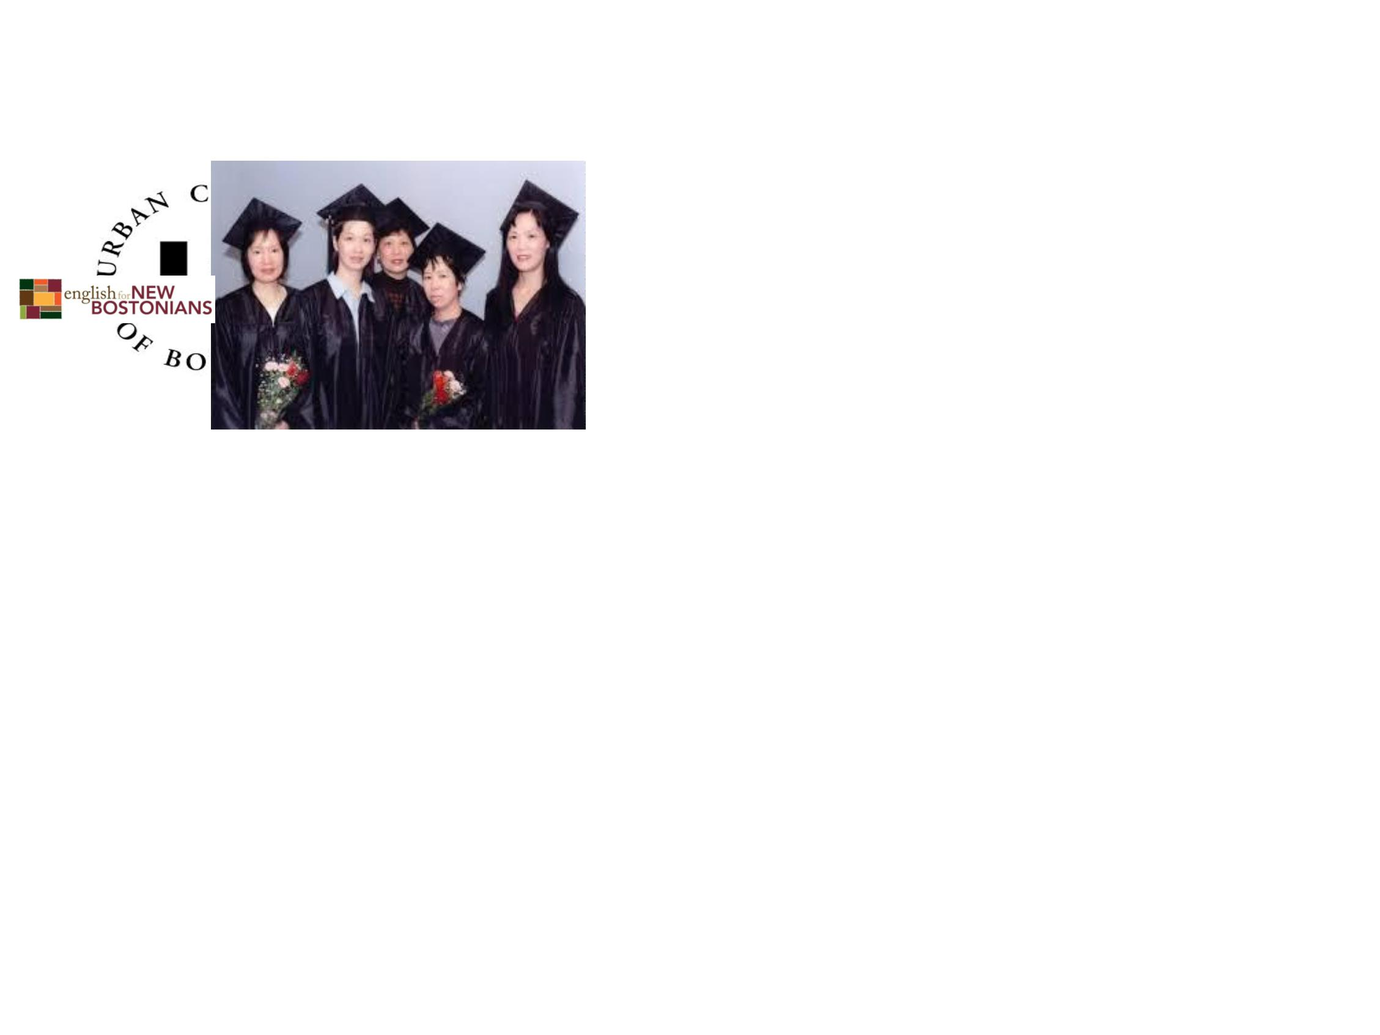

What else will I need to study
and learn?
•
•
How to plan interesting
and appropriate
activities for children
How to work with
parents and caregivers
so they can help their
children grow and
develop
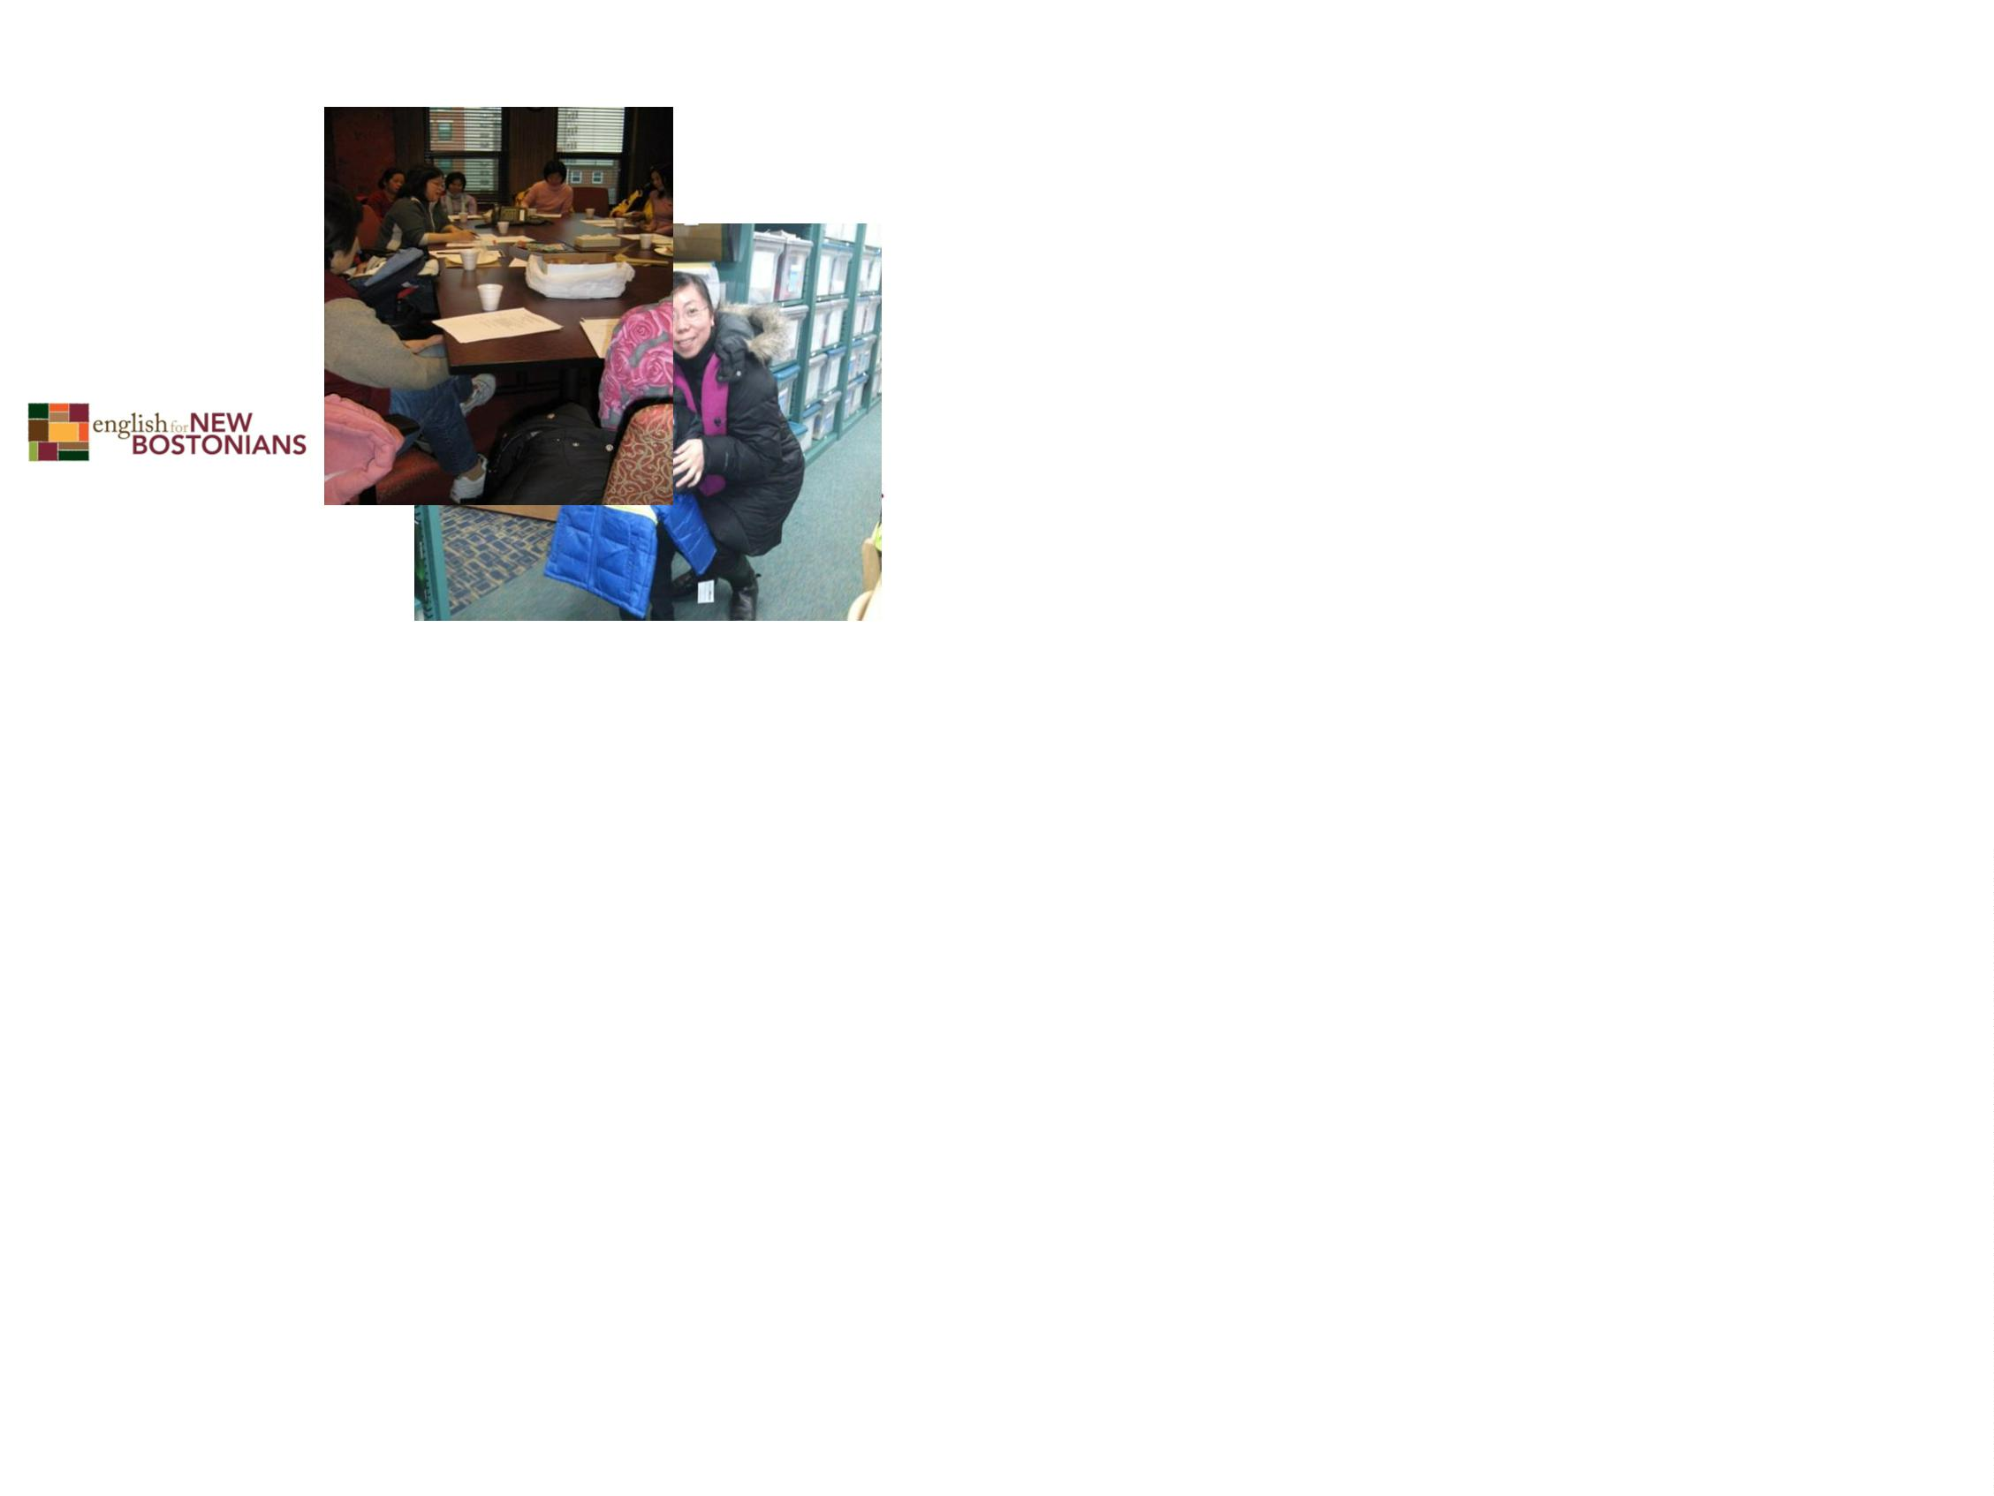

Other classes I can choose?
There are many interesting subjects such as
choosing children’s books, planning for science
and math experiences, and helping children to
be healthy and safe.
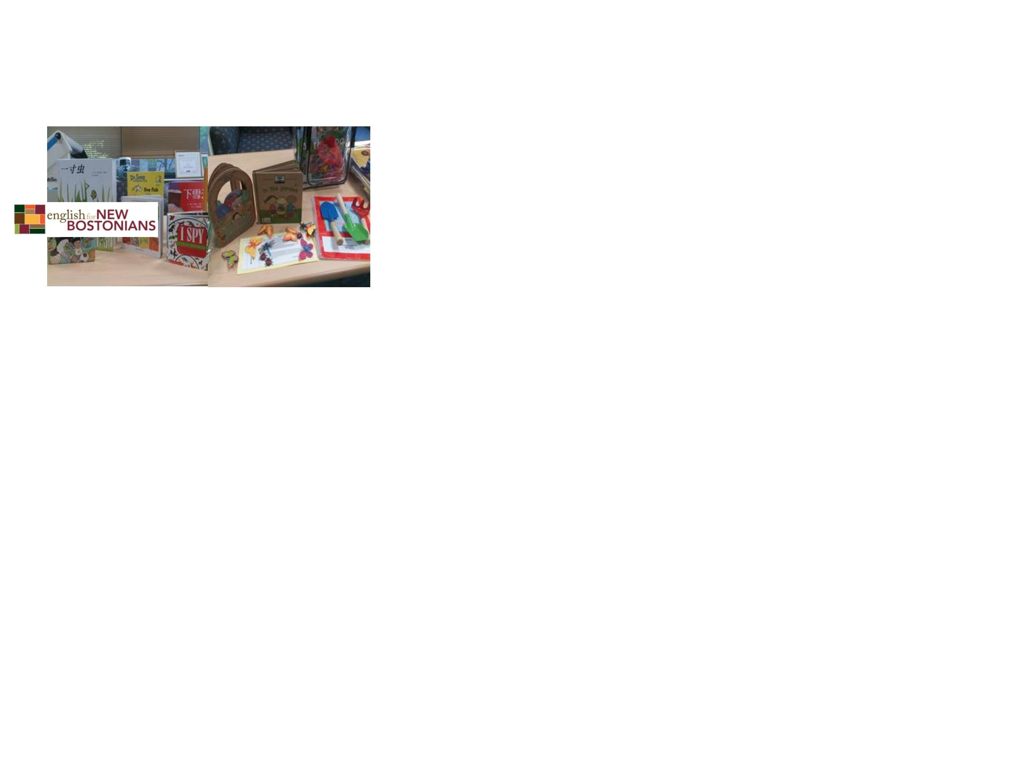

Will I need a degree?
•
A degree always helps and in the future more and more jobs
will require a degree. But now, many jobs in early childhood
education only require certificates.
Some possibilities are:
-
-
-
-Certification as an EEC teacher
-A child care certificate
-A CDA (Child Development Associate)
•
Family Day Care does not require any certification. But you
must attend 10 hours of training every year.

Experience
You will also want to gain some supervised experience
in a child care program. You can do this in several ways.
a) Work as a substitute teacher
b) Become an intern through a college
c) Work as an assistant in a child
care program
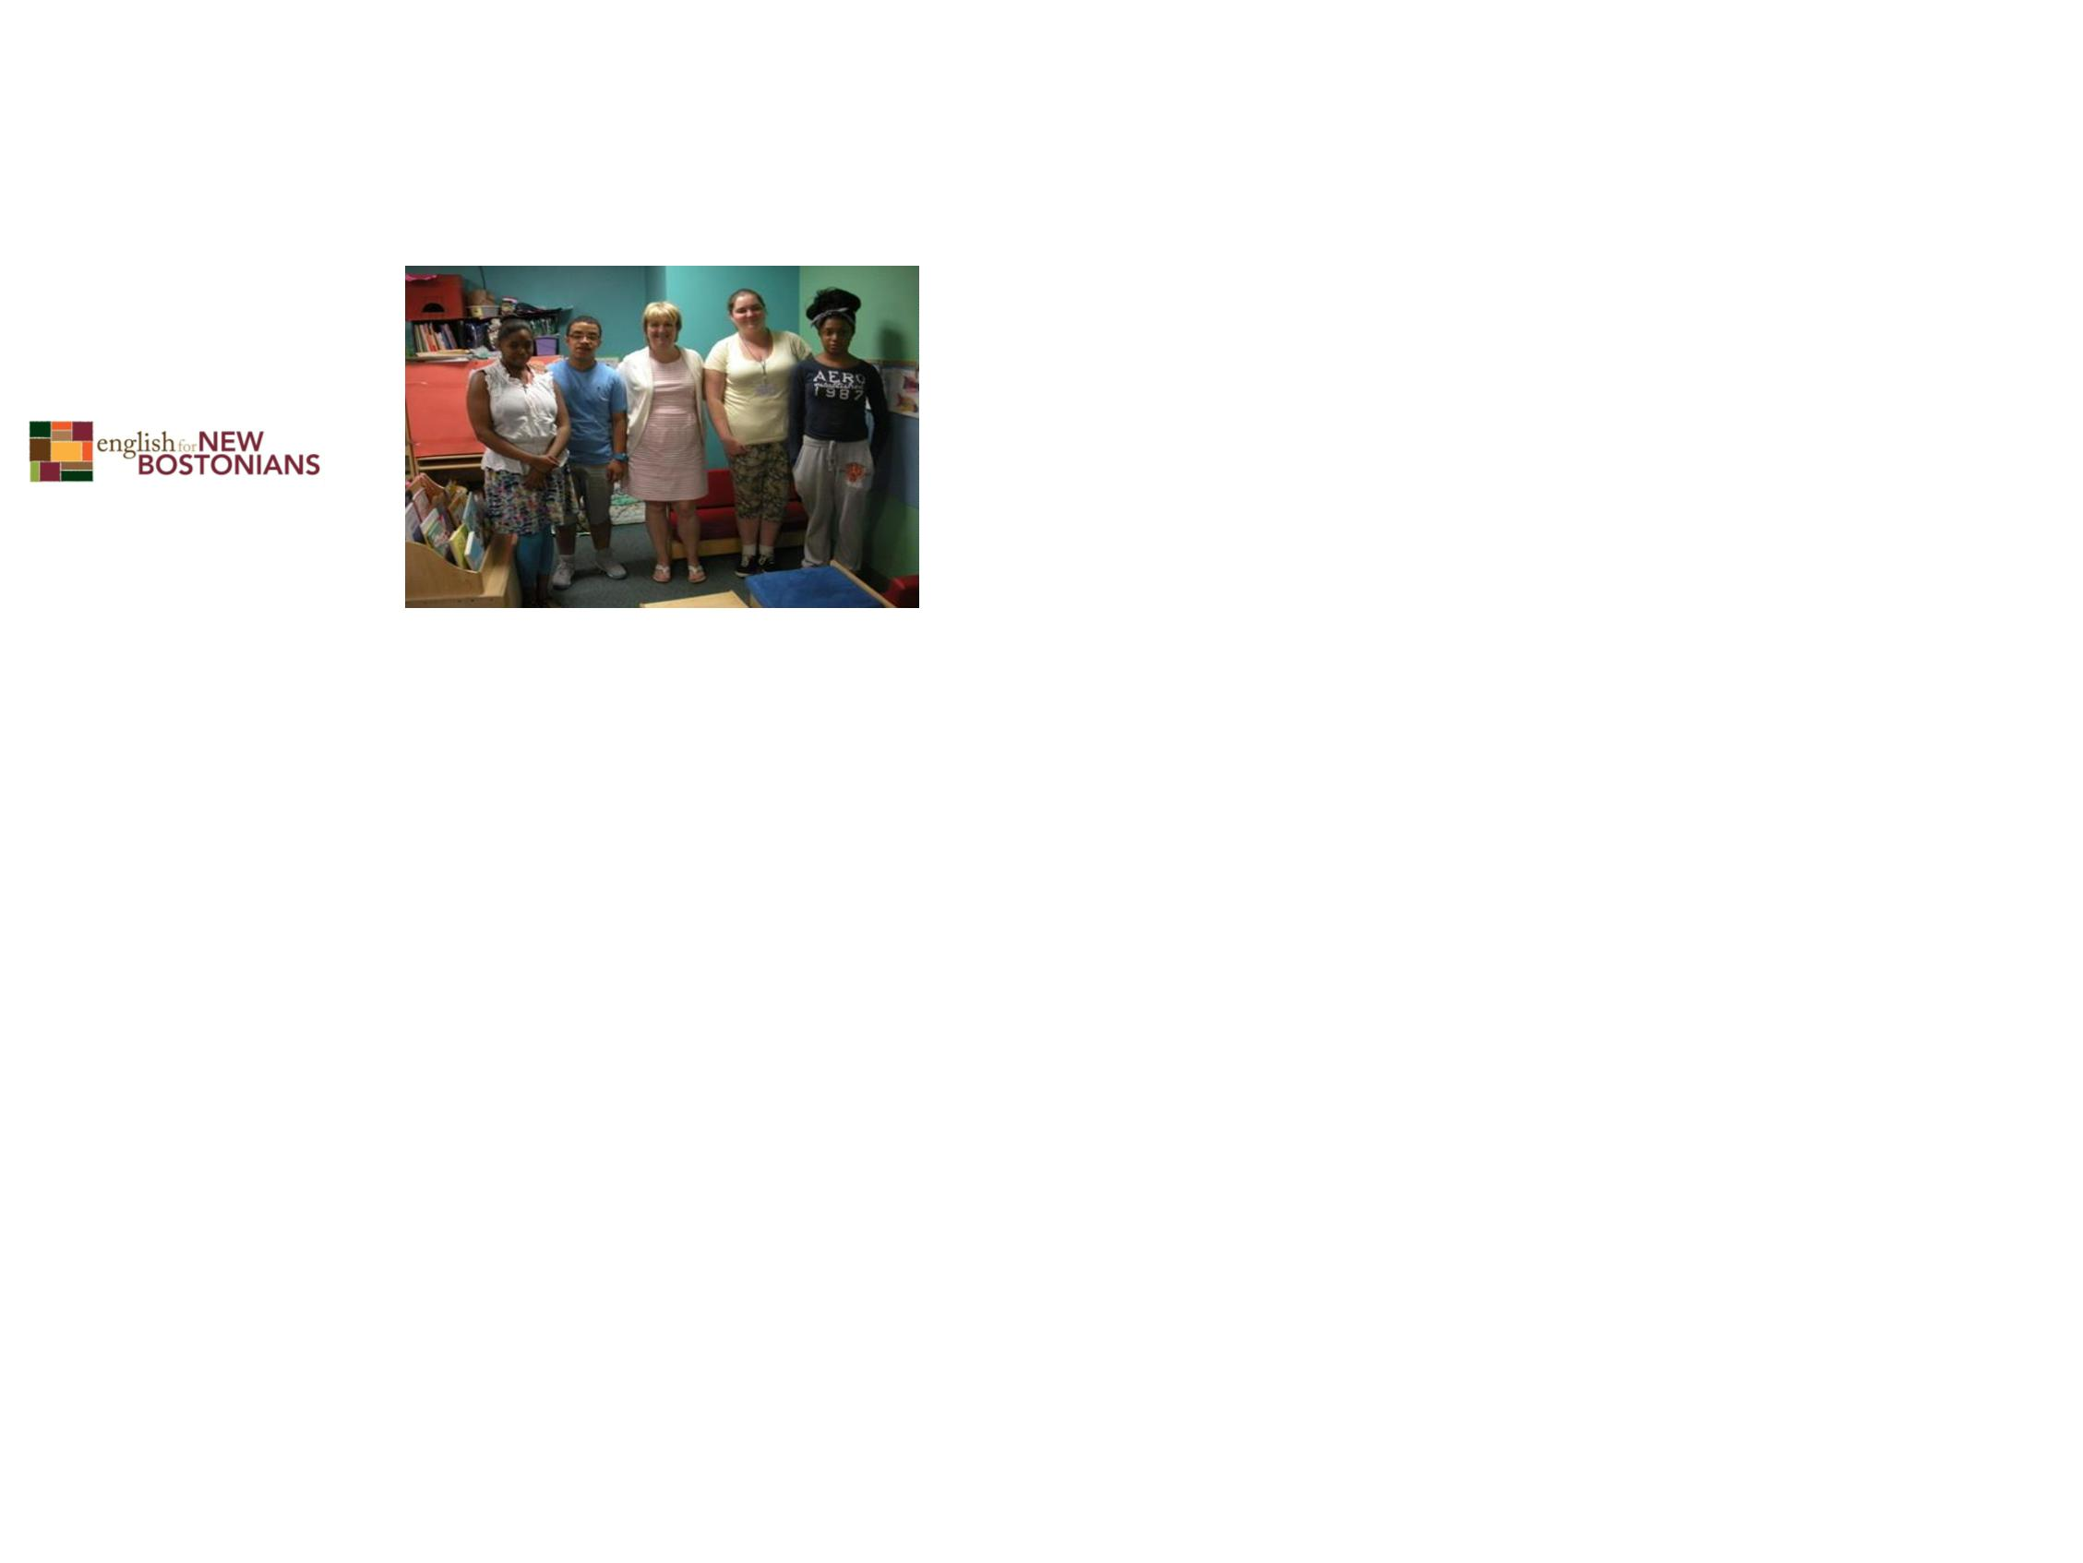

What else do I need?
•
A criminal and sexual record check and to
be finger printed to prove you are safe to be
around children
•
•
A physical and proof you are healthy
A first aid training certificate

How do I enroll in a college?
•
•
You can get information at the Boston Public
Library College Planning Center at the Copley
Square main branch.
Their services are free and you can drop in
without an appointment.

What if I’m not ready for college?
•
•
You can start with
workshops and
gradually begin to take
college courses.
You can work as a
substitute assistant
teacher in a child care
classroom and see if
you like working with
children.
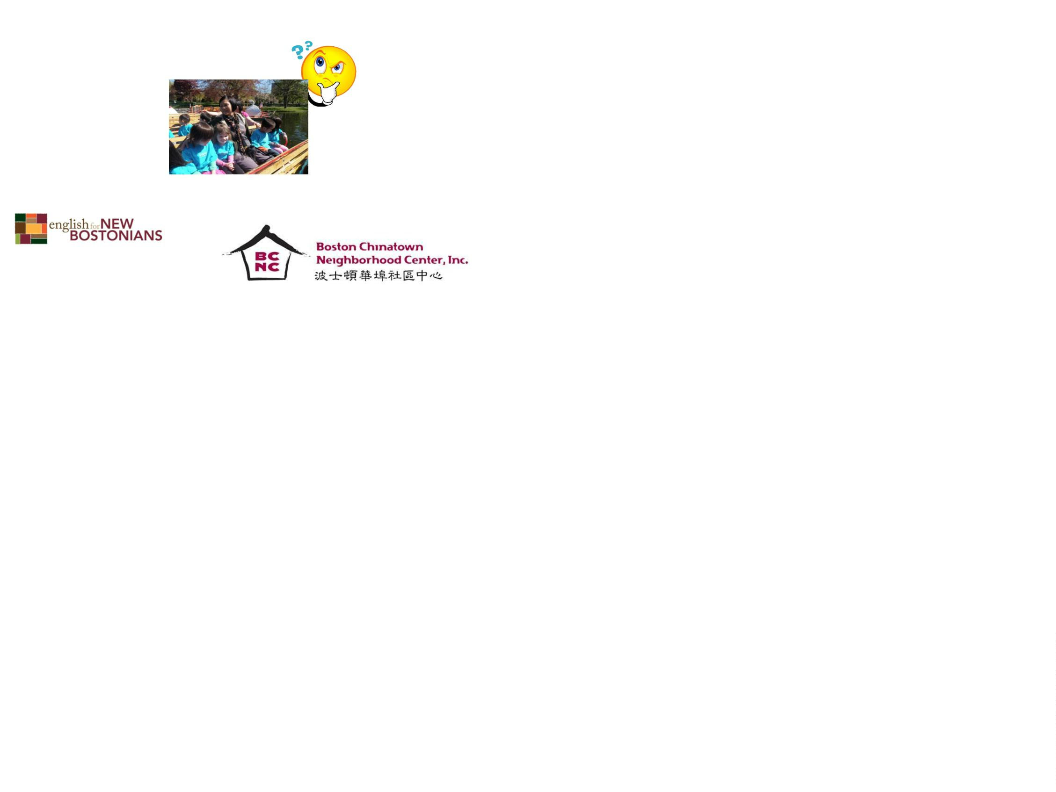

What else can I do in a child care
center?
You can be:
•
•
•
•
•
•
•
An administrator in a child care program
An administrative Assistant
An educational specialist
A director
An assistant director
A teacher/mentor
A center cook
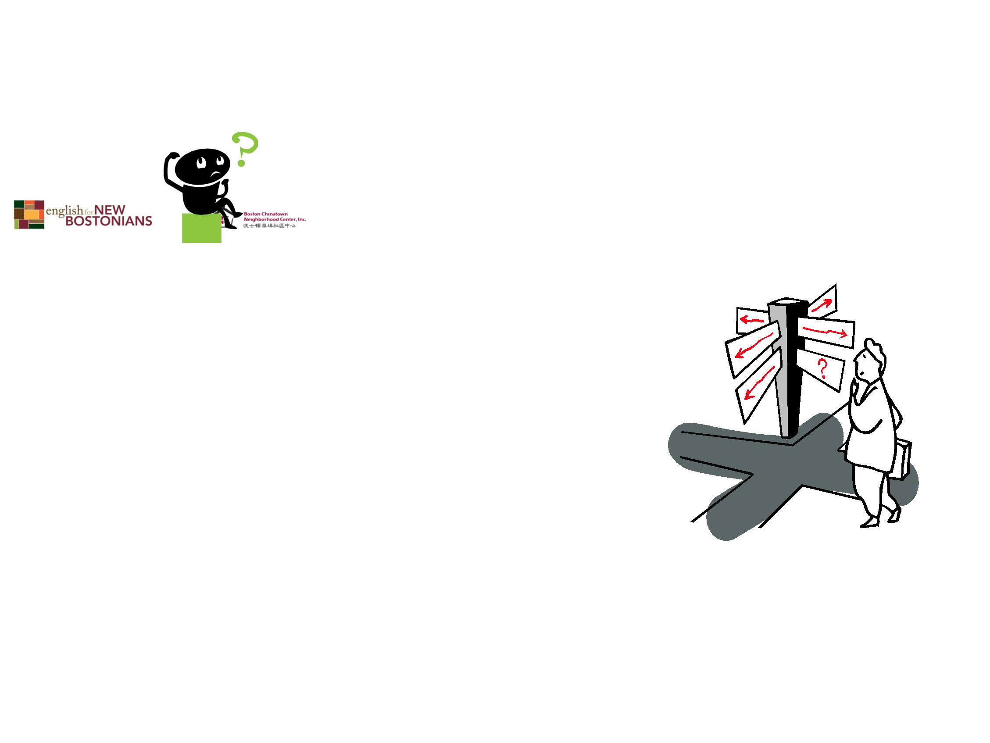

What if I want to work in a Boston
public school program as a teacher
or paraprofessional?
•
To be a teacher, you
will need to get a
Master ’s Degree. To
be a paraprofessional,
4
4 credits of higher
education or a AA or
BA degree are
required.
These can be from a
university in your country.


What about out of school?
Out of school positions require some of the same
things.
•
•
Health care check up
Criminal Record check, sexual record check, and
fingerprints
•
•
3-9 months experience in a licensed out of school
program (depending on education)
Training hours

Out of School
•
•
You will work with
elementary school age
children when they are
out of school.
Most of the year, hours
will be part time but
will switch to full
time in the summers
and on vacations.
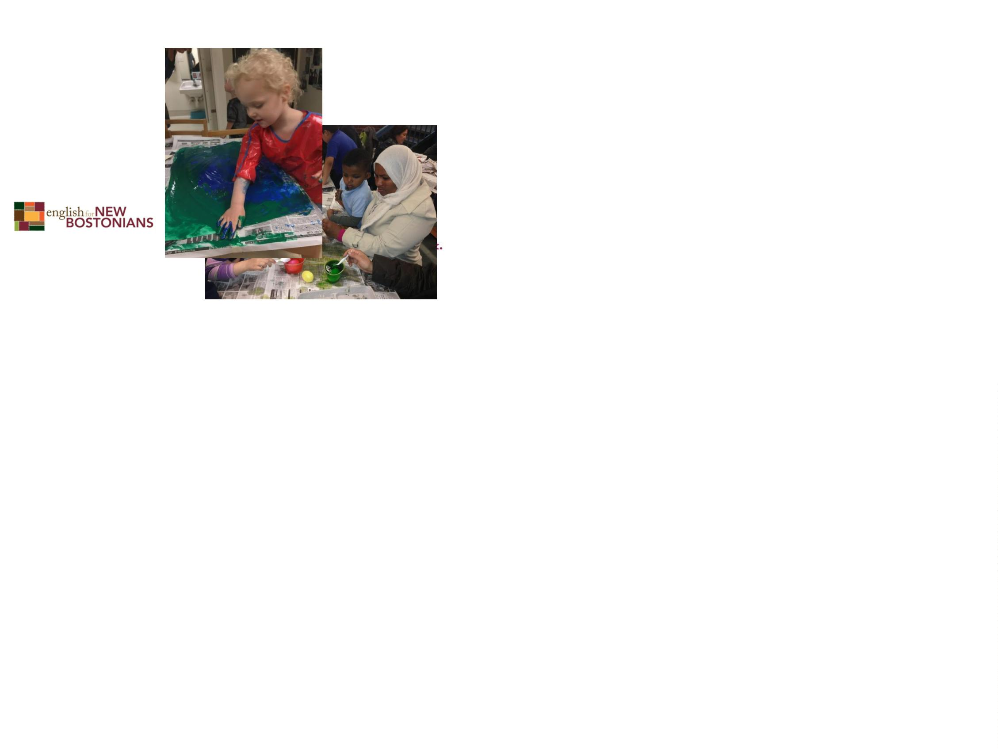

What else do I need?
•
•
•
Academic skills to help children with
homework
Ability to develop strong relationships
with children and their parents
A passion to share:
–
–
–
–
–
–
–
Art
Music
Sports
Children’s literature
Dance
Science
Computers
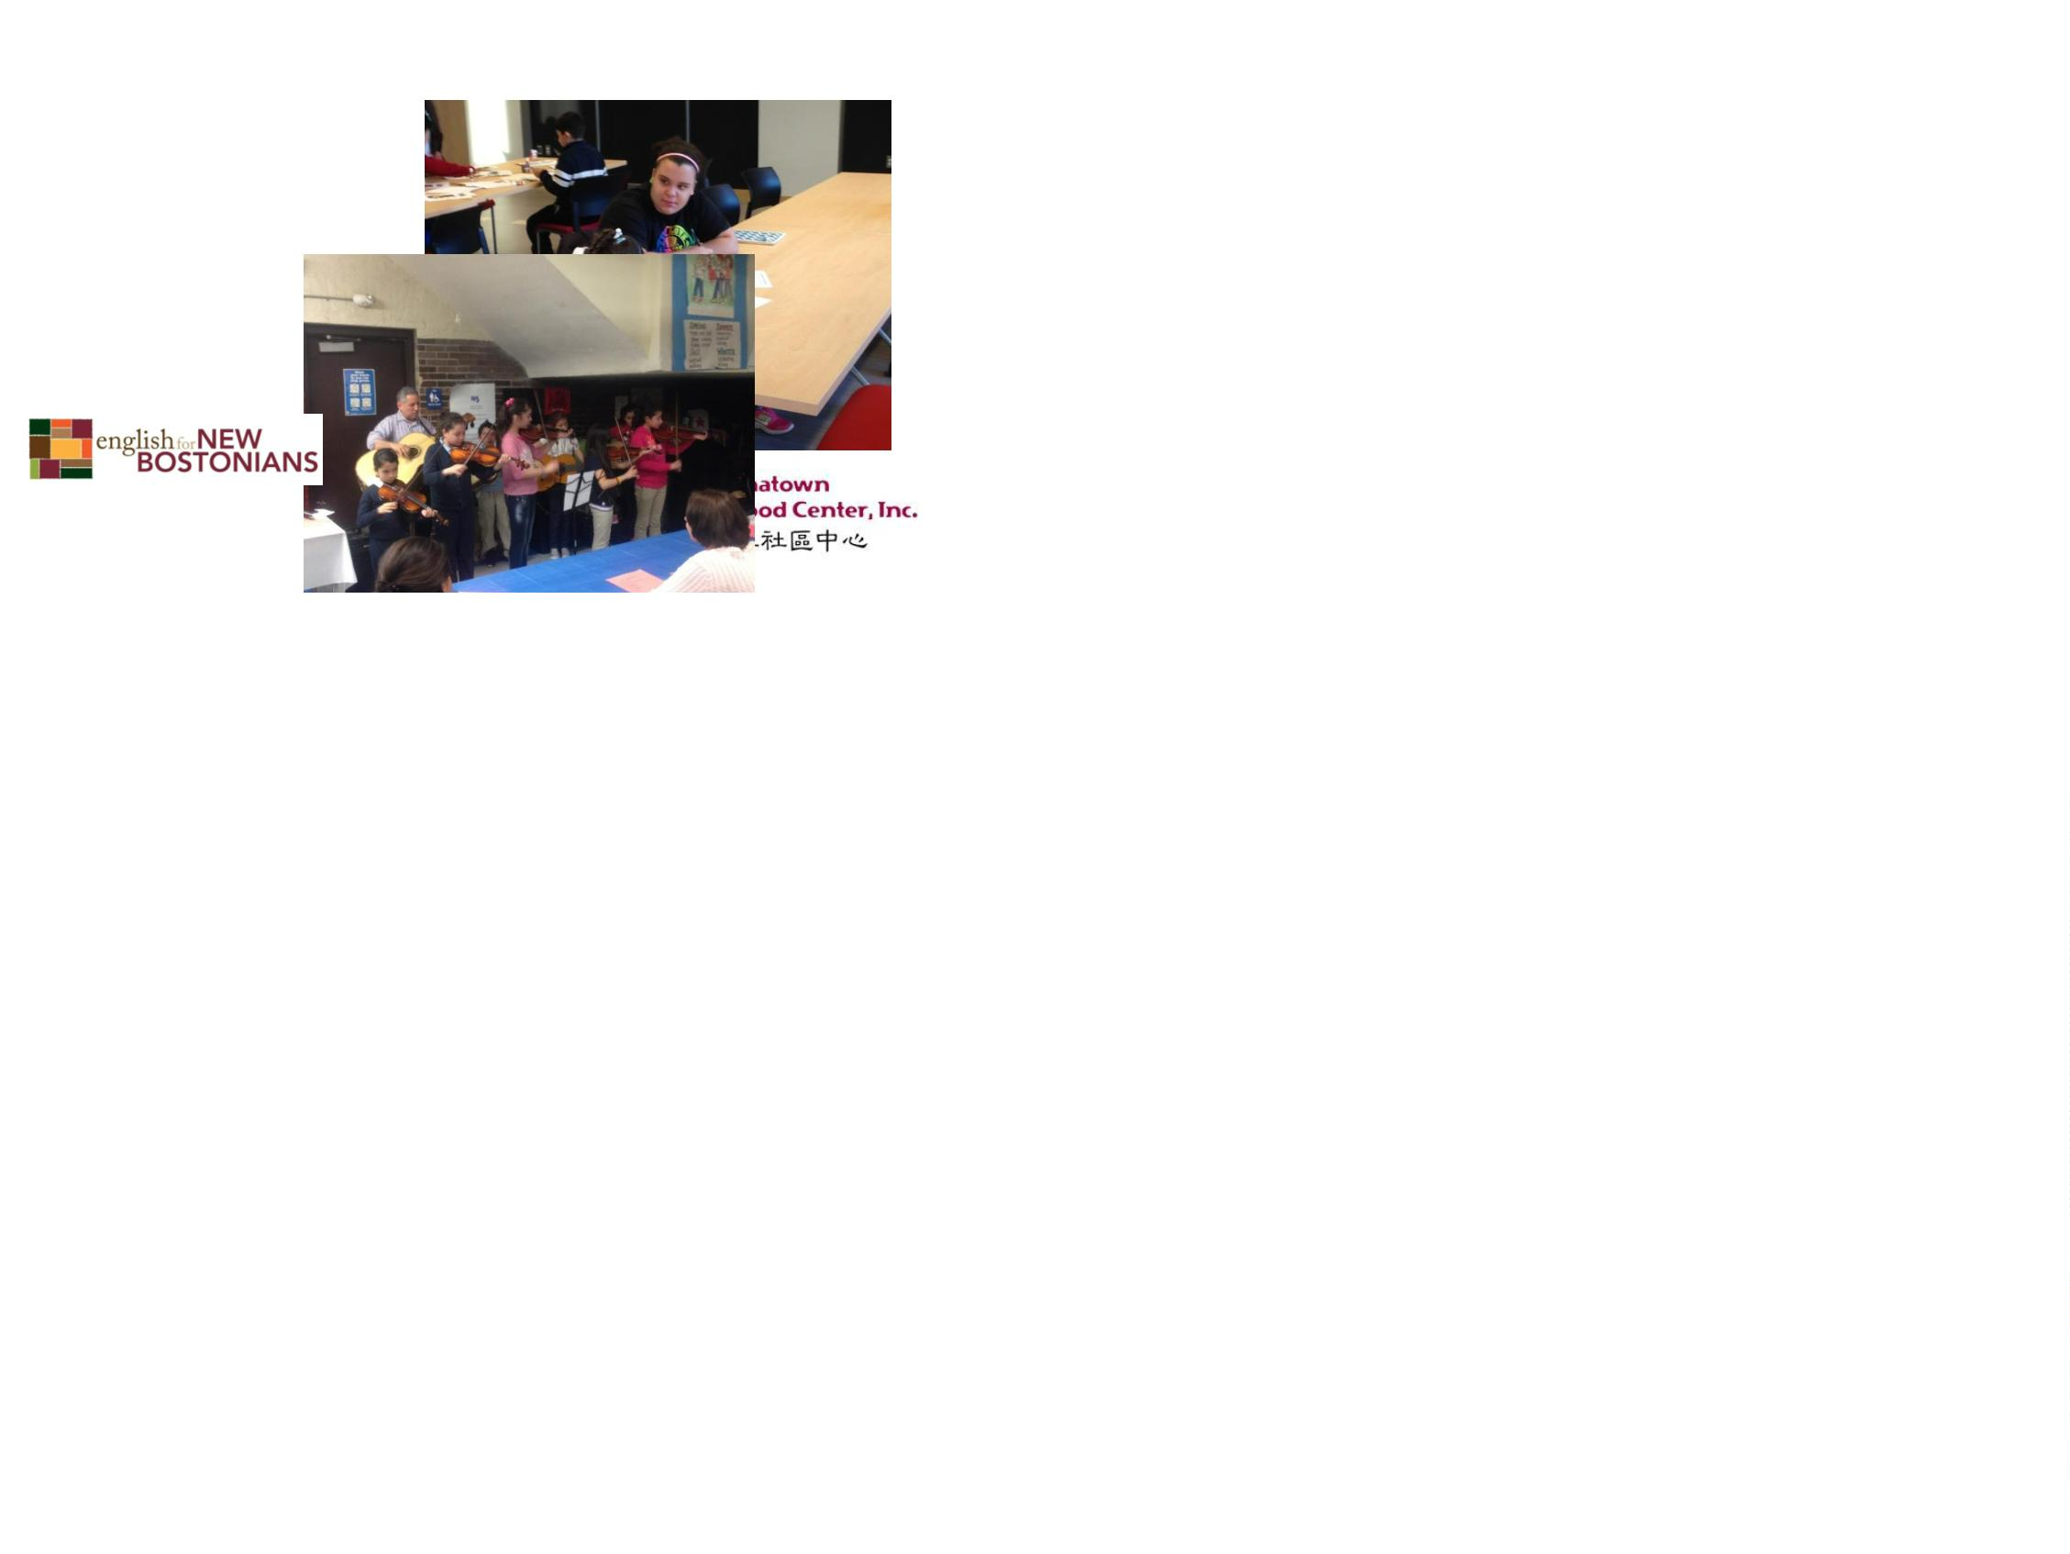

Are there any full time jobs in out
of school?
You can be an administrator, a director, or a site
coordinator and be responsible for supervision,
program planning, and funding an out of school
program.

Where do I start?
•
•
There are different paths for different people
Different end careers
•
Family Child Care
FCC •Home visitor
College
•
•
Child Care Educator
Child Care Administrator
Work
Early
Childho
od
•
•
Out of School Administrator
Out of School Group Leader
Out of
School
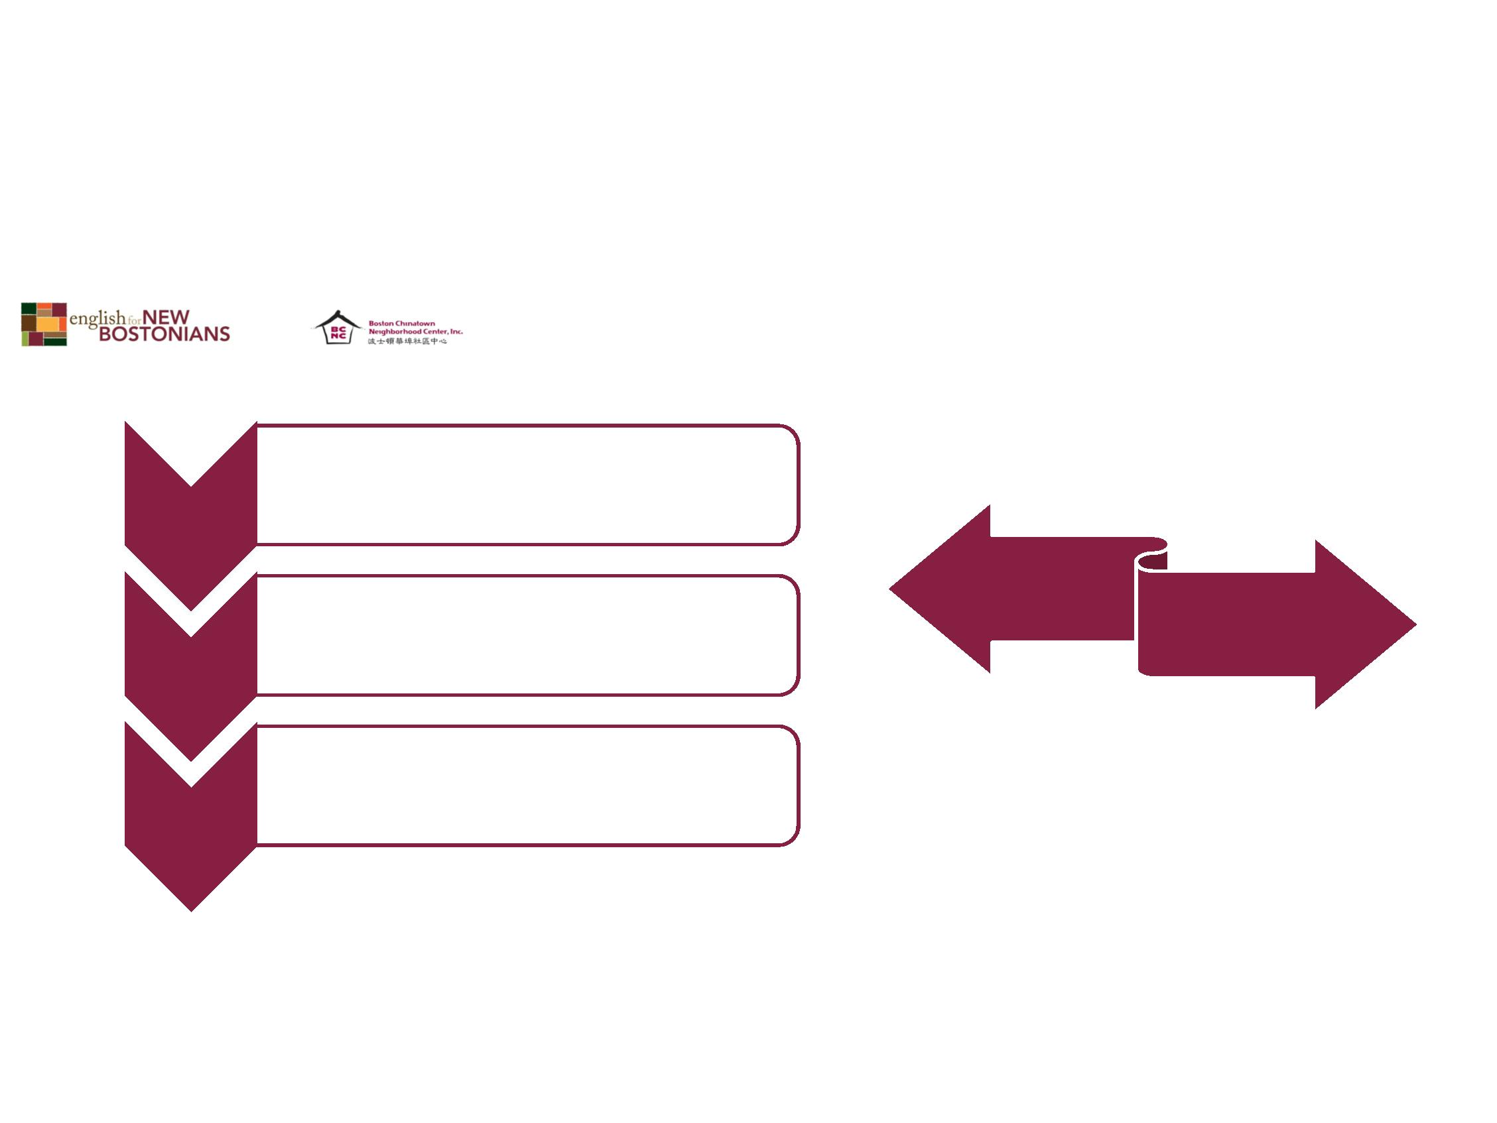

What if I don’t know yet?
•
•
•
Start with workshops
You can volunteer
Be a substitute teacher
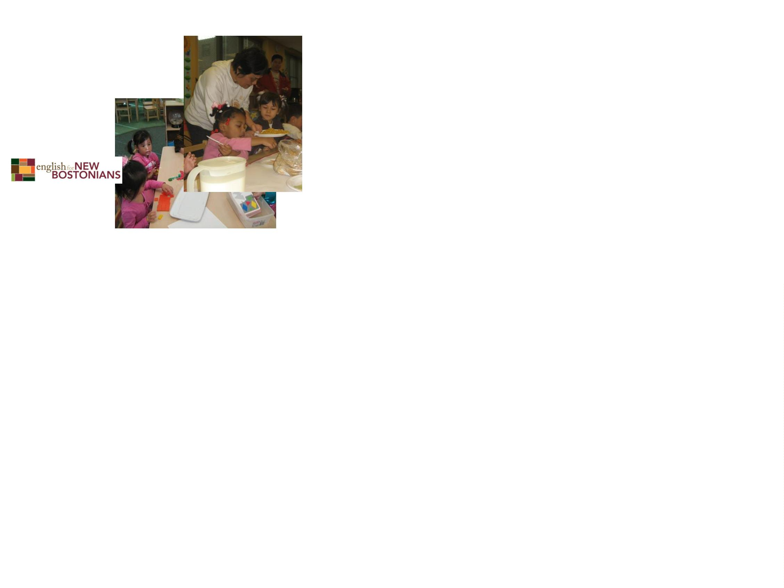

Why should I choose child care?
•
•
Children are our future and your work matters.
If you like being with children you will love your
work.
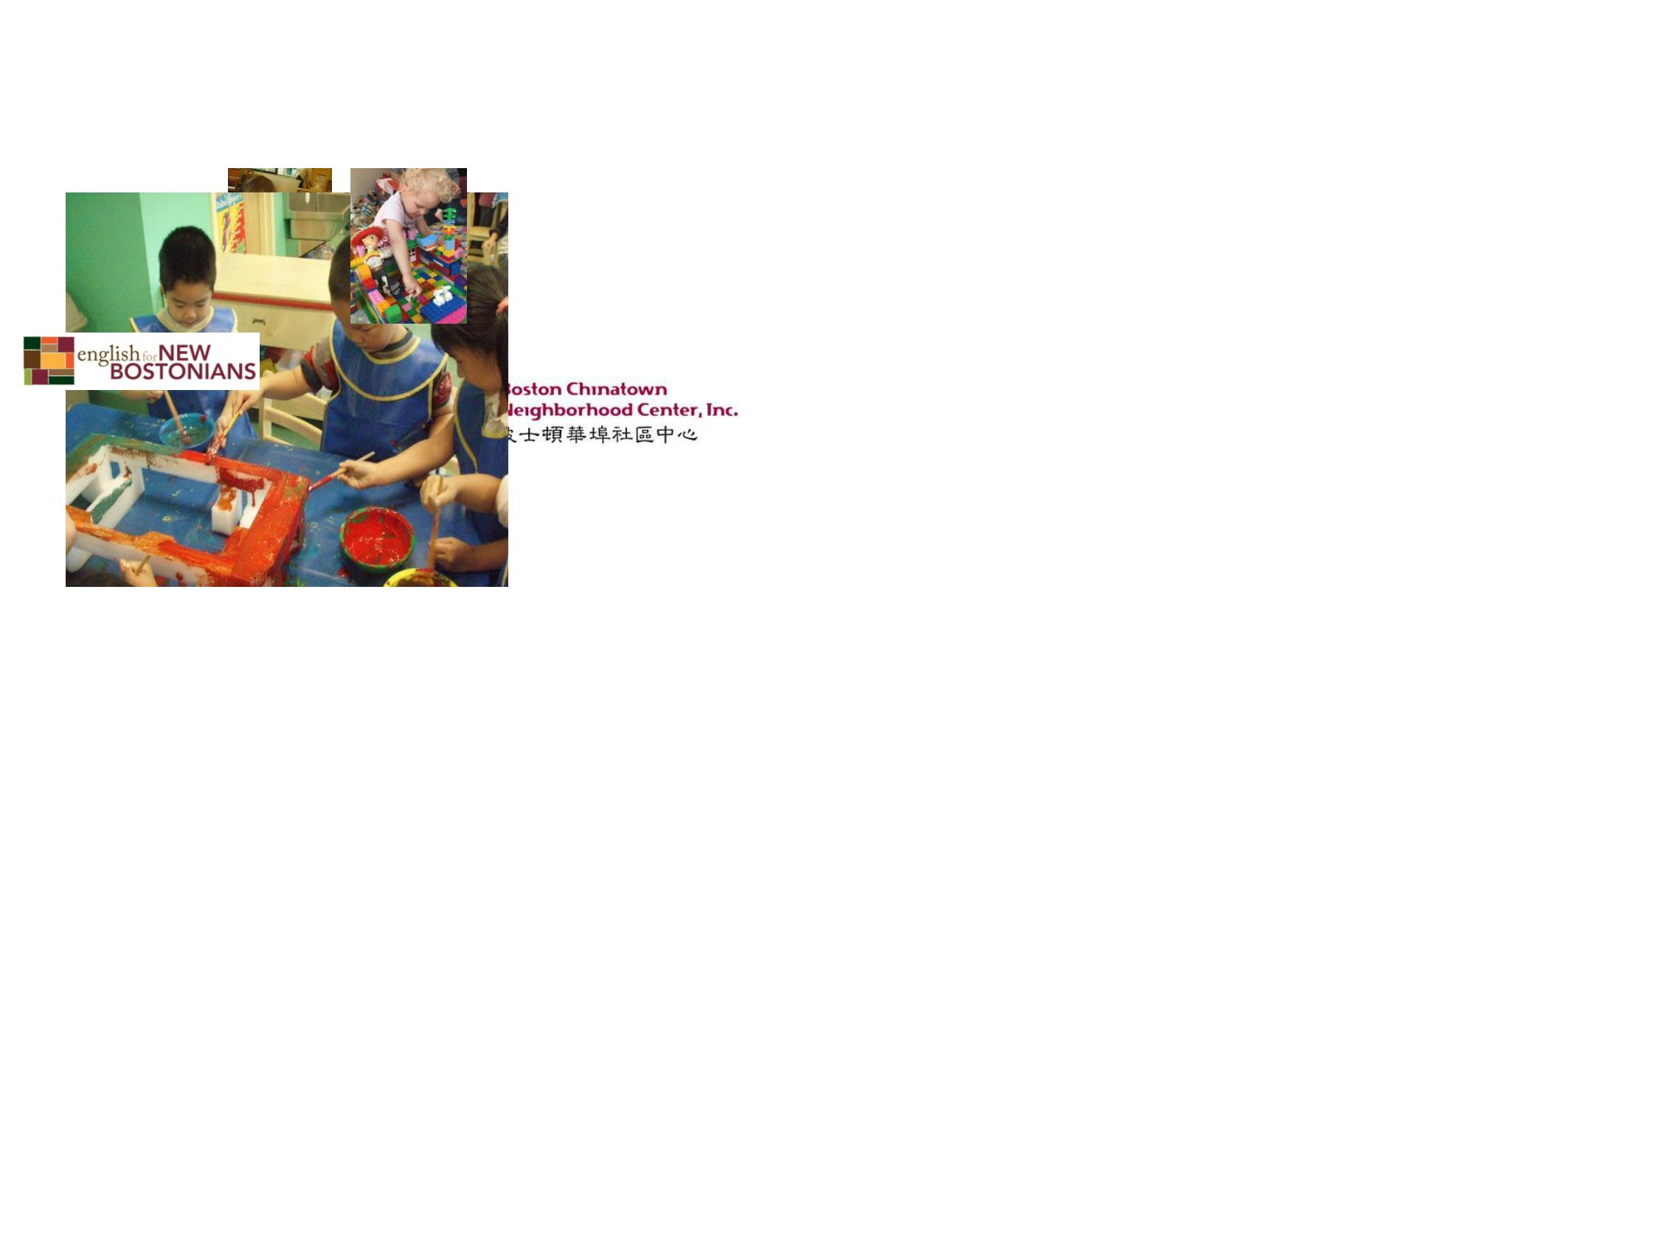

It’s becoming a recognized
profession
•
We now know that critically important brain
development takes place between the ages of
0
-3. So early child education is now recognized
as key to children’s success.
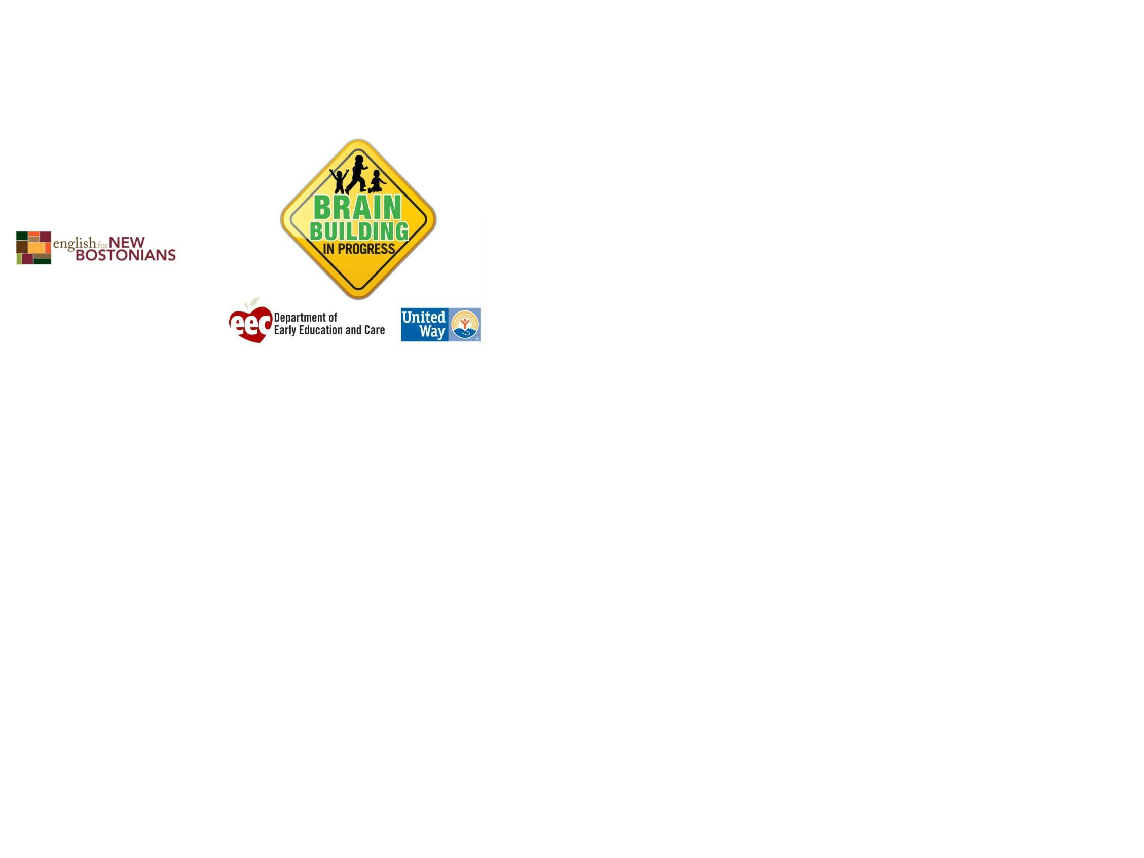

Will I make a lot of money?
•
Not compared to
some other
professions, but you
will always have work
and a meaningful life.
It matters if you come
to work and many
people find they can
make a living wage.
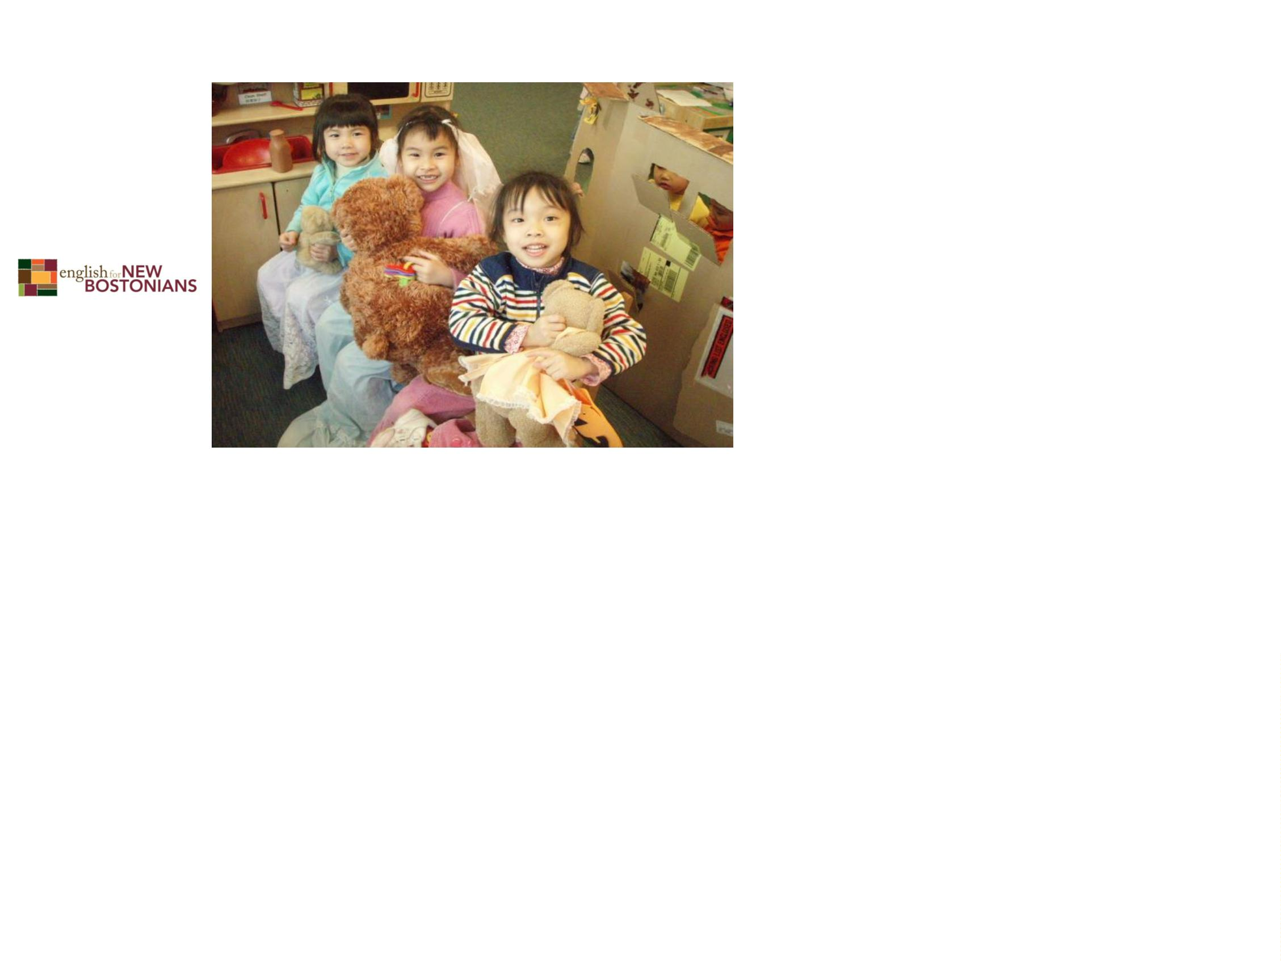

What else?
•
The best reason is because you really like
being with children and seeing them grow and
develop and you love working with young
families. If you do, early childhood education
may be the right career for you.

