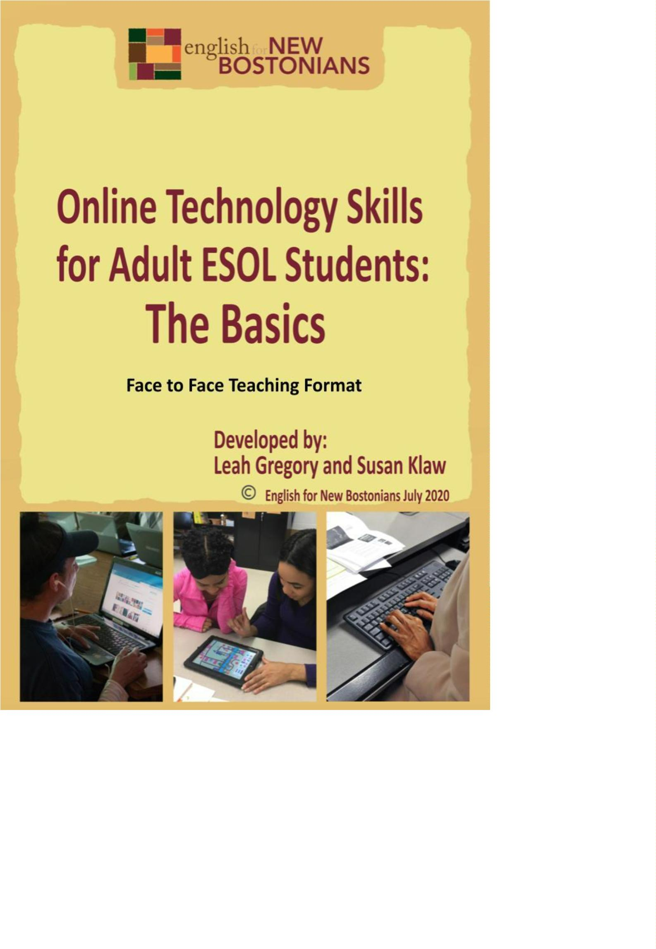

Face to Face Teaching Format: The Basics of
Online Technology Skills for Adult ESOL
Students
Pre-Activity: Identifying Technology Skills
Worksheet #1: Technology Skills Assessment and Goals
Activity 1: Chromebook Introduction and Setup
Worksheet #2: Chromebook Basics
-
-
-
What is a Chromebook?
Frequently Asked Questions
Check for Understanding
Guide #1: Opening and Using Your Chromebook
-
-
-
Introduction Video
Common Vocabulary
Chromebook Setup
Activity 2: Setting up a Google Email Account (Gmail)
Guide #2: Creating a Gmail during the Chromebook Setup
Guide #3: Creating a Gmail on a web browser (on any device)
Worksheet #3: Email Vocabulary
Worksheet #4: Email Vocabulary (cont.) and Greetings
-
Formal vs. Informal
Worksheet #5: Writing an Email
Guide #4: Attaching a Document to an Email
Activity 3: Downloading and Using Zoom and other Applications on a Chromebook
Guide #5: Downloading and Using Application on your Chromebook
-
Discussion Questions
Guide #6: Download and Signing in to Zoom
Guide #7: Using Zoom on a Chromebook
-
Exercise: Zoom Chromebook Review
Guide #8: Using Zoom on a Smartphone
Exercise: Zoom Smartphone Review
-
Activity 4: Student Guide to Google Classroom
Worksheet #6: Google Classroom Basics (for students)
-
-
-
What is Google Classroom?
Frequently Asked Questions
Check for Understanding
Guide #9: Connecting to a Google Classroom on a Chromebook
Introduction Video
-
Unit 1: Technology Skills for Beginners in a Face to Face Setting
English for New Bostonians July 2020
2


-
Google Classroom Guide
Worksheet #7: Google Classroom Exploring
Unit 1: Technology Skills for Beginners in a Face to Face Setting
English for New Bostonians July 2020
3


Pre-Activity: Identifying Technology Skills
Rationale: It is important to note that Online Learning and Technology literacy requires whole sets of
skills that most learners have to acquire if they have never been a part of an online learning platform.
These skills need to be taught and recognized as necessary skills in order to complete an online learning
course. Know that many of the skills in this brief curriculum are skills that will assist in a student’s
learning, but are not everything. Careful planning and consideration of time, devices, connection, self-
motivation and discipline are necessary for successful online learning for students of all ages. This
curriculum supplement is merely a skills guide for beginner online learners during Face to Face learning.
It can serve to assist the teacher in teaching technology skills to their students and as a Guide for
students working independently at home.
Student Objectives:
-
-
Students will identify skills that they have and skills that they need to acquire.
Students will make goals for themselves when starting online learning.
Materials:
-
Worksheet #1: Technology Skills Assessment and Goals
Activity Outline:
1
.
Explain the objectives. As teachers, we need to empower students with the knowledge that they
already have and show how it can help them tackle new challenges. Technology is certainly a new
challenge! By allowing students to share what they already know about technology, it allows you to
know where you stand in your class via digital skills. And students can be very helpful to their
classmates as they work through mastering digital skills. Read through the worksheet Technology
Skills Assessment and Goals worksheet and have students identify the skills they know right now.
Review the discussion questions and ask students to discuss their answers in small groups.
Have students identify a few technology goals that they would like to achieve throughout the year.
2
3
.
.
Follow-Up: These questions could also be used in a worksheet or small group at the end of a cycle or
year to determine what the students know now after completing the course.
a. Did your skills change?
b. Was your goal achieved? Or did you make steps towards meeting your goal?
c. What was a skill you learned that was helpful in an area outside of class?
Unit 1: Technology Skills for Beginners in a Face to Face Setting
English for New Bostonians July 2020
4

Name: ___________________
Worksheet #1: Technology Skills Assessment and Goals
Directions: Read through the technology skills needed to successfully do online learning. What skills
do you need more help with? What skills do you already have? Put a Y (yes) for skills that you have
right now or N (no) for skills you will need to learn. Note: A Chromebook is a type of laptop.
Pre-Class Technology Skills Assessment
Phone
Laptop
1
2
. I have a Gmail or another type of email account.
. I know how to use an internet browser (search, back button, etc.).
3
4
5
6
7
8
9
1
1
1
. I can send and receive emails.
. Send an attachment to another person.
. Receive and open an attachment from another person.
. I can copy and paste text or pictures into an email or document.
. I can describe a technical problem to my teacher.
. I can open a Google doc in my Google Drive.
. I can access a meeting link to join my class (Zoom, etc.).
0. I can download an application.
1. I can restart my computer.
2. I can type, but I want to improve my typing skills.
Discussion Questions:
1
2
3
. What skills do you need more help with?
. What skills do you already have?
. What skills do you want to improve?
Unit 1: Technology Skills for Beginners in a Face to Face Setting
English for New Bostonians July 2020
5


Goals: Write about one technology goal that you hope to achieve after you complete online
learning.
For example: I hope to feel more confident in typing OR I want to learn how to attach a
document.
Activity 1: Chromebook Introduction and Setup
Rationale: As we navigate a digital world, the relevance of digital and technological literacy is
increasingly important. Furthermore, understanding and using technology for work and family life has
never been so important. In this activity, we take a look at what a Chromebook is and how students can
use it. Chromebooks are an accessible, user-friendly laptop that is used throughout the nation in school
districts and at home.
Student Objectives:
-
-
-
-
Students will learn about the capabilities of a Chromebook and its basic features.
Students will learn how to connect to WiFi.
Students will learn vocabulary related to Chromebooks and technology in general.
Students will set up their Chromebook and learn about “Sign In” options.
Materials:
-
-
-
Chromebook (and cable cord)
Worksheet #2: Chromebook Basics
Guide #1:: Opening and Using your Chromebook
Activity Outline:
1
.
Explain the objectives. Print and distribute Guide #1 for students so they can have a hard copy to
follow and to save at home. The Guide is much easier to follow if you are able to print it in color.
Before students begin, review the Chromebook Basics worksheet together. There may be words
that are new to the students as they are technology words used mainly in speaking about
technology. Ask if any students are familiar with Chromebooks and what has been their experience
with them.
2
.
3
4
.
.
Ask the students to work in small groups to complete the true and false exercise.
When you start Guide #1, make sure your video is ready to be played on a screen and ensure that
subtitles are turned on. You can control the speed of a video using the YouTube video settings.
This is a great learning tool for students so show them how to do it and compare the speed
differences in terms of comprehensibility.
5
6
.
.
After watching the video, check for understanding. Review the vocabulary words and ensure
correct pronunciation. This can also be done before you show the video. Then, read through the
definitions and decide if you want to complete the exercise as a group or individually.
Before you start the step by step part (after the video), take a poll of who does and doesn’t have a
Gmail account. This will help know if students will need to create a Gmail during setup.
Unit 1: Technology Skills for Beginners in a Face to Face Setting
English for New Bostonians July 2020
6


7
8
.
.
If Chromebooks are NOT new, please skip to page 14 to assist students in logging in to an already
set up Chromebook.
Guide #1 is meant to be used with new Chromebooks so all students can follow the instructions as
they go. Proceed step by step with students and make sure that students are not jumping ahead as
they may miss an important step. Ensure that all Chromebooks are charged and/or plugged in. It is
important to write the Wifi Network name and password on the board so it is visible.
Follow-Up: Students should be able to do setup and login at home on their own. At the end of Guide #1
students are also given login options. Ask students to practice logging in as a guest or with their child’s
email at home.
Name: ___________________
Worksheet #2: Chromebook Basics
Directions: Read through the basics of a Chromebook and then watch the setup video. Complete the
small quiz at the end of this worksheet.
A. What is a Chromebook?
1
2
. Chromebooks are inexpensive laptops.
. They have basic tools and functions like:
○
○
○
○
connecting to the internet
checking email
browsing websites
downloading applications (apps)
3
. Chromebooks have a Google operating system (Chrome OS).
B. Frequently Asked Questions (FAQs)
Q. Does a Chromebook have internet access?
A. Chromebooks need to connect to a private or public network. They do not have
automatic internet access.
Q. Can my Chromebook work if I don’t have internet access?
A. Yes, but first you need to turn on the “offline” option.
Q. Can my Chromebook get a virus?
A. Anything is possible, but Chromebooks are much safer than regular laptops.
Q. Does a Chromebook come with Microsoft Office or other programs?
A. No, you need to download applications specifically for Chromebooks.
Unit 1: Technology Skills for Beginners in a Face to Face Setting
English for New Bostonians July 2020
7

C. Let’s check your understanding. Circle if the sentence is true (T) or false (F).
1
2
3
4
5
. Chromebooks are exactly the same as a laptop.
. Chromebooks have the internet automatically.
. It is possible to check email and download applications.
. Chromebooks are more expensive than a desktop computer.
. Chromebooks are safe machines.
T
T
T
T
T
F
F
F
F
F
Unit 1: Technology Skills for Beginners in a Face to Face Setting
English for New Bostonians July 2020
8


Guide #1: Opening and Using your Chromebook
Directions: Watch the video for an overview of the setup (double click on the picture or link). Then,
follow the instructions in Part C to go through each part step by step.
A. Setting up your new Chromebook. In this video you will learn how to:
○
○
○
○
Turn on and off your Chromebook
Choose your settings
Connect to wifi
Log in as a user or guest
Click on the picture to view the video in YouTube
Courtesy of Tech Goes Home
B. Read the vocabulary words and match with the definitions by putting the correct letter
next to the vocabulary word. These vocabulary words will help you understand the
directions.
1
2
3
4
5
6
7
8
9
1
. Plug in _____
. Charge _____
. Press _____
a. To select something electronically
b. Options to make something easier
c. Moving up or down on a computer
d. Connect to electrical outlet in the wall
e. Conditions of an agreement
f. Connect to a battery
. Click _____
. Choose _____
. Accessibility _____
. Proceed _____
. Scroll _____
g. To continue something
h. Apply pressure to something
i. To select an option
. Terms _____
0.Trackpad _____
j. A touch sensitive square on a laptop
Unit 1: Technology Skills for Beginners in a Face to Face Setting
English for New Bostonians July 2020
9
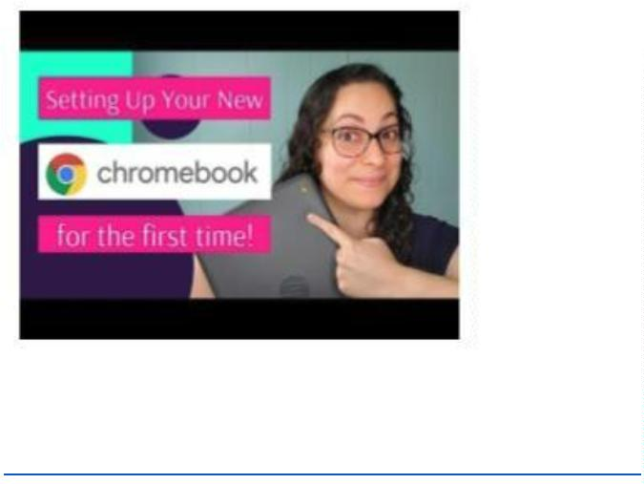

C. Follow this Guide as you go through your Chromebook setup.
1
. Plug in your Chromebook to charge. Open your Chromebook and press the power key.
Google
2
. Understand your trackpad:
Google
3
. Choose the language you prefer. Then click “Let’s Go”. We recommend English so that
you can receive help from your teacher if needed.
Google
Unit 1: Technology Skills for Beginners in a Face to Face Setting
English for New Bostonians July 2020
10
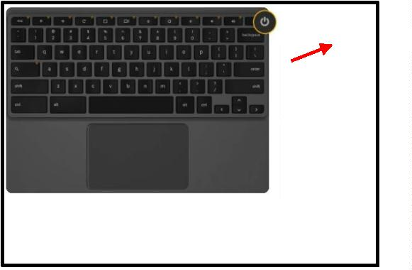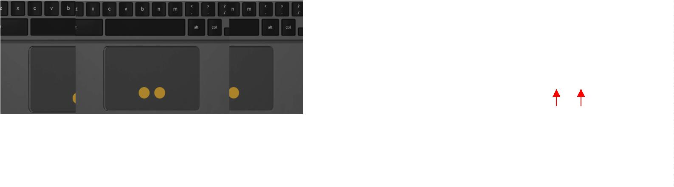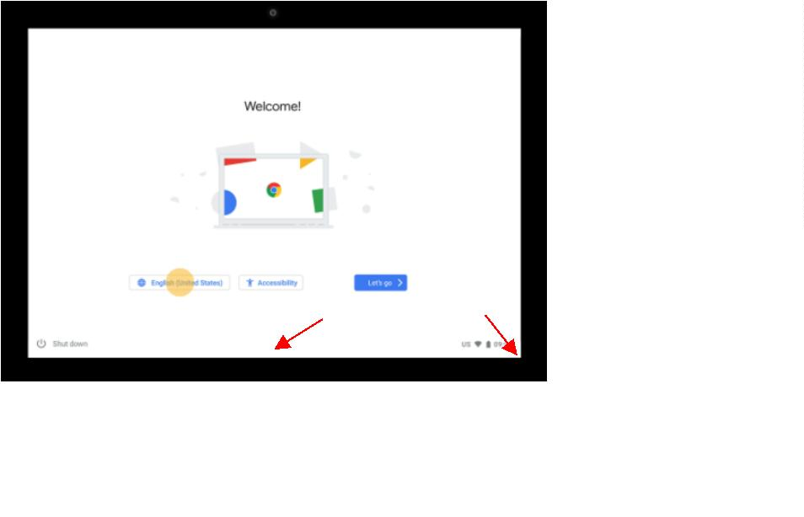

4
5
6
. Choose the language and keyboard options. Then select OK.
Select OK
Google
. Choose accessibility features if you want. After, click OK, then proceed to Let’s go!
Google
. Now we will connect to WiFi. Choose your network, then click next. If your network
has a password, enter the password and click next.
Select WiFi
Google
Unit 1: Technology Skills for Beginners in a Face to Face Setting
English for New Bostonians July 2020
11
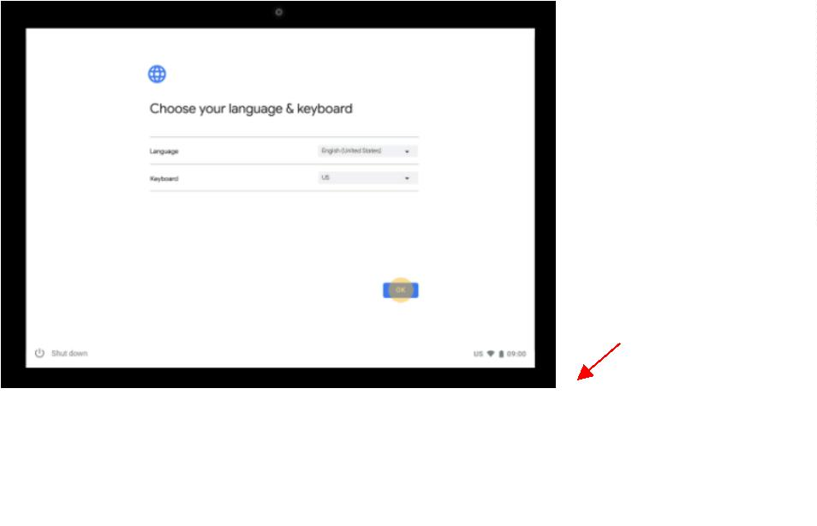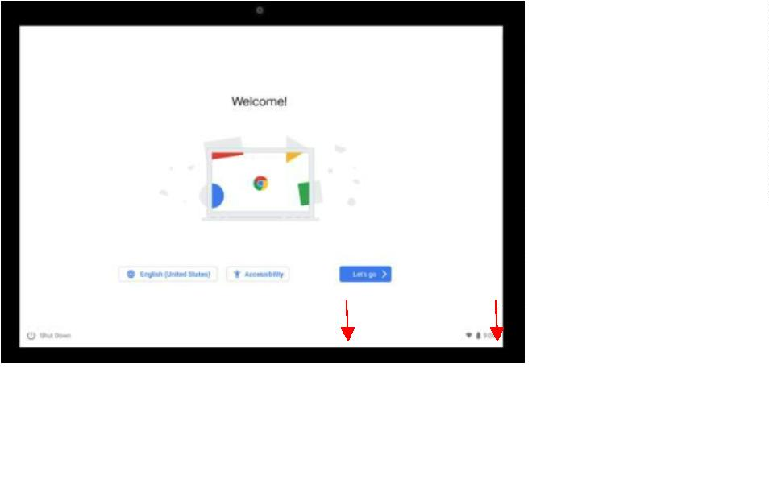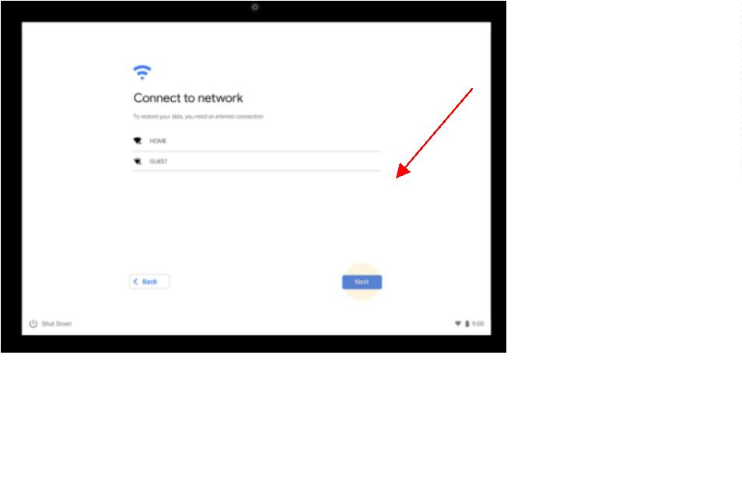

7
. Review the terms and click accept and continue.
Google
8
. Type your Google email address (Gmail) and click Next. If you don’t have Gmail, please
create it (see Create a Gmail on your Chromebook here or on page 12). A Gmail
account needs to be used with a Chromebook. A Yahoo or Hotmail email will not be
valid.
Write your Gmail here.
Create a new email if you don’t
have a Gmail.
Google
9
. Type your password and click Next. To view your password click the “
” button.
Type your password here
Google
Unit 1: Technology Skills for Beginners in a Face to Face Setting
English for New Bostonians July 2020
12
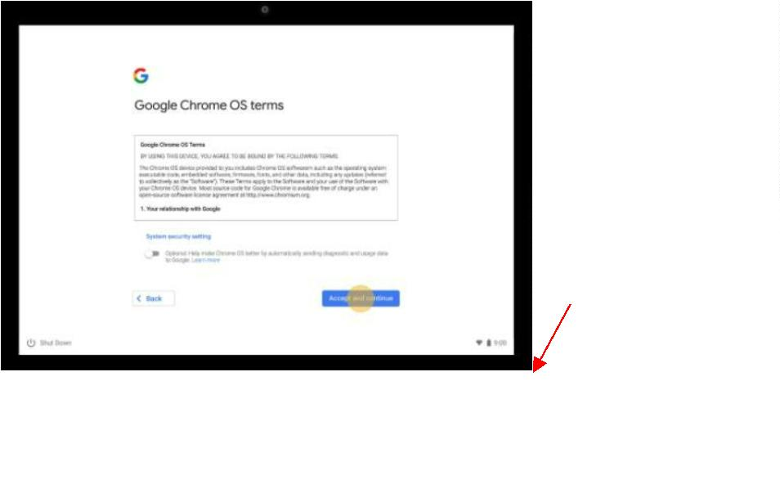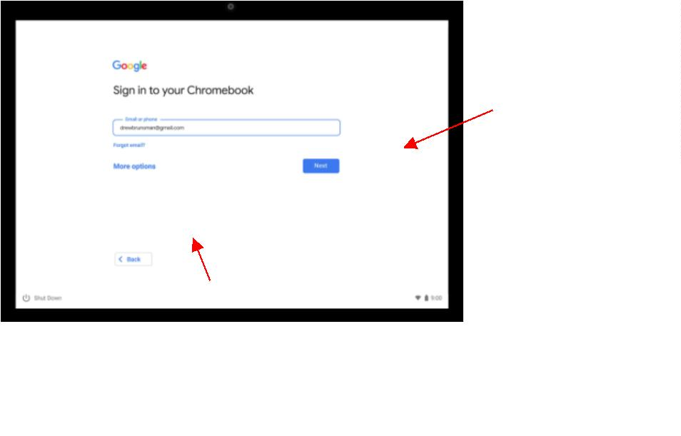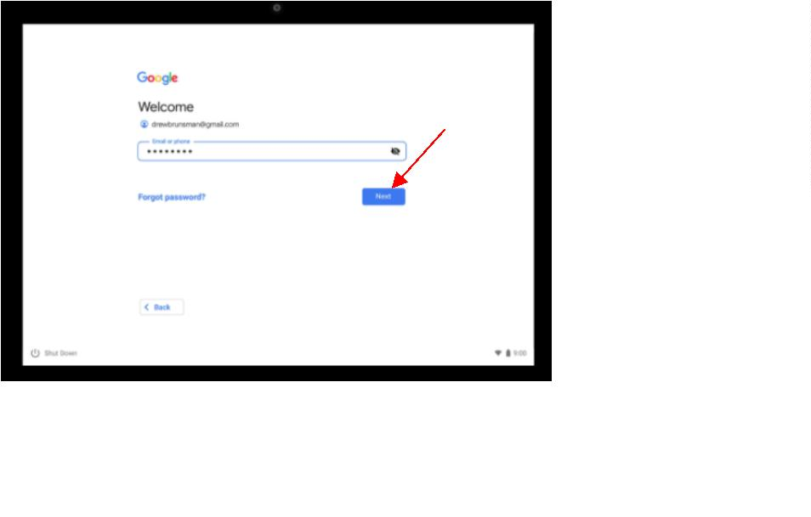

1
0. You are signed in! Now accept and continue.
Google

Note: A Chromebook can directly connect with your Android phone and install the same
Two options to Sign In to an already set up Chromebook:
Option #1: You may also click “Browse as a Guest”. This means anyone can use the Chromebook,
they do not need to have a Gmail.
Option #2: You can add another person to your Chromebook. Click “Add Account” to add another
Gmail account.
Sign out of an account: To sign out of an account and sign in to another one, click the
time/battery in the bottom right
corner, then click →
Option 1: Browse as
Sign Out
Option 2: Add
Google
Unit 1: Technology Skills for Beginners in a Face to Face Setting
English for New Bostonians July 2020
13
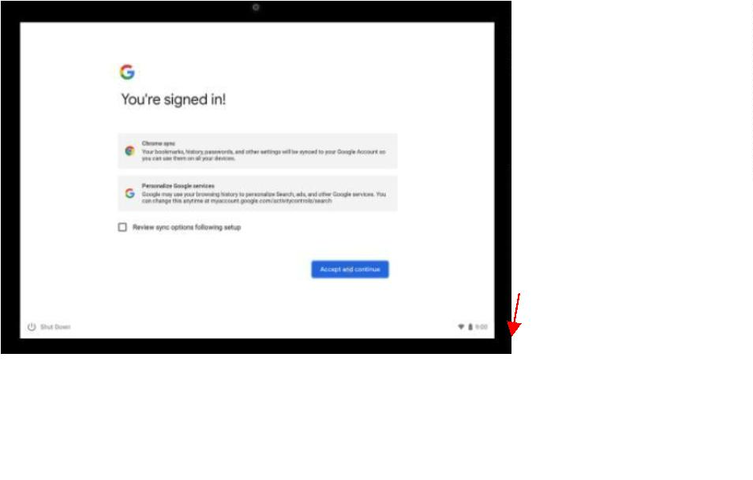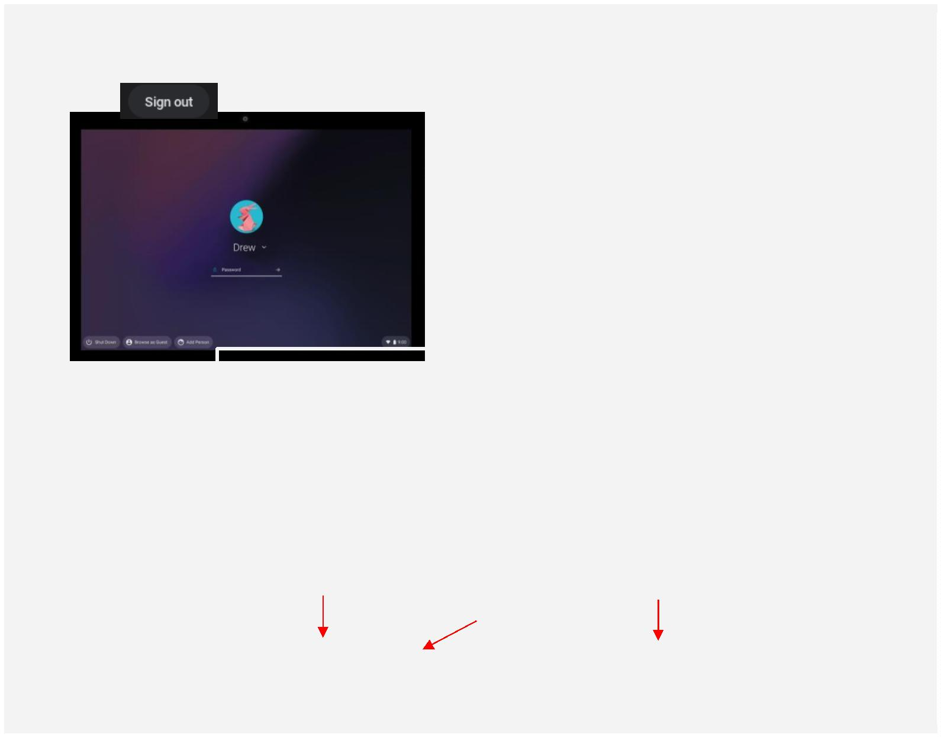

Activity 2: Setting up a Google Email Account (Gmail)
Rationale: As we navigate a digital world, the relevance of digital and technological literacy is
increasingly important. In this activity, we take a look at creating and writing an email as well as attaching
documents such as important forms, paperwork and/or homework assignments. This activity was
designed to help students not only create an email, but learn the vocabulary and functions of Gmail.
Student Objectives:
-
-
-
Students will learn how to create an account on Gmail.
Students will learn about informal vs. formal greetings in an email.
Students will learn relevant vocabulary in order to write emails and add an attachment.
Materials:
-
-
-
-
-
-
-
Chromebook (and cable cord)
Guide #2: Creating a Gmail during the Chromebook Setup
Guide #3: Creating a Gmail on a Web Browser
Worksheet #3: Email Vocabulary
Worksheet #4: Email Vocabulary (cont.) and Greetings
Worksheet #5: Writing an Email
Guide #4: Attaching a Document
Activity Outline:
1
.
Explain the objectives. Distribute the Guide #2, Creating a Gmail during the Chromebook Setup, if
your students are creating a Gmail as they are setting up a new Chromebook.
2
.
Distribute Guide #3 Creating a Gmail on a Browser if students are using Chromebooks that have
already been setup. They will use the Chrome Browser on their Chromebooks. On a phone and/or
tablet they can use other browsers.
3
.
As the class moves through the Gmail steps, make sure to stress the importance of not only a secure
password, but also of remembering and storing their passwords. Brainstorm places to store
passwords where they won’t be lost.
4
5
6
7
.
.
.
.
After accounts are created, the teacher could create a document where all student emails are
available for classmates to access (written or electronic). This will aid in future activities.
Brainstorm with students how often they use Gmail and in what contexts. Add to the list any
employment or school related uses which students haven’t mentioned.
Next, in the worksheets Email Vocabulary and Email Greetings, work with students to learn new
vocabulary in order to navigate Gmail, as well as appropriate greetings and subjects for emails.
The worksheet Writing an Email should be used as a written activity first so that the teacher can
correct it and then the student can type the final draft on their Chromebook. Teachers could put all
the class emails in a hat and have students draw a name to send their email to. This could be done
before or after the draft is written. This worksheet could also be given as homework.
Distribute the Guide #4, Attaching a Document and ensure that students have a document to attach
or simply practice identifying where the attachment buttons are. This is not an easy task and
remember that they first need a document to attach before they can do the actual exercise.
8
.
Follow-Up: Create scenarios where your students can practice writing various types of emails (child’s
teacher, doctor, boss, or friend). Then ask them to attach a picture from their phone or Chromebook.
Encourage students to check their email frequently by sending out emails to the class and having a
Unit 1: Technology Skills for Beginners in a Face to Face Setting
English for New Bostonians July 2020
14

competition to see who responds the fastest. Or ask students in class to stand up in response to
questions about how often they check their emails: Once a day? Once a week? Etc.
Unit 1: Technology Skills for Beginners in a Face to Face Setting
English for New Bostonians July 2020
15

Guide #2 : Creating a Gmail during the Chromebook Setup
Directions: During your Chromebook setup, if you don’t have a Gmail account, follow the
instructions below to set up an account.
Follow these steps below to create your account on a Chromebook:
1
. When it says “Sign in to your Chromebook” and you do not have a Gmail, click “Create
Account”.
Create account
2
3
4
. Type your first and last name. Click “Next”.
. Type your information, month, day, birth year, and gender. Click “Next”.
. Choose your Gmail address. You can choose an address they created for you or click “Create
your own Gmail address”. Click “Next”.
5
. Create a strong password. Do not use your name or birthday in your password. Click
“
Next”.
Don’t forget to Include:
Letters (upper and
lower case)
Numbers (1,2,3,4)
6
. Add a phone number in case you forget your password and click “Yes, I’m in” or scroll down
(with two fingers!) and click “Skip” if you don’t want to put your phone number.
. Review your account. Click “Next”.
7
8
9
. Scroll down in the terms and click “I agree”.
. Done! Now you have a Gmail account. Click “Accept and Continue”.

Note: Write down your username and password in a safe place or in a secure location on your
Return To Chromebook Setup
Unit 1: Technology Skills for Beginners in a Face to Face Setting
English for New Bostonians July 2020
16
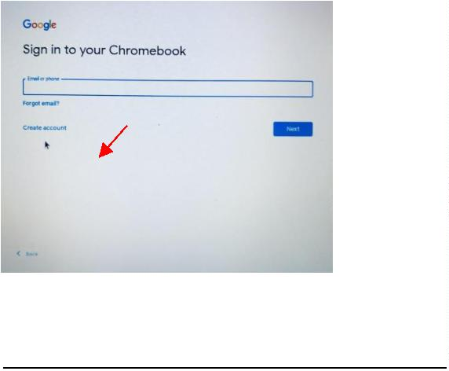

Guide #3 : Creating a Gmail on a web browser (on any device)
Directions: Follow the directions below if you are creating a Gmail account on another device
(different laptop, tablet and/or smartphone).
Follow these steps below to create your account on a web browser (Chrome, Safari, etc.):
1
. In your browser type gmail.com and press enter:
2
. Complete the information. This includes, First Name, Last Name, Username (your email
address name), password and then type your password again to confirm. Click “Next”.
3
. Add a phone number or a different email address (optional) if you forget your password this
will help you create a new one.
Unit 1: Technology Skills for Beginners in a Face to Face Setting
English for New Bostonians July 2020
17
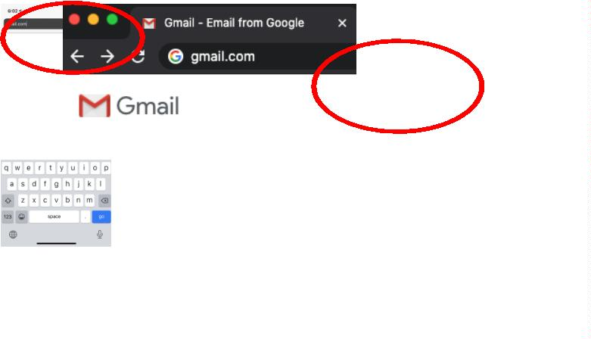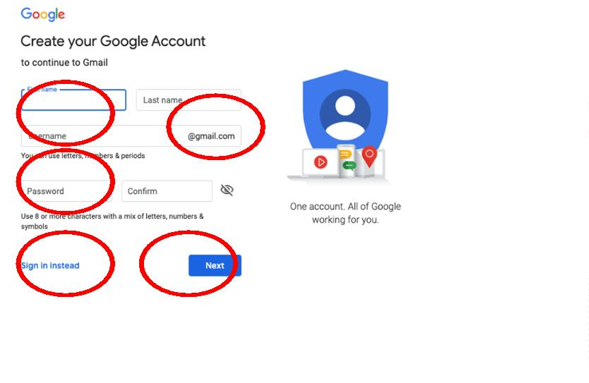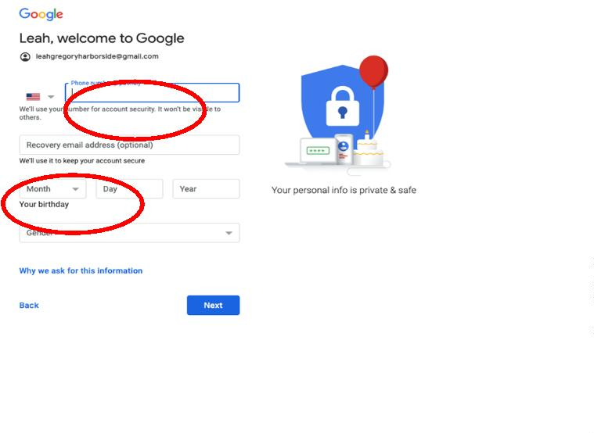

4
. Create a strong password. Do not use your name or birthday in your password. Click
Next”.
“
Don’t forget to Include:
Letters (upper and
lower case)
Numbers (1,2,3,4)
5
. Next, read through the terms and scroll down (with two fingers!). Click “I agree”.
6
. Done! You created a Gmail account.

Note: Write down your username and password in a safe place or in a secure location on your phone.
Unit 1: Technology Skills for Beginners in a Face to Face Setting
English for New Bostonians July 2020
18
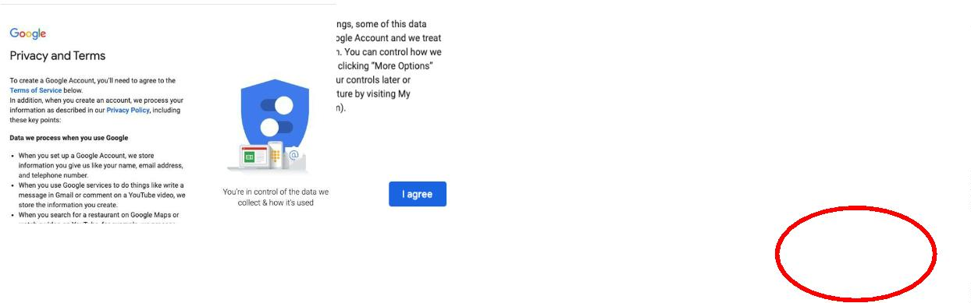

Name: ___________________
Worksheet #3: Email Vocabulary
Directions: Complete the following activities to learn more about email vocabulary.
A. Email Vocabulary
Let’s learn how to say our email.
Remember:
Now, let’s practice! Repeat these emails
with a partner:
@
.
_
= at
= dot
= underscore
jamesbond@gmail.com
susie_q@gmail.com
Let’s practice with your email:
1
2
3
4
5
. Write your email address here: ___________________________________________________
. Now recite your email to a partner.
. Check your partner’s writing and make sure it is correct.
. Now listen to your partner as they tell you their email address.
. Write your partner’s email address here: ____________________________________________
Unit 1: Technology Skills for Beginners in a Face to Face Setting
English for New Bostonians July 2020
19


B. Read the vocabulary words and match with the definitions by putting the correct letter next
to the vocabulary word.
1
2
3
4
5
6
7
8
9
1
. Sender ______
a. To write an email
. Recipient ______
b. 2-3 words or a short sentence about the email
c. When you write back to an email.
. Spam / Junk ______
. Subject ______
d. When you send an email you received to another person
e. A space where you can add another email address that
is indirectly for another person. Everyone sees email.
f. An electronic folder where your emails are received.
g. The person who sends the email
. CC / “carbon copy” ______
. BCC / “blind carbon copy”______
. Compose ______
. Inbox
_____
. Reply
______
h. A space where you can add another email address that
indirectly for another person. Nobody can see the email.
i. Emails from unknown senders with false information
j. The person who receives the email
0. Forward ______
Unit 1: Technology Skills for Beginners in a Face to Face Setting
English for New Bostonians July 2020
20


Name: ___________________
Worksheet #4: Email Vocabulary (cont.) and Greetings
Directions: Review and read through the different parts of an email. Then, read through and
identify different greetings used in informal and formal emails.
A. Review the vocabulary in the email.
Body (your
email!)
B. Greeting options to start an email:
Formal
Informal
●
●
●
●
●
Dear Ana,
●
●
●
●
●
Hi Ana,
Dear Ms. Santana,
Hi all,
Dear Mrs. Ramos,
Hey Ana,
To Whom it May Concern
Dear Sir, / Dear Madam,
Hello!
No greeting necessary
C. Signatures options to close an email:
Formal
Informal
●
●
●
●
Best,
●
●
●
●
Thanks,
My best,
Sincerely,
Thank you,
Talk to you soon,
See you soon,
Take care,
Unit 1: Technology Skills for Beginners in a Face to Face Setting
English for New Bostonians July 2020
21
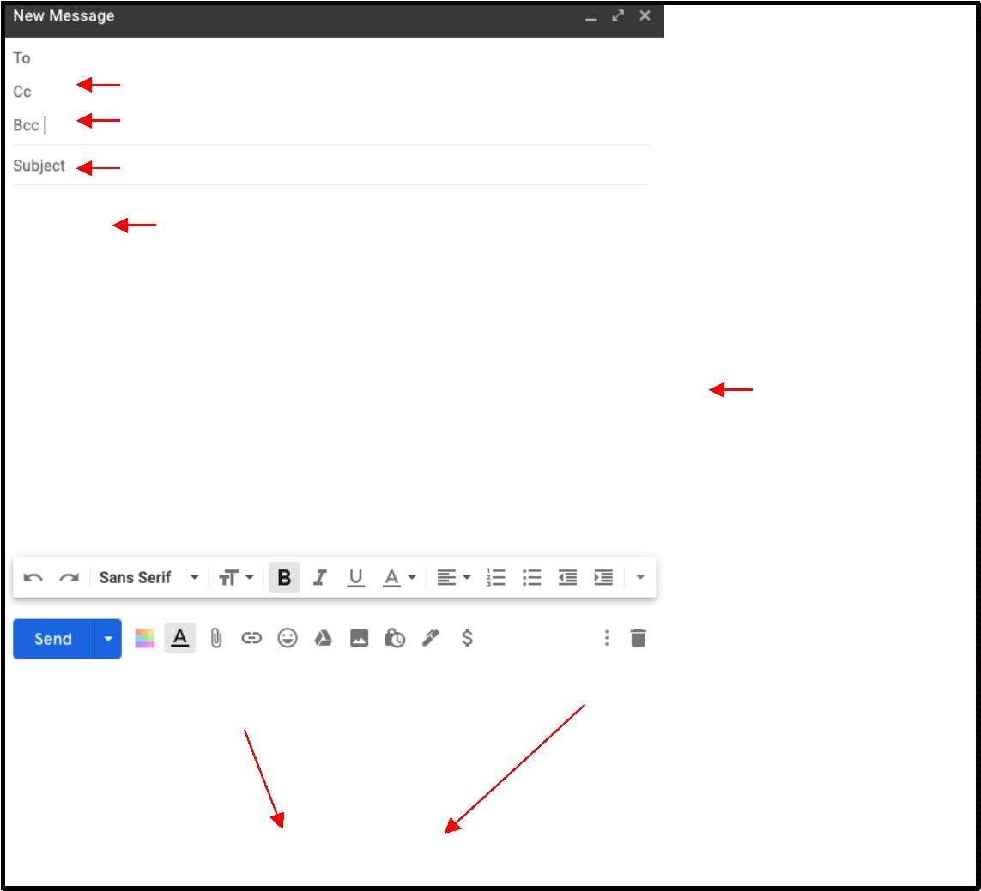

●
Respectfully,
●
Cheers,
Unit 1: Technology Skills for Beginners in a Face to Face Setting
English for New Bostonians July 2020
22

Name: ___________________
Worksheet #5: Writing an Email
Directions: Practice writing an email to a classmate, coworker or teacher. Make sure to include all
the parts of an email. After this practice, type your email on your Chromebook.
Now practice typing on your Chromebook!
Unit 1: Technology Skills for Beginners in a Face to Face Setting
English for New Bostonians July 2020
23
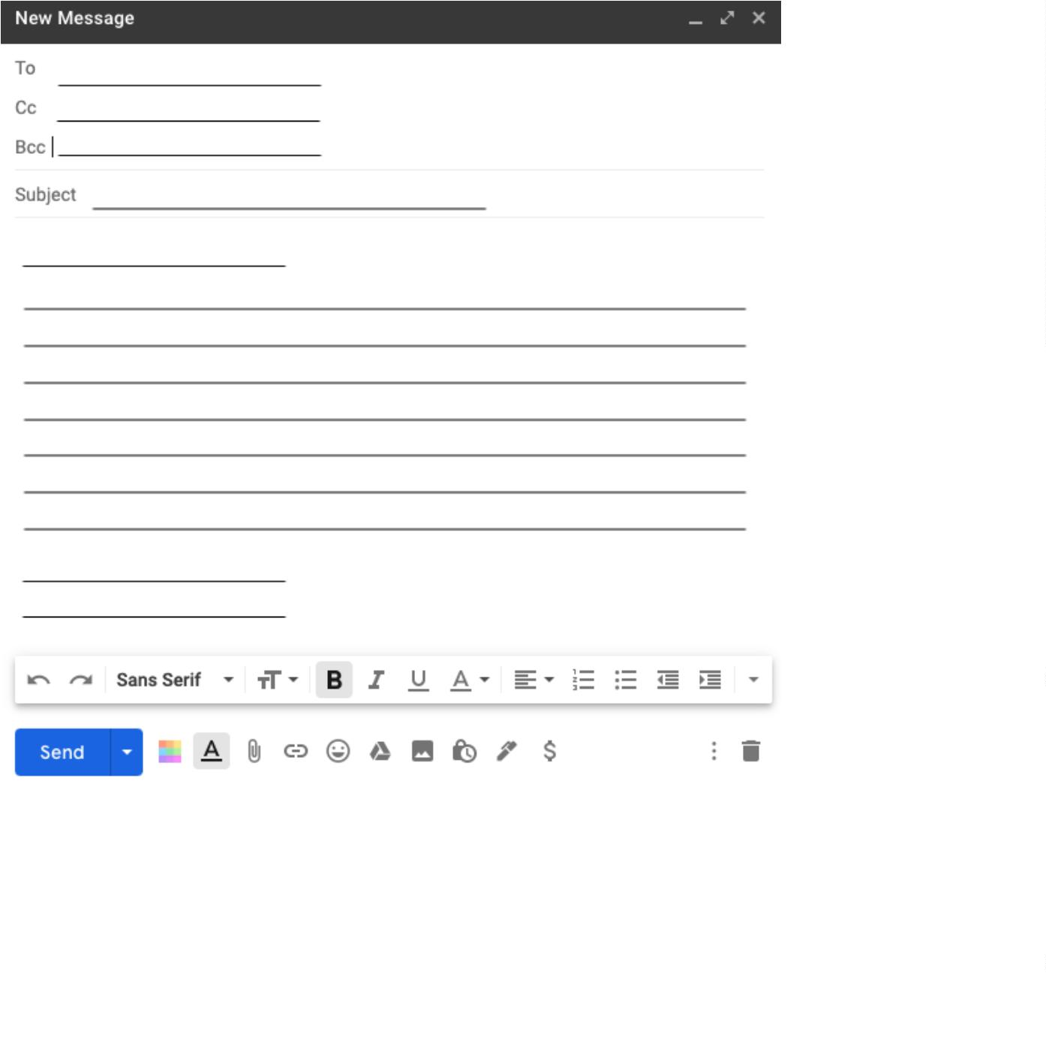

Name: ___________________
Guide #4: : Attaching a Document to an Email
Directions: After you write your email, read through the Guide below to learn how to attach a
document from your computer or from your Google Drive.
A. Many times teachers ask students to send their homework, a picture, or some type of
document in their email. This can be confusing so let’s look at the options. When you write an
email you have two options to attach a document.
Option 1
Option 2
Option #1: This option attaches something that is on your computer (in a folder or desktop). If you
click the small paperclip ( ) then it will open a new window with all the documents on your
computer and you can search for the document to include.
Option #2: This option attaches something that is in your Google Drive. Your Google Drive is where
your teacher might send homework or quizzes and connects with Google Classroom (we will talk
about this in Activity 4). If you click the triangle ( ) then your Google Drive will open and you can
search for the document to include.

Note: Google Drive is “cloud space”, this means that it is extra space on the internet for you
to put your work and documents. This is connected to your email. Just like you have folders for
your class, Google Drive is a place where you can organize your electronic documents!
Unit 1: Technology Skills for Beginners in a Face to Face Setting
English for New Bostonians July 2020
24
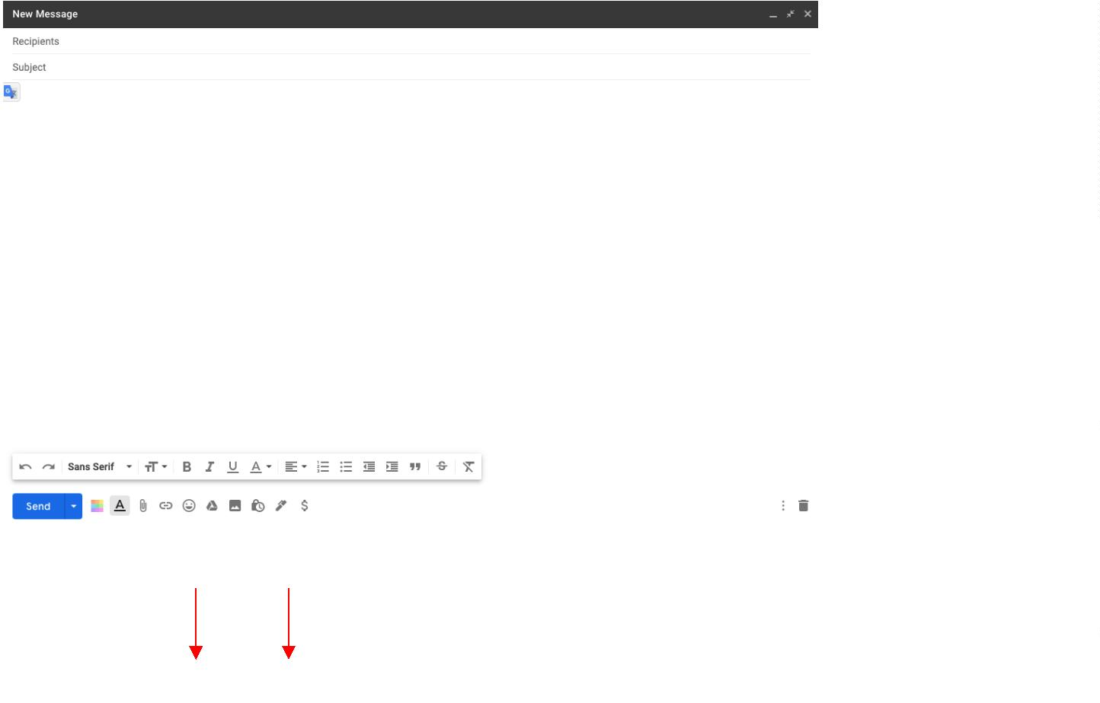

Activity 3: Downloading and Using Zoom and Other Applications on a Chromebook
Rationale: As we navigate a digital world, the relevance of digital and technological literacy is
increasingly important. Furthermore, understanding and using technology for work, home and family life
has never been so important. In this activity, we will explore downloading and using applications,
specifically Zoom, on a Chromebook and smartphone. Please note: Technology is ever-changing. These
application worksheets and the Guides are current as of July 2020.
Student Objectives:
-
-
-
Students will learn to download applications on the Chromebook (specifically Zoom).
Students will become familiar with the settings and options available on Zoom.
Students will learn how to download and use Zoom on a smartphone.
Materials:
-
-
-
-
-
Chromebook (and cable cord)
Guide #5: Downloading and Using Applications on your Chromebook
Guide #6: Downloading and Signing in to Zoom on your Chromebook
Guide #7: Using Zoom on a Chromebook
Guide #8: Using Zoom on a Smartphone
Activity Outline:
1
.
Explain the objectives. Explain to students that the majority of Chromebooks have Google Play
Store in their launcher, but some older Chromebooks may not or need updating. In this case, the
Chrome Web Store can be accessed through a browser and used to download apps the same way.
Teachers should describe the difference between the Google Play Store app and the Chrome Web
Store. That is, Google Play Store works directly with android apps that can work on a Chromebook
and an android phone. Chrome Web Store works with the Chrome browser. Either way, the stores
both download apps to the Chromebook. It is noted on the picture in the Guide #5 Downloading
and Using Applications on your Chromebook that you can use either.
2
.
3
4
.
.
Distribute and read through Guide #6 Downloading and Signing in to Zoom on your Chromebook.
Explain that Zoom is a common platform that teachers use for their online classes. Feel free to
explore downloading a different application such as Google Meets.
Using Zoom on a Chromebook looks different than on a laptop, desktop and phone. For this
reason, the Guide #7 Using Zoom on a Chromebook outlines how the Zoom application looks
currently on a Chromebook and will provide guidance to students and teachers who are not
familiar with how it may look on a Chromebook. Distribute and go through the exercise with the
class. It would be helpful to already create a Zoom meeting that students can access.
If the classroom has the ability to project a Zoom call on a large screen, then an option to review
the Zoom app could be projecting it on a screen and going through each function. However, this
could be done on individual Chromebooks too. In order to complete the exercise on the
worksheet, students should be in an active meeting.
5
6
.
.
Many students find it easier to use Zoom on their smartphone and then navigate through Google
Classroom or other websites on their Chromebook. Use the Guide #8 Using Zoom on a Smartphone
to help students understand how to add the application to their smartphone.
Unit 1: Technology Skills for Beginners in a Face to Face Setting
English for New Bostonians July 2020
25

Follow-Up: Assign students with a partner in the class that they need to connect with via Zoom to
complete an assignment. Encourage students to connect using a smartphone and/or a Chromebook.
Unit 1: Technology Skills for Beginners in a Face to Face Setting
English for New Bostonians July 2020
26

Guide #5 : Downloading and Using Applications on your Chromebook
Directions: Follow the Guide to learn more about downloading different applications to your
Chromebook. This is similar to how a phone or tablet works.
1
2
3
. Login to your Chromebook using your username and password (Gmail email and password).
Google
. Click the button in the bottom left corner. This is called the “Launcher”.
Google
. Next, click the up arrow to see all your applications.
Google
Unit 1: Technology Skills for Beginners in a Face to Face Setting
English for New Bostonians July 2020
27
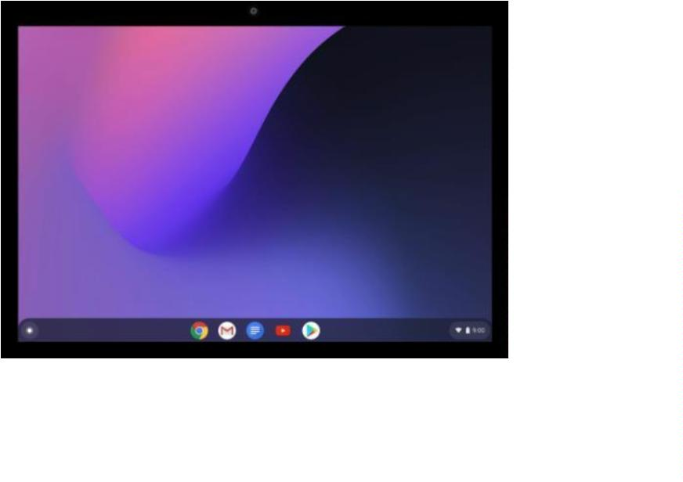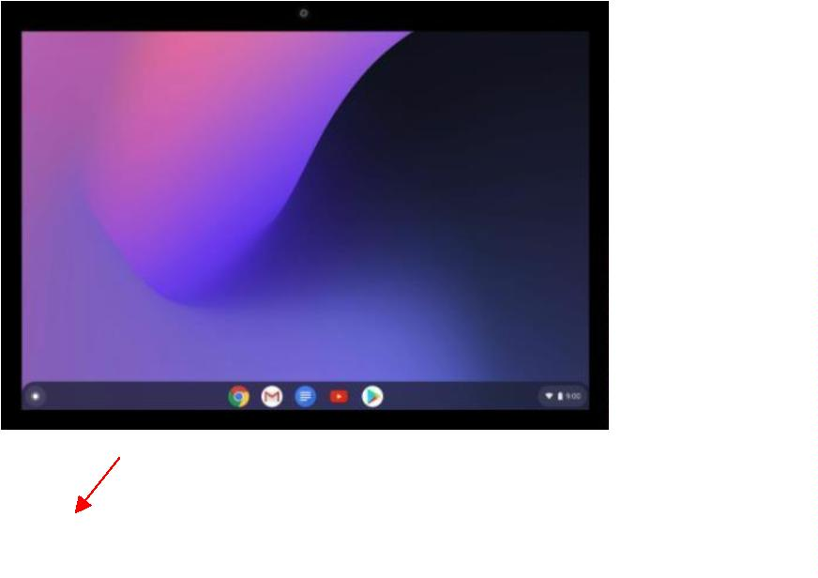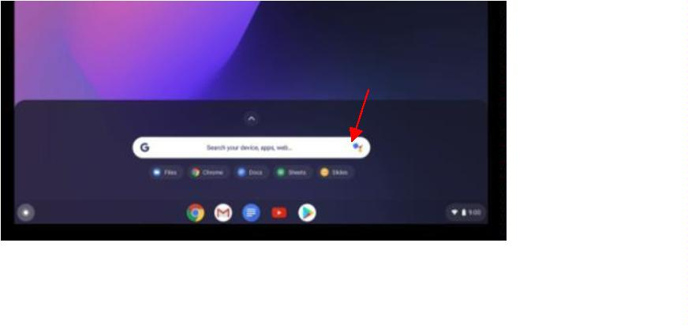

4
. Click Google Play Store or click the small dots on the right side of the screen to find the Web
Store App. Alternatively, you can search in the Chrome browser to find an app on the Web
Store.
To find the
Google
5
. Search for the application you want and click install. Now you can find your applications in
your launcher or at the bottom of your screen.
Launcher
Google
6
. Now you can install applications like Zoom or Google Classroom. The Chromebook already
comes with many applications like: Google Chrome, Gmail and YouTube.
Questions for Discussion:
1
. What apps do you use on your phone?
2
. Are they available on your Chromebook? (hint: search in the Play Store or Chrome Web store)
3
. List two apps that are already installed on your Chromebook:
1.
2.
4
. List two apps you want to install on your Chromebook:
1.
2.
Unit 1: Technology Skills for Beginners in a Face to Face Setting
English for New Bostonians July 2020
28
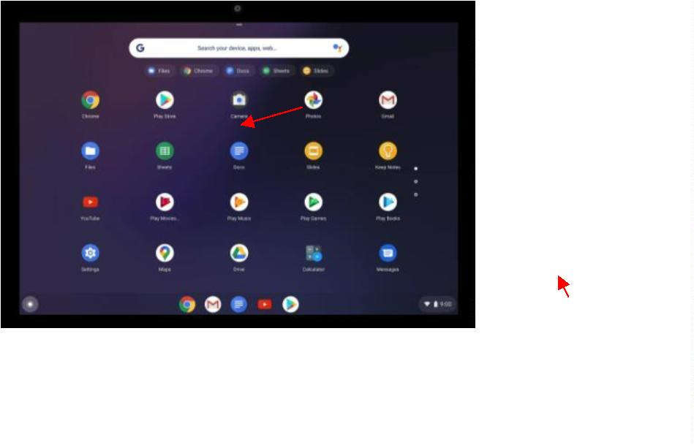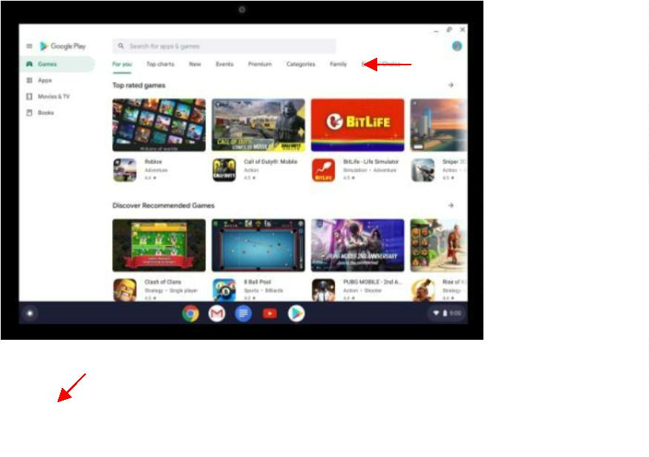

Guide #6: Downloading and Signing in to Zoom
Directions: Follow the instructions to download an application on your Chromebook. Search for
“
Zoom” and download this application to your Chromebook.
1
. After you have downloaded Zoom to your Chromebook, it will be in your toolbar at the
bottom of your screen or in your launcher.
2
. Open your Zoom application and login using your Gmail (you can also create an account, but
it's easier to use your Gmail).
3
4
. Now you will enter the login page. Type your Gmail address, then Gmail password. Click
“
next”.
. Alternatively, you can “join a meeting” directly if you have the Meeting ID and Password.
Make sure you do not check “☑” the “Don’t connect to Audio” box.
Guide #7: Using Zoom on a Chromebook
Unit 1: Technology Skills for Beginners in a Face to Face Setting
English for New Bostonians July 2020
29
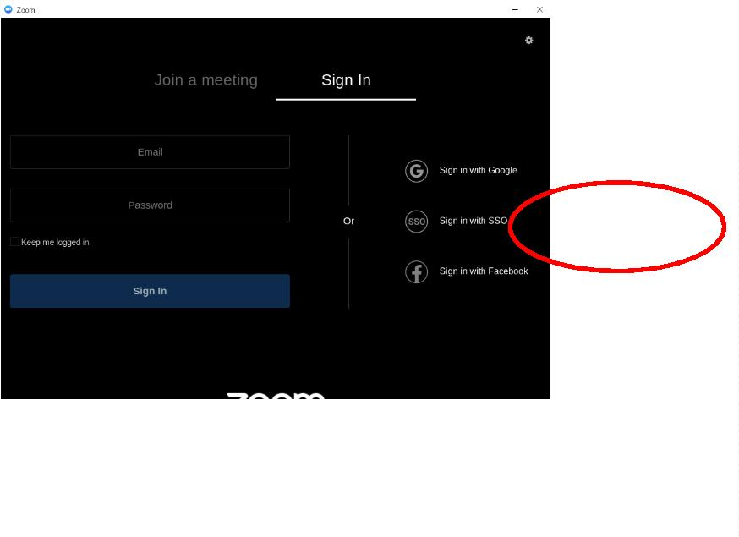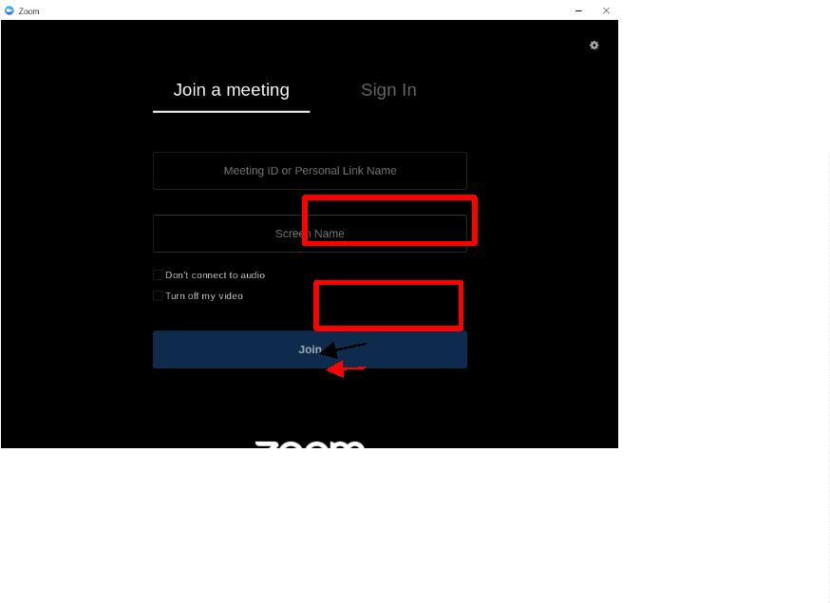

Directions: Practice logging in to a class meeting and using the controls. Let’s review first!
1
. There are two options to connect to a Zoom meeting.
○
Option #1: Manually enter the meeting by typing in the Meeting ID and Password you
have gotten after opening the Zoom application.
○
Option #2: Click on a link that was sent to you by the Host. (A “host” is the owner of the
meeting) and this will open the Zoom application or a browser window (depending if you
have the application installed or not)
2
3
. Before you enter the meeting, Zoom will ask you to “Join with Video” or “Join without Video”.
Choose the option you prefer. If you want your camera on so your picture can be seen, click
“
Join with Video”, if you don’t want your camera on, click “Join without Video”.
. When you enter, you probably will enter a waiting room and it will be a white screen. Wait
here until the Host lets you into the meeting. The white screen looks like this:
4
. When you enter the meeting, your screen will look like this:
Unit 1: Technology Skills for Beginners in a Face to Face Setting
English for New Bostonians July 2020
30
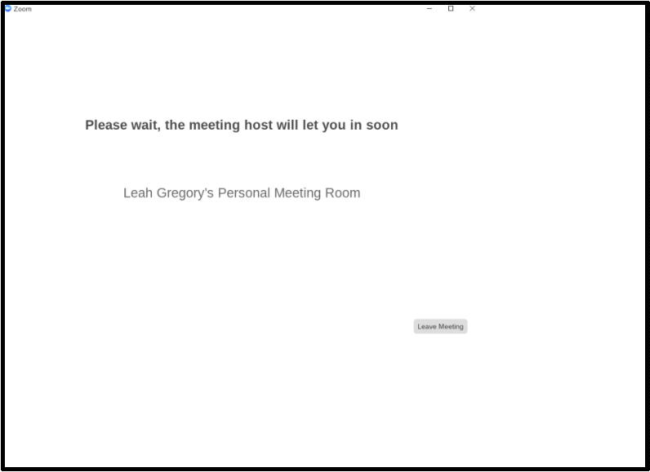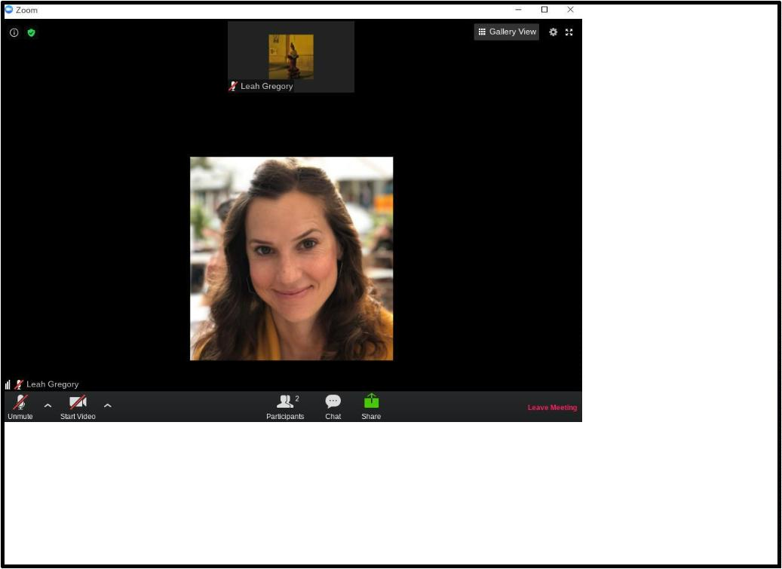

5
. Let’s take a look at the different options and settings in Zoom.

Note: If you do not see the “Start a Meeting” option it is because you are not signed in. You must
sign in to start a meeting with someone. Remember to sign in using your Gmail.
Exercise: Now open the Zoom screen, connect to a call (with a link or Meeting ID and password) or
start a meeting and view the options in the picture above. Please remember that this is a participant
view and the host view will look a little different (no raise hand option).
1
. Practice clicking the Mute/Unmute button. What does the red line on the microphone mean?
2
. Change your view from Speaker View to Gallery View. What is the difference?
3
4
5
. Raise your hand so the teacher can see you have a question. How do I put my hand down?
. Change your name to include your class name (ex. Leah - ESOL 2). What did you change it to?
. Open the chat and write something to everyone. Confirm that your teacher and classmates can
see your message.
Unit 1: Technology Skills for Beginners in a Face to Face Setting
English for New Bostonians July 2020
31
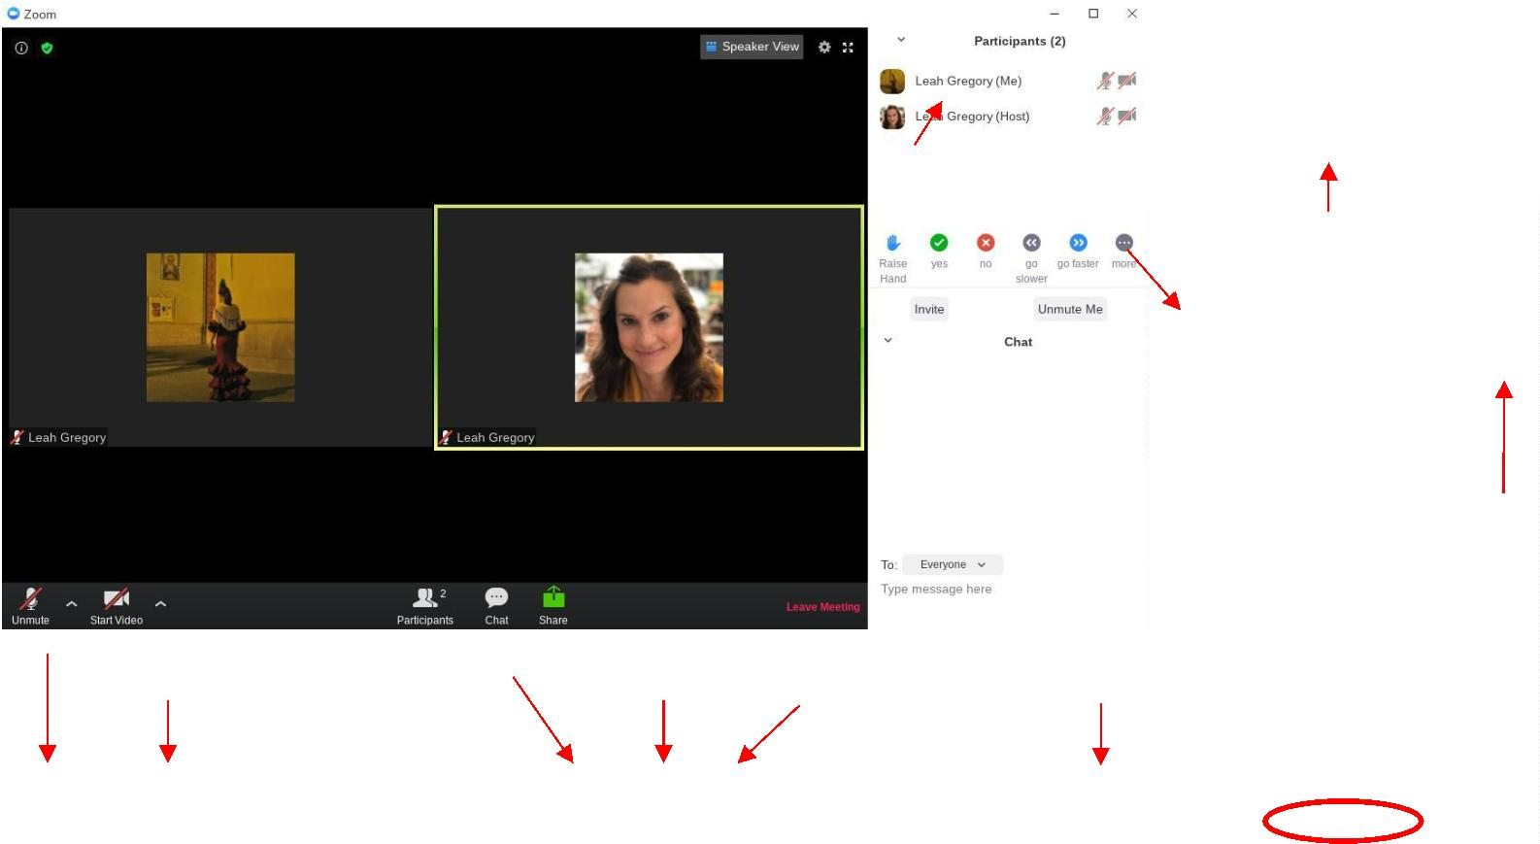

Guide #8: Using Zoom on a Smartphone
Directions: Download the Zoom Application on your smartphone in the Google Play Store store or
the Apple App Store. This App is free.
1
. Download the app on your smartphone and then sign in using your Gmail email address and
password. The full name of the app is “ZOOM Cloud Meetings”.
○
○
Android: https://bit.ly/zoomandroidENB
Iphone: https://bit.ly/zoomappleENB
2
3
. Your teacher may send you a direct link, if you click this link you will enter directly into Zoom
and will not have to sign in (skip to #6).
. When you open the application on your smartphone, you will see the “sign in” window (or you
will already be signed in, go to step #4). Click sign in and then sign in with your Gmail address
OR you can Join a Meeting directly using a Meeting ID and Password.
Option 2 Join a Meeting
Unit 1: Technology Skills for Beginners in a Face to Face Setting
English for New Bostonians July 2020
32
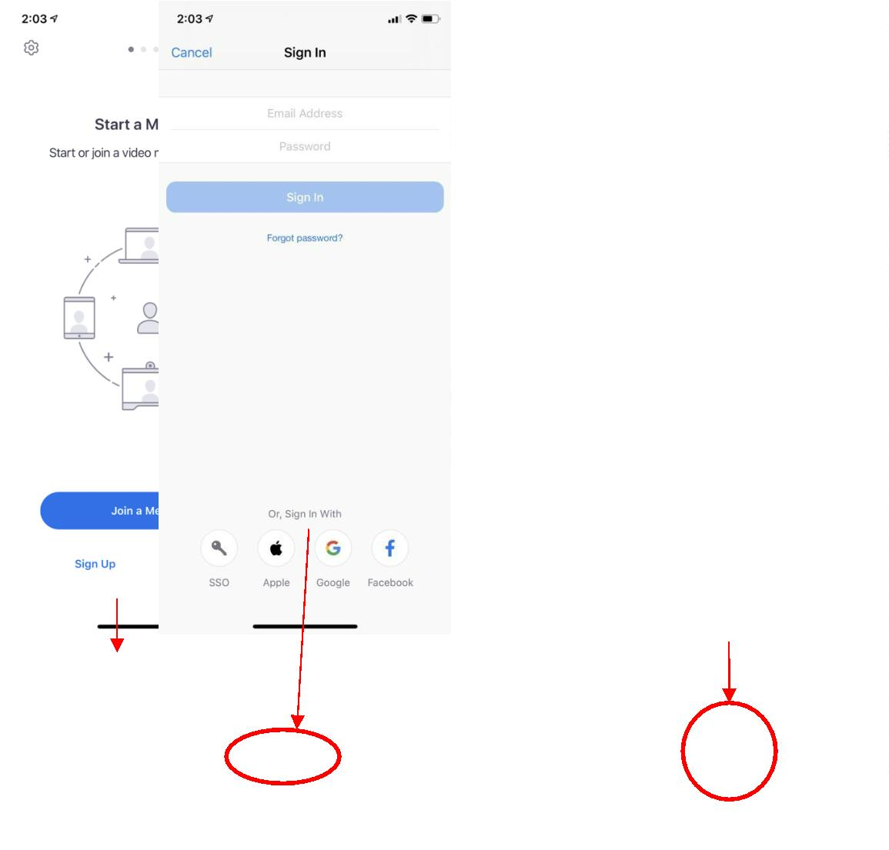

4
. After you sign in your application will look like this picture. You have the option to host a
meeting or join a meeting (remember, a “host” is the owner of the meeting).
Host your
Join a
5
. If you decide to join a meeting, you need to to type your Meeting ID and Password. Ask the
host for this information.
Type the Meeting ID
Type your name
6
. Zoom will ask you to preview your video (or you can turn it off). Then click “Join with video”
or “Join without Video”.
Unit 1: Technology Skills for Beginners in a Face to Face Setting
English for New Bostonians July 2020
33
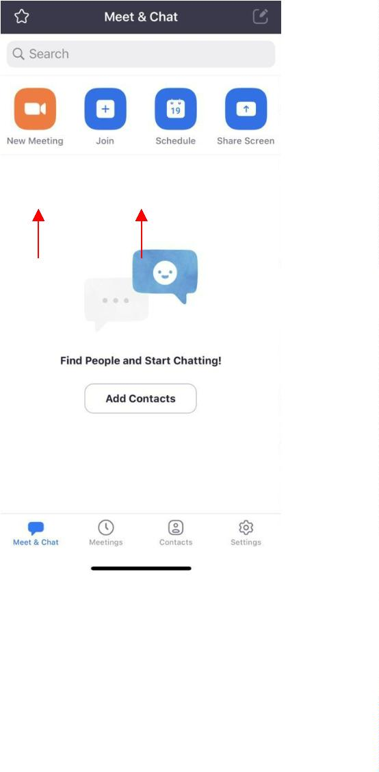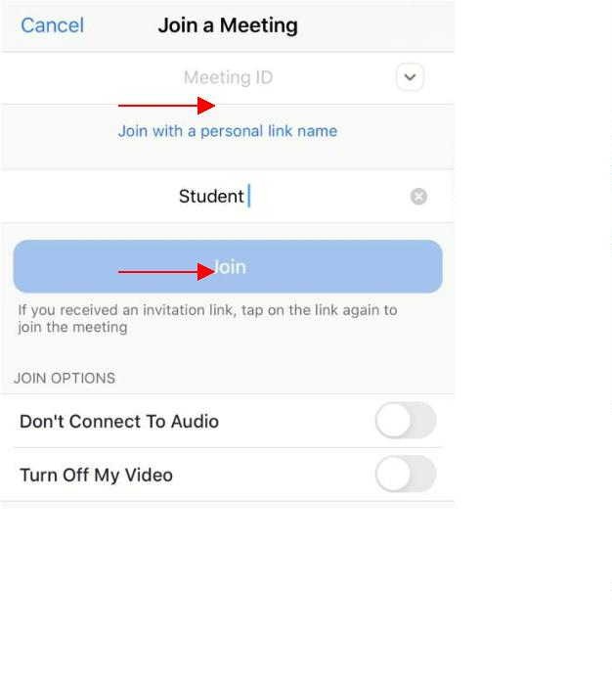

7
. Next, you will enter a waiting room and you need to wait until the Host adds you to the class.
Then you will enter the meeting and you can see your options.
Unit 1: Technology Skills for Beginners in a Face to Face Setting
English for New Bostonians July 2020
34
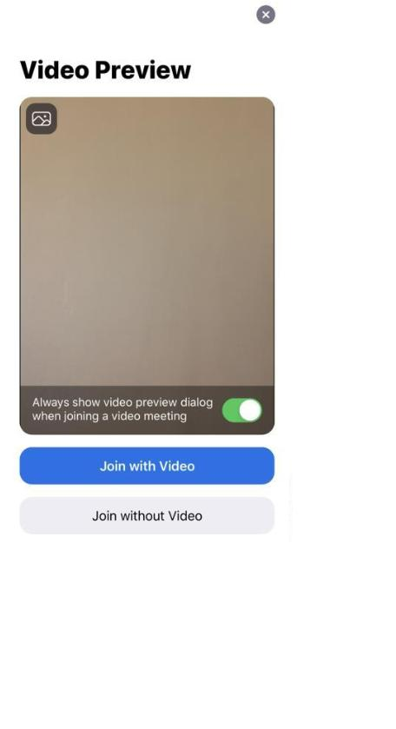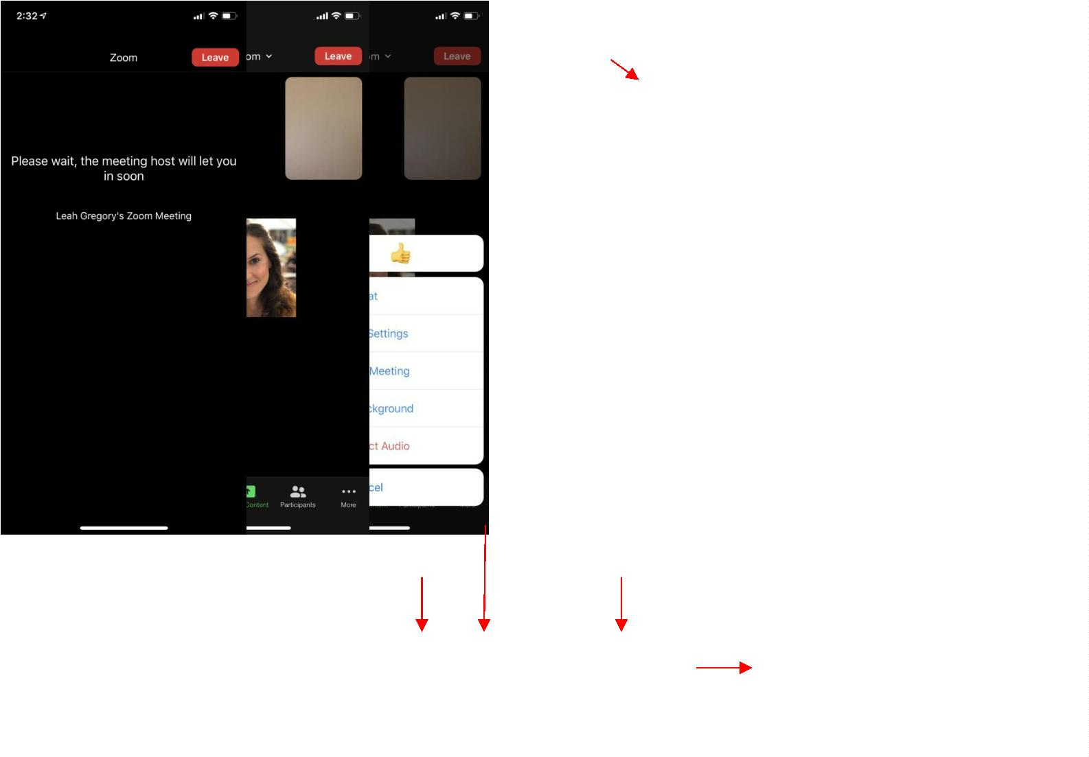

8
. On your phone you also have the option to Chat, View Participants and raise your hand. To
raise your hand, click “Participants” and you can see your options. Click “More” to see other
options. Click on your name to change your name.
Unit 1: Technology Skills for Beginners in a Face to Face Setting
English for New Bostonians July 2020
35
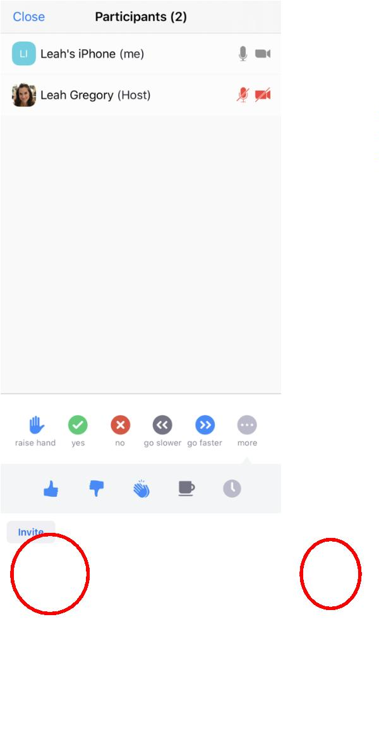

Exercise: Now open the Zoom App on your smartphone, connect to a call or start a new meeting and
view the options. The directions and pictures represent the participant view, if you are a host,
your view will look a little different. Write or discuss your answers with your class.
1
2
3
4
. Practice clicking the Mute/Unmute button. What does the red line on the microphone mean?
. Raise your hand so the teacher can see you have a question. How do I put my hand down?
. Change your name to include your class name (ex. Leah - ESOL 2). What did you change it to?
. Open the chat and write something to everyone. Confirm that your teacher and classmates can
see your message.
Activity 4: Student Guide to Google Classroom
Rationale: As we navigate a digital world, the relevance of digital and technological literacy is
increasingly important. In this activity, we take a look at Google Classroom and how students can
connect to this platform to receive notifications, get homework and receive grades/feedback. The
following Guides and exercises are meant to be a basic introduction and exploration of Google
Classroom, but students will probably need more guidance depending on what the teacher decides to do
and how they use it.
Please note that teachers should know how to navigate and post in a Google Classroom before teaching
these activities to their students. Teachers can choose to use Google Classroom at a basic level
(disseminate information and messages via the Stream) or at a more advanced level (posting homework,
quizzes, using other programs that integrate Google Classroom, etc.) A good resource for teachers is
Google’s great Google Classroom Resource.
Student Objectives:
-
-
Students will learn about the tools, functions, and three main sections of Google Classroom.
Students will learn how to access their Google Classroom.
Materials:
-
-
-
-
Chromebook (and cable cord)
Worksheet #6: Google Classroom Basics
Guide #9: Connecting to a Google Classroom
Worksheet #7: Explore Google Classroom
Activity Outline:
1
.
Explain the objectives. Review the worksheet Google Classroom Basics with the class and check
their understanding by completing the small True/False questions.
Unit 1: Technology Skills for Beginners in a Face to Face Setting
English for New Bostonians July 2020
36


2
.
Set up the video on a projector to view in the classroom. Alternatively, students could watch it on
their own with headphones. After viewing the video, students could watch as the teacher
demonstrates how to join a classroom by going through the steps on the projected screen.
Alternatively, the teacher could send an invite to the class during the class time so the students
can follow the steps on their Chromebooks (or smartphones). Please note, if students join on their
smartphones, they need to download the Google Classroom application.
3
4
.
.
Print out a copy of Guide #9 Connecting to a Google Classroom for each student to have.
Remember that the teacher is responsible for inviting students to their classroom, posting
homework, grading and returning assignments, and can post updates and notifications. It is
suggested that the Google Classroom is already set up with a message from the teacher, plus an
assignment students can view when they enter the classroom (such as a Google form).
Ask students to write a message in the stream and make sure students have notifications turned on.
It also may be beneficial to have students connect to the Google Classroom on their smartphones
by downloading the app and connecting to the classroom using the class code.
5
6
.
.
Depending on the assignment, if the student needs Google Docs to complete it, they will also need
to download this application. To keep it simple, ask students to write on the stream as their first
assignment. Complete the worksheet Explore Google Classroom.
Follow-Up: Students could work with their children to better understand Google Classroom, as many K-
2 students are using it. Children could open up their Google Classrooms and show their parents
assignments due and turned in. Teachers should post regularly so students can get used to using it.
1
Unit 1: Technology Skills for Beginners in a Face to Face Setting
English for New Bostonians July 2020
37

Name: ___________________
Worksheet #6: Google Classroom Basics (for students)
Directions: Read through the basics of a Google Classroom. Complete the small quiz at the end of
this worksheet.
A. What is Google Classroom?
1
2
. Google Classroom is an application that students and teachers can use to
communicate with each other.
. It has basic tools and functions where students and teachers can:
○
○
○
○
Write messages, notifications and updates
Send homework documents and worksheets
View and Grade homework, quizzes and other assignments
Share resources, videos or other material
3
. To use Google Classroom, a teacher needs to add you to their class and then you can
access all the materials.
B. Frequently Asked Questions (FAQs)
Q. Can I use Google Classroom anywhere?
A.
Yes. Anywhere you have internet access, you can use Google Classroom. There is an
offline option that has limited things you can do.
Q. What can I do in Google Classroom?
A.
You can communicate with your teacher and classmates, access homework, quizzes
and assignments from your teacher, complete assignments using Google Docs,
Sheets or Slides (different applications) and send them back to your teacher, and
view your grades.
Q. Can I use Google Classroom to DO my homework?
A. No. Google Classroom will give you your homework, but you need to use other
applications (Google Docs, Sheets, Slides, Forms) to complete your assignments. On
your smartphone, you need to download all 5 applications.
C. Let’s check your understanding. Mark if the sentence is true (T) or false (F).
1
2
3
4
5
. Google Classroom is a place where I can see my teacher.
. I can view and submit homework to my teacher.
. I can complete my homework in Google Classroom.
. My teacher can send messages and notifications.
. I can’t view Google Classroom on my smartphone.
T
T
T
T
T
F
F
F
F
F
Unit 1: Technology Skills for Beginners in a Face to Face Setting
English for New Bostonians July 2020
38


Guide #9: Connecting to a Google Classroom on a Chromebook
Directions: Watch the video for an overview of Google Classroom. Then, follow the instructions in
Part B to go through each part step by step.
A. Connecting to a Google Classroom. In this video you will learn how to:
○
○
○
Accept an invitation to join a Google Classroom
Learn about the different parts of Google Classroom
Access your homework
Click on the picture to view the video on YouTube.
B. Follow this Guide as you connect for the first time to your Google Classroom
1
. You have two options to connect to your Google Classroom.
○
Option #1: Your teacher will send you an email invitation and you can click
Join” (demonstrated in the video above).
“
○
Option #2: Your teacher will give you a code to enter the classroom. When you
have the code, go to classroom.google.com , sign in with your Gmail and click
on the “+” symbol in the top right corner. It looks like this:
1. Click the plus sign
2. Enter class code
Unit 1: Technology Skills for Beginners in a Face to Face Setting
English for New Bostonians July 2020
39
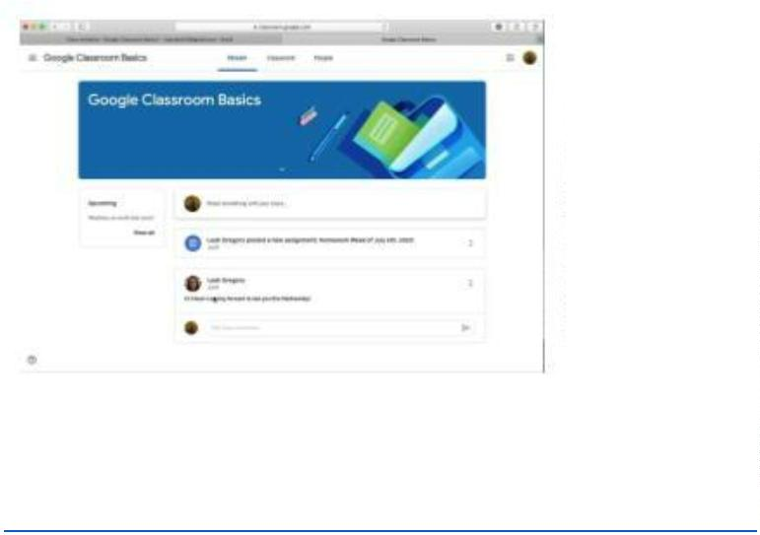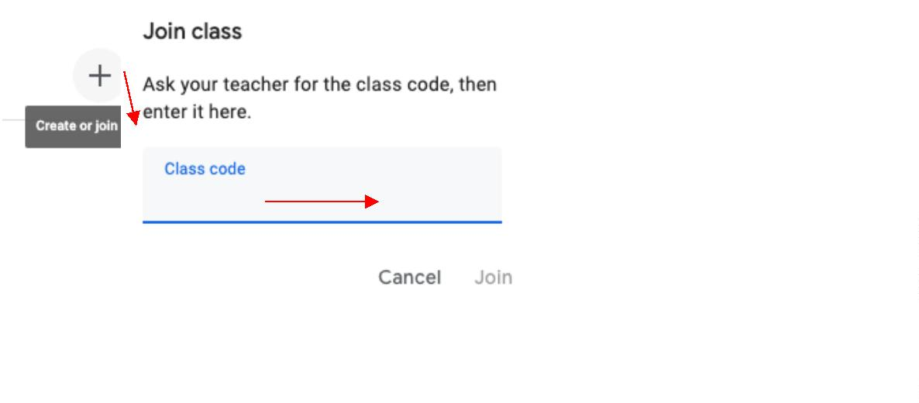

2
3
. When you connect to the Google classroom for the first time, you do not need to
connect again. You can access your Google Classroom by going to
classroom.google.com
. Now you are in the classroom. Let’s take a tour. There are three sections in the
classroom: Stream, Classwork and People.
These are the different sections:
1
. Stream: write and read notifications from your teacher and/or your
classmates.
2
3
. Classwork: view and access your homework and material from your teacher.
. People: view your teachers and classmates in your class.
C. Turn on Notifications
It is important to turn on notifications for the Google Classroom, so every time your teacher
posts something you will receive a notification.
1
. Click on the 3 lines in the top left corner.
Unit 1: Technology Skills for Beginners in a Face to Face Setting
English for New Bostonians July 2020
40
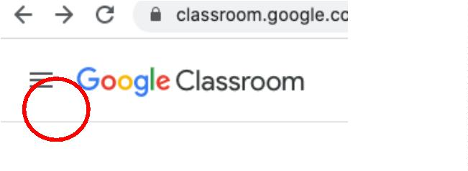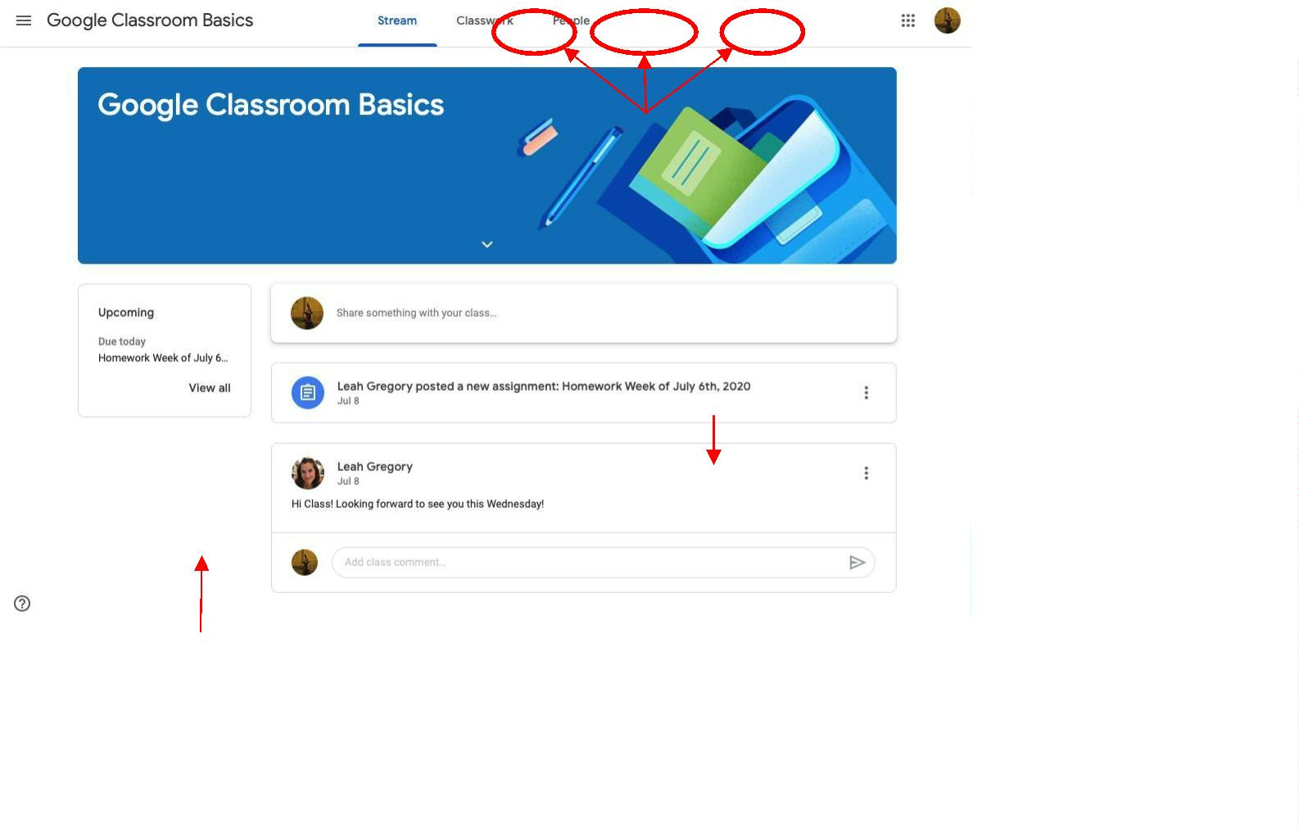

2
3
. Scroll down and click “Settings”.
. Make sure Notifications are turned on. Like in this picture:
4
. Click the 3 lines again to return back to your classroom page.

Note: If you connect and use Google Classroom on your smartphone, you must
D. Access Homework
1
. Your teacher will add homework to the “Classwork” section in the Google Classroom.
To view the homework, click “Classwork” and then click the homework. In the
homework, click “View Assignment” .
View Assignment
Unit 1: Technology Skills for Beginners in a Face to Face Setting
English for New Bostonians July 2020
41
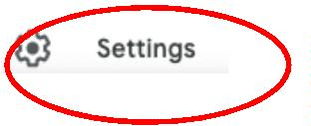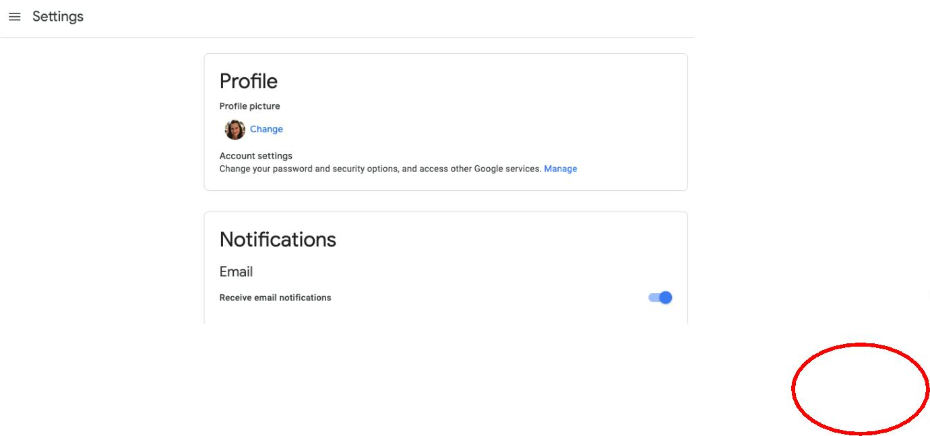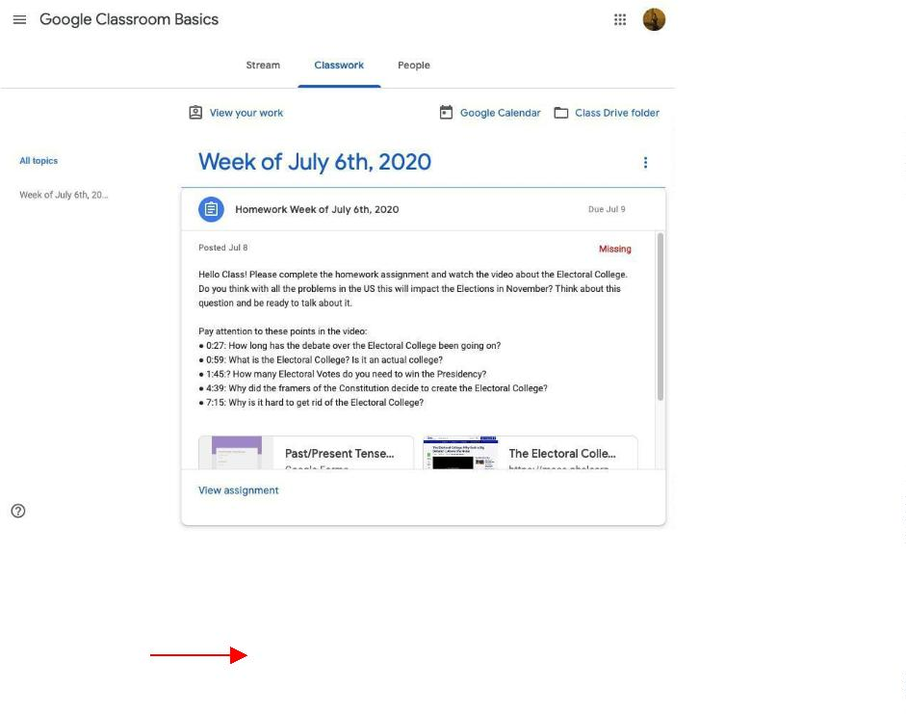

2
3
. When you view the assignment, you will view the exercise and you need to open the
Google Doc or Form to complete the assignment.
. After you complete the assignment, return to the Google Classroom and click “Turn
In”. You can also send your Teacher a private message about the assignment.

Note: If you connect and use Google Classroom on your smartphone or tablet to complete your
Unit 1: Technology Skills for Beginners in a Face to Face Setting
English for New Bostonians July 2020
42
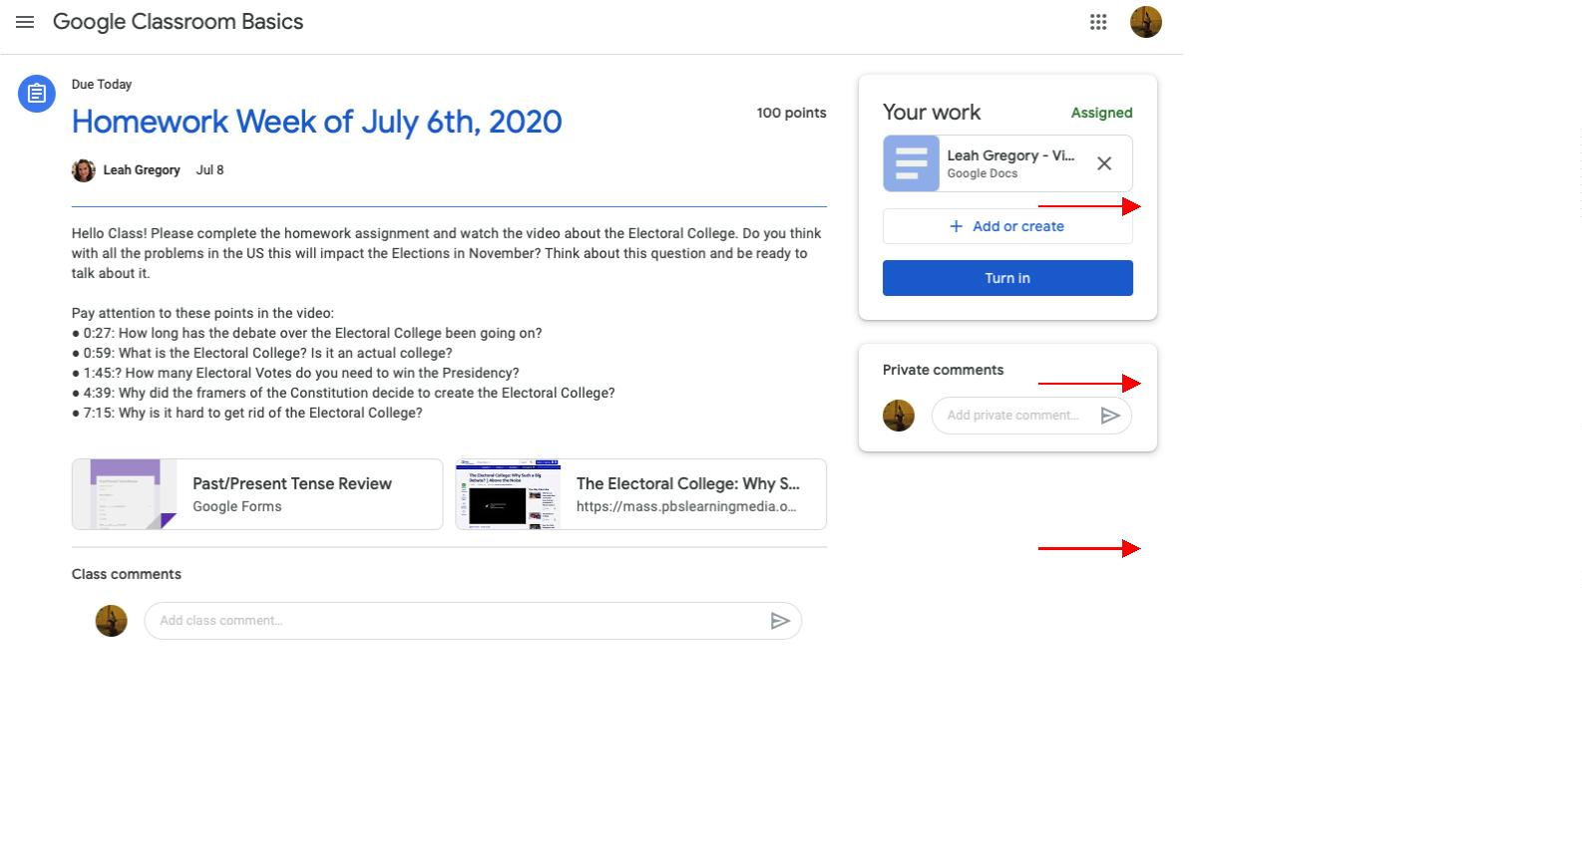

Name: ___________________
Worksheet #7: Google Classroom Exploring
Directions: Access the Google Classroom with your teacher’s invitation. Explore Google Classroom
with a partner and complete the exercises below.
A. Google Classroom Review
1
. What are the three sections of Google Classroom?
1
2
3
.
.
.
2
3
. Where can I write a message in Google Classroom?
. Write a message to your class introducing yourself, include:
○
○
○
Your Name (My name is…)
Where are you from? (I am from…)
What is your favorite food? (My favorite food is…)
B. Google Classroom Assignment
1
. If your teacher gave you an assignment:
a. View the assignment
b. Open the Document
c. Complete the Assignment
d. Return to Google Classroom
e. Click “Turn In”
Unit 1: Technology Skills for Beginners in a Face to Face Setting
English for New Bostonians July 2020
43


