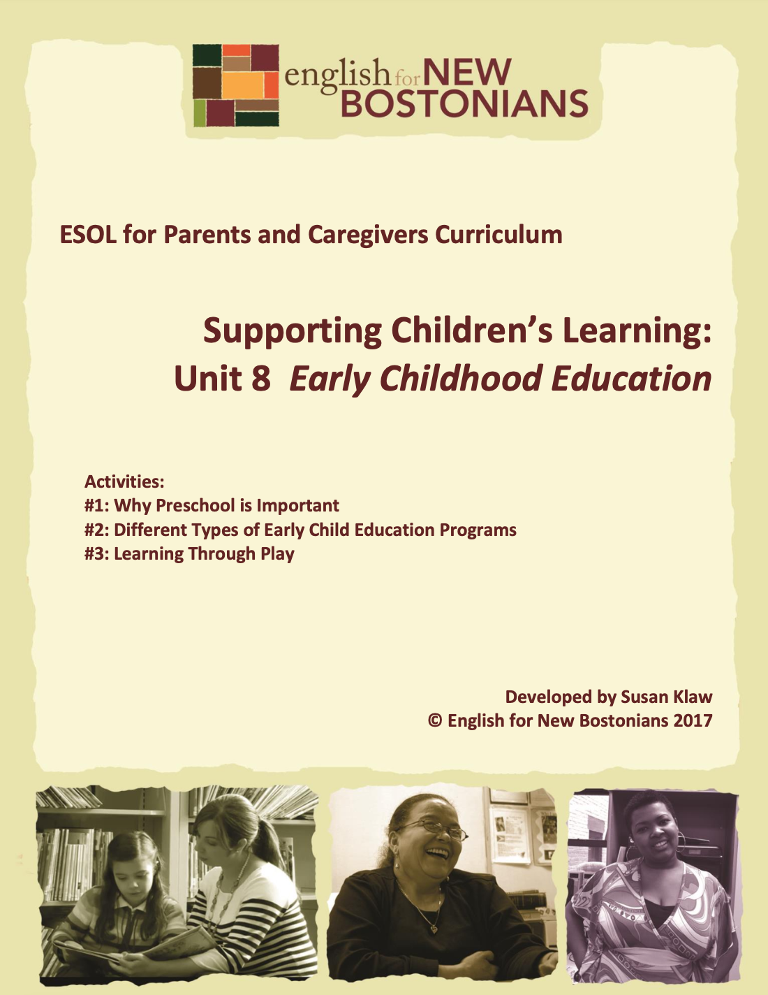About English for New Bostonians
Developed by Susan Klaw
© English for New Bostonians 2023

English for New Bostonians (ENB) invests in the future of our region by fostering a high-quality ESOL system that prepares immigrants to pursue their educational, economic and civic aspirations. Through grant making, training teachers, and building public awareness, ENB expands the number of English for Speakers of Other Languages (ESOL) seats, improves program quality across agencies, customizes curricula to diverse subpopulations, and leverages private and public resources. Founded in 2001 by the Mayor’s Office for Immigrant Advancement (MOIA), immigrant leaders, and local foundations, ENB now involves several city departments, approximately 20 public and private funders, and numerous community organizations.

About the ESOL for Parents and Caregivers Initiative
Through ESOL for Parents and Caregivers, ENB guides ESOL providers and immigrant-rich schools in building partnerships to facilitate parent engagement in schools, enabling parents/caregivers to improve their English and digital literacy skills, navigate school systems, and understand expectations and opportunities for school involvement and ways to optimize children’s learning. At the same time, ESOL for Parents helps adults prepare to pursue their own educational and employment goals, while supporting children’s learning – aiming to eliminate multigenerational poverty.

About Susan Klaw
Susan Klaw has directed, taught in, and developed original curriculum materials for Boston-based parent ESOL programs since 1991. She has delivered extensive training locally and nationally on various aspects of Family Literacy and been named a “Literacy Champion” by the Massachusetts Literacy Foundation, Parent Educator of the Year by the Children’s Trust Fund, and Adult Educator of the Year by the Massachusetts Coalition for Adult Education.

About the ESOL for Parents and Caregivers Curriculum
The Curriculum (on ENB website and available free of charge) gives ESOL teachers background materials, lessons and activities designed to help immigrant parents learn English and become more effectively involved in their children’s education. Selecting curriculum units and lessons relevant to their classes, ESOL teachers can orient immigrant parents to the U.S. school system and provide practical skills such as interpreting report cards, participating in teacher conferences, advocating for children, and supporting children's learning at home. While some information is Boston specific, much can be used in any locale. ENB can assist in adapting materials for school districts. Additionally, ENB offers a Companion Middle/High School Guide, as well as a Digital Learning Guide to support online instruction.

Using the ESOL for Parents and Caregivers Curriculum
All materials are intended to be downloaded and widely used. Please cite English for New Bostonians and credit English for New Bostonians on all reproductions. We welcome feedback and stories on how you and your students are using the ESOL for Parents and Caregivers Curriculum!

Thanks to the many public and private funders that have supported this project, especially the Highland Street Foundation, Shipley Foundation, Hamilton Foundation, Moses Kimball Foundation, Plymouth Rock Foundation, Blum Shapiro Foundation and the Mayor’s Office for Immigrant Advancement’s We Are Boston Gala.

Contact us at info@englishfornewbostonians.org
or visit us online at www.englishfornewbostonians.org

ACTIVITY #1: WHY PRESCHOOL IS IMPORTANT
Rationale:
Immigrant parents know about school and soon learn that children in the U.S. start school (kindergarten) when they are four or five. Many, however, don’t understand the concept of or the advantages of preschool. Numerous studies have shown that preschool improves the learning and development of young children, and that the benefits of preschool are long lasting. Enrollment in preschool has been associated with less grade repetition, higher rates of high school graduation, and improved social behavior. Children from low-income homes in particular benefit from preschool education in comparison with their peers from high-income homes. An added benefit for children whose families do not speak English at home is that preschool gives them an earlier start on learning English. In recent years many school districts, including Boston, have phased in what Boston calls K1 e.g. kindergarten for four year olds. While neither K1 nor K2 are mandatory, many more parents are now taking advantage of public preschool.
Student Objectives:
∙ Students will be able to define the term preschool.
∙ Students will be able to name at least two reasons why preschool is important for children.
∙ Students will be able to extract meaning from an English language video.
∙ Students will improve their writing skills.
Materials:
∙ Handout A: Why Preschool is Important: Eight Top Reasons
∙ Handout B: Work Sheet for the Video, Early Childhood Education ∙ YouTube Video, “Early Childhood Education,” A preschool teacher shows a few of her classroom activities and talks about why preschool is important. Two minutes.
∙ Handout C: Write a Letter to a Friend about the Advantages of Preschool Activity Outline:
1. Explain objectives.
2. Write on board and explain the standard breakdown by age of Early Childhood Programs:
∙ Infant Programs: Children from birth to 15 months
∙ Toddler Programs: Children from 15 months to 2 years, 9 months
∙ Preschool Programs: Children from 2 year, 9 months to 5 years old.
∙ Pre-K: Kindergarten for 4 year olds. In BPS referred to as K1.

Explain that this activity will focus on preschool programs or programs for 3 and 4 years olds before they start Kindergarten at age 5. Explain that when they hear the term “preschooler” or “preschool child” this means a 3 or 4 year old. For additional vocabulary building, do a quick prefix lesson. Show how “pre-” means before.
Other words to include that relate to learning would be predict, preview, preface, and prepare.
3. Ask for a show of hands of students whose children go to or went to preschool or K1. In pairs or small groups, have those students describe to their classmates what their children did in preschool. If most parents sent their children to preschool, use the circle question technique to have each student speak about that experience. This is a good way to share information and practice asking questions, always hard in English. With this technique, you write a question on the board, and then ask the student on your left the question. She answers it, and then asks the same question to the person on her left, etc. You continue this process until you have gone all the way around the circle.
∙ Circle question #1: What preschool does (did) your child go to?
∙ Circle question #2: What does (did) your child learn in preschool?
∙Circle question #3: What does (did) your child like about preschool?
If students need help with the verb tenses, write stems on the board for students to consult as they answer. For example,
My son went to _____________________________________ and
My daughter goes to________________________________
4. Distribute and read together the handout: Why Preschool is Important: Eight Top Reasons. Have students identify what they think is a particularly important reason by asking them to complete the following sentence:

I think that Reason Number ________ is most important because
_______________________________________________________________________
When students have finished, have them read their opinions to the class.
5. Distribute and read together the worksheet for the short video you are about to watch. It helps parents focus on what they should listen for. Explain that “early childhood education” is another term for preschool.
6. Watch the two-minute YouTube video” Early Childhood Education,” several times, with students partially filling in the worksheet after each viewing. List on the board the reasons students wrote on their worksheets. Beginning level students could benefit from the video but might need a scaffolded activity, e.g. a transcript and cloze.
7. Summary: Ask for a show of hands: How many of you would now tell your friends that they should enroll their children in preschool?

8. Homework: For intermediate students, give out the writing prompt and have them do the first draft of this letter writing assignment at home.

Handout A: Why Preschool is Important:
Eight Top Reasons
Reason one: Preschool helps prepare children academically for kindergarten by teaching them letters, numbers, shapes, colors and lots of new vocabulary.
Reason two: Preschool helps children learn how to interact in a group. They learn to share, to take turns, to listen to each other, and to raise their hands when they want to talk.
Reason three: Preschool helps children learn how to be away from their parents.
Reason four: Preschool gives children a place where they can engage in imaginative play with their peers.
Reason five: Preschool helps children learn to be more independent, particularly with using the bathroom, putting on their coats and shoes, etc.
Reason six: Preschool helps children learn to follow a regular schedule.
Reason seven: Preschool helps children learn to take responsibility for their own things, such as putting their stuff in their backpacks, etc.
Reason eight: Preschool helps children learn English if they speak a different language at home.

Handout B: Worksheet for the video:
Early Childhood Education
In the video “Early Childhood Education” the teacher gives many reasons why the children in her class will do well in kindergarten. List three of the reasons she gives for why her students will do well in kindergarten.
1.____________________________________________________________ 2.____________________________________________________________ 3.____________________________________________________________

Handout C: Write a Letter to a Friend
About the Advantages of Preschool
Directions: Imagine you have a friend from your country with a one year old and a three year. This friend is moving to Boston. Write the friend a letter or an email in which you explain what preschool is. Encourage your friend to find a preschool for her three year old child. Explain to your friend why preschool is important.

Date:______________________________
Dear ______________________,
Name of your friend
______________________________________________________________ ______________________________________________________________ ______________________________________________________________ ______________________________________________________________ ______________________________________________________________ ______________________________________________________________ ______________________________________________________________ ______________________________________________________________ ______________________________________________________________ ______________________________________________________________
Love to you and your family,
____________________
Your name

ACTIVITY #2: DIFFERENT TYPES OF EARLY CHILDHOOD EDUCATION PROGRAMS
Rationale:
Here students are exposed to a range of early childhood education options-- BPS based, center based, family based-- through means of a chart which they learn to read and extract information from. They also explore the concept of income eligibility as it pertains to Head Start programs.
Student Objectives:
∙ Students will be able to name at least two different types of Early Childhood programs
∙ Students will be able to extract information from a chart about early childhood programs
∙
Materials:
∙ Handout A: Chart: Early Childhood Education Options in Boston
∙ Handout B: Getting Information from the Chart—A Worksheet
Activity Outline:
1. Explain objectives.
2. Using the chart yourself as a reference, go over with students the different types of early childhood programs—BPS, Head Start, Center Based and Family Based. With Family Based programs, explain the difference between licensed and unlicensed programs. If a family based program has a license, it means the provider has been approved by the state and meets state guidelines for safety, space, staffing and curriculum. Have students share any experiences they have had with any of these different options.
3. Distribute Handout A: Chart: Early Childhood Education Options in Boston. Explain that you want students to practice reading and getting information from charts. Review the headings of the four columns and show how for each type of program, you read across to get a description, the cost, and information on how to contact and apply for those programs.
4. Distribute Handout B: Getting Information from the Chart—A Worksheet and pair students up to work together on answering the questions. Go over answers together in the whole group.
5. Summary discussion: What preschool option would you choose if you had a three or four year old child? Note: if parents choose the BPS option, reiterate that they have to register in the first school choice application round (whenever that is in any given BPS school year) or their child is unlikely to get a K1 seat.
Follow-Up:
∙ As a group, visit a pre-school or K1 classroom or have a speaker from Head Start come to your class and talk about the program.
∙ Ask any parents who have visited or used preschool programs or family day care programs to report on this to the class.
∙ If students are interested in working in early childhood education themselves, download the power point on the ENB Website called A Life Spent With Children.

Handout A: Early Childhood Education Options in Boston
TYPE OF  PROGRAM | DESCRIPTION | COST | HOW TO CONTACT/HOW TO APPLY
BPS  -K1  -K0  -K0 Early  Intervention | In Boston Public  Schools.  For 4 year olds. 85% of BPS elementary schools have K1  programs, same  hours as K2- gr.5.  For 3 year olds. Six Early Learning  Centers in Boston offer grades K0-Gr 1, full day with before and after school  programs.  For 3-4 year olds  who have an IEP  through BPS  Department of  Special Education | All Free | Apply in the first round (January) through the BPS lottery system. Go to BPS website and look for information in multiple languages about school registration at www.bostonpublicschools.org  Apply through the BPS lottery system. Go to BPS website and look for information in multiple languages about school registration.  www.bostonpublicschools.org  Go to BPS website and search for Special Education Department. Call for more information and screening if you think your child may be delayed.
Head Start  - | A program for low income families  serving children 0-5. Many programs around the city. Home visits and other family services. Typical hours: 8:30am-1:30 pm, Mon.-Fri. | Free for  low  income  families  who meet income  guidelines. | ABCD runs the Head Start programs in Boston. Call 617 634 6272 for  information on the programs near you. Or go to:  Head start & Early Head start - Action for Boston Community Development (bostonabcd.org) Scroll down to Map Locations to see a list of all Boston Head Start programs. To apply, make an appointment to go in. Bring proof of income, child’s birth certificate, and proof of Boston residency. You can apply at any time.

TYPE OF  PROGRAM | DESCRIPTION | COST | HOW TO CONTACT/HOW TO APPLY
Center  Based  Programs  (Example YMCA) | In  community agencies.  Programs  serve a  variety of  ages, with  infant,  toddler and preschool  programs.  Each  program is  different.  Usually  these are full day  programs.  Also called  Day Care  Programs. | Charge  weekly  fees.  Most  accept  vouchers . | For listings of programs near you, go to the MA Early Education and Care website:  Contact individual programs for how and when to apply. Visit program before enrolling your child.
Family  Based  Programs | Small groups of children in private  homes.  Called Family Day Care.  Serve  various ages. Make sure  program is a licensed  program. | Charge  weekly  fees. | For listings of licensed programs near you, go to the MA Early Education and Care website:  Call and visit any family based program to see if you like the day care provider and the space she uses in her  home for the children. Ask whether the program is licensed and ask to see the license.

Handout B: Getting Information from the Chart: A Worksheet

Directions: Working with a partner, answer the following questions based on information in the chart called Early Childhood Education Options in Boston.

BPS:
1. How do you apply for the BPS K1 programs? _________________________________ ___________________________________________________________________
2. What hours are K1? ___________________________________________________ 3. Where are K1 classrooms? _____________________________________________
Head Start:
1. What ages does Head Start serve? _________________________
2. What number do you call to get more information about Head Start programs in your neighborhood? _______________________ If you want to get that same information Online, what website do you go to? ___________________________
3. Is Head Start free? _________________________________________________
Center Based Programs:
1. Are center based preschool programs all the same? __________________________ 2. Are center based programs free? ___________________________
3. Before you enroll your child in a program, what should you do? ___________________
Family Based Programs:
1. Where are family based programs? ____________________________________
2. Are all family based programs the same? ___________________________
3. What should you ask to see when you visit a family based program? __________________________________________________________________

ACTIVITY #3: LEARNING THROUGH PLAY
(Can be used/adapted for use with beginning level students)
Rationale:
Students may not realize how much their children learn through play, especially preschool age children. Through play, 2-4 year olds develop the skills that are the foundation of future learning.
Student Objectives:
∙ Students will be able to name some of the skills preschoolers learn through play.
∙ Students will learn vocabulary related to play and child development.
∙ Students will practice the present progressive tense.
Materials:
∙ Blocks or Legos, dolls or stuffed animals, drawing materials (for opening role plays) ∙
∙ Handout A: Words that Describe Play
∙ YouTube video: Children’s Perspective on Playing
∙ YouTube video: “Dramatic Play (10 minutes)
∙ Handout B: The Value of Pretend Play
Activity Outline:
1. Explain objectives.
2. Review or briefly teach the present progressive tense.
3. Warm up: Do three quick role plays to begin to elicit play related vocabulary. Use pairs of parent volunteers acting as children playing with whatever toys you have given them. If students aren’t used to role playing, you might play one of the children yourself. After each one, ask the rest of the class, what are the children doing? List words on the board.
▪ Role Play #1: Give “children” blocks or Legos to play with.
▪ Role Play #2: Give “children” dolls or stuffed animals or puppets to play with.
▪ Role Play #3: Give “children” simple art supplies to play with.

4. Play vocabulary: Distribute and go over Handout A: Words that Describe Play. Act out or ask students to act out as many of the words as possible. Ask students to contribute other words to the list.
5. Watch the YouTube Video, “Children’s Perspective on Playing.”
∙ Watch this lovely video of an Irish preschool several times. Explain to parents that if the English sounds a little different to them it is because it is an Irish accent. Make sure to turn on close captioning. After watching the video several times, have parents answer such questions as What are the children doing? What do they like to play with? Have parents go around the class and say what is their child’s favorite thing to play with.

6 . Write keyword pretend play on the board. Ask students to guess what it means. Ask whether their children did pretend play when they were preschoolers. Give examples from your own experience. Add that pretend play is also called imaginary play or dramatic play.

7. Show You Tube video “Dramatic Play.” This 10 minute video shows preschoolers in the costume corner of their room dressing up and pretending. The first few minutes will suffice for students to get the idea of what dramatic or pretend play is. With level 3 students, use the Handout C: The Value of Pretend Play, and read it together as a group.
8.. Homework: Parents with preschool age childen observe their own child playing. They write down at least three things they see the child doing.
Follow-Up:
- Go as a group or encourage parents to take their families to The Children’s Museum. On Friday nights it is open until 9 pm and from 5-9 pm it costs $1 per person. The museum is designed around the philosophy that children learn through play and both the exhibits and the bilingual signage reflect that philosophy.

Handout A: Words that Describe Play
Build
Draw
Cut with scissors
Climb
Run
Jump
Throw and catch a ball
Kick a ball
Explore
Touch
Pretend
Push
Balance
Take turns
Share
Cooperate
Be fair
Things children play with:
  - blocks
  - stuffed animals
  - dolls
  - sticks
  - puzzles
  - sand
  - water
  - play dough

  - What other words can you add to this list?

Handout B: The Value of Pretend Play¹
Your preschooler spends most of their day playing, but that play has a lot of value! Play provides opportunities for children to practice skills they are learning, and sort out their ideas and feelings. A variety of play experiences can enhance all areas of development including:
∙ Social skills - Learning to share and resolve conflicts.
∙ Emotional development - Expressing herself creatively and feeling success.
∙ Motor development - Using small muscles in hand to color and build or large muscles to climb and dance.
∙ Intellectual development - Experimenting with cause and effect or decision making during pretend play.
∙ Language skills - Telling stories, singing songs, reading books, or scribbling.
Pretend play is one activity that boosts many areas of development. Your child will be using symbolic thinking as he uses objects to represent something else, a skill he will need later in school as he uses symbols (numbers and letters) for more advanced learning.
Your child will be using words and language to tell about what she is pretending, enhancing her vocabulary and using creative thinking. Children also get to engage in role-playing during pretend play, offering an opportunity to explore his feelings about many topics.
Pretend play develops in stages as children grow and mature. Young children pretend by acting out familiar situations, using materials that look much like the real thing. At this stage, she may need help to get started with a suggestion from you.
As children get older, they will become more creative in their pretending, making up stories to act out and using more abstract objects (for example pretending a box is a spaceship). You can help by providing enough time and materials for him to experiment with and incorporate into his play.
So how can you encourage pretend play with your child?
- Observe her play - Notice what topics she enjoys and what interests her.
- Provide a variety of experiences - Take him on outings, talking about what you see and do there and then offer it as a suggestion when you play later.
3. Provide the right materials - Open-ended materials (play-dough, blocks), realistic toys (play phones, brooms, kitchen utensils, tools), and around the house items to encourage pretending (empty boxes, stuffed animals, dolls).

¹By Stacey Chaloux, Parent Educator at Parents as Teachers Program in Lee’s Summit, MO; Dec. 28, 2010

What types of make-believe play can you provide for your child? The possibilities are endless, but here are a few ideas to get you started:
∙ Grocery Store: Collect empty food boxes and containers, or cut out pictures of foods from grocery store ads or magazines. Find a pretend cash register or calculator, old grocery bags, and play money. Set up your store using your props and pictures, inviting your child to talk about how each should be used. Take turns being the “cashier” and the “shopper,” acting out your roles.
∙ Beauty/Barber Shop: Offer your child brushes, combs, mirrors, toy hair dryer, empty shampoo bottles, and towels. Offer to be your child’s “client” and allow her to style your hair, and then reverse roles if she wants to.
∙ Zoo: Gather a variety of stuffed animals, empty boxes for cages, and toys or food for your animals. Work with your child to make a map of your zoo. Allow your child to choose to be a zookeeper or person visiting the zoo.
∙ Fire Station: Find raincoats, boots, pieces of an old hose, hats, and walkie-talkies. Find a large box to be your “fire engine” and decorate it. Pretend to need a rescue and invite your child to be the firefighter to come put out the fire. This can be an excellent opportunity to talk about fire safety as well.
∙ Construction Site: Make a “toolbox” for your child with toy or real tools, and find a tool belt or apron for him to wear. Provide blocks, boards, or large pieces of cardboard to build with. Show him how to make a “blueprint” with paper and pencils before building, allowing for some planning and decision-making skills.
Remember to join your child in their pretend play, sending the message that you believe her play is important and you are interested in her ideas. You can extend her ideas by asking questions or giving more ideas, but remember to follow her lead instead of taking over. This will allow her to experiment with new vocabulary and you will gain insight into her understanding.
If you spend just a little time gathering your materials and creating your pretend play scenes you will enjoy hours of fun with your child, helping him to learn and grow at the same time!

