Integrating Workplace Soft Skills at
all Levels of ESL Instruction
Ronna Magy
Donna Price
English for New Bostonians
May 11, 2023
1


A few questions as we begin ………
1
. What do you think are the goals of most adult
education students?
2
. Look at these words. What do they have in common?
punctual, friendly, helpful, reliable, dependable,
organized
2
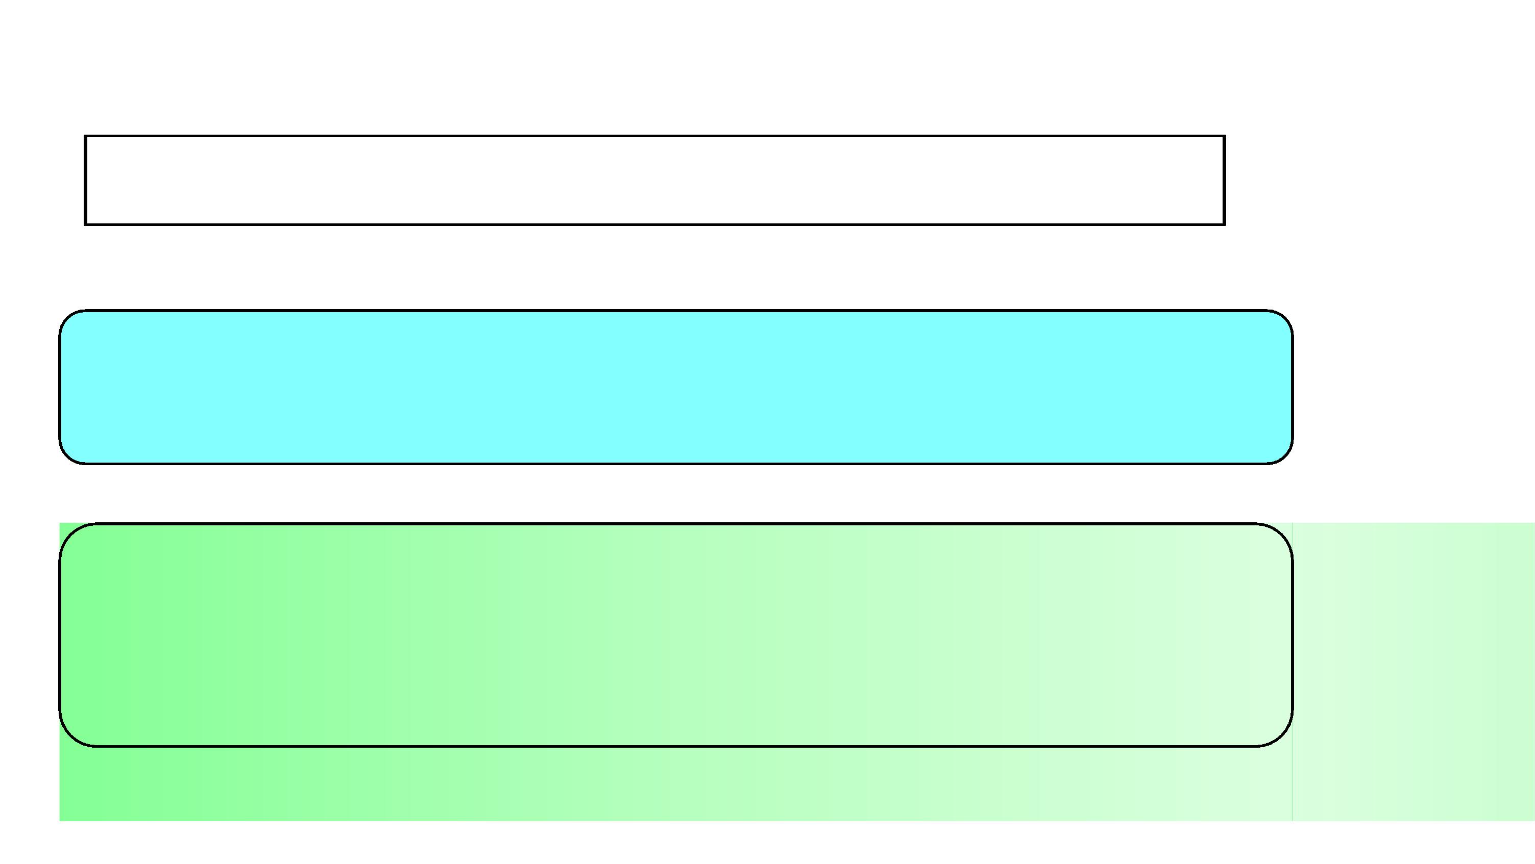

Agenda and Objectives
•
•
•
Research based background information
Soft Skills
Focus on Oral & Written Communication:
One-word selfie
Conversation cards
Useful language phrases
Language frames (oral and written)
Problem solving
Classroom jobs
Exit tickets
3


Soft Skills: Interpersonal and Communication Skills
•
•
•
Listen well/understand instructions
Interact with others
Work in a team
•
•
•
•
•
•
•
Teach job duties to others
Manage time
Read and comprehend work documents
Solve problems
Ta ke initiative and responsibility
Lead/plan/delegate
Monitor performance
Sources: SCANS report; 21_{st} Century Skills


Hard Skills: Technical Knowledge and Skills
•
•
•
•
•
•
•
Make and repair products (fix a car, weld a pipe)
Operate machines
Provide required service
Use appropriate computer hardware and software
Demonstrate knowledge of safety standards
Market and sell merchandise
Implement appropriate office procedures
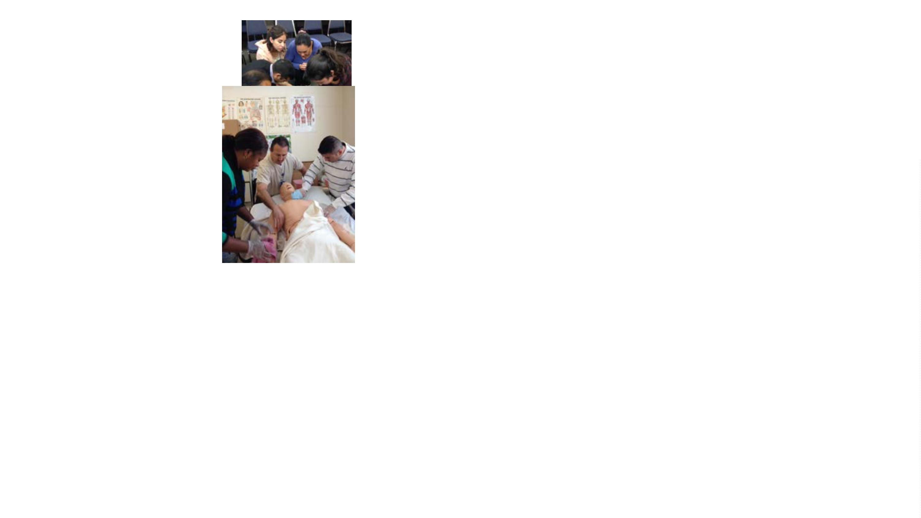

English Language Instruction and Soft Skills
Critical thinking, problem solving, verbal and written
communication skills, teamwork skills, and professional
manners are the top-rated “soft skills” managers seek
in employees (Wonderlic, 2016) and are suitable
instructional targets for adult English language classes.
Hellman, A., Harris, K. Wilbur, A. (2019) The 6 Principles for Exemplary Teaching of English Learners:
Adult Education and Workforce Development.
6


LinkedIn
Berger 2016
7
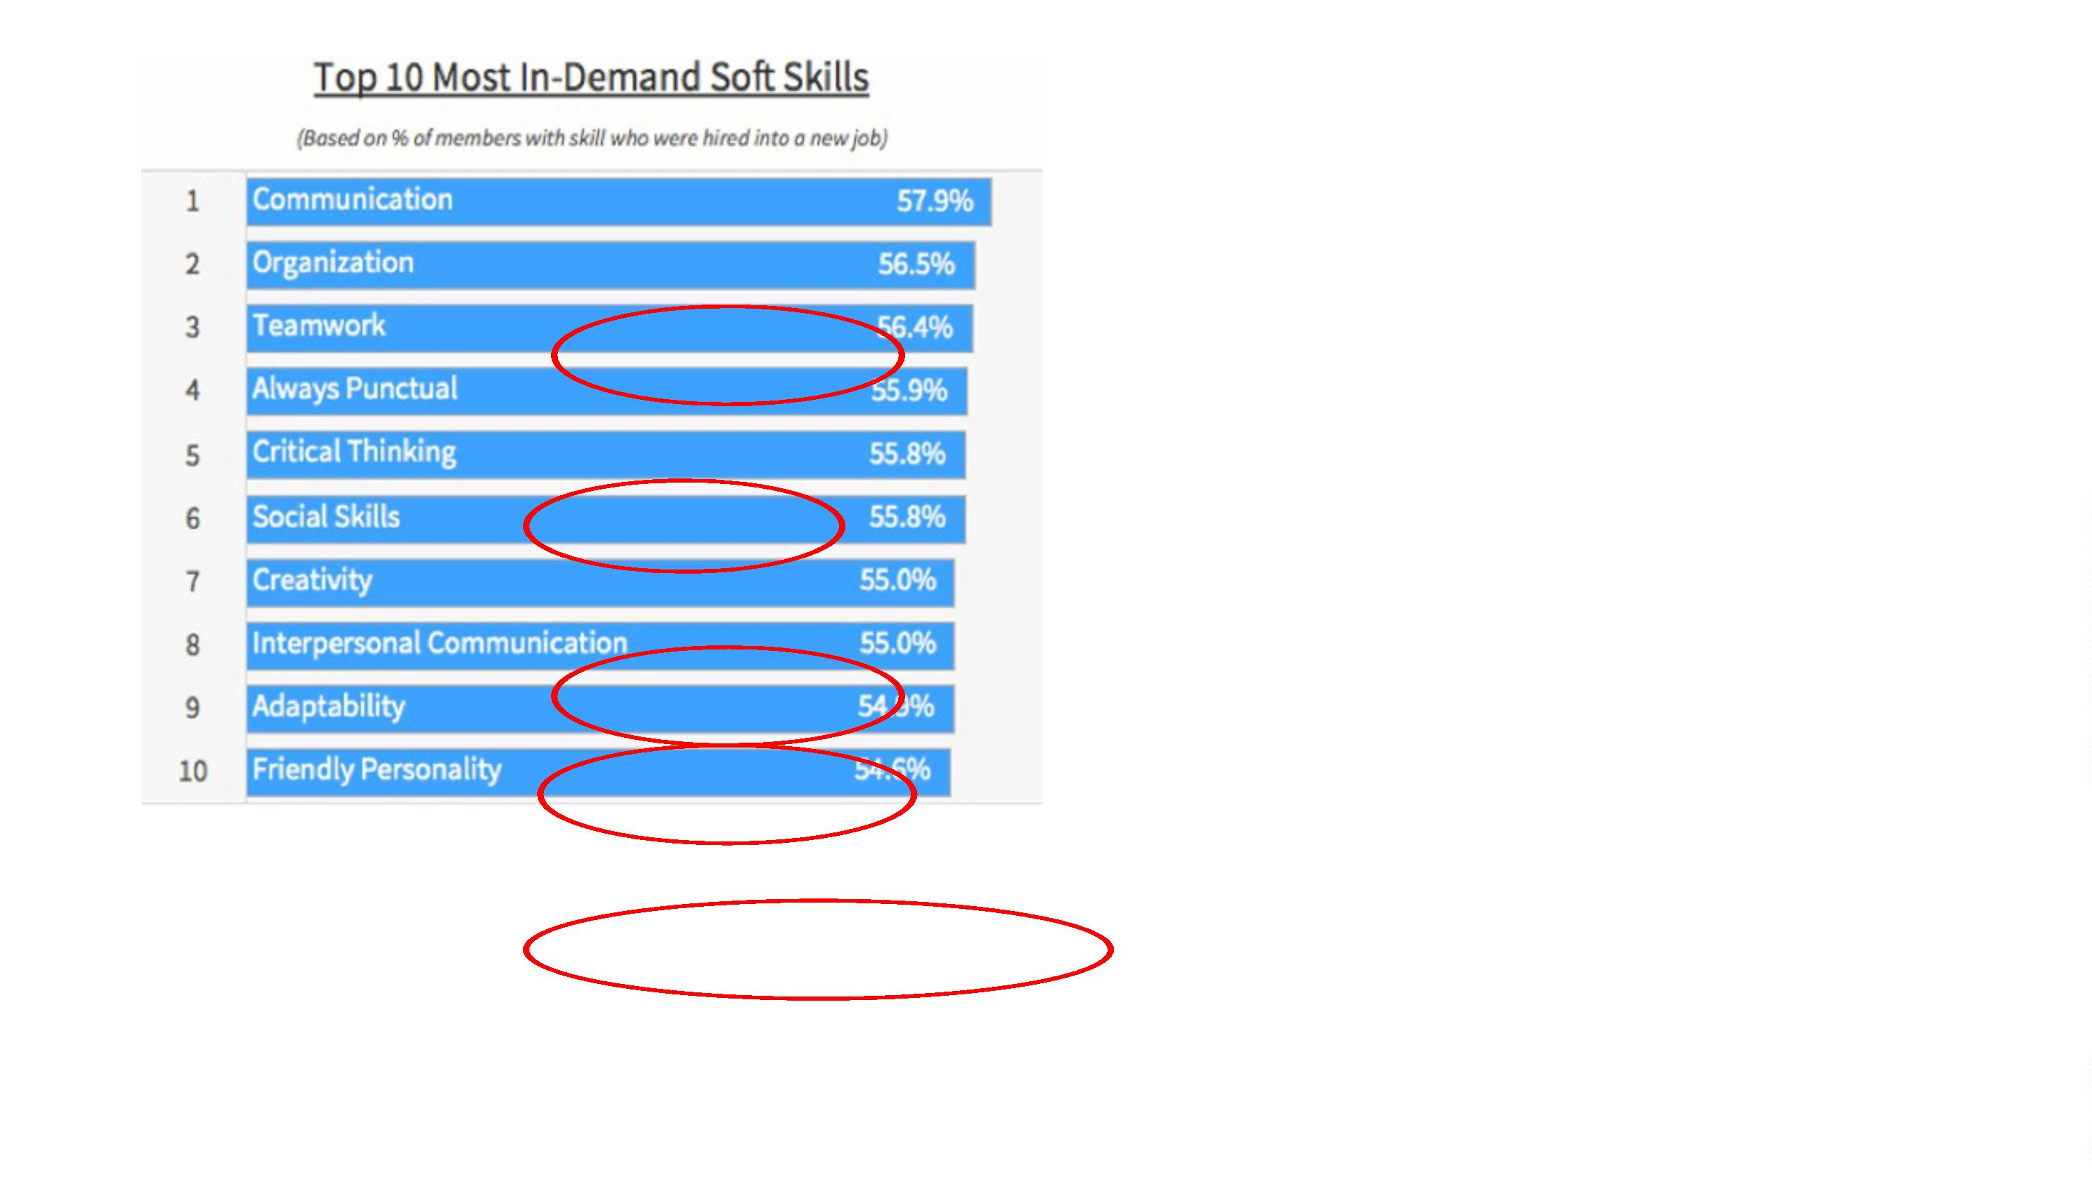

Dewar 2023
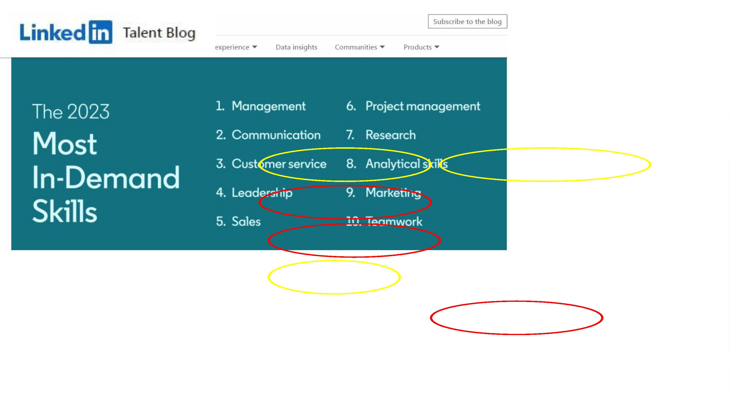

Hart Research Associates
Hart
Research
2
018
9
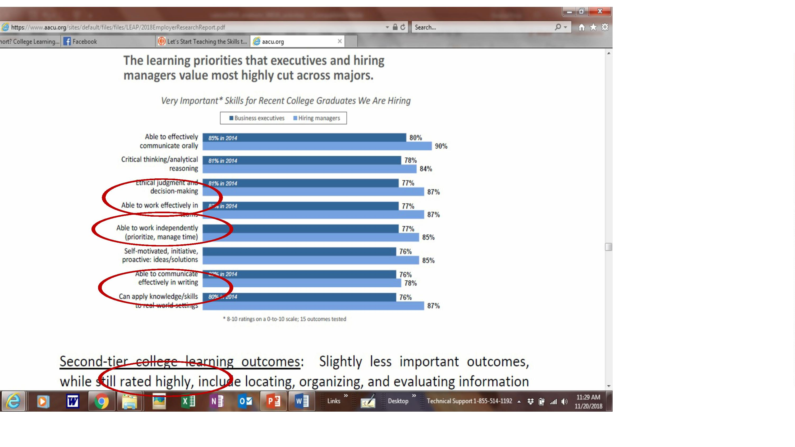

Oral Communication: One-word Selfie
Adapted from Katie Welch, TESOL 2020: Differentiating instruction in online classrooms
1
0


Favorite word selfie: One Wo rd
Donna
Yeelena
Reine
Discuss the words in the context of transferable soft skills in the workplace.
1
1
Adapted from Katie Welch, TESOL 2020: Differentiating instruction in online classrooms


Waterfall Chat:
What is your favorite selfie
word? What is one word
that describes you?
Rationale
The waterfall chat is a fun technique because
students are all thinking at the same time, but
can’t copy each other. In addition, it gives the
students who need more time to process
information time to type in their answers. Chats
are usually are very fast. The waterfall chat slows
things down.
Procedure
Type your word in the chat but DON’T HIT
ENTER!!! When I say 3, press enter.
Ready? I-2-3. Enter.
1
2


Ice-breaker: Favorite Wo rd Selfie
To get to know your students better, do this
“favorite word selfie” activity.
1
2
) Students post selfie* with one word that describes themselves.
) Students introduce themselves and tell why they chose that
word.
3
) Students find someone who they have something in common
with and explain why.
In beginning level classes, give students a list of five words and let
them choose from: friendly, helpful, cooperative, on time,
organized.
*
Post on Padlet, Canvas, Google Slides, website, etc.
Adapted from Katie Welch, TESOL 2020: Differentiating instruction in online classrooms
1
3


Favorite Wo rd Selfie Breakout Rooms
Now that you have decided on one word that describes yourself, you
are going to see how it feels to practice with your word in a breakout
room.
1
. Introduction & Selfie Share: Introduce yourself to your
partners, tell them the word you chose and why you chose it.
2
. Find Commonalities: Find someone you have something in
common with and discuss what you have in common.
3
. Report Back: Be ready to come back to the whole group to
report something you learned about yourself and your partners.
Does anyone want to share one thing
you heard from another person?
1
4


One Wo rd Selfie Activity on Padlet
1
5
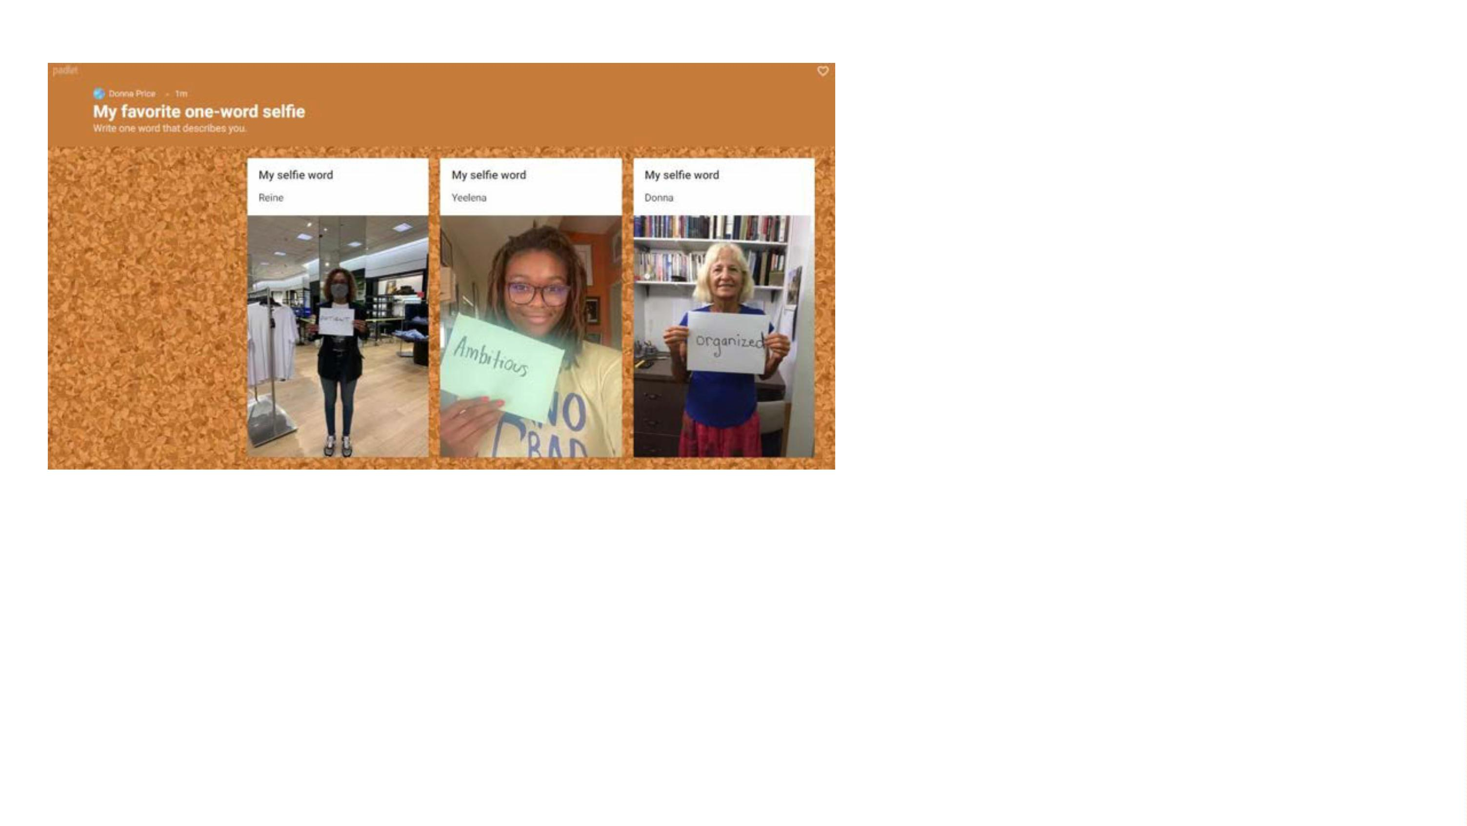

Favorite Wo rd Selfie Homework: Directions and Model
Beginning Level: Write one paragraph.
My name is Donna. I was born
in Kansas. I have lived and worked in
My name is _______________. I was
born in ________. My favorite word is
San Diego for over 40 years. I enjoy
working with people, swimming and
_
_______ because __________.
running.
Intermediate/Advanced:
The word that describes me is
organized. I chose that word for
Write two paragraphs.
many reasons. First, I keep track of
•
1st paragraph: Background information
about yourself.
my ideas and make to-do lists. Also, I
have a schedule and manage my
2nd paragraph: Why you chose your
favorite word. Give at least two
examples.
time. I meet deadlines and work well
•
with people in case I need assistance
to finish a job. Finally, I’m organized
because I need to find things I’m
•
You will read your paragraphs to your
classmates and submit it to your
teacher.
looking for!
1
6


Favorite Wo rd Selfie Assessment
1
2
) After students write their two-paragraph assignment
about their favorite selfie word, they read it aloud to
the class.
) Students submit their written assignment to the
teacher (email, text, or LMS).
Adapted from Katie Welch, TESOL 2020: Differentiating instruction in online classrooms
1
7


Oral Communication: Conversation Cards
1
8
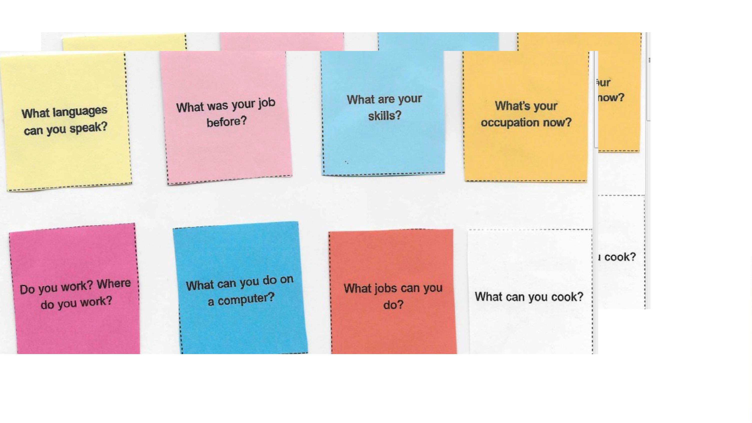

Conversation Cards
Student A: Ask any question to student B.
Student B: Answer the question and then ask a different question to student C.
Student C: Ask a new question to student A.
Do you like to
work alone or
with people?
Do you like to
work the day
shift or the night like to do at
What are two
things you do not things you like to
What are two
do at work?
shift?
work?
1
2
3
4
Do you have a
manager, or do
you like to be
your own
Do you speak
English or your
native language
at work?
What are two
jobs you do not
want to have?
Do you like to go
out for lunch or
bring lunch from
home?
manager?
5
Adapted from
Ventures Online
Resources
www.cambridgeone.o
rg
6
7
8
Do you write
letters, emails or calls or take
reports at work? messages at
Do you answer
Do you take a car, What are two
bus or train to
work?
jobs you want to
have?
12
1
9
9
work? 10
11
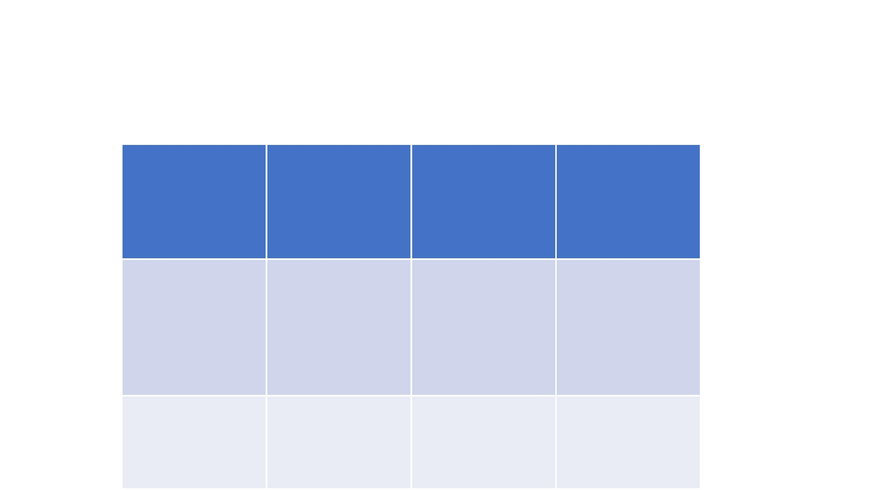

Ways to Practice Conversation Cards Online
1
. Teacher shares screen with conversation questions. In a chain drill
fashion, students ask each other the questions.
2
. Students in Zoom Gallery view. Teacher posts the questions in the
chat box. In a chain drill fashion, students ask each other the questions.
3
. Students in Breakout Rooms. Teacher posts the questions in the
chat box. Students ask each other the questions. Or, teacher posts a file
in the chat box and students open the file and share their screen.
4
. Students photograph the questions. They toggle back and forth
between Zoom screen and questions if they are on a phone.
2
0


Conversation Cards Assessment
1
. After students come back to the whole group from
breakout rooms, ask, “What did your partner say about….”
2
. After students ask and answer in gallery view, teacher asks
about students’ answers, for example, “What can Maria
cook? Who remembers? What languages does Bin
speak?”
3
. For homework, students can write out the answers to the
questions and submit them to their teacher. Students can
also practice the questions and answers orally at home.
2
1

Oral Communication: Useful language phrases
There is a great need for functional language
associated with asking for information, making
requests, providing explanations, discussing problems
or making amends when things go wrong. (Wrigley 2015)
e.
tim
o^{ur}
y
o^{r}
f
k^{s}
an
Th
Are you with me?
2
2
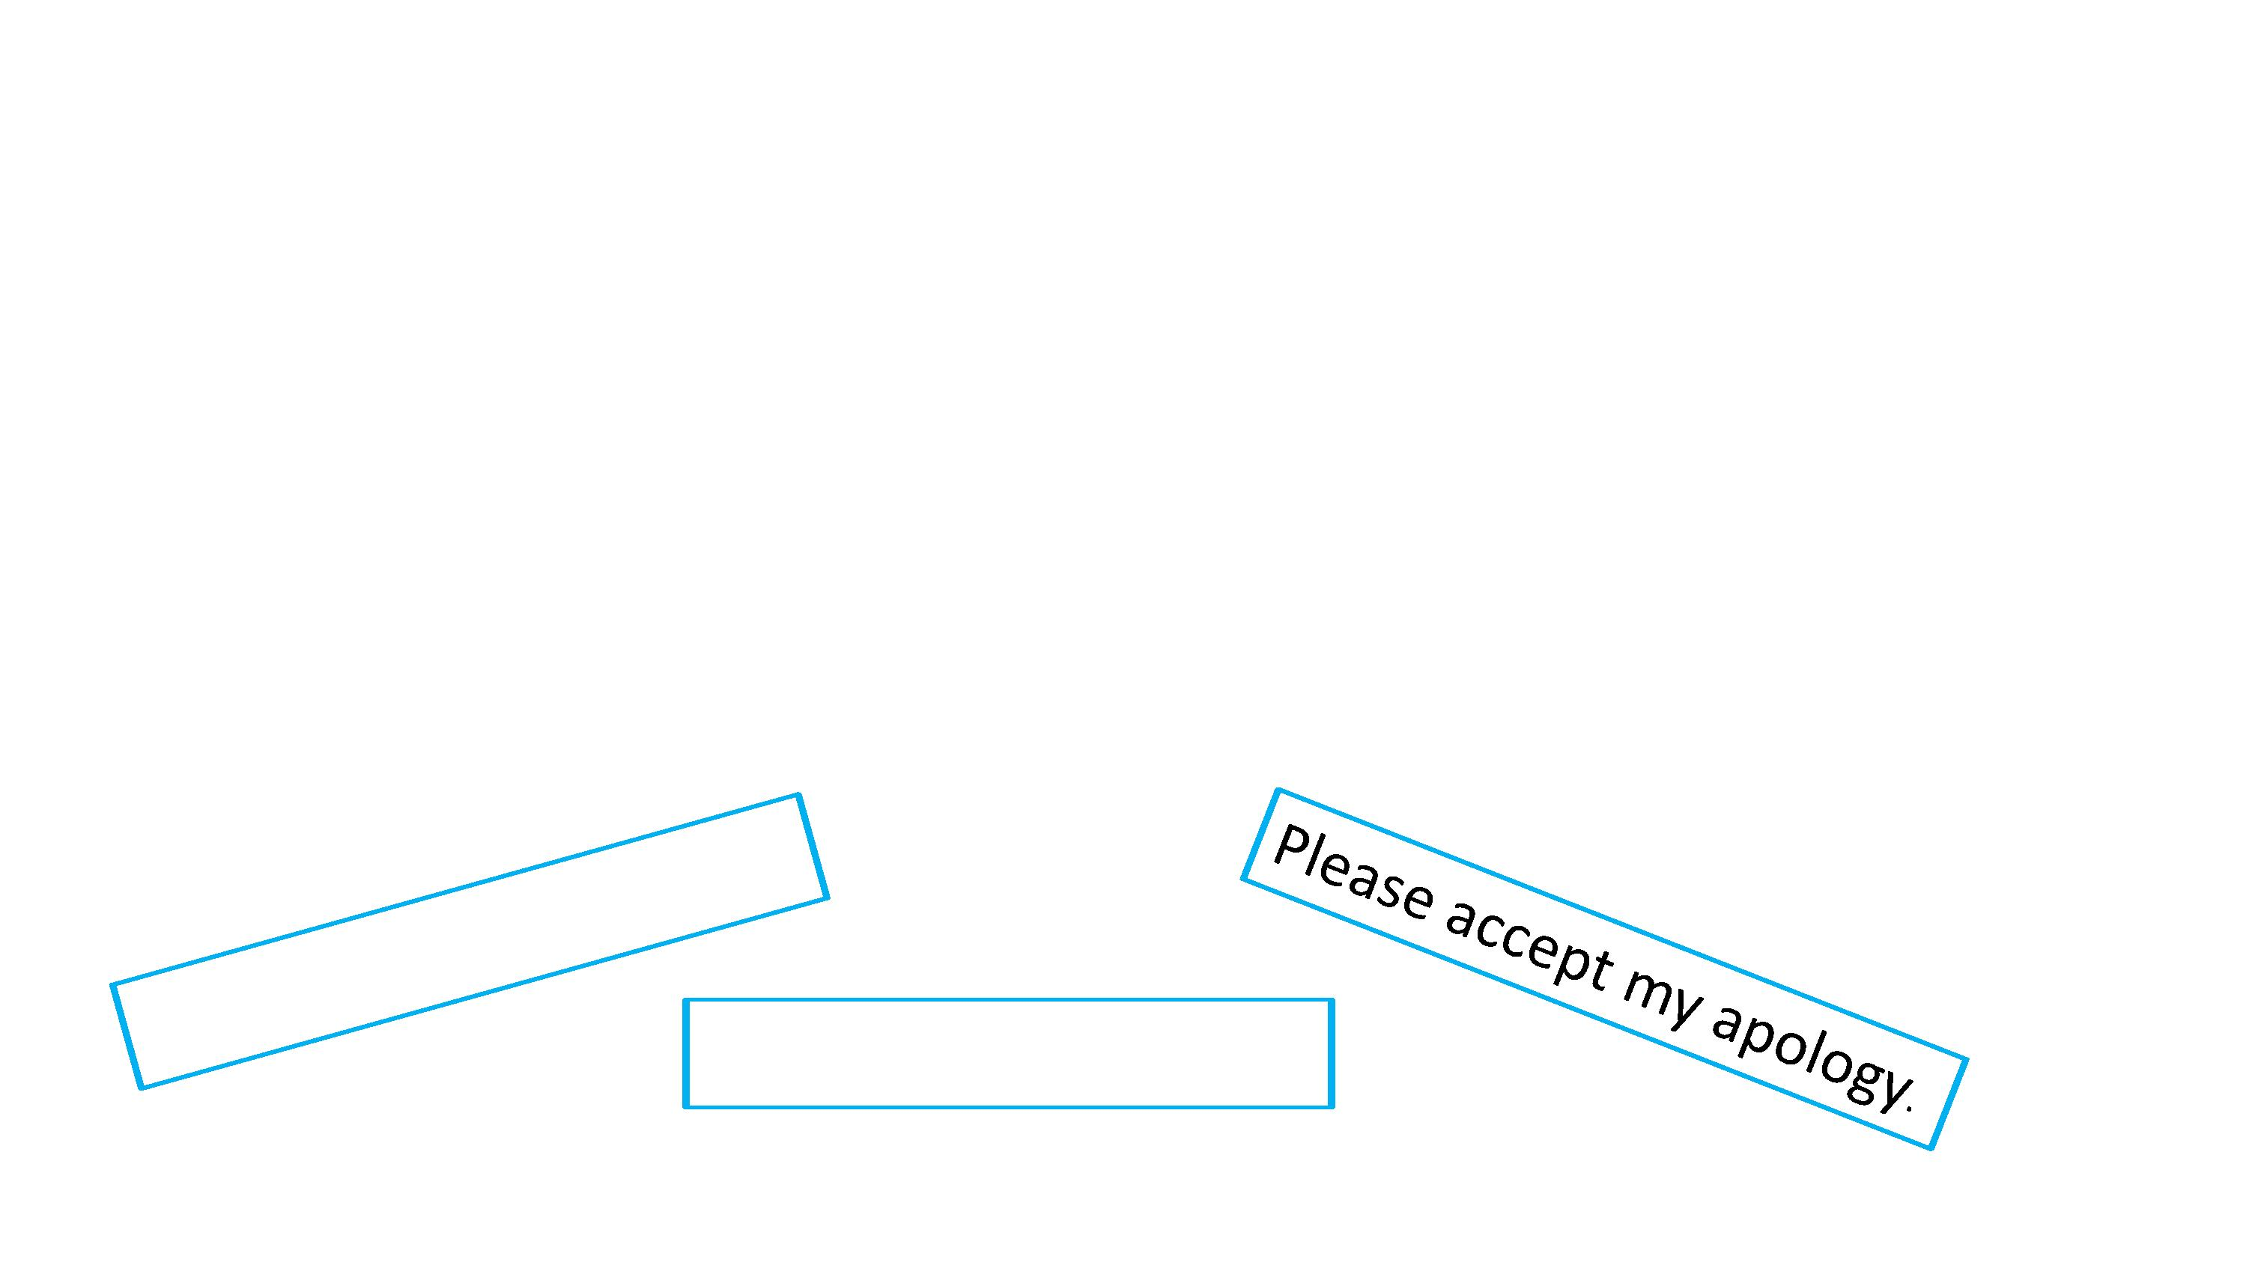

Useful Phrases
Courtesy: Simple Phrases for Leaving
Casual:
•
•
•
It was nice talking to you.
Thanks for your help.
See you later.
More formal:
•
•
•
I look forward to working with you again soon.
It was a pleasure to work with you.
I don’t want to take up any more of your time.
2
3
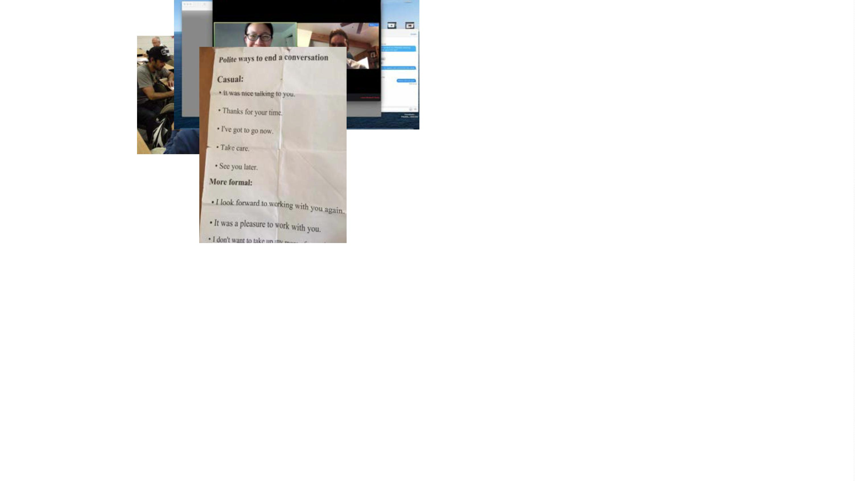

Oral Communication: Language Phrases
Chat
From Me to Everyone:
Polite phrases to say
goodbye
It was nice talking to
1
. Zoom Gallery View: Teacher posts several useful phrases for
one function in the chat box.
2
. Modeling: Teacher models how to embed the phrases into the
lesson. For example, when the breakout room activity is over,
students end the conversation with simple phrases for leave
taking.
you.
Thanks for your time.
I look forward to
3
. Breakout Rooms: Students refer to the phrases in the chat box working with you again.
and use one or two when appropriate while completing an
assigned task.
4
. Assessment: Teacher drops in and out of breakout rooms to
monitor students’ use of the phrases
2
4


Oral
Communication:
Oral Language
Frames
What did you do last weekend?
I went_______________________________.
I saw a lot of people _______________ing.
2
5
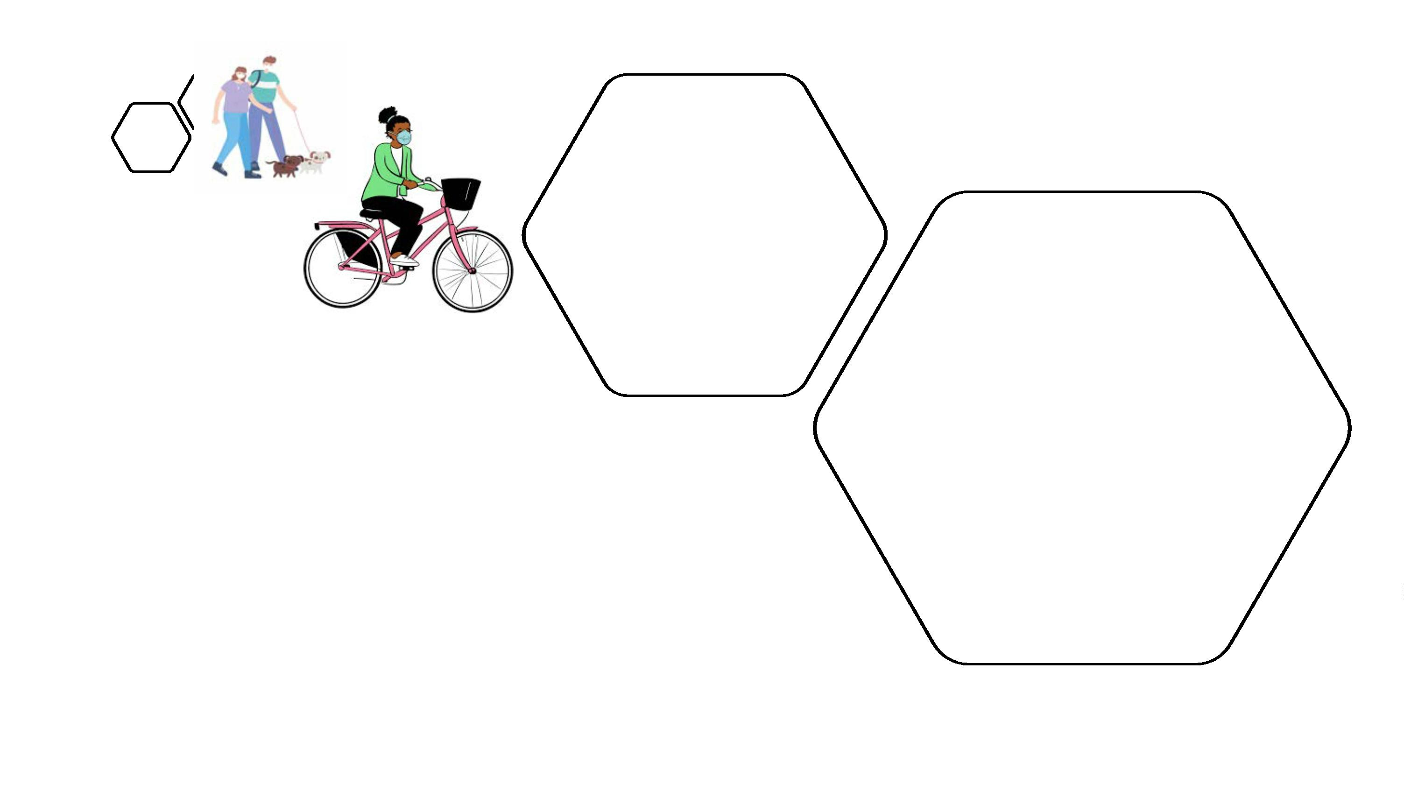

Why Use Frames for Oral and Written Language?
Frames……..
•
Guide and structure learning
•
•
Can be used for both synchronous and asynchronous learning
“….help students to gradually pick up academic language and
eventually use it to compose their own…..without help.”
~
Zwiers, J., (2004) Developing Academic Thinking Skills, p. 50.
•
Scaffolded language and is more easily accessible to students.
Frames provide language models on which students can build
their own ideas and content.
~
Parrish, B., (2019) Teaching Adult English Language Learners,
pp.168-170.
2
6
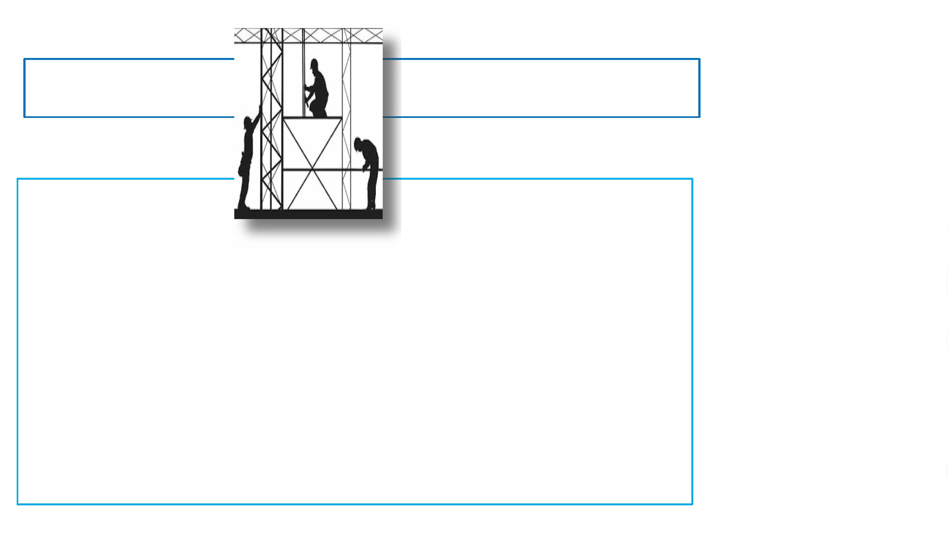

Chat
Oral Language Frames
From Me to Everyone:
What did you do last weekend?
I went _________________ and I
saw some people _________.
Ways to Practice Online and Face-to-Face
In the context of a speaking and listening lesson….
1
. Zoom Gallery View: Teacher posts questions and language
response frames in chat box.
2
. Modeling: Teacher calls on individual students. They complete
language frames with their own information.
3
. Breakout Rooms: Round Robin style, students take turns
asking and answering using the language frames.
4
. Assessment: Students return to whole class and report what
one of their classmates said in the breakout room.
2
7


Oral Language Frame: Practice Activity 1
1
. What time did you get up this morning?
I got up at _________because ______________________________.
2. What time did you go to bed last night?
I went to sleep at ___________because _____________________.
3. What time did you_________________?
I _________________ at ____________ because ______________.
Assessment: For community building, when students return to whole class,
ask individuals to report on how a classmate responded to one of the
questions. Who did you talk to? What did he/she say?
2
8


Oral Language Frame: Talking about Current Events
A. What is an advantage of _______________?
B. One of the advantages of ______________is
_
_____________________.
A. What is a disadvantage of _____________?
B. One of the disadvantages of _________is
•
Ge_{tt}
in_{g}
in
g a
^{va}cci
^{nate}d
&
ge
tt g
a
^{bo}o
st_{er}
•
Ta_{ki}
n
_
_________________.
cl_{a}
ss
o_{n}
e
lin_{e}
•
Sh
op_{p}
in_{g}
on
lin
•
•
W
Wa
o
tc
rk_{in}
g
g
re_{m}
o
n
te_{ly}
^{h}in
th_{e}
^{e}w
s
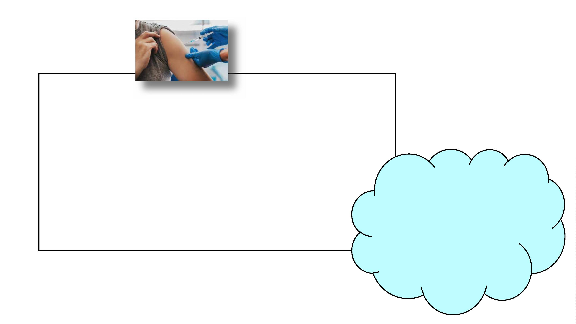

Written
Communication:
Writing Frames
3
0


Written Communication
in the Workplace
•
•
During the job search:
•
•
•
•
Job application forms
Resumes
Cover letters
Thank you notes
On the job:
•
•
•
Memos
Emails
Text messages
•
Instant messages
Instructions
•
•
•
•
•
•
Business letters
Safety reports
Accident reports
Proposals
Bulletins
•
Promotional reviews
3
1


Hart Research Associates
Hart
Research
2
018
3
2
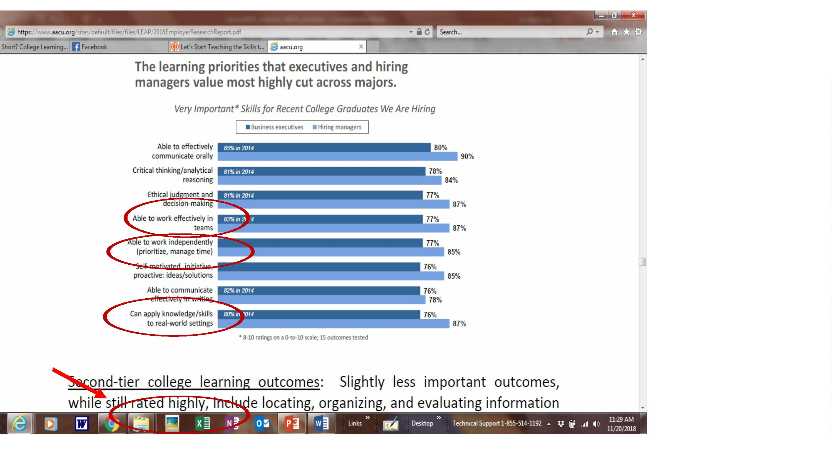

Written Communication: Sentence Frames
Job History/Job Resume
1
2
3
4
) I came to this country in _____________________.
) In my home country, I worked as a ________________.
) My first job in this country was as a ___________________.
) I’m looking for a job as a ____________________________.
5
_
) My work skills are: I can _________, _________, and
__________.
3
3
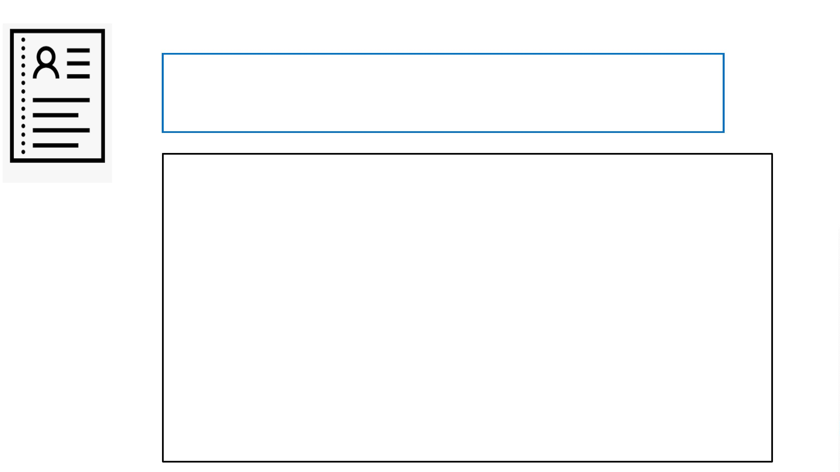

Written Communication: Paragraph Frames
Important Events
I want to describe three important events in my life.
First, _________________________________________________.
Second, ______________________________________________.
Third, ________________________________________________.
Next year I’m going to ______________________________.
Adapted from Jeff Zwiers
3
4


Written Communication: Paragraph Frames
Beginning Level
Draw pictures of three important events in your life.
Write about your pictures.
Three Important Events
My name is ___________________.These are my important events.
First, _________________________________________________
Second,_______________________________________________
Third,_________________________________________________
3
5
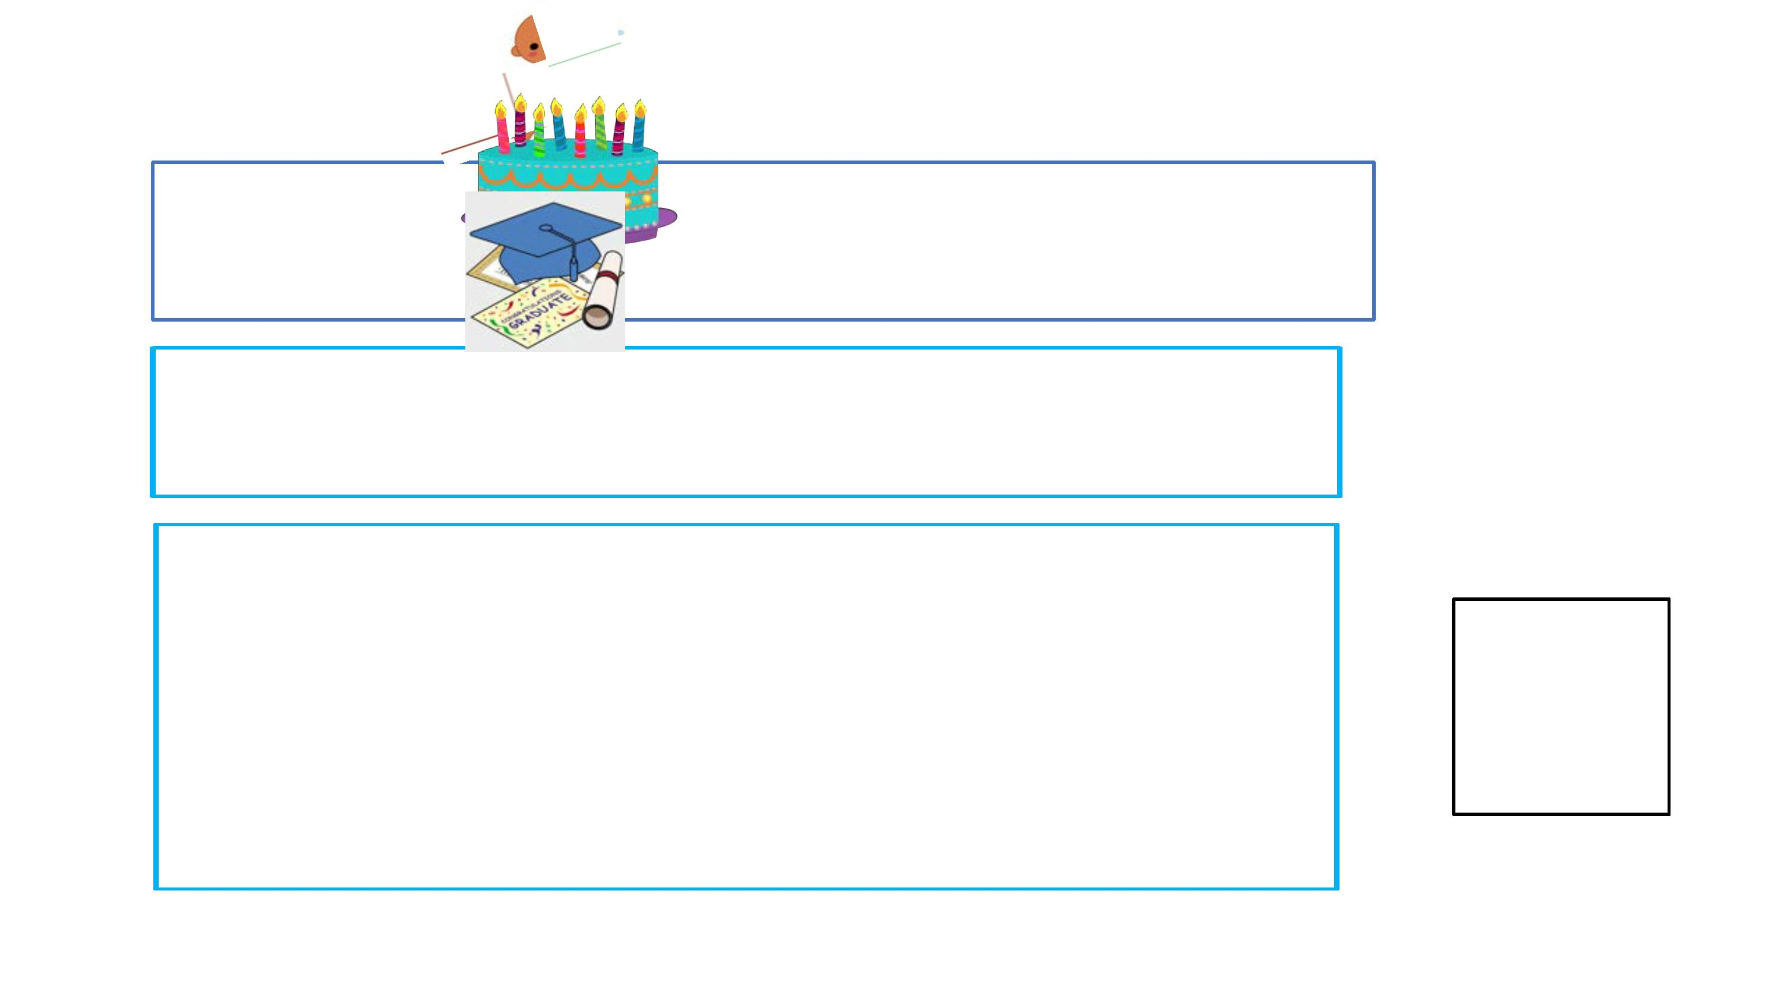

Written Communication: Wo rd Bank
Ventures, Book 1
3
6
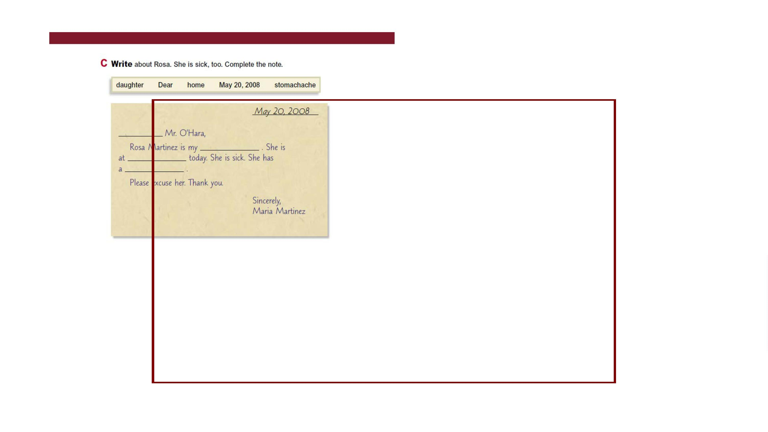

Written Communication: Paragraph Frames
Analyze Information
Future 2e, Student Book 1
CCRS Writing
3
7
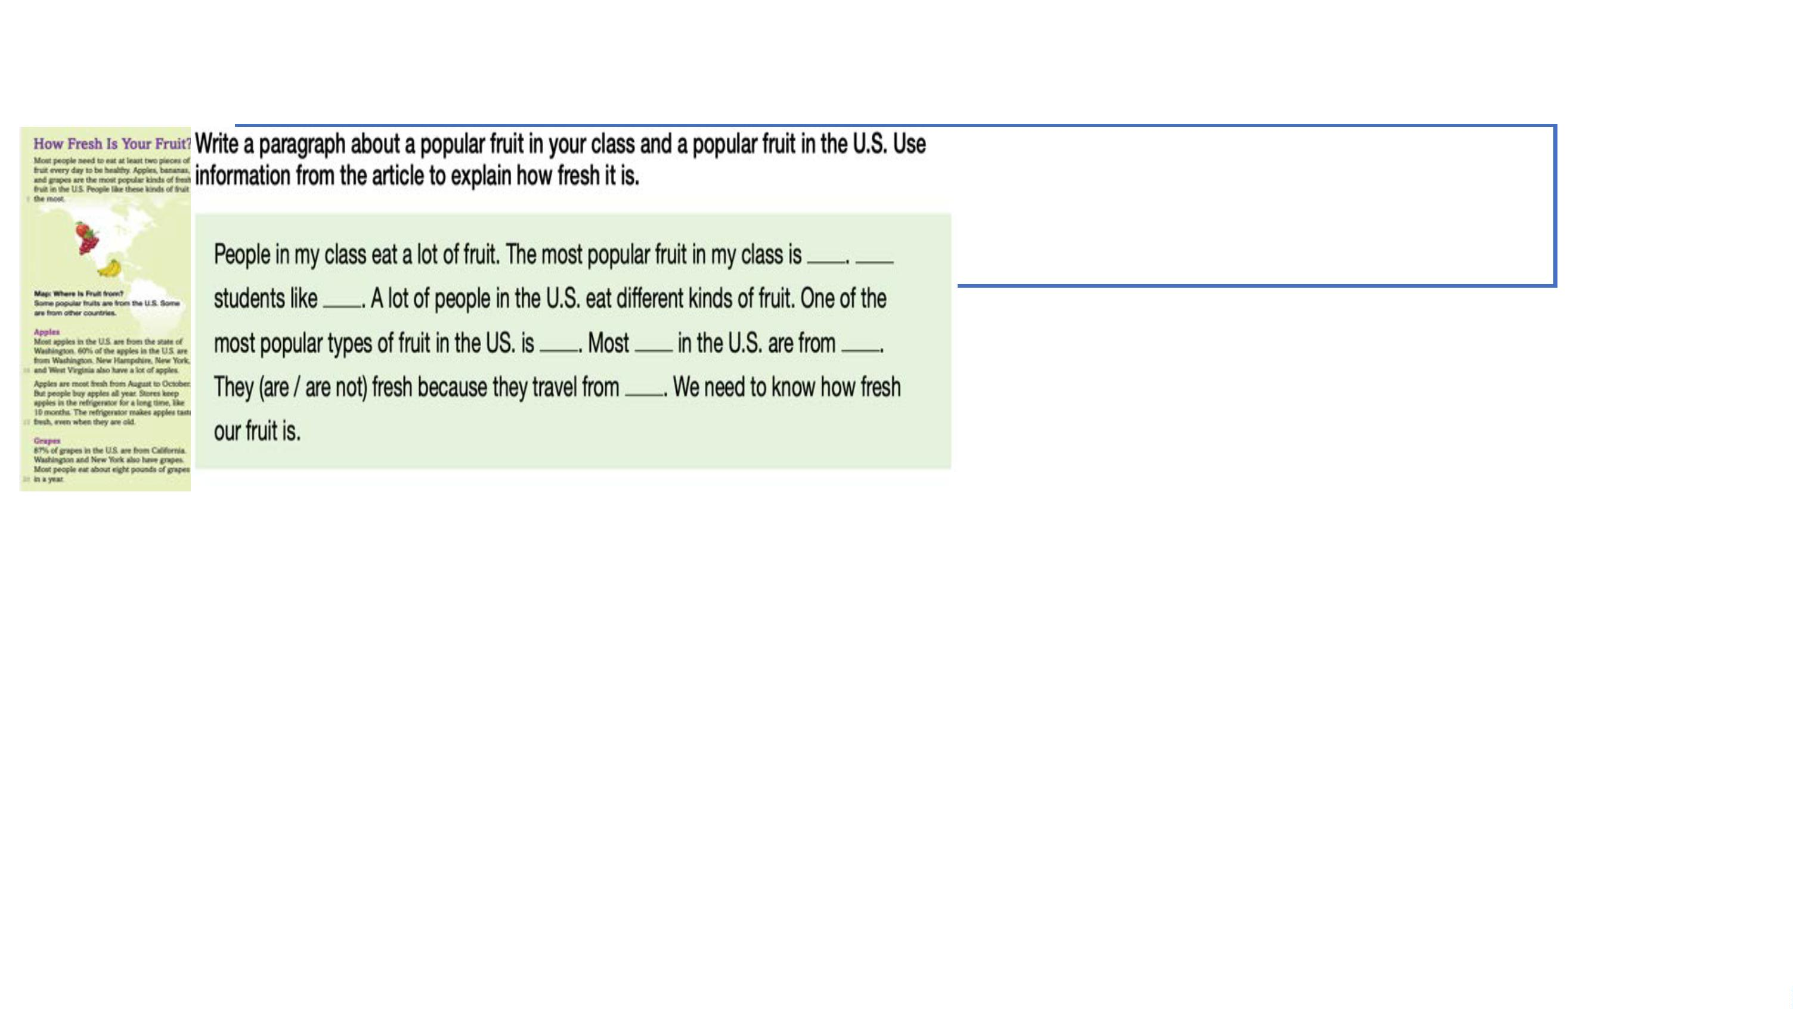

Written Language Frames: Ways to Practice
Online practice
1
. Zoom Gallery View: After class discussion about the writing task,
teacher posts a written language frame in the chat box.
2
. Breakout Rooms: Working individually and together, each student
fills in their own language frame.
3. Assessment: Students return to whole class and read their work.
3
8


Oral Communication: Problem Solving
3
9


LinkedIn
Berger 2016
4
0
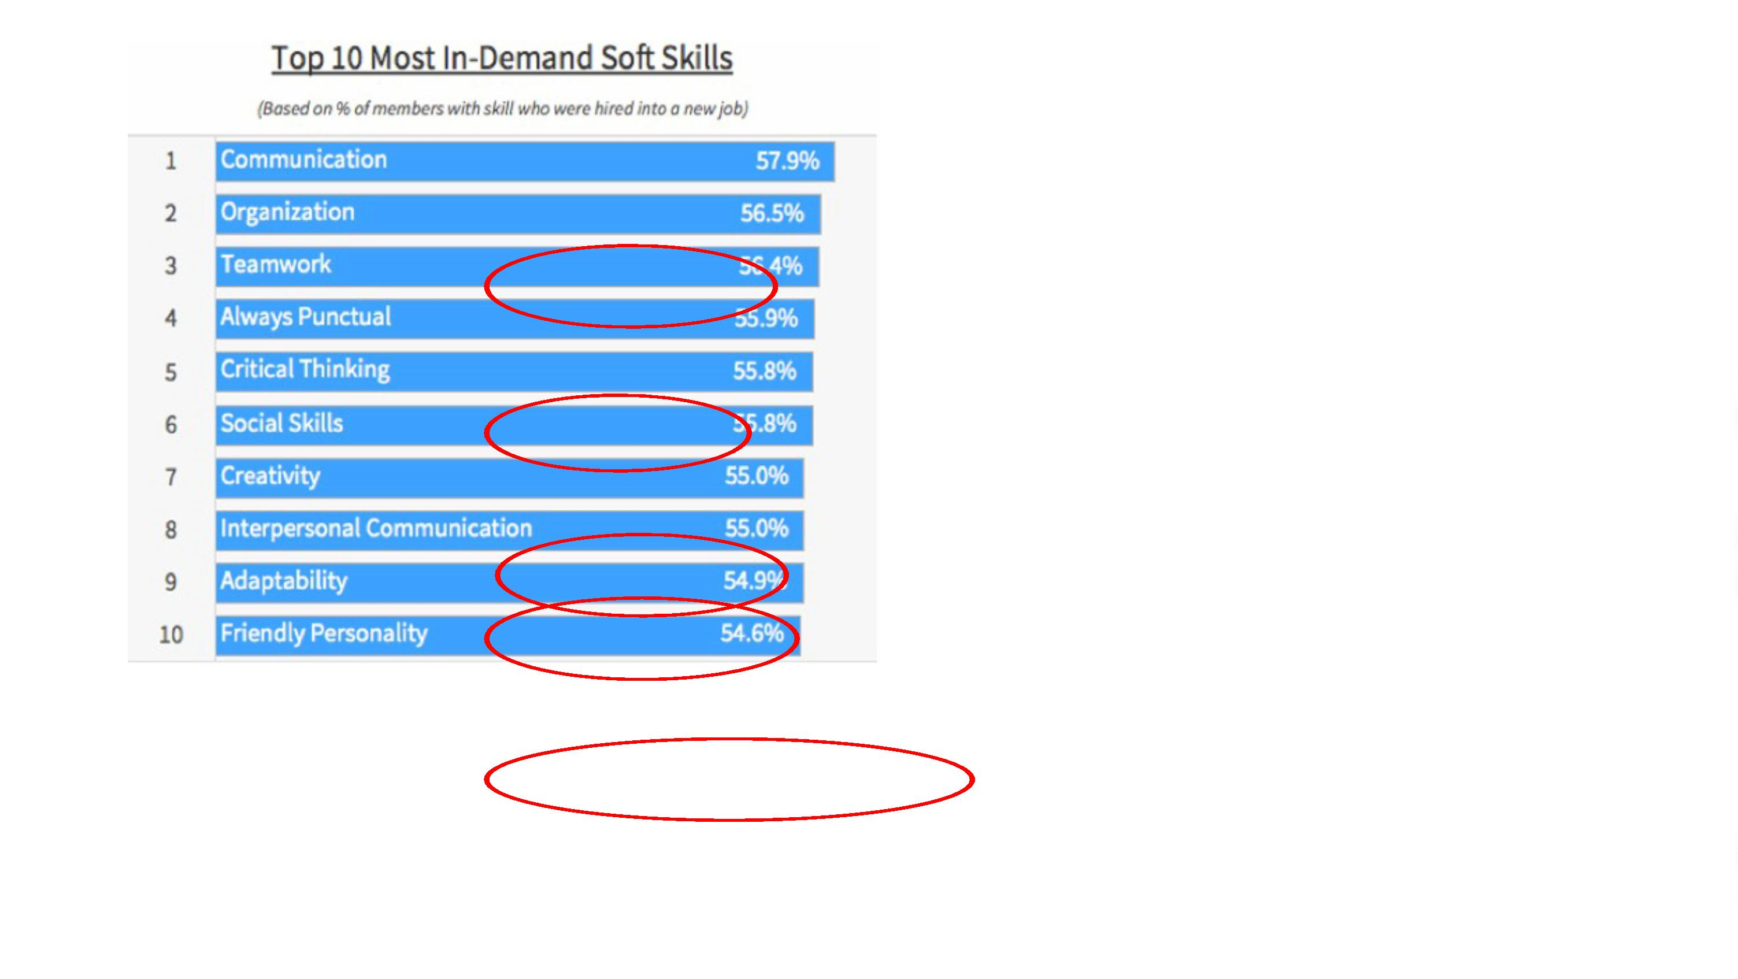

Why Teach Problem Solving?
In the Problem-Solving Process……..
•
•
Real-life problems are posed in oral or reading contexts
Individuals and student groups build the soft skills of oral
communication, leadership, collaboration, teamwork, critical
thinking, decision making
•
•
Student groups/whole class collaborate to identify the problem,
possible solutions, consequences, build consensus based on the
best solution
Language frames scaffold and guide group conversations
4
1


Problem Solving Scenario
Problem:
Freddy is a painter. He paints houses. The supervisor gives Freddy and
his co-workers instructions every morning. The supervisor speaks very fast.
Freddy doesn’t understand what the supervisor is saying.
What should Freddy do?
1
2
3
4
. Freddy says to the supervisor, “I’m sorry. Could you repeat that?”
. Freddy asks his co-workers questions when the supervisor leaves.
. Freddy doesn’t ask questions. Then he starts to work.
. Freddy_____________________________________________.
Future Second Edition, Student Book 1, p. 44.
4
2
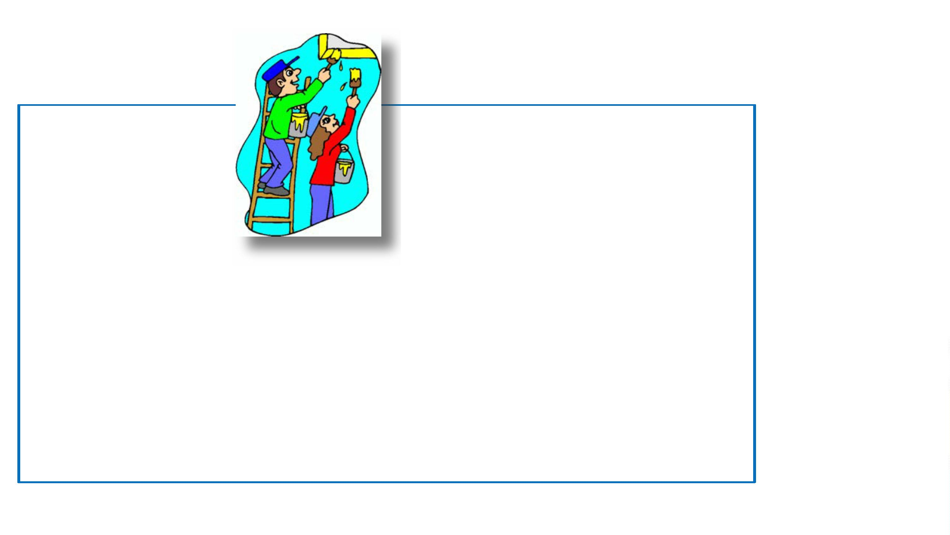

Problem Solving
Oral Language Frames
Ask for an opinion
•
What do you think she/he should do _________?
Provide a possible problem solution
•
I think he/she should _____________because______________.
Consider the consequences of taking an action
•
If she/he does ______________, then _________might happen.
Report a group decision to the whole class
•
•
Our group thinks he/she should __________because _______.
Some of the people in our group think that she/he should____
because__________. Others think that he/she should ________.
4
3


Make a Decision
+
Consider the
Consequences!!
What should Freddy do?
4
4


Problem Solving Breakout Room Instructions
In the breakout room:
1
2
3
. Select a group leader, recorder/reporter, timekeeper.
. The group leader reads the problem aloud.
. Each person gives their opinion (one minute) about how to solve the problem.
I think she/he/they should___________ because _______.
4
. As the group talks and tries to come to consensus, the group considers the
consequences of possible decisions.
If he/she/they do/does_____________, then________.
5
. When each group returns to gallery view, the reporter reports the group’s decision to
the class.
We think she/he/they should _______because_______.
4
5

Problem Solving Scenario #2:
Breakout Room
Problem:
It ’s Monday at 1:00 pm. Cecilia is working on her job as
a hotel front desk agent. She just got a call from the
school nurse. Her son is sick, and she needs to pick him
up. Cecilia is scheduled to work until 4 pm. She asks the
hotel manager for the afternoon off. The manager
wants to help, but no one in the building is available to
take Cecilia’s shift.
What should Cecilia do?
1
. Cecilia should leave work, even though her manager
said no one is available to work for her.
2
. Cecilia should try to call another worker to substitute
for her.
3
4
. Cecilia should pretend she is sick.
. Cecilia should call her husband or a neighbor to pick
up her son at school.
5
. Cecilia should _________________.


Problem:
It ’s Monday at 1:00 pm. Cecilia is working
on her job as a hotel front desk agent. She
just got a call from the school nurse. Her
son is sick, and she needs to pick him up.
Cecilia is scheduled to work until 4 pm.
She asks the hotel manager for the
afternoon off. The manager wants to help,
but no one in the building is available to
take Cecilia’s shift.
In the breakout room:
1
. Select a group leader, recorder/reporter,
timekeeper.
2. The group leader reads the problem aloud.
3
. Each person gives their opinion (one minute)
about how to solve the problem.
I think she/he/they should______ because _____.
4
. As the group talks and tries to come to
What should Cecilia do?
consensus, the group considers the consequences
1
. Cecilia should leave work, even though
of possible decisions.
her manager said no one is available to
work for her.
If he/she/they do/does_________, then_______.
2
. Cecilia should try to call another worker
5
. When each group returns to gallery view, the
to substitute for her.
reporter reports the group’s decision to the class.
3
. Cecilia should pretend she is sick.
. Cecilia should call her husband or a
We think she/he/they should _____because____.
4
neighbor to pick up her son at school.
5. Cecilia should _________________.
4
7


Jamboard: Sticky note brainstorming template
Click here to edit
an existing sticky
note
Click here to add
a sticky note
4
8
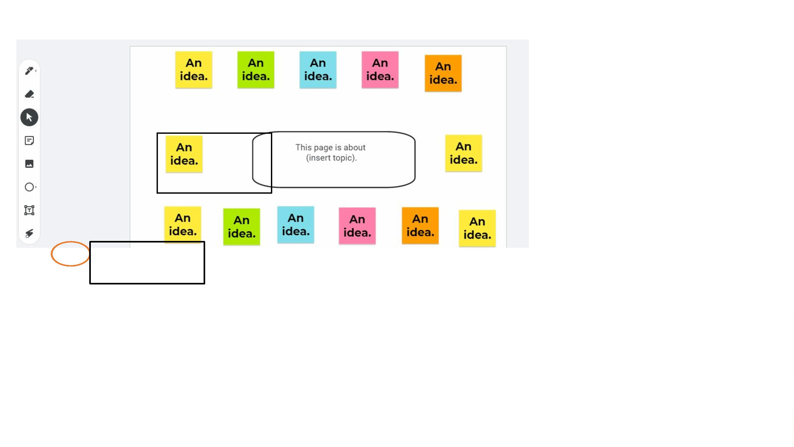

Jamboard: Sticky note brainstorming
Click here to
add a sticky
note
Click here to
edit an
existing sticky
note
https://jamboard.google.com/d/1i064nin8vJJEbDGdblT1HAmWxH
Q_JAEDCi147K6CjU4/viewer?f=0
4
9
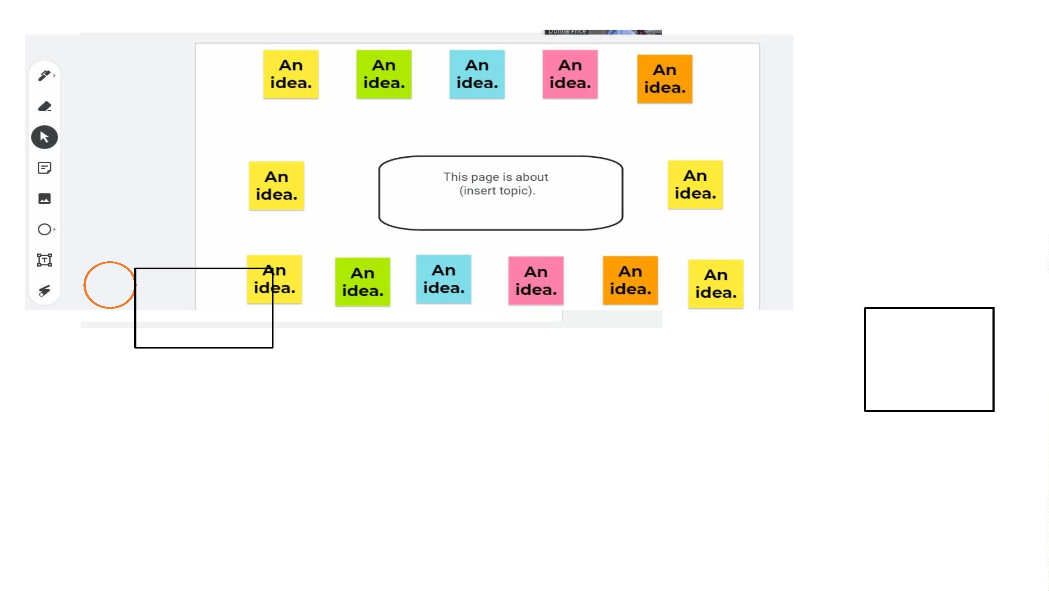

Problem Solving Assessment: Polls
Teacher reads each of the
possible solutions aloud,
tabulates and summarizes
class information.
•
•
•
•
Everyone agrees that Cecilia should_____________.
Some people think that Cecilia should___________.
Most people think that Cecilia ought to__________.
According to our class, the best solution is for Cecilia
to_______________.
5
0
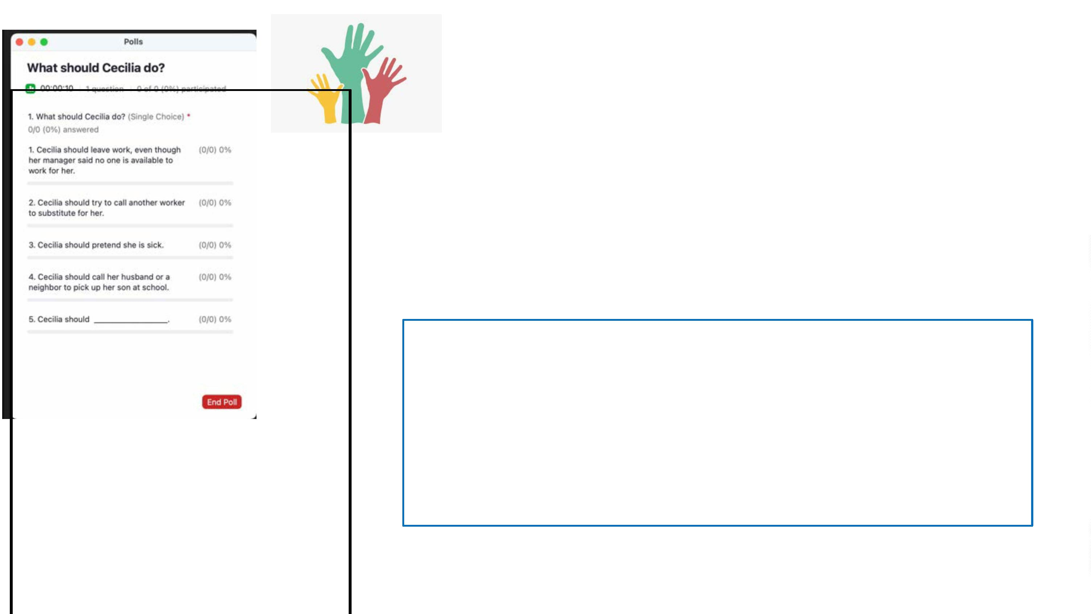

Problem Box:
Discuss real problems
Online classes: students
Face-to-face classes
Online classes: email
send a private message
in chat
5
1
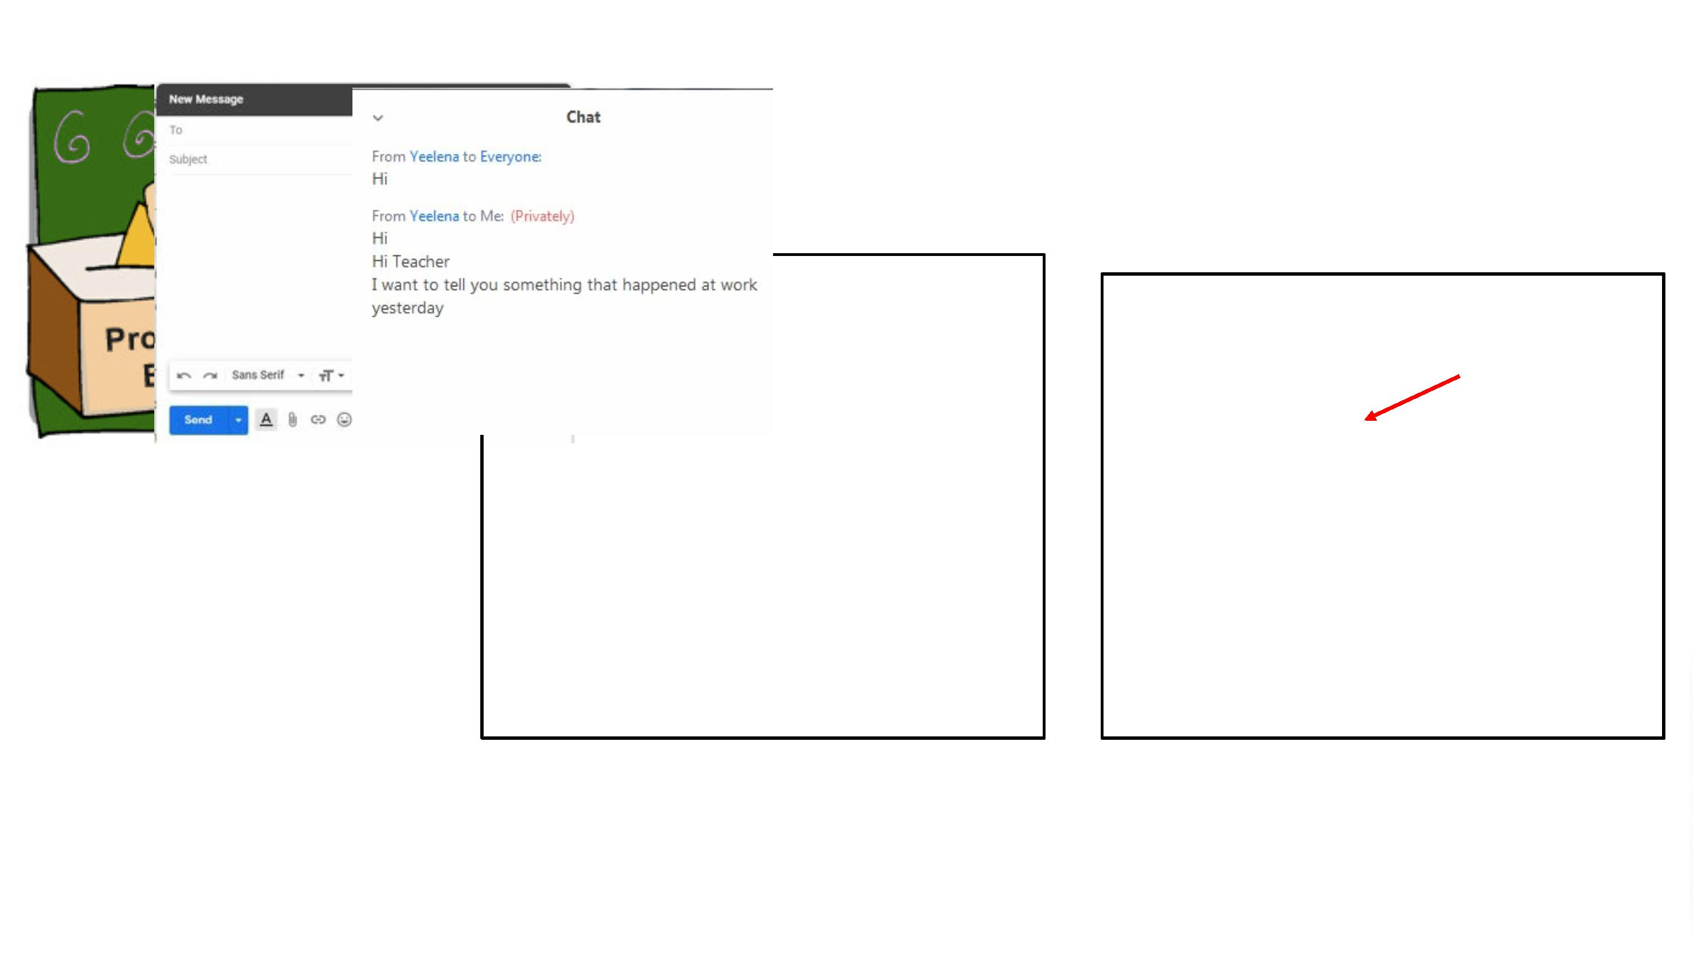

Classroom Job: Athletic Trainer
Hi everyone!
It ’s time to ta ke a stretch break.
Stand up, stretch, reach, look left and right…
5
2


Transferable Work Skills: Classroom Jobs in Online Classes
Classroom jobs:
•
•
•
•
•
Provide students opportunities to use English in practical ways
Provide ways for students to learn real world skills in practical ways
Boost student engagement in the class
Build autonomy
Help support the teacher
From Sam Kary, New EdTech Classroom and Thom Gibson,
Essential Student Jobs for the Classroom of Tomorrow
https://www.youtube.com/watch?v=vbkRanR1rNU&ab_cha
nnel=NewEdTechClassroom
5
3

Transferable Work Skills: Student jobs in the virtual classroom
JOB
JOB DUTIES
LANGUAGE FOR THAT JOB
Trainer
• Demonstrates to students how to • What can I help you with?
do something on Zoom or in a
learning management system.
• What ’s the matter?
• Let ’s meet on Zoom later.
•
•
Uses the chat box to communicate Digital language:
with students
• Click, scroll, drag and drop,
May stay after Zoom class to assist
students
delete, arrow, etc.
Athletic
Trainer
• Uses a timer to stop the class after • It ’s time to take a stretch break.
45 minutes.
Leads the class in a stretch break
for 1-2 minutes.
• Stand up, stretch, reach, look left
•
and right, etc.
Meteorologist • Provides a 1-minute summary of
• Today the weather is going to be
clear, cold, cloudy, windy, etc.
• I’m going to share some
important news with you.
News Anchor
the weather for the day/week.
Summarizes an important news
event.
•
Essential Student Jobs for the Classroom of Tomorrow, by Thom Gibson
5
4
https://www.youtube.com/watch?v=vbkRanR1rNU&ab_channel=NewEdTechClassroom
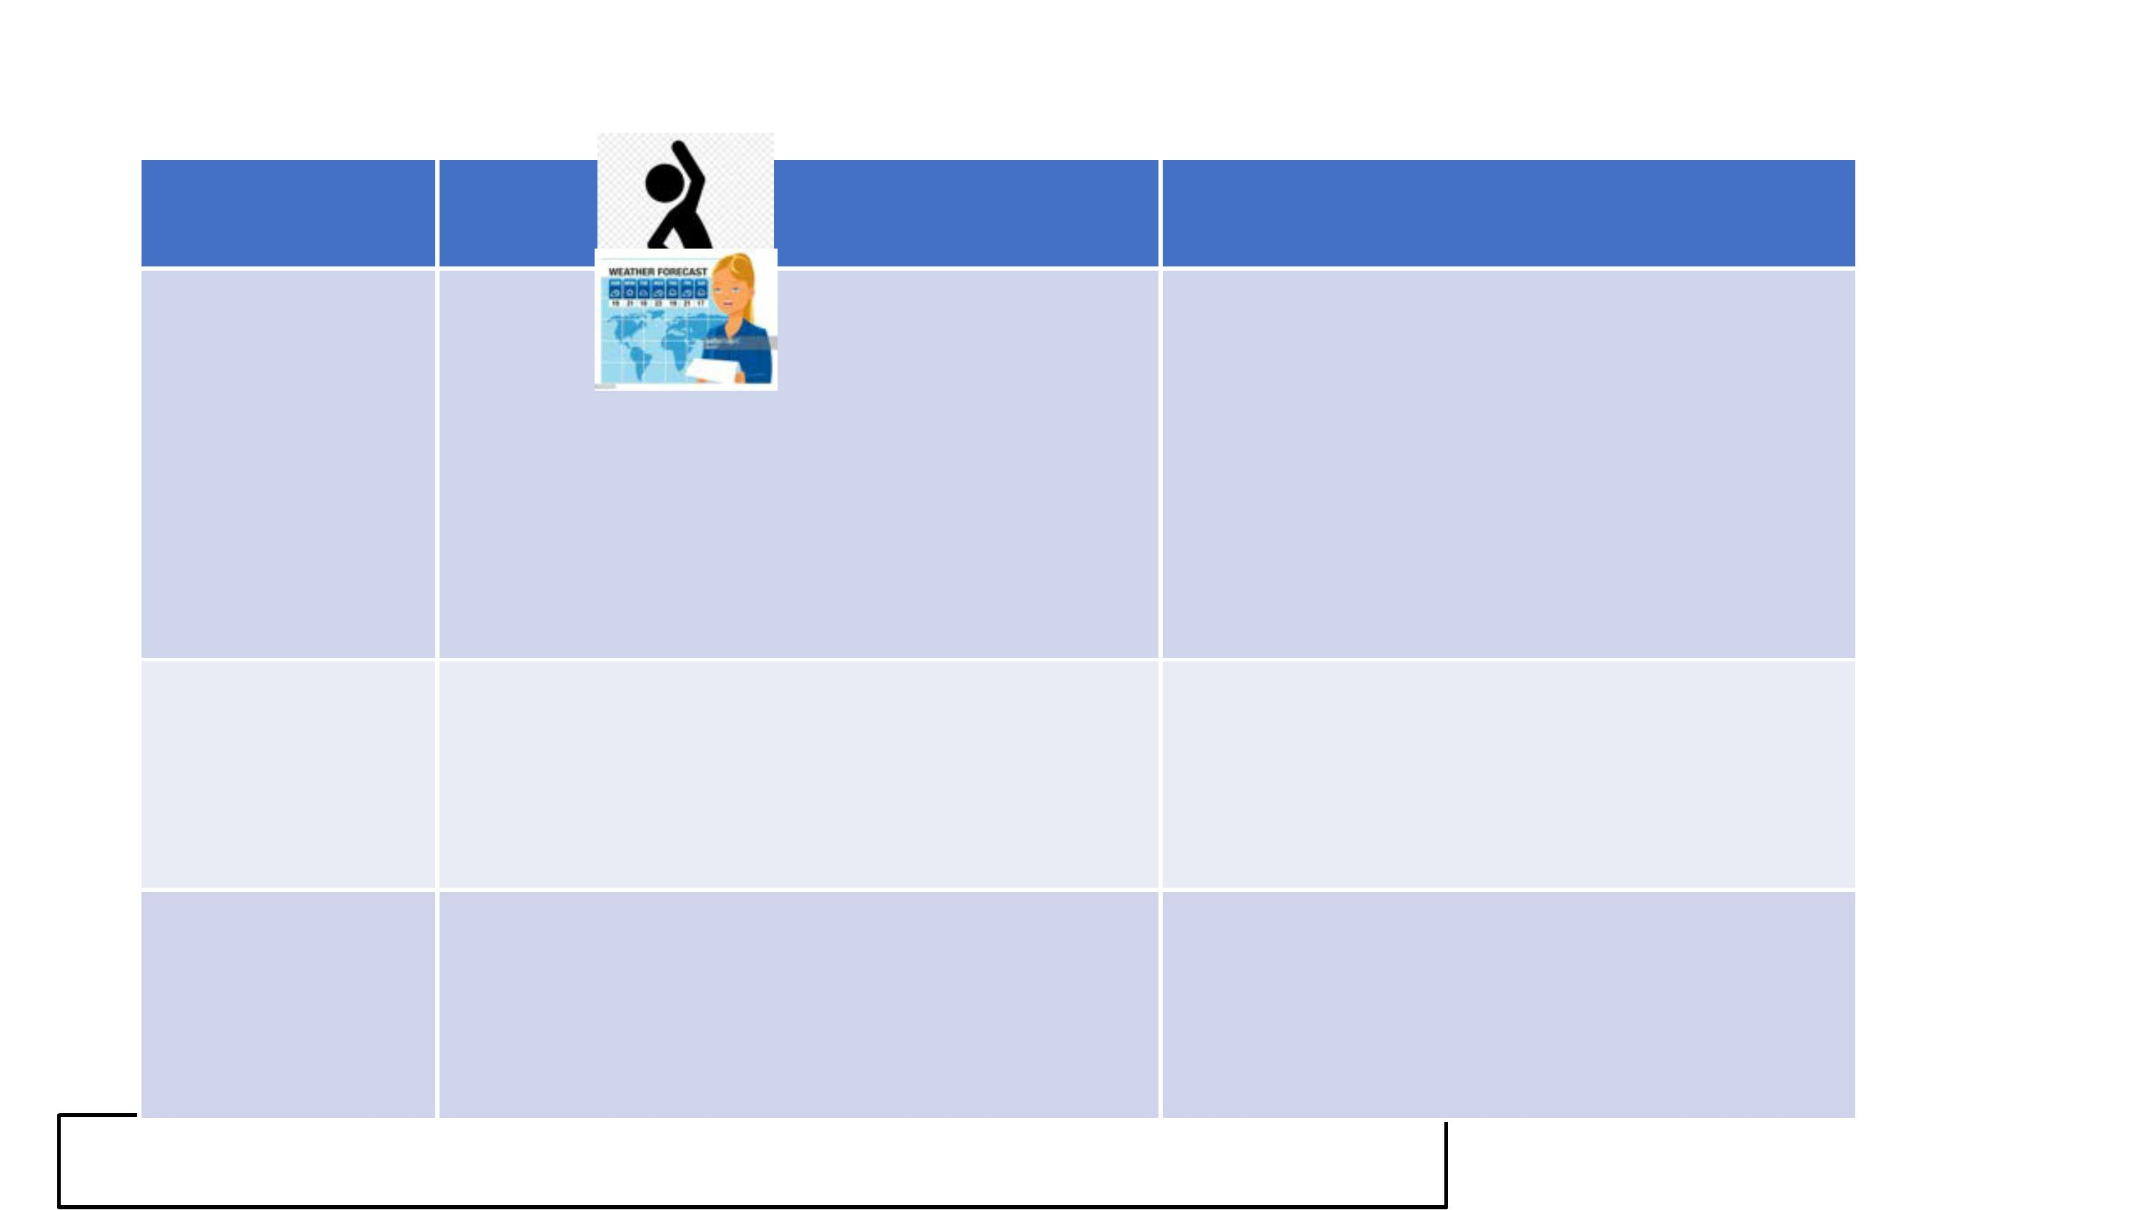

Transferable Skills: Classroom Jobs in Online Classes
1
. Zoom Gallery View: Teacher describes several jobs, what the
duties of the jobs are and some of the language needed to do the
job. The teacher only does a few jobs at a time and after a week or
two adds a new job. She explains the idea of ‘transferable skills.’
Chat
From Me to Everyone:
Choose a job you would
like to do for two
weeks.
Trainer
Athletic trainer
2
. Modeling: Teacher models how to do the job and the language
needed for that job. For example, the trainer assists students who
have computer problems. Trainers can work with the students who
need assistance online after the Zoom class or discuss when to
meet in the chat box.
3
. Assessment: Teacher assesses how students are doing with their
jobs and gives private feedback.
5
5


Transferable Work Skills: Student jobs in the face-to-face classroom
JOB
JOB DUTIES
LANGUAGE FOR THAT JOB
•
•
Hi. Welcome to the class. My
Trainer
• Help new students. Ask them to
name is ___ What's your name?
sit with you. Introduce yourself.
Every day you sign this sheet
when you come in. When you
leave, you sign out. (Show the
student the sign-in sheet).
•
Show the new students where to
sign in. Show them where the
materials are.
•
Help the students feel
comfortable.
•
•
The books and materials are
over there in the cabinet. (Show
the student).
If you have any questions,
please ask me. I can help you.
•
•
•
Pass out papers for the teacher.
Distribute and collect books.
Materials
Manager
• Did everyone get a handout?
• Here you are. Here you go.
Be sure the cabinet is neat before
you leave.
•
•
•
Who needs one?
There is one book missing.
Who forgot to put back the …
•
Be sure all materials (dictionaries,
books, etc.,) are put away before
5
6
you leave.
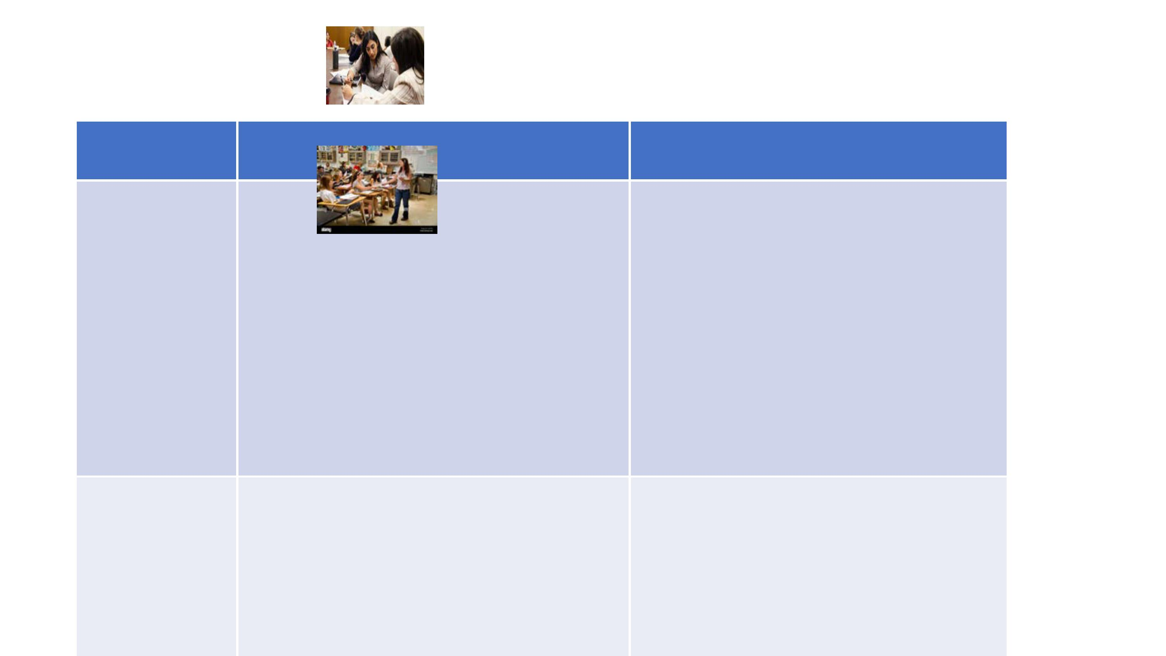

Communication:
Exit Tickets
5
7


Exit Tickets: Oral and Written
Communication
•
•
What workplace skills did you practice today?
(teamwork, oral communication, adaptability….)
What academic skills did you practice today?
(reading, writing, grammar….)
•
•
What do you want to practice more?
What did you like today?
Adapted from Sarah Lynn and Susan Reade COABE 2020
5
8
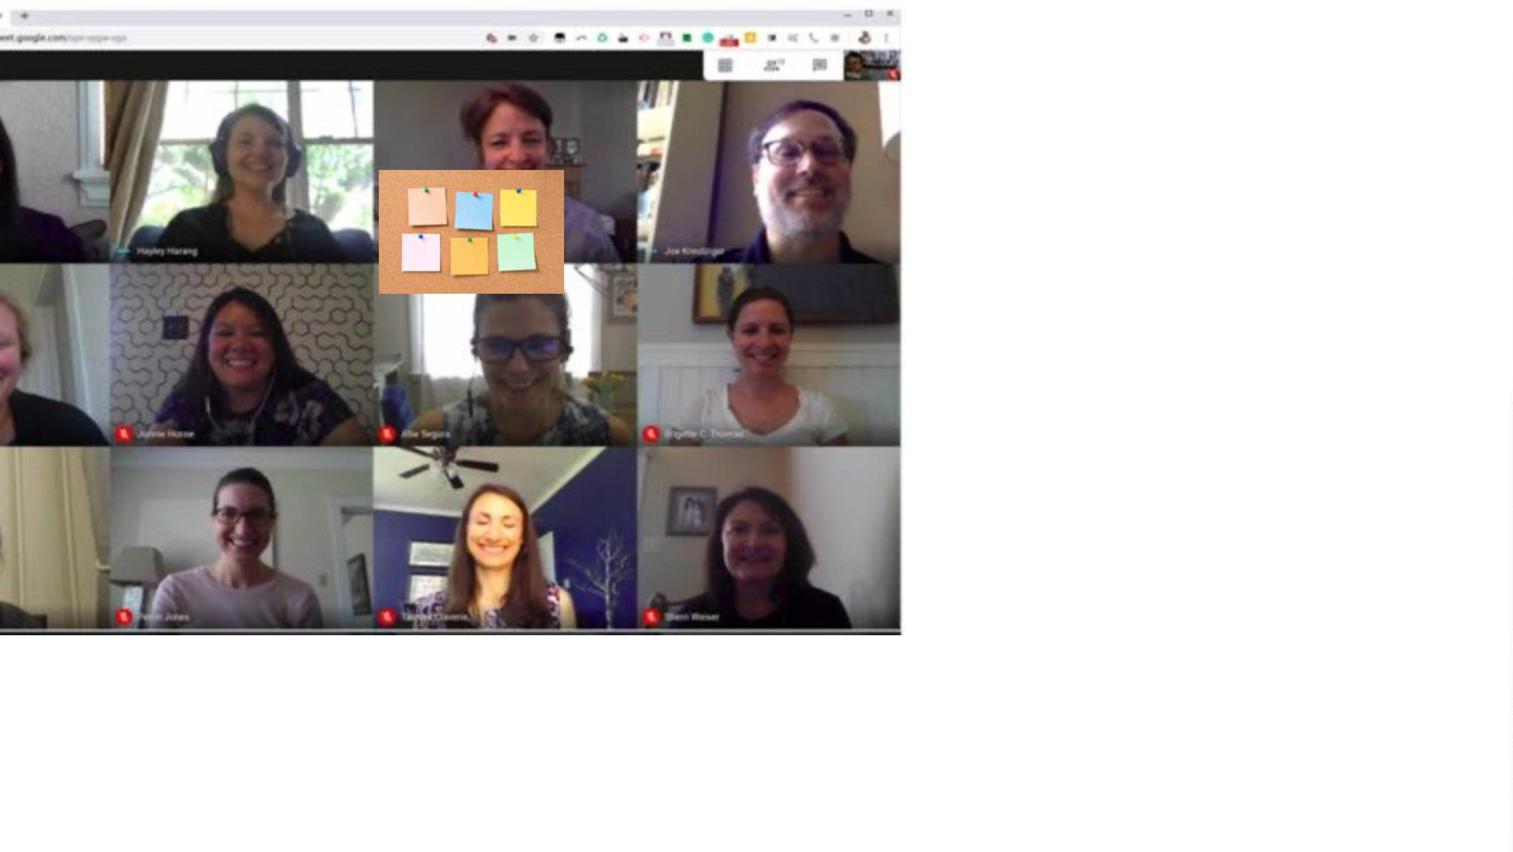

Exit Tickets on Padlet
5
9
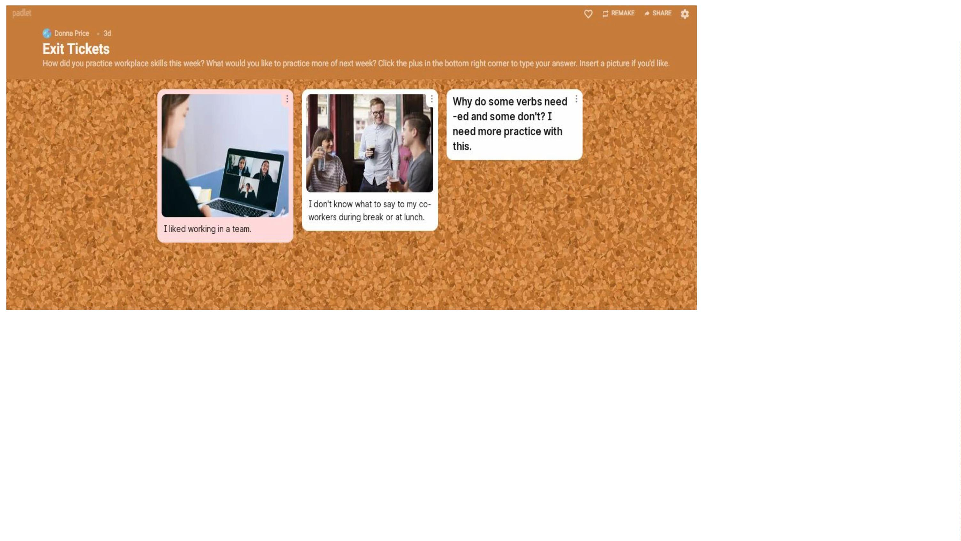

Did We Meet Our Objectives?
Can you identify several oral and written communication activities
that can be taught in ESL classes?
•
•
•
•
•
•
•
One-word selfie
Conversation Cards
Useful phrases
Language Frames (oral and written)
Problem Solving
Classroom jobs
Exit tickets
Can you describe some of them to a colleague?
6
0


Your Biggest Takeaway
What is your biggest takeaway from today ’s
presentation? Write your answers in the chat.
Which two activities do you think you might do in the
next couple of weeks? Write your answers in the chat.
Oral and
written
frames
One-word
selfies
Problem
solving
Classroom
jobs
Exit
tickets
Useful
phrases
Conversation cards
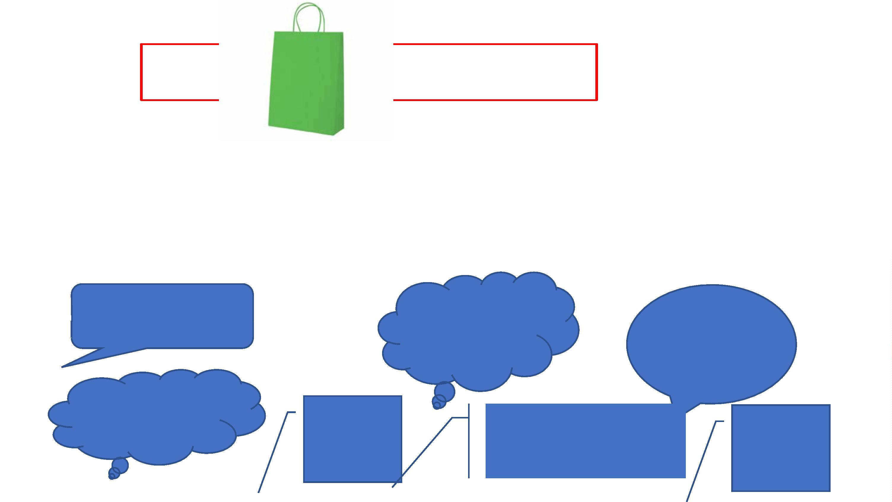

Contact Information
Ronna Magy– ronnawrite@sbcglobal.net
Donna Price – dprice007@gmail.com
6
2


